新北市立溪崑國民中學108學年度第二學期第一次定期評量 英語科 試題卷

九年級　　　班 座號　　　 姓名

**一、聽力測驗30%**

**(一)辨識句意：每題均有三張圖片，請依據所聽到的句子，選出符合描述的圖片(每題2分，共10分)**

1. ＿＿＿  
   (A)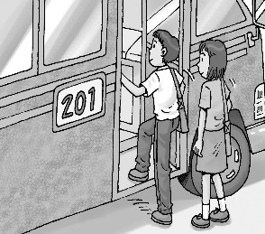 (B)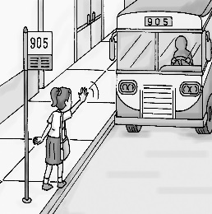 (C)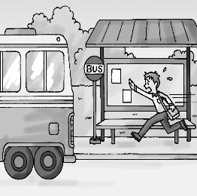
2. ＿＿＿  
   (A) (B)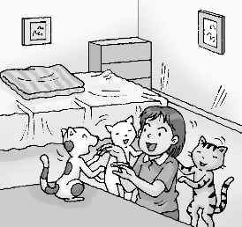 (C)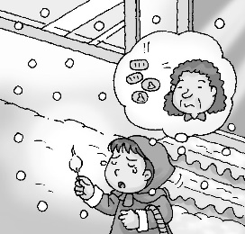
3. ＿＿＿  
   (A)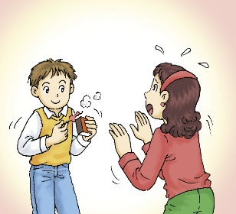 (B)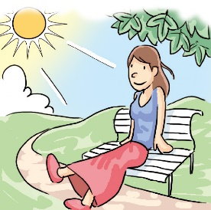 (C)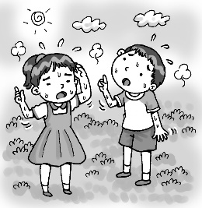
4. ＿＿＿  
   (A)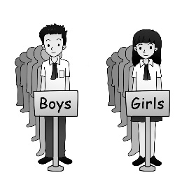 (B)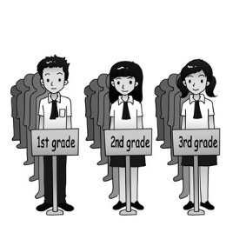 (C)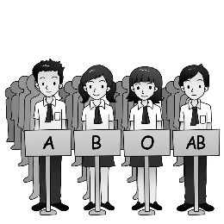
5. ＿＿＿  
   (A)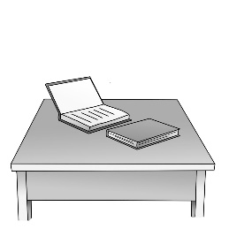 (B)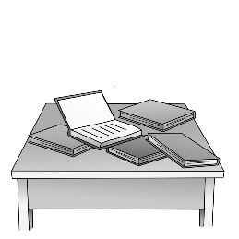 (C)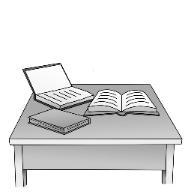

**(二)基本問答：每題均有三個選項，請依據所聽到的內容，選出一個最適合的回應(每題2分，共10分)**

1. ＿＿＿  
   (A) OK, I’ll call you as long as I have time.  
   (B) Yes, I’ll chat with you on the social media.  
   (C) All right, I’ll go home as soon as possible.
2. ＿＿＿  
   (A) No, I have read her message.  
   (B) Yes, my smartphone does not work well.  
   (C) Yes, and she looked happy and excited.
3. ＿＿＿  
   (A) She has to keep her word.  
   (B) She was shocked by the bad news.  
   (C) She can’t explain everything.
4. ＿＿＿  
   (A) Let’s put it off.  
   (B) Let’s look for it.  
   (C) Let’s take it away.
5. ＿＿＿  
   (A) Maybe you can take it away.  
   (B) Maybe you can order another one.  
   (C) Maybe you can turn it off.

**(三)言談理解：每題均有三個選項，請依據所聽到的對話與問題，選出一個最適當的答案(每題2分，共10分)**

1. ＿＿＿  
   (A) A set of old stamps.  
   (B) Some expensive stickers.  
   (C) The old birds in the cage.
2. ＿＿＿  
   (A) The man had found the person before the woman called.  
   (B) The man had caught the person before the woman called.  
   (C) The man had turned off his phone before the woman called.
3. ＿＿＿  
   (A) Sam.  
   (B) Larry.  
   (C) Both Sam and Larry.
4. ＿＿＿  
   (A) Both the man and the woman will eat in another restaurant.  
   (B) The woman will leave for another restaurant, but the man won’t.  
   (C) Both the man and the woman will keep waiting for the food in the restaurant.
5. ＿＿＿  
   (A) He will read the report on the screen.  
   (B) He is waiting for the woman to print out the report.  
   (C) He won’t print the report out for the woman.

**二、綜合測驗30%**

16. The Titanic hit an iceberg on its first trip across the Atlantic and . Many people died there were not enough lifeboats.

(A)turned down; because (B) turned over; because (C) turned off; if (D) passed on; as long as

17. We always sent photos to our grandparents to share our lives with them.

(A) everyday (B) homeless (C) every day (D) message

18. When the plane landed at the safely, everyone on it clapped and cheered.

(A) group (B) global (C) station (D) airport

19. I lost my in the supermarket. There were some business cards and money inside it. Although I asked for Lost and Found, I still couldn’t find it.

(A) wallet (B) ticket (C) secret (D) strip

20. I try to myself lying on the green grass and looking at the sky when I feel stressed.

(A) print (B) picture (C) draw (D) pack

21. Jemery in Taiwan for almost 20 years before he to the USA. So he speaks good Chinese.

(A) has lived; has moved (B) lived; moves (C) was living; moving (D) had lived; moved

22. Judy asked me to pick her up at the train station. she arrives at the train station , she me.

(A) As soon as; will call (B) As long as; was calling (C) As soon as; would call (D) If ; calls

23. Sam said his parents friends for years before they got married.

(A) has been (B) had been (C) are (D) would be

24. I don’t care what you did as long as you .

(A) told me the truth (B) tell me a lie (C) told me a lie (D) tell me the truth

25. You haven’t gone camping, and . Maybe we can go together next time.

(A) neither has my family (B) neither hasn’t my family (C) my family has, either (D) so hasn’t my family

26. Kevin shout when he heard his favorite singer singing, but now he chooses to enjoy it quietly.

(A) is used to; excitingly (B) used to; excitedly (C) used to; excited (D) gets used to; excitingly

27. Jay looks sad for the losing game. Let’s .

(A) cheer up him (B) cheer him for (C) cheer him up (D) pick on him

28. Some of my classmates have joined the class group on Line, but haven’t.

(A) the others (B) others (C) other (D) the other

29. Neither Emma nor Kelly come to the meeting. can just stay home and wait for my call.

(A) have to; Both of them (B) has to; All of them

(C) have to; Every of them (D) has to; Both of them

30. The refrigerator still runs well it’s very old .

(A) because (B) as long as (C) until (D) although

**三、克漏字測驗10%**

**(一)**

|  |
| --- |
| It (31) that a picture can say more than a thousand words. However, imagine that you (32) see. How can you picture the world (33) ? This is a problem children who can’t see or can’t see well face when they read books with words and pictures. They can read the words by touching the dots, but it is hard for them to imagine (34) .  Things are different now because we have 3D printing. (35) , the pictures can be made into real 3D objects. For example, when blind children read the book, they can understand the story by touching those printing characters. They can feel the shapes of them. Although the blind children aren’t using their eyes, they are still “ seeing ” what we see. |

31. (A) said (B) is said (C) is saying (D) says

32. (A) couldn’t (B) wouldn’t be able to (C) are not able to (D) will not able to

33. (A) a writer creates (B) which a writer had created (C) a writer was creating (D) where a writer creates

34. (A) what are the pictures like (B) where are the pictures (C) what do the pictures look like (D) what the pictures are like

35. (A) By drawing well (B) With the help of a 3D printer (C) With the help of a smartphone (D) By use a 3D printer

**四、閱讀測驗30%**

**(一)**

Babe Ruth,

standing on the home base,

Looks at the ball in the pitcher’s left hand,

Wondering how fast the baseball will move this time

And what his last chance will turn out to be.

In Babe’s ten years’ experience

As a baseball player,

He knows he is dealing with a thorny issue .

The pitcher is smart, strong, and careful.

The ball he throws is like a lightning.

Worried,

He knows

He has little chance of hitting a home run,

Which his team needs to win the game.

The pitcher nods at the catcher,

And he raises his left hand.

The ball comes Babe’ way at more than 170km an hour.

Babe Ruth has less than one second to decide

How he will swing his bat.

Babe swings his bat hard.

The ball flies high away,

And so does the last chance of winning the game.

36. What does a thorny issue mean?

(A) A good chance to win. (B) An exciting moment. (C) A difficult problem. (D) An easy game.

37. What is NOT mentioned in the reading ?

(A) Which team Babe Ruth is on. (B) How fast the ball flies. (C) How long Babe Ruth has played baseball.

(D) How Babe Ruth feels before he hits the ball.

38. What can we learn from the reading ?

(A) Babe Ruth wins the game for his team. (B) Babe Ruth lets his team down at last. (C) Babe Ruth believes he will hit a home run easily. (D) Babe Ruth swings but misses the ball.

**(二) The Death of Kobe Bryant**

Kobe Bryant was the most **respected** and well-known basketball player of all time. His **contribution** to the sport is second to none – he entered the NBA (National Basketball Association) in high school and spent his whole career on the Los Angeles Lakers team. He not only **distinguished** himself at home, but he was also excellent at the 2008 and 2012 Summer Olympics where he won two gold medals for the U.S.A. He won the respect of people all over the world. In 2016, he **retired** from the game. Even though he had retired, he still had a bright future ahead of him in other basketball-related work.

Sadly, his great career came to an end on 26 January, 2020. On that day, Bryant was on a helicopter that crashed into the hills of California near Los Angeles. On the morning of 26 January, the weather in California was not ideal for flying because there were a lot of clouds in the sky which were close to the ground. In fact, the Los Angeles Police had grounded all police helicopters.

However, Bryant’s pilot wasn’t worried about the weather and decided to fly into heavy fog which meant he couldn’t see clearly enough where he was going. Just before the crash, the pilot told air traffic control that he was rising through the clouds. Really, the pilot was just about 30 meters short of breaking through the clouds when the helicopter crashed into a hillside. Bryant and the pilot weren’t the only ones who died in the crash – onboard was the basketball player’s thirteen-year-old daughter and seven other people.

His angry and sad wife is complaining the helicopter company for killing her family members. American government have ruled out **mechanical** failure as a reason for the crash. Also, they believe that the pilot caused the crash. It will take about another year until we know all the answers.

Vanessa Bryant described Kobe as “the perfect husband.” About their daughter, she said: “Her smile took up her entire face, like me. She had my fire and my characters. She had the best laugh. It’s in her blood. ” The memorial service for Kobe and his daughter was held at the Los Angeles stadium where Bryant spent most of his career. He 41. by his fans all over the world.

|  |
| --- |
| respected備受尊敬的 contribution 貢獻 distinguish 表現傑出 mechanical 機械的 |

39. Which does “ retire ” mean?

(A) Join a club. (B) Leave the job. (C) Recover from the sadness. (D) Look forward to a new job.

40. Which is Not true according to the reading?

(A) The memorial service for Kobe and his daughter was held at the Los Angeles stadium.

(B) Bryant retired from the game in 2016, but he still had a bright future ahead of him in other basketball-related work.

(C) Bryant entered the NBA (National Basketball Association) in high school.

(D) The weather in California was not ideal for flying and Bryant told the pilot to fly.

41. Choose the best answer for 41. .

(A) will surely be remembered (B) will not be remembered

(C) will not be known (D) will be heard

**(三)**  Coronavirus: How to Protect Yourself By Leila Pereira

Since the end of December 2019, the world has known about COVID-19, the newest coronavirus infecting the globe since SARS in 2003 and MERS in 2012. The virus spreads quite quickly and many people are wondering (45) . Here are some important tips:

**1. Wash Your Hands Often, WITH SOAP!**

You should wash your hands after coughing or sneezing, as the virus can be hiding in water droplets. You should also wash your hands before, during, and after food preparation, as well as before eating any food. If you’re not sure, just wash your hands! You can also wear gloves or use hand sanitizer if you don’t have chance to soap and water. But soap is the most efficient way to kill the coronavirus. Why? When you add soap to your hands – the water-hating tail of the virus will cling to the oil, and the water-loving head will stick to the water. Now, the oil will come straight off. Because the soap molecules are so similar to the ones making up the outer layer of the virus. This breaks the neatly-ordered shell around the virus, killing it in the running water.

|  |
| --- |
| A lipid bilayer with the round, hydrophilic heads pointing outwards and the hydrophobic tails pointing inwards © LadyofHats / Public domain a coronavirus |

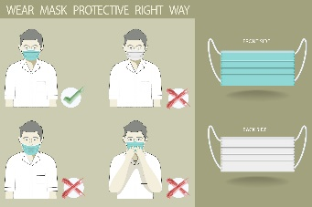**2. Wear a Mask,** **PROPERLY!**

Masks are more for protecting other people from you, than protecting you from the virus. Regular surgical masks can stop a virus most of the time. You should make sure the mask is pulled closely against the skin, or the virus can come in from the open spaces.

|  |
| --- |
| hand sanitizer 乾洗手 molecules 分子 neatly整齊地 |

42. Your hands are dirty, but there is no soap and water. What can you do?

(A) Use hand sanitizer. (B) Nothing. Dirty hands are fine.

(C) Wipe my hands on my clothes. (D) Don't touch anything until you can find some water.

43. How can the virus still come in even if people wear a mask?

(A) The mask is too thin. (B) It's not strong enough.

(C) The color of the mask is wrong. (D) The mask is not pulled closely against the skin.

44. Which of the following disease is NOT a coronavirus?

(A) MERS (B) Covid-19 (C) Flu B (D) SARS

45. What’s the best answer for (45) ?

(A) when Covid-19 will be gone (B) how to protect themselves (C) where Covid-19 begins (D) who to ask for help when you get Covid-19

(四) Types of Bullying

There are three types of bullying:

* **Verbal bullying** is saying or writing mean things. Verbal bullying includes:
  + Teasing
  + Name-calling
  + Inappropriate sexual comments
  + Taunting
  + Threatening to cause harm
* **Social bullying**, sometimes referred to as relational bullying, involves hurting someone’s reputation or relationships. Social bullying includes:
  + Leaving someone out on purpose
  + Telling other children not to be friends with someone
  + Spreading rumors about someone
  + Embarrassing someone in public
* **Physical bullying** involves hurting a person’s body or possessions. Physical bullying includes:
  + Hitting/kicking/pinching
  + Spitting
  + Tripping/pushing
  + Taking or breaking someone’s things
  + Making mean or rude hand gesture

|  |
| --- |
| taunting嘲諷 threaten威脅 reputation聲譽 rumor謠言 embarrass使尷尬 possessions財產spitting隨地吐痰tripping絆倒 |

46. Which is Not a kind of bullying?

(A) On birthday, John brought snacks to school and shared with all classmates except Alice.

(B) Tim said unkind things to Jack and laughed at him so that he became angry and upset.

(C) Kevin kept calling Andy “ Black ” because of his dark skin.

(D) Mary volunteered to help Jenny with her science homework after school.

47. David: “Jack, Toby never lends me his math notebook. Today he even said NO when I asked him to show me the answers of the English test. Let’s not talk to him anymore. Besides, if you talk to him, you won’t be my friend anymore.”

In the above example, what kind of bullying is it?

(A) Physical bullying. (B) Social bullying. (C) Verbal bullying. (D) It’s not a bulling.

(五)

Malala

Malala Yousafzai came to public attention in 2009, at the age of eleven, by writing a BBC diary about life under the Taliban. Using the pen name Gul Makai, she often spoke about her family’s fight for girls’ education in her country.

In October 2012, Malala were targeted by the Taliban and shot in the head while riding the bus home from school and (49) . Instead, her miraculous recovery has taken her to an extraordinary future from a small village in Pakistan to the United Nations in New York.

In honor of her courage and ideas, she has received hundreds of awards. Being the youngest person for the Nobel Peace Prize in 2014 makes her become a global symbol of peace and bravery. What’s next for Malala? She said, “ I want to get my education-a good university education. My dream is to empower myself with education, and then it is a weapon.” “Ms. Yousafzai’s example as a symbol of peace and bravery has been established across the world.”-*NEW YORK TIMES 2017*

|  |
| --- |
| target目標 miraculous 奇蹟的 |

48. When did Malala come to public attention?

(A) After she got the Nobel Peace Prize in 2014. (B) After she was shot in the head in 2012.

(C) After she wrote a BBC diary about life under the Taliban in 2009. (D) After she finished her university education.

49. What’s the best answer for (49) ?

(A) few expected her to stay alive (B) people listened to her speech (C) many people thought she would stay alive (D) she wrote the experience in her diary

50. Please place these sentences in correct time order.

a. Malala got shot in the head on her way home.

b. Malala started her university education.

c. Malala became the youngest winner of the Nobel Peace Prize.

d. Malala used the pen name Gul Makai to write to BBC.

(A) b-c-a-d (B) d-c-a-b (C) c-b-d-a (D) d-a-c-b

108-2-1 九年級 英語科－解答

1~5 CCCBB 6~10 CCBBB 11~15 AABAC

16~20 BADAB 21~25 DABDA 26~30 BCADD

31~35 BCADB 36~40 CABBD 41~45 AADCB

46~50 DBCAD

新北市立溪崑國民中學108學年度第二學期第一次定期評量

九年級 英語科 聽力測驗稿

**一、辨識句意：每題均有三張圖片，請依據所聽到的句子，選出符合描述的圖片**

1. 《腳本區》  
   CD: The bus had left when the student arrived at the stop.  
   《題目區》  
   ＿＿＿  
   (A) (B) (C)

《答案區》  
答案：C

難易度：易

題號：C06L1190

1. 《腳本區》  
   CD: The girl cried as soon as she thought of her grandmother.  
   《題目區》  
   ＿＿＿  
   (A) (B) (C)

《答案區》  
答案：C

難易度：易

題號：C06L1192

1. 《腳本區》  
   **CD: (Woman:) I feel hot. So does my brother.**《題目區》  
   ＿＿＿  
   (A)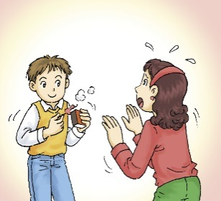 (B)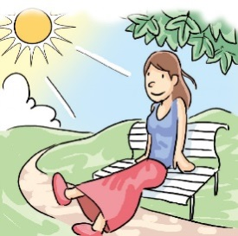(C)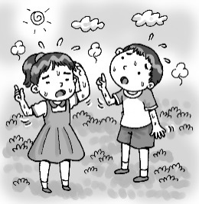

《答案區》  
答案：C

難易度：中

題號：C06L2191

1. 《腳本區》  
   **CD: The students are grouped into different grades.**《題目區》  
   ＿＿＿  
   (A) (B) (C)

《答案區》  
答案：B

難易度：中

題號：C06L2197

1. 《腳本區》  
   **CD: One of the books on the desk is open, and the others are not.**《題目區》  
   ＿＿＿  
   (A) (B) (C)

《答案區》  
答案：B

難易度：中

題號：C06L3197

**二、基本問答：每題均有三個選項，請依據所聽到的內容，選出一個最適合的回應**

1. 《腳本區》  
   CD: I have something to tell you. Could you come home as soon as you finish the job?  
   《題目區》  
   ＿＿＿  
   (A) OK, I’ll call you as long as I have time.  
   (B) Yes, I’ll chat with you on the social media.  
   (C) All right, I’ll go home as soon as possible.

《答案區》  
答案：C

難易度：中

題號：C06L1092

1. 《腳本區》  
   CD: Did you just make a video call to Emma?  
   《題目區》  
   ＿＿＿  
   (A) No, I have read her message.  
   (B) Yes, my smartphone does not work well.  
   (C) Yes, and she looked happy and excited.

《答案區》  
答案：C

難易度：中

題號：C06L1098

1. 《腳本區》  
   **CD: Lisa appeared to be scared. What happened?**《題目區》  
   ＿＿＿  
   (A) She has to keep her word.  
   (B) She was shocked by the bad news.  
   (C) She can’t explain everything.

《答案區》  
答案：B

難易度：中

題號：C06L2089

1. 《腳本區》  
   **CD: I just lost my wallet. Can you help me find it?**《題目區》  
   ＿＿＿  
   (A) Let’s put it off.  
   (B) Let’s look for it.  
   (C) Let’s take it away.

《答案區》  
答案：B

難易度：中

題號：C06L3087

1. 《腳本區》  
   **CD: I’ve finished a bowl of noodles. Why am I still hungry?**《題目區》  
   ＿＿＿  
   (A) Maybe you can take it away.  
   (B) Maybe you can order another one.  
   (C) Maybe you can turn it off.

《答案區》  
答案：B

難易度：中

題號：C06L3090

**三、言談理解：每題均有三個選項，請依據所聽到的對話與問題，選出一個最適當的答案**

1. 《腳本區》  
   CD: Man: What are you looking at?  
   Woman: A set of stamps I found in my grandmother’s old box.  
   Man: Wow. They’re old but beautiful. Each of them shows a kind of bird that is commonly seen in our country.  
   Woman: Do you think I can sell them at a good price online?  
   Man: Well, could you sell them to me?  
   Question: What are they talking about?  
   《題目區》  
   ＿＿＿  
   (A) A set of old stamps.  
   (B) Some expensive stickers.  
   (C) The old birds in the cage.

《答案區》  
答案：A

難易度：中

題號：C06L1109

1. 《腳本區》  
   CD: *[Phone ringing...]*  
   Man: Raymond speaking.  
   Woman: Raymond, it’s been hours. Haven’t you seen the guy?  
   Man: I have, and I was even so close to catch him until you called. Now the guy has run away because of your call.  
   Woman: Er. Why didn’t you turn off your phone then?  
   Question: What happened before the woman called?  
   《題目區》  
   ＿＿＿  
   (A) The man had found the person before the woman called.  
   (B) The man had caught the person before the woman called.  
   (C) The man had turned off his phone before the woman called.

《答案區》  
答案：A

難易度：難

題號：C06L1117

1. 《腳本區》  
   CD: Man: Excuse me. Are you Ms. Lin?  
   Woman: Yes, are you Larry Wu?  
   Man: No, I’m Sam. Larry can’t come today, so he asked me to pick you up. I’ll take you to our hotel.   
   Woman: Then he should at least give me a call.  
   Man: In fact, he did, but you didn’t answer the phone, so he left a voice message. Just check your phone.  
   Question: Who was the person that sent the message to the woman?  
   《題目區》  
   ＿＿＿  
   (A) Sam.  
   (B) Larry.  
   (C) Both Sam and Larry.

《答案區》  
答案：B

難易度：中

題號：C06L1120

1. 《腳本區》  
   **CD: Man: I can’t believe it. This restaurant’s still full of people after two p.m.  
   Woman: I’m so hungry. I can’t wait anymore.  
   Man: Neither can I. Let’s go to another restaurant.  
   Question: What will happen next?**《題目區》  
   ＿＿＿  
   (A) Both the man and the woman will eat in another restaurant.  
   (B) The woman will leave for another restaurant, but the man won’t.  
   (C) Both the man and the woman will keep waiting for the food in the restaurant.

《答案區》  
答案：A

難易度：中

題號：C06L2119

1. 《腳本區》  
   **CD: Man: Linda, I’ve e-mailed the report to you. Tell me what you think after you read it.  
   Woman: OK. But could you please print it out and put it on my desk? I’m a little busy now.  
   Man: Well, to protect the Earth, it’d be better if you read the report on the computer screen.  
   Question: What does the man mean?**《題目區》  
   ＿＿＿  
   (A) He will read the report on the screen.  
   (B) He is waiting for the woman to print out the report.  
   (C) He won’t print the report out for the woman.

《答案區》  
答案：C

難易度：難

題號：C06L4110