新北市立溪崑國民中學109學年度第一學期第三次定期評量 英語科 試題卷

七年級　　　班 座號　　　 姓名

一、聽力測驗：30%

I. 辨識句意 (符合圖意內容的選 A，不符合選 B)

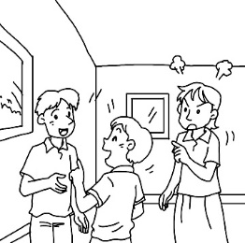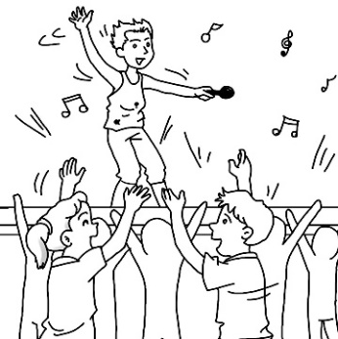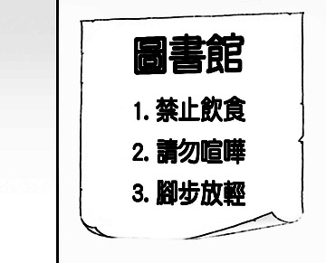 1. 2. 3.

4.　 5.

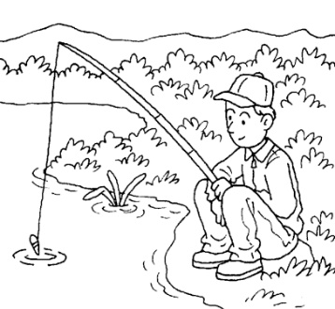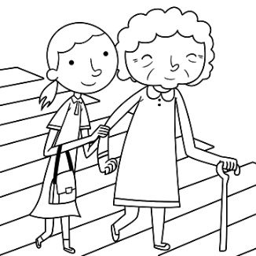

II. 基本問答 (依據聽到的對話內容，選出最適合的回應)

6. (A) Let’s run.

(B) Don’t sit here.

(C) You’re so kind.

7. (A) Yes, it’s a bus station.

(B) Yes, let’s go into it.

(C) No, it’s not the train station.

8. (A) Let’s talk now.

(B) You’re welcome.

(C) Sorry. It’s my cellphone.

9. (A) No, it’s at four p.m.

(B) No, it’s at nine a.m.

(C) No, it’s on Friday morning.

10. (A) On Monday morning.

(B) At 2:00 p.m.

(C) This afternoon.

III. 言談理解（根據聽到的對話內容與問題，選出正確的答案）

11. (A) Write on the desk.

(B) Don’t talk.

(C) Listen carefully.

【背面尚有試題】

12. (A) The man and the woman are in front of a fruit stand.

(B) The old lady’s cakes are very scary.

(C) They are in a long line for some special cakes.

13. (A) The metro station is next to the museum.

(B) There is a metro station under the museum.

(C) The man and the woman are on the metro.

14. (A) No rules for the game.

(B) Don’t make any noise.

(C) Play the game at night.

15. (A) Yes, it is.

(B) No, it’s at 7:15 p.m. on Wednesday.

(C) No, it’s at 7:30 p.m. on Thursday.

二、請依題意選出最適當的答案：40 %

16. Please ________ the traffic rules. It’s dangerous to break them.

(A) make (B) follow (C) shout (D) draw

17. Everyone ______ singing happily on the bus.

(A) is (B) are (C) am (D) can

18. There are some mice ________ around in the dirty kitchen.

(A) run (B) runs (C) is running (D) running

19. It’s already _______ 7:30 p.m. Let’s have _________.

(A) x ; dinner (B) at ; dinner (C) x ; a dinner (D) at ; a dinner

20. I’m __________ my book, but I can’t find it.

(A) look at (B) look for (C) looking at (D) looking for

21. He’s standing ______ the door and _______ for his son.

(A) in ; wait (B) in ; waiting (C) at ; wait (D) at ; waiting

22. Don’t _________ at your brother ____ the metro.

(A) shout ; in (B) shouting ; in (C) shout ; on (D) shouting ; on

23. ____________ for the car in front of you.

(A) Hurry up (B) Watch out (C) Have fun (D) Take a seat

24. A: Let’s ________ in class. B: No _________.

(A) not talk ; problem (B) don’t talk ; problem (C) not say ; problem (D) don’t say ; problems

25. A: ____________ is your PE class? B: It’s __________.

(A) What day ; Sunday (B) What day ; on Sunday (C) What time ; Sunday (D) What time ; on Sunday

26. Always _______ other people.

(A) nice to (B) be nice (C) be nice to (D) be nice for

27. Which sentence is **NOT** correct?

(A) Please take a seat, John. (B) Take a seat, please, John.

(C) John, please take a seat. (D) John, take a seat, please.

28. ________ is the day before Wednesday. It’s also the third day of the week.

(A) Monday (B) Tuesday (C) Saturday (D) Friday

29. Choose the correct sentence.(選出正確句子)

(A) Leo is chating with his friends in the living room.

(B) Amy is studing in her room.

(C) Mom is preparing dinner in the kitchen.

(D) They are playing the basketball in the gym.

30. Joyce ________ a good time at the party, and her classmates are, too.

(A) has (B) have (C) is having (D) are having

31. A: Don’t talk loudly in the museum. B: Oops, ___________.

(A) You’re welcome. (B) I’m sorry. (C) That’s the rule. (D) Be quiet.

32. The welcome party for Betty is ____ Saturday morning.

(A) at (B) in (C) on (D) of

33. Please ________ hello to your classmates.

(A) say (B) speak (C) talk (D) chat

34. It’s time _______ school. Hurry up!

(A) to (B) at (C) in (D) for

35. Our English class is ______ 10:00 a.m. _____ Wednesday.

(A) x ; on (B) at ; on (C) x ; in (D) at ; x

三、克漏字選擇及閱讀測驗：30 %

|  |
| --- |
| Mom: What are you 36. in your room?  Fanny: I’m 37. the tests.  Mom: Can you help me tidy up the room later?  Fanny: No, I can’t. I will go to the movies with Sue 38. 2:30.  Mom: It’s already 2:10. You have to 39. .  Fanny: Oh, no! |

36. (A) do (B) to do (C) does (D) doing

37. (A) prepare (B) prepare for (C) preparing (D) preparing for

38. (A) at (B) on (C) in (D) X

39. (A) stand in line (B) hurry up (C) watch out (D) run fast

|  |
| --- |
| Hello, class. I’m your new teacher, Ms. Chen. Please follow the rules in my class.   1. Don’t 40. for the class. 2. Don’t eat 41. drink in class. 3. Please keep quiet and 42. me carefully. |

40. (A) late (B) is late (C) be late (D) being late

41. (A) and (B) or (C) but (D) so

42. (A) listen (B) listen at (C) to listen (D) listen to

|  |
| --- |
| Emma has a new bicycle. It is bright pink and shiny. It was a gift from her father. He hid it behind a bush to surprise her. When Emma looked behind the bush and saw the bicycle, she jumped for joy. It was just what she wanted. She gave her father a big hug. She loves her new bicycle, and she loves her father. |

43. What color is the bicycle?

(A) dark blue (B) light brown (C) bright red (D) bright pink

44. Who was the gift from?

(A) Emma (B) Emma’s uncle (C) Emma’s brother (D) Emma’s parent

45. Where was the bicycle hidden?

(A) beside the bush (B) in front of the tree (C) behind the tree (D) behind the bush

46. Was Emma happy when she saw the bicycle?

(A) No, she was sad. (B) No, she was angry. (C) Yes, she was happy. (D) We don’t know.

【背面尚有試題】

|  |
| --- |
| “Look, Ned, here is a nest! It is made of hay, and the old hen is in it.”  “Put your hand into the nest, Mary.”  “Oh no, the hen will not let me! The hen is protecting something.”  “Mary, I will hold onto her.”  “Well, Ned, if you can hold her, I will put my hand into the nest,” said Mary as she moved her hand  towards the nest. “Oh Ned, there are some little chicks under the hen!”  “Are there?” asked Ned.  “Take her out of the nest so we can see them.”  Ned lifted the hen out of the nest. The children could see the chicks. There were six of them.  “Oh, the dear little chicks! How pretty they are,” said Ned. “Should we help the hen to feed them, Mary?”  “Yes, I will run and get some food and give them some water,” shouted Mary as she ran towards her house.  nest 巢 towards 接近 lift 抬起 |

47. What is the nest made of ?

(A) hair (B) hen (C) hay (D) eggs

48. How many chicks were there in the nest?

(A) 5 (B) 6 (C) 7 (D) 8

49. What will the children do for the little chicks?

(A) They will give them food and water.

(B) They will protect them.

(C) They will lift the hen.

(D) They will take them out of the nest.

50. Why won’t the hen let Mary put her hand in the nest?

(A) The hen is sleeping.

(B) The hen is hungry.

(C) The hen is protecting the nest.

(D) The hen is protecting the chicks.

**【試題結束】**

**Good luck and have a wonderful winter vacation!**

109-1-3 七年級 英語科－解答

1-10 BAABA ABCAB

11-20 ACBBC BADAD

21-30 DCBAB CBBCC

31-40 BCADB DDABC

41-50 BDDDD CCBAD