新北市立溪崑國民中學110學年度第一學期第一次定期評量 英語科 試題卷

九年級　　　班 座號　　　 姓名

**一、聽力測驗 (30%)**

(A) 辨識句意：根據聽到的內容，選出符合描述的圖片。

1. **(Ａ) 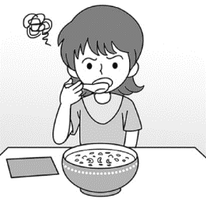(Ｂ) 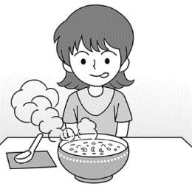(Ｃ)** 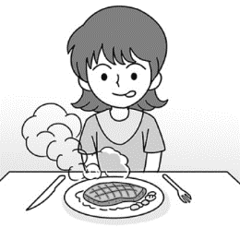
2. **(Ａ) 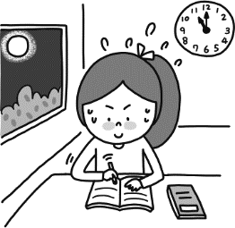　 (Ｂ) 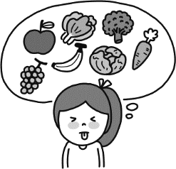　 (Ｃ)　 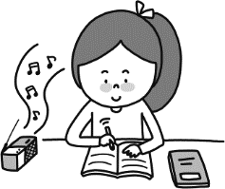**
3. **(Ａ) 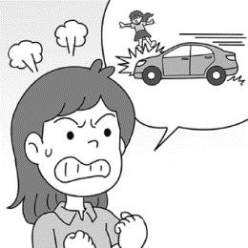 　 (Ｂ)　 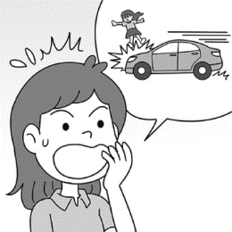 (Ｃ)　 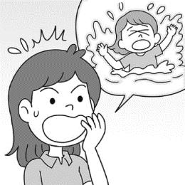**
4. **(Ａ) 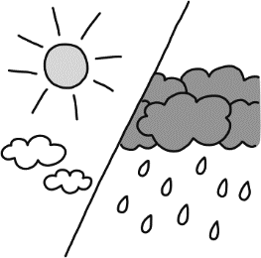 　 (Ｂ) 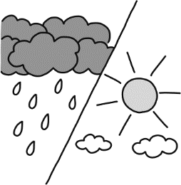 　 (Ｃ)　 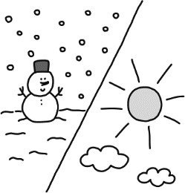**
5. **(Ａ) 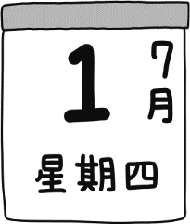 　 (Ｂ)　 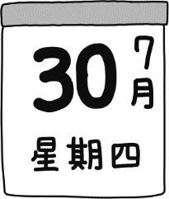 (Ｃ)** 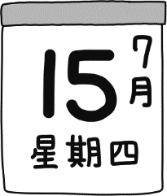

**(B) 基本問答：根據聽到的內容，選出一個最適合的回應。**

**6. (A) No, I haven’t heard from you.**

**(B) Yes, I have. They are a famous band.**

**(C) Yes, I live in Taiwan.**

**7. (A) They like scary movies.**

**(B) Don’t be afraid of it.**

**(C) Because of its terrible smell.**

**8. (A) I am so tired that I just want to stay at home.**

**(B) That is very kind of you.**

**(C) It was so boring.**

**9.(A) Yes, he was working out in the gym then.**

**(B) It is a piece of good news for me.**

**(C) No. No one has heard from him since he left.**

**10.(A) No, never. But he really wants to visit there someday!**

**(B) Yes, he will visit my grandmother.**

**(C) No, he was in Japan two days ago.**

**(C) 言談理解：根據聽到的內容，選出一個最適合的答案。**

**11. (A) They run as fast as possible.**

**(B) They stand still and don’t move.**

**(C) They find something to hit the snake.**

**12. (A) She is gaining some weight.**

**(B) She doesn’t have time to have lunch.**

**(C) She is always tired after work.**

**13. (A) Yes, she will.**

**(B) No, she won’t.**

**(C) She hasn’t decided it yet.**

**14. (A) She is going to paint the bedroom by herself.**

**(B) She is going to become a famous youtuber.**

**(C) She can make a beautiful mask by herself.**

**15. (A) Buy some food in the supermarket.**

**(B) Go to the movies together.**

**(C) Take a plane to another country.**

**二、綜合測驗 (32%)**

**16. Simon is my best friend. We have known each other _________ 20 years.**

1. **in (B) during (C) since (D) for**

**17. A:Have you ever watched Fast & Furious 9? It was so _______.**

**B:Yes, I felt _____, too. I almost fell asleep.**

**(A) boring; boring (B) bored; bored (C) boring; bored (D) bored; boring**

**18. A: Has Steve ever taken a boat? B: No, ___________.**

**(A) He never does. (B) He does never. (C) He has never. (D) He never has.**

**19. Students, please pick up your trash near your seats and throw it in the _________ can in the classroom .**

**(A) garbage (B) envelope (C) diet (D) castle**

**20. A: Would you like to play tennis with us this Sunday? B: _______ I have other plans.**

**(A) I can’t wait. (B) I’ll past. (C) Count me in. (D) I’ll pass.**

**21. Tai Tzu-Ying ________ playing badminton since she was nine. Her dream is to become a top badminton player.**

**(A) has interested in (B) has interesting to (C) has been interested in (D)has been interesting to**

**22. Ms. Lee _______ English at our school from 1999 to 2012. She doesn’t teach English now.**

**(A) teached (B) taught (C) has teached (D) has taught**

**23. Three days _______ to see everything in London in England.**

**(A) aren’t too long (B) isn’t too long (C) aren’t long enough (D) isn’t long enough**

**24. All the girls were _______ the end of the movie. They couldn’t believe it.**

**(A) surprised to (B) surprising to (C) surprised at (D) surprising at**

**25. Sam will go hiking with his classmates next weekend, and they are all excited ______ it.**

**(A) about (B) at (C) with (D) of**

**26. A: How has your grandmother _______? B:She’s been fine these days.**

**(A) gone (B) been (C) gone to (D) been to**

**27. The little boy ______ a hole in the garden and _______ a map inside yesterday.**

**(A) dug; hid (B) deg; hid (C) dag; hided (D) deg; hided**

**28. The Wang family often goes _______ in summer. They love traveling to different countries.**

**(A) serious (B) crazy (C) unhappy (D) abroad**

**29.Tell me what happened at your office. I am ________.**

**(A) all right (B) all ears (C) right (D) ear**

**30. Peter loves reading Ken’s _______ on the Net because he shares lots of exciting fishing experiences.**

**(A) pieces (B) tickets (C) spells (D) posts**

**31. Eddie is 15 years old. He is now a _____, not a child.**

**(A) teenager (B) stamp (C) towel (D) heart**

**三、克漏字測驗 (8%)**

**Mary：Where are May and Jim? I haven’t seen them for several days.  
Tina：They 32 Boracay on vacation. Didn’t they tell you?  
Mary：Of course not. Is it just the two of them?  
Tina：Yes, they have been together for two months. They 33 to take a trip abroad two weeks ago.  
Mary： 34 I wouldn’t mind lying on a white sand beach with my boyfriend.  
Tina：It might not be so much fun for them because both of them are too self-centered. They will probably have a lot of arguments if they 35 each other well.  
Mary：That’s true.  
self-centered我中心的 probably大概; argument爭吵**

**32. (A) are going to (B) go to (C) have been to (D) have gone to**

**33. (A) decide (B) decides (C) will decide (D) decided**

**34. (A) Boracay is a good choice.**

**(B) Where will they go on a trip?**

**(C) Maybe they will invite us to lunch some time.**

**(D) I love the delicious food at the new restaurant.**

1. **(A) haven’t understood (B) didn’t understand (C) don’t understand (D) won’t understand**

**四、閱讀測驗 (8%)**

**(一)**

**Tired of your news feed bursting with selfies from friends? Or maybe you’re just dying to upload that selfie you took on the way to school. Whether you love or hate them, selfies have become one of the hottest trends to sweep through the Internet.**

**According to one study , over one million selfies are share online every day. They have become very popular because they allow the photographer to control how he or she appears in the picture. Yet some argue the selfies can be signs of self-esteem problems.**

**The truth is that the Internet has increased our contact with others, and the selfie is a useful picture for holding a conversation on social media. Selfies may neither bad or nor good, but it is important not to define yourself or judge others based on a selfie. We need to learn how to deal with the selfie, because it won’t be disappearing from our news feeds anytime in the near future.**

**news feed動態消息 burst塞滿 trend潮流 photographer拍照者 self-esteem自尊 increase增加 define給--下定義**

**36.What is a reason given in the reading for why people take selfies?**

**(A) Because all of their friends are also taking selfies.**

**(B) Because they think selfies are cute.**

**(C) Because they can control how the look in the picture.**

**(D) Because they want to share them on their Facebook news feeds.**

**37.What does the writer believe about selfies?**

**(A) The writer thinks that the popularity of selfies will not last long.**

**(B) The writer believes the selfies will be popular.**

**(C) The writer thinks that more women than men take selfies.**

**(D) The writer says that only young people take selfies.**

**(二)**

**Have you ever wondered why people who live in tropical countries tend to like hot and spicy food? One theory is that people who live in hot places eat spicy food so they can cool down by sweating.**

**Another theory focuses on health. Scientists have discovered that spices used on food can actually kill bacteria. Because of this, people who use spices on their food are often healthier. Many feel that the spicier the food, the better!**

**Of course, spices also add flavor and variety when only a few types of food are available. One grain and one meat source can make a range of uniquely delicious dishes when a mixture of different spices is used.**

**Besides there is no denying that eating heavily spiced food can be both exciting and challenging. One game show in Japan even dares contestants to eat the hottest food they can.**

**tropical熱帶的 spicy辣 bacteria細菌 variety多樣 available可獲得的 deny否認 dare向--挑戰 contestant參賽者**

**38.Why does the writer say people in topical countries eat hot and spicy food?**

**(A) Spices make food taste delicious.**

**(B) Spices are part of a healthy diet.**

**(C) Spicy food cool the body down in hot places.**

**(D) all of the above are correct.**

**39.Why does the writer mention in Japan?**

**(A) To give an example of hot location where spicy food is eaten.**

**(B) To show that people in cool places eat spicy food, too.**

**(C) To introduce how eating spicy food can be challenging.**

**(D) To say where the world’s hottest food is eaten.**

**五、寫出動詞的過去分詞形式(6%)**

**例: see seen**

**40. cut _____ 41. swim ______ 42. study______ 43. plan _____ 44. find _____ 45. come______**

**六、依提示作答 (4%)**

**46. They have known each other since they were in senior high school.(依畫線部分造原問句)**

**47. The table is too heavy for the little boy to move. (請用so…. that… 改寫句子)**

**七、翻譯 (12%)**

**48. 吃太少或只吃幾種食物都不利於你的健康。**

**49. 你最近花太多時間玩線上遊戲，所以你的考試都考得很差。**

**50. 電視或新聞公司通常在發布新聞前會查證事實。**

**51. 在網路上，有些人甚至故意寫假新聞，為了盡可能獲得大量的點擊數。**

新北市立溪崑國民中學110學年度第一學期第一次定期評量 英語科 答案卷

九年級　　　班 座號　　　 姓名

**五、寫出動詞的過去分詞形式(6%)(每題1分)**

|  |  |  |  |  |  |
| --- | --- | --- | --- | --- | --- |
| **40** | **41** | **42** | **43** | **44** | **45** |
|  |  |  |  |  |  |

**六、依提示作答 (4%)(每題2分)**

|  |  |
| --- | --- |
| **46** |  |
| **47** |  |

**七、翻譯 (12%) (每題3分)**

|  |  |
| --- | --- |
| **48** |  |
| **49** |  |
| **50** |  |
| **51** |  |

110-1-1 九年級 英語科－解答

1. **聽力測驗 (30%)**

|  |  |  |  |  |
| --- | --- | --- | --- | --- |
| **1** | **2** | **3** | **4** | **5** |
| **C** | **A** | **B** | **B** | **C** |
| **6** | **7** | **8** | **9** | **10** |
| **B** | **C** | **A** | **C** | **A** |
| **11** | **12** | **13** | **14** | **15** |
| **B** | **A** | **B** | **C** | **C** |

1. **綜合測驗 (32%)**

|  |  |  |  |  |  |  |  |
| --- | --- | --- | --- | --- | --- | --- | --- |
| **16** | **17** | **18** | **19** | **20** | **21** | **22** | **23** |
| **D** | **C** | **D** | **A** | **D** | **C** | **B** | **D** |
| **24** | **25** | **26** | **27** | **28** | **29** | **30** | **31** |
| **C** | **A** | **B** | **A** | **D** | **B** | **D** | **A** |

1. **克漏字測驗 (8%)**

|  |  |  |  |
| --- | --- | --- | --- |
| **32** | **33** | **34** | **35** |
| **D** | **D** | **A** | **C** |

1. **閱讀測驗 (8%)**

|  |  |  |  |
| --- | --- | --- | --- |
| **36** | **37** | **38** | **39** |
| **C** | **B** | **D(送)** | **C** |

1. **寫出動詞的過去分詞形式(6%) (每題1分)**

|  |  |  |  |  |  |
| --- | --- | --- | --- | --- | --- |
| **40** | **41** | **42** | **43** | **44** | **45** |
| **cut** | **swum** | **studied** | **planned** | **found** | **come** |

**六、依提示作答 (4%)(每題2分)**

|  |  |
| --- | --- |
| **46** | **How long have they known each other?** |
| **47** | **The table is so heavy that the little boy can’t move it.** |

**七、翻譯 (12%) (每題3分)**

|  |  |
| --- | --- |
| **48** | **Eating too little or eating several types of food is bad for your health.** |
| **49** | **You’ve spent too much time playing online games lately, so you did terribly on your exams.** |
| **50** | **TV or newpaper companies usually check the facts before they report the news.** |
| **51** | **On the Internet, some people even write pieces of fake news by design to get as many hits as possible.** |

新北市立溪崑國民中學110學年度第一學期第一次定期評量

九年級 英語科 聽力測驗稿

1. 辨識句意：根據聽到的內容，選出符合描述的圖片。
2. The steak is too hot for Alice to eat. She wants it to become a little bit cooler.
3. Don’t always do your report at the last minute. That’s a bad habit.
4. Judy is surprised to hear that her best friend died in the car accident.
5. The weather has been rainy and cloudy in the last few days. I hope the sun will come out soon.
6. It has been half a month since summer vacation started.
7. 基本問答：根據聽到的內容，選出一個最適合的回應。
8. Have you ever heard of Maroon 5? They are going to have a concert in Taiwan.
9. Why are so many people scared of eating stinky tofu?
10. Why don’t you go to the party tonight?
11. Have you heard from Tim? I miss him so much.
12. Has your brother been to Japan before?

(C) 言談理解：根據聽到的內容，選出一個最適合的答案。

11. W: Why don’t you move, Nick?

M: Because there is a snake in front of me. I am so scared that I can’t move.

W: Well, I think it is a good idea that we stand still and don’t move now. Maybe the snake will leave soon.

M: Okay.

Q: What are they going to do now?

.

12.M: A banana for lunch?

W: Well, I’ve put on ten kilograms. I need to lose weight.

M: Do you get enough exercise?

W: No. After work, I am too tired to do anything but watch TV.

M: You really need to work out three times a week. Why not join a health club with me?

W: Sounds good. Maybe you can teach me and we can go there together.

Q: What is the woman’s problem?

13. M: Karen, are you interested in going mountain climbing with me this Sunday afternoon?

W: I’d love to go, but I have to do my science report at home.

M: Science report? I think we still have much time to do that.

W: Not really, we have to hand in the report next Monday. Thus, I don’t think we have much time. Maybe we can go mountain climbing next weekend.

Q: Will Karen go mountain climbing with the man this Sunday?

14. M: Hi, Nancy! Why are you so excited?

W: Look at this. I can make a mask by myself.

M: It surprises me that you can make such a beautiful mask. I didn’t know you were good at painting.

W: Well, I learned it from Youtube. I just follow the steps, and I can make it. It is cool, isn’t it?

Q: Why is Nancy excited?

15. M: We’ve got to the airport.

W: Let’s make sure we have everything with us. Do you have your passport?

M: Of course.

W: How about the plane ticket?

M: Here it is.

W: Great. And don’t forget we have to change some money in the airport.

Q: What are the man and woman going to do?