新北市立溪崑國民中學109學年度第一學期第三次定期評量 英語科 試題卷
八年級 班 座號 姓名
- 辨識句意：依據所聽到的內容，選出符合描述的圖片。(每題2分，共10分)
1. | (Ａ)  | (Ｂ)  | (Ｃ) 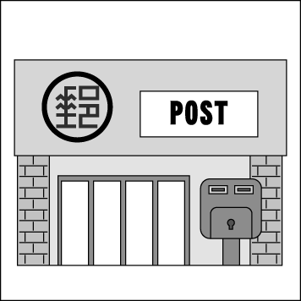
2. | (Ａ) 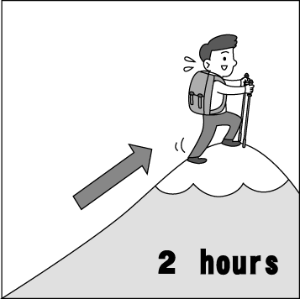 | (Ｂ) 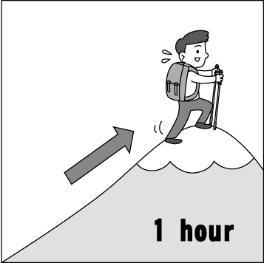 | (Ｃ) 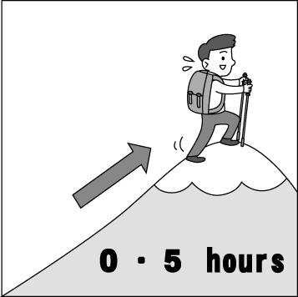
3. | (Ａ) 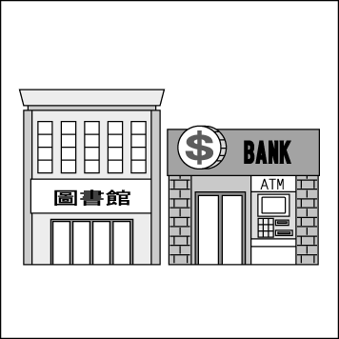 | (Ｂ)  | (Ｃ) 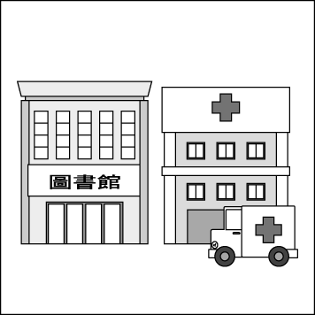
4. | (Ａ) 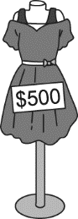 | (Ｂ) 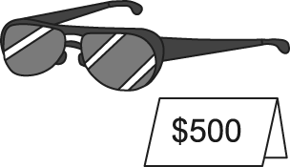 | (Ｃ) 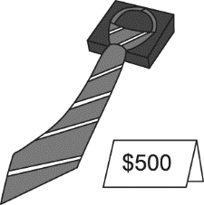
5. | (Ａ) 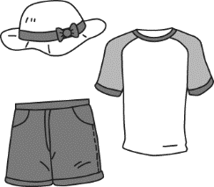 | (Ｂ) 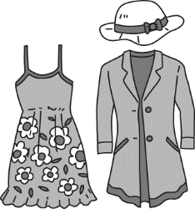 | (Ｃ) 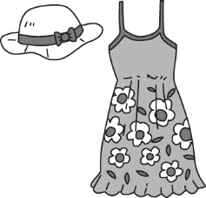

- 基本問答：根據聽到的內容，選出一個最適合的回應或最適合的問句。(每題2分，共10分)
6. | (A) Go straight for one block.  It’s on your left | (B) It’s difficult to do that. Ask  someone for help. | (C) You can get off at the next station.
7. | (A) It is a good place for sightseeing. | (B) I often take the bus there. | (C) It took me around 4 hours by plane.
8. | (A) I don’t really like wearing shoes. | (B) They look nice on you. | (C) I think it is a very great idea.
9. | (A) They go well with your shirt. | (B) They are three thousand in total. | (C) They are on a big sale now.
10. | (A) No, I am leave at 9. | (B) I enjoy traveling the the USA. | (C) Yes, I am going to work there.

- 言談理解：根據聽到的內容，選出一個最適合的答案。(每題2分，共10分)
11. | (A) On foot. | (B) By MRT. | (C) In a car.
12. | (A) Next to a bus stop. | (B) In an MRT station. | (C) At Banquio Night Market.
13. | (A) Go jogging. | (B) Go shopping | (C) Go swimming.
14. | (A) At half past four. | (B) At a quarter to five. | (C) At twenty to five.
15. | (A) It was $1,200. | (B) It was $1,800. | (C) It was $4,800.

- 綜合測驗：選出最適合的答案 (每題2分，共40分)
16. Karen’s grandmother stayed in the _______ for weeks, and everyone in the family worried about her very much.
(A) factory | (B) hospital | (C) museum | (D) theater
17. Hansel and Gretel got ______ in the forest. They couldn’t find their way back home.
(A) cheap | (B) free | (C) heavy | (D) lost
18. At the lake, Kate had fun in the water. Not like her sister, Lancelot doesn’t like water sports, so he went ____ around the lake.
(A) biking | (B) sailing | (C) surfing | (D) swimming
19. Next week, all the drinks in the coffee shop are going to be ______. Remember to go and check it.
(A) around the corner | (B) in common | (C) on sale | (D) on foot
20. Alyssa: I want to go shopping in the new department store. Are you coming with me?
Austin: No, thanks. I decided to go bird watching. I love being close to _____.
(A) autumn | (B) nature | (C) polyester | (D) science
21. Most people buy sporting goods just because of their company marks. They don’t ______ the cost to the environment and poor
workers
(A) think about | (B) take off | (C) think of | (D) get off
22. Romeo: How much did the big breakfast cost you during your stay at the hotel?
Juliet: Not much. I _____ only fifty dollars for it.
(A) cost | (B) paid | (C) spent | (D) took
23. Thanks to fast fashion, ______ new clothes with nice designs at a low price isn’t just a dream.
(A) buy | (B) buys | (C) bought | (D) buying
24. The English singing contest for the eighth graders is around the corner. Every class is busy ________ their songs.
(A) practice | (B) practices | (C) practicing | (D) to practice
25. (At the checkout) Clerk: The total is NT$999. How would you like to pay, _____ cash or ______ card?
(A) in; by | (B) on; by | (C) by; at | (D) in; with
26. The Apple AirPods headphones cost people an arm and a leg, but we will start selling them at half price tomorrow.
You can buy one at a(n) _____ price.
(A) cheap | (B) expensive | (C) high | (D) low
27. Remember to wear your new _____ of glasses to school, or you are not going to see the words on the blackboard when you sit in
the back of the classroom.
(A) change | (B) design | (C) kind | (D) pair
28. It is a good way for students to learn English by ______ to English songs.
(A) listen | (B) to listen | (C) listening | (D) to listening
29. There ______ tomorrow, so we won’t go mountain climbing.
(A) will be rainy | (B) will be much rain | (C) will rain a lot | (D) will have a lot of rain
30. Dad: Did you do your homework? Maggie: No, I didn’t. I _____ it later.
(A) do | (B) did | (C) was doing | (D) will do
31. Claire: ______ Nicky and her friend going to sign up for the video game design club?
Carter: Yeah. Being an engineer is their dream job.
(A) Is | (B) Are | (C) Was | (D) Were
32. Ted and Kate ______ to the library tomorrow morning because it doesn’t open.
(A) will go | (B) are going to go | (C) won’t go | (D) isn’t going
33. My dad _____ me a funny story next to my bed at two thirty in the morning. I couldn’t stop _____.
(A) read; to laugh | (B) reads; laughing | (C) is reading; to laugh | (D) was reading; laughing
34. Sean, _____ for a second before starting your work. I think you will need more time to make a plan for any changes in the future.
(A) stop | (B) stops | (C) stopping | (D) to stop
35. ______ their grades up but still have a good time at school, hard-working students will make good use of their time..
(A) Keeping | (B) Keep | (C) To keep | (D) Kept

- 克漏字測驗 (每題2分，共20分)
(Cloze A) This is Nini’s schedule of Sunday morning.
8:00 ~ 9:00 a.m. | wake up & have breakfast
9:00 ~ 10: 00 a.m. | play with dolls
10:00~ 10:30 a.m. | catch some z’s
10:30~ 11:00 a.m. | eat some snacks
11:00~ 12:00 a.m. | listen to English stories
Last Sunday, Nina didn’t have to go to work. So she needed to stay at home and looked after her daughter, Nini. Nini woke up at 8:00 a.m., but Nina ___36.___ at that time. Nini really wanted someone to play with her. So she decided to use her little hand to hit Nina’s eyes in a soft way. Then, Nina woke up and saw Nini looking and smiling at her. Suddenly, Nini felt very hungry and started to cry out. Nina fed Nini with 180 cc of milk. However, Nini drank the milk so slowly. It ___37.___ Nini 30 minutes ___37.___ her milk. After finishing her milk, Nini ___38.___ one hour ___38.___ with her favorite dolls. Next, Nini felt tired, so she fell asleep. She caught some z’s for 30 minutes. After that, Nina bought some snacks from the supermarket for Nini. They were cheap. They ___39.___ her only NT$15 dollars. Also, they are yummy, too. Nini liked them so much. During the last hour of Sunday morning, Nina read Nini English stories from some expensive storybooks. Nina ___40.____ a lot of money ___40.___ these books, but she still felt happy because her daughter had a great time listening to the English stories.

36. | (A) slept | (B) sleeps | (C) is sleeping | (D) was sleeping
37. | (A) cost; to finish | (B) took; to finish | (C) spent; on finishing | (D) paid; for finishing
38. | (A) cost; to play | (B) took; playing | (C) spent; playing | (D) spent; to play
39. | (A) cost | (B) took | (C) spent | (D) paid
40. | (A) cost; to buy | (B) took; to buy | (C) spent; to buy | (D) spent; on

(Cloze B)  NY Pet  Shop  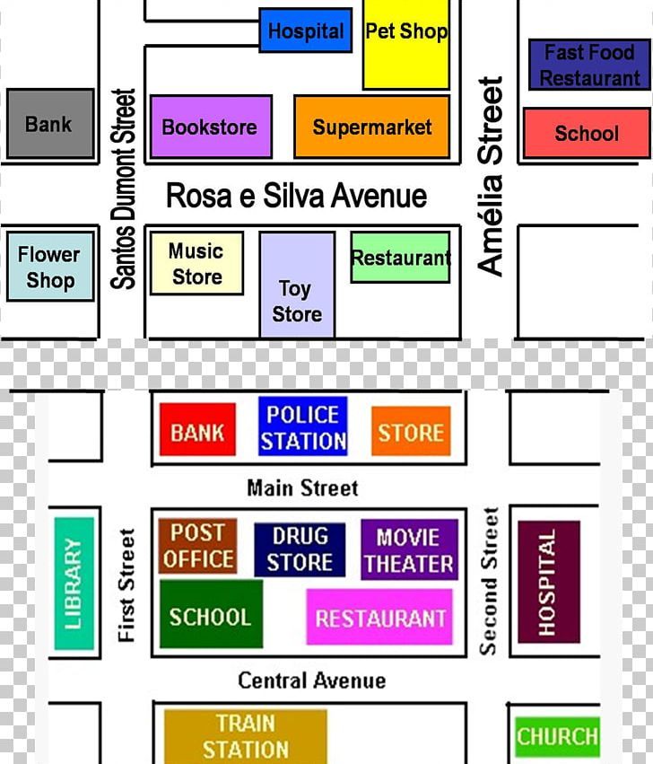  Magic  Science  Museum  Happy  Elementary  School  KFC  Fast Food  Restaurant  Hero Fire  Station  Cindy’s  Coffee Shop  Bobo  Hotel  Post  Office  Blue  Park  May’sGift  Shop  Joy’s  Bookstore  Wow  Temple  Number One  Police Station  First  Church  Berkeley  Supermarket  City  Bank  Bolton  Hospital  Sky  Library  Sunny  Department  Store  Movie Theater  Green Train  Station  Brown’s  Flower  Market  Toy  Store | Carol: Dad, we got off at Green Train Station half an hour ago.  Now, we are back on Central Avenue again.  Dad: We don’t have a map. Let’s ask someone for help.  (They saw a woman outside the Green Train Station.)  Carol: Excuse me. ___41.___ do we get to the Bobo Hotel?  Woman: Go straight and turn right on First Street. Go along the  street for one block. and you can see Bobo Hotel on your right. It is ___42.___ Cindy’s Coffee shop.  Dad: Sorry, but we still have another question. Can you show us  the way to the City Bank, please?  Woman: That’s easy.Just keep going down the First street for  about three blocks. The bank is right ___43.___ Rosa e  Silva Avenue and Santos Dumont Street.  Dad: Okay, I got it. By the way, is there a restaurant around  here? We are a little hungry.  Woman: Yes, it’s not far away from here. Go down the Central  Avenue, too. But this time, ___44.___ a left turn ___44.___ Second Street. Then, walk down the street. You can see a department store and a science musuem along the way. In the end, the KFC Fast Food Restaurant is ___45.___ the Happy Elementary School and the magic Sicence Museum.  Dad & Carol: Thanks for your help. It’s really nice of you.

41. | (A) How | (B) Where | (C) What | (D) When
42. | (A) between | (B) next to | (C) across from | (D) on the corner of
43. | (A) at | (B) between | (C) around the corner | (D) on the corner of
44. | (A) get; at | (B) have; in | (C) make; on | (D) take; between
45. | (A) in | (B) on | (C) between | (D) next to

- 閱讀測驗 (每題2分，共10分)
Adapted from <<When I Was Gone>> by Eminem  Did you love someone so much before?  You would give an arm for them.  When they know they’re your heart.  And you know you are their favorite.  And you will fight for them if anyone tries to hurt them.  But what happens when life goes wrong?  What happens when you become the pain of theirs one day?  “Daddy, look! I made this,” “Dad’s going to catch a plane.”  “Daddy, where’s mommy? I can’t find mommy, where is she?”  “I don’t know, go play, Hailie baby, your daddy’s busy.  Daddy’s writing a song, a song isn’t going to write on its own.”  “I bought you one cute doll, Barbie. And she can play with you.  You can have fun on the swing (鞦韆) together in the park.”  Then I turned right around in that song and told her I loved her.  Yeah, that was Slim Shady, a dark sound in my head.  Yeah, Slim Shady was crazy.  He was telling me to do the wrong thing.  Slim Shady made me, like a mean, bad daddy.  But tonight, Slim Shady is going to say goodbye.  On the plane, I kept having this dream.  I was pushing Hailie on a swing (鞦韆) in the park.  She was happy and laughing so hard.  And she didn’t want me to sing.  “You’re making mommy cry, why, why is mommy crying?”  “Baby, daddy is not leaving.”  “No, daddy, you’re lying (說謊).  You always say that, you always say this is the last time  But you can’t leave no more, daddy, you’re mine.”  She was putting boxes in front of the door and trying to stop me.  “Daddy, please, daddy, don’t leave, daddy. No, stop it!”  Her hand went into her jacket, pulled out a small chocolate.  There was a I-love-you-daddy card on it.  “This will keep you safe, daddy, take it with you.” | I look up, now it’s just me standing in front of the mirror (鏡子).  This wall is talking, like a human because I can hear it.  It’s saying, “you got one more chance to do it right.  And it’s tonight, now go out and show them you love them  before it’s too late.”  And just when I’m going to walk out of my bedroom door,  Suddenly Hailie and mommy are gone.  And I’m singing on a stage.  Sixty thousand people all jumping out from their seats.  They’re throwing flowers at my feet.  I take a bow (鞠躬), and thank them all for coming out.  They’re cheering loud, I take one last look at the crowd (人群).  I look down, I don’t believe my eyes.  “Daddy, it’s me, help mommy, there is blood on her hands.”  “But baby we’re in Sweden. How did you get to Sweden?”  “I followed you, daddy. You told me you weren’t leaving.  However, you lied to me, daddy.  Now you made mommy sad.”  “And I bought you this trophy, it says number one dad.  That’s all I wanted, I just want to give you this trophy.  You got it, fine, me and mommy are going.”  “But baby wait!”  “It’s too late dad, you made your choice (選擇).”  “Go out there and show your fans you love them more than us.  That’s what they want. They want you, Marshall.  They are calling your name.  It’s no wonder you can’t go to sleep with your family.”  The sky is getting dark, my life flashes.  The plane falls down and breaks into pieces.  That’s when I wake up.  My clock’s ringing, and there are birds singing.  It’s spring and Hailie’s outside swinging (盪鞦韆).  I walk right up to Kim and kiss her tell her I miss her.  Hailie just smiles and looks at her little sister, Helen.
46. What does it mean to “give an arm for” here in the song?
(A) To sell your arm and give the money to those in need. | (B) To be a good doctor and fix people’s health problems.
(C) To give up something or someone, not to want them at all. | (D) To do almost everything to get something or someone special.
47. How many people are speaking in the song? And who are they?
(A) Two; Hailie and Marshall. | (B) Three; Slim Shady, Marshall, and Hailie.
(C) Four; Barbie, Slim Shady, Marshall, and Kim. | (D) Five; Barbie, Hailie, Marshall, Kim, and Helen.
48. What might be the job of Marshall?
(A) A book writer. He writes very interesting books. | (B) A famous singer. He has fans around the globe.
(C) A fast runner. He wins many times and gets trophies. | (D) A full-time father. He takes care of his kids all the time.
49. Which is true about the song?
(A) Hailie’s mom left the world a long time ago. | (B) Slim Shady helped Marshall to be a good father.
(C) Marshall was always busy on his job before. | (D) Kim and Helen are Hailie’s sisters.
50. What lesson does Marshall learn from the bad dream?
(A) If your dreams don’t scare you, they’re not big enough. | (B) Let today be the start of something new.
(C) Life hurts a lot more than death (死亡). | (D) To a child, “love” is spelled “t-i-m-e.”

109-1-3 八年級 英語科－解答
01-05 | B | C | C | A | A | 06-10 | A | C | B | B | C
11-15 | C | A | B | C | A | 16-20 | B | D | A | C | B
21-25 | A | B | D | C | A | 26-30 | D | D | C | B | D
31-35 | B | C | D | A | C | 36-40 | D | B | C | A | D
41-45 | A | B | D | C | C | 46-50 | D | A | B | C | D

