新北市立溪崑國民中學109學年度第一學期第二次定期評量 英語科 試題卷
九年級 班 座號 姓名

第一部分聽力測驗20%

(一) 辨識句意：根據聽到的內容，選出符合描述的圖片5%
- (Ａ) 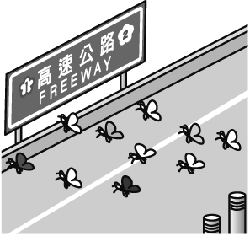(Ｂ) 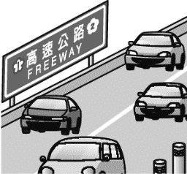(Ｃ) 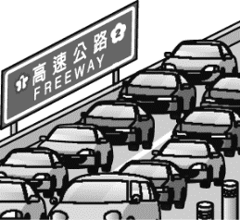
- (Ａ) 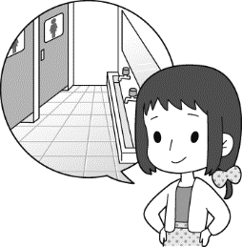(Ｂ) 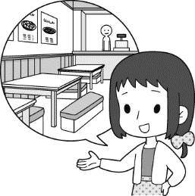(Ｃ) 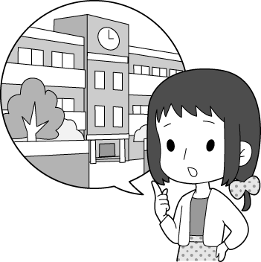
- (Ａ) 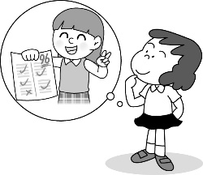(Ｂ) 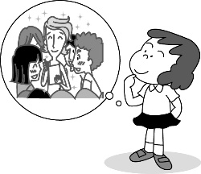(Ｃ) 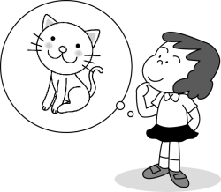
- (Ａ) 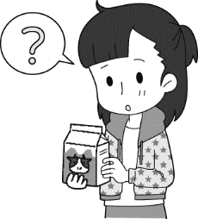(Ｂ) 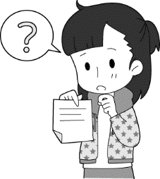(Ｃ) 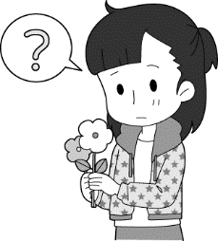
- (Ａ) 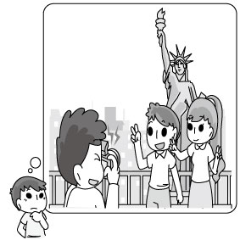(Ｂ) 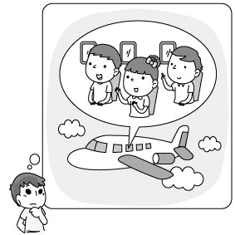(Ｃ) 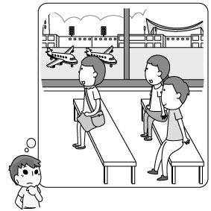

(二)基本問答：根據聽到的內容，選出一個最適合的回應句5%
- (Ａ) Bats cannot see very well.
(Ｂ) I don’t see anything in the room.
(Ｃ) I noticed a man getting out of a car.
- (Ａ) Oh, the picture is really great.
(Ｂ) It was drawn by my best friend, Amy.
(Ｃ) It was sold at a very low price at the market.
- (Ａ) Perhaps not.
(Ｂ) He appears to be sad.
(Ｃ) I won’t do that anymore.
- (Ａ) I’m not sure.
(Ｂ) I got a day off last week.
(Ｃ) Yes, Christmas is on December 25th.
- (Ａ) We can teach him how to drive.
(Ｂ) I think he’s too young to do it.
(Ｃ) He doesn’t know how to row a boat.

(三)言談理解：根據聽到的內容，選出一個最適合的答案10%
- (Ａ) He is full.
(Ｂ) He wants to eat cake later.
(Ｃ) He wants to leave the room.

- (Ａ) It is next to the supermarket.
(Ｂ) It is next to the bus stop.
(Ｃ) It is three blocks away.
- (Ａ) A computer game.
(Ｂ) A comic book.
(Ｃ) A play.
- (Ａ) Whether Jason likes animals or not.
(Ｂ) Whether Jason will join the party tonight.
(Ｃ) Whether Jason will agree with them or not.
- (Ａ) No one is smart enough to answer John’s questions.
(Ｂ)The questions are too easy for John.
(Ｃ) Whether John can answer the difficult questions or not.
第二部分 綜合測驗 36%
- The old building is so weak _____ , _____ it?
(A) that no one can stay in ; is (B) to stay in it ; is (C) that no one can stay in it ; can (D) that no one can stay in it ; isn’t
- What language was your book ?
(A) written (B) be written (C) written in (D) wrote
- English is spoken this country.
(A) by (B) in (C) with (D) for
- Before hard to make a spider come out, Sokha has to look for its hole first.
(A) he dig ; hiding (B) he dig ; hidden (C) digging ; hidden (D)digging ; hiding
- Andy: Do you know_____ as the volleyball team leader?
Maggie: I have no idea. It may be Jack.
(A) Who is picking our teacher (B) who will our teacher pick (C) who our teacher will be picked (D) who will be picked
- I’ll do it _____. But if you help me, I can do it better and faster.
(A) whether you will help me (B) if you will help me (C) whether you help me or not (D) if you help me or not
- _____ the tickets to the baseball game ______ out so far?
(A) Were ; sold (B) Have ; sold (C) Did ; be sold (D) Have ; been sold
- Choose the correct sentence.
(A) The song is listened by most people on the radio.
(B) A mail was written to President Trump.
(C) Coffee is grown by Brazil.
(D) Let the sentence write on the blackboard.
- Do you know _____ these children are running so fast?
(A) that (B) where (C) when (D) why
- The little boy doesn’t know_____ because nobody has spoken to him about it yet.
(A) how to do (B) what to do it (C) what should be done (D) what’s it for
- I’d like to know _____.
(A) how much money have been spent so far
(B) how long does it take to get there
(C) if Jenny dates with me tonight
(D) why you keep sitting on the stairs
- The trip to Hehuanshan was too great _____
(A) to be forgotten (B) to forget it (C) to remember (D) to forget
- I’ve never thought _____ the story is true.
(A) whether (B) what (C) when (D) how
- As for your skin problem, you can _____ by going to a doctor.
(A) be solved (B) turn it down (C) work it out (D) be treated
- Our dad is supposed _____ because his health is getting worse and worse.
- quitting smoking (B) to quit smoking (C) to quit smoke (D) quitting to smoke

- Who _____ the smartphone _____ ?
(A) is ; belonged to (B) does ; belong (C) did ; belong (D) does ; belong to
- The problem is _____ in a short time.
(A) so easy that we can solve (B) too difficult for us to solve it (C) too easy for us to solve (D) not easy enough for us to solve
- Choose the wrong sentence.
(A) Nobody knows when Uncle Roger arrives in Taiwan.
(B) I’ll ask Uncle Roger to call me up when he gets to Taiwan tomorrow.
(C) We are not sure if Uncle Roger will appear at the welcome party tonight.
(D) We’ll take Uncle Roger to Din Tai Fung if he comes to Taipei again next year.
第三部分克漏字選擇8%
Eason: __34___ for our social studies report? I really have no idea.
Mark: Well, I’m not sure __35___ you are interested in Mt. Ali.
Eason: Tell me __36___ about Mt. Ali. I don’ t know __37___ going there.
Mark: Oh, it’s famous for its sunrise and forest train.
Eason: That sounds good.
34. (A) How I can do (B) What I should do (C) What should I do (D) What can do
35. (A) weather (B) what (C) if (D) where
36. (A) what do you know (B) what you know (C) how do you know (D) whether to know
37. (A) where people like (B) how people like (C)when people like (D) why people like

第四部分 閱讀測驗20%
Deaf people use sign language to communicate with each other and with non-deaf people. There are hundreds of different sign languages around the world. They are like spoken languages, with their own vocabulary words and systems of grammar. Many schools for the deaf use sign language in class.
Signs are made by making shapes with one’s hands. A sign may include moving the hands or pointing in a certain direction. For example, in American Sign Language, to say “smart,” point to your forehead with your middle finger. In some languages, the expressions on a signer’s face can change the meaning of the sign.
deaf 聾 forehead 前額 similar類似 exactly 準確
38. How are signs made?
(A) With a person’s mouth. (B) With a person’s eyes. (C) With a person’s forehead. (D) With a person’s hands.
39. How are sign languages similar to spoken languages?
(A) They both use signs made by a person’s hands. (B) They both have their own rules and vocabulary words.
(C) They are both used in every school around the world. (D) They both have exactly the same kinds of grammar
40. Why are a person’s expressions important in some sign languages?
(A) They can change a person’s face. (B) They can change a sign’s meaning.
(C) They can change the shape of a person’s hands. (D) They can change the grammar of a sign language.
If you’ve ever had a cockroach in your house, you’ll know first-hand how hard they are to kill. Sometimes even stamping on a cockroach isn’t enough to kill it. It’s also been said that they can survive a nuclear bomb. And now scientists have discovered that these amazing insects can stay alive even after getting their heads cut off!
The reason for this is that, unlike humans, cockroaches don’t breathe through their mouths. Instead, a cockroach breathes through tiny holes all over its body. Also unlike a human, a cockroach has a tiny “mini-brain” in each part of its body. This means that even without a head, it can still feel and move around. And, to top it all off, cockroaches don’t need nearly as much food as humans do. A cockroach can live for weeks on just one meal.
Although their bodies will die sooner or later, headless cockroaches have been known to stay alive for several weeks! Even stranger, their heads can stay alive, too! A cockroach’s head will keep waving its antennae for hours after being separated from its body. This probably makes the cockroach the toughest living thing on the planet!
survive 生存 nuclear核子 tiny 微小 antennae 觸角 tough 強硬 focus 焦點
41. Which of the following facts is the writer’s main focus?
(A) Cockroaches are difficult to kill. (B) Cockroaches can stay alive even without their heads.
(C) Cockroach brains aren’t like human brains. (D) Cockroaches can live for a long time without food.
42. Which of the following is said about cockroaches?
(A) They have three stomachs. (B) They eat through little holes all over their bodies.
(C) They don’t have a brain. (D) They don’t breathe through their mouths.
43. What does the writer mean by “sooner or later”?
(A) At some point. (B) Never. (C) Earlier than expected. (D) Right away.

We‘re trying to understand people’s exercise habits.
Please check one answer for each question.
- How often do you exercise? 4. What’s the most important reason to exercise?
( ) Once a week ( ) To lose weight
( ) Several times a week ( ) To look better
( ) Less than once a week ( ) To keep healthy
- When do you prefer to exercise? 5. What kind of exercise do you prefer?
( ) On weekdays ( ) Walking or running
( ) On weekends ( ) Swimming
( ) Any day of the week ( ) Working out at a gym
- What time of the day do you like to exercise? 6. Do you feel you exercise enough?
( ) In the morning ( ) Yes
( ) In the afternoon ( ) No
( ) At night ( ) I’m not sure.
Current Results
1. Once a week 36% 4. To lose weight 43%
Several times a week 21% To look better 28%
Less than once a week 33% To keep healthy 29%
2. On weekdays 55% 5. Walking or running 40%
On weekends 26% Swimming 33%
Any day of the week 19% Working out at a gym 27%
3. In the morning 31% 6. Yes 28%
In the afternoon 46% No 56%
At night 23% I’m not sure. 16%
prefer 偏愛 purpose 目的 poll 問卷 current 當前 result 結果 encourage 鼓勵
44. What is the purpose of the poll?
(A) To encourage people to exercise more. (B) To find out how many times each week people exercise.
(C) To get information about the way people exercise. (D) To change people’s thinking about exercising.
45. What does the poll tell people to do?
(A) Read each question and choose only one answer. (B) Choose as many answers as they like.
(C) Choose the answer that will make the poll takers happy. (D) Find somebody and try to understand his exercise habits.
46. According to the poll, most people exercise _____ .
(A) at a gym (B) in the morning (C) less than once a week (D) from Monday to Friday
47. Which of the following is true about the people polled?
(A) 28% of the people exercise to keep healthy. (B) More people swim than walk or run.
(C)More than 50% of the people don’t exercise enough. (D) Most of the people exercise several times a week.

第四部分 非選擇題 (題目在答案卷上，請在答案卷作答)

新北市立溪崑國民中學109學年度第一學期第二次定期評量 英語科 答案卷
九年級 班 座號 姓名
第四部份 非選擇題16%
(A) 看中文寫出英文單字4%
1.有禮貌的 2. 舒服的 3. 濃密的 4. 制服
(B) 翻譯12%
- 他的家裡養鵝,但是只有在特別的日子他們才會被供應做食物。
- 要記住,外表並非一切。做你自己並且愛你自己。
- 我們應該彼此多溝通以更加了解彼此。這樣子,我們就會知道什麼是無理而什麼不是。
- 當我今天早上醒來時, 我發現窗戶破了。我很想知道是誰做的。

(A) 看中文寫單字4%
1. | 2. | 3. | 4.

(B) 翻譯12%
1.
2.
3.
4.

109-1-2 九年級 英語科－解答1-10 一題1分 其餘2分
1.CABBC 6.CBAAB 11.BAABC 16.DCBDD 21.CDBDC 26.DDACB 31.DDACC 36.BDDBB 41.BDACA 46.DC
單字4% 1.polite 2. comfortable 3. thick 4. uniform
翻譯 12%
- His family raises geese, but they will only be served as food on special days.
- Remember, appearance isn’t everything. Be yourself and love yourself.
- We should communicate with each other more to understand each other better. This way, we’ll know what is rude and what is not.
- When I woke up this morning, I found the window was broken. I’m wondering who did it.

新北市立溪崑國民中學109學年度第一學期第二次定期評量
九年級 英語科 聽力測驗稿
- 辨識句意：根據聽到的內容，選出符合描述的圖片或符合圖片的描述。
- （ ）
(Ａ)
(Ｂ) 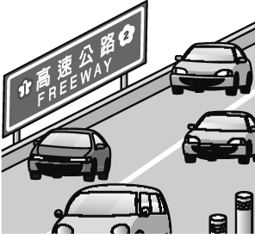
(Ｃ) 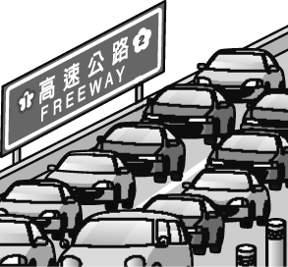
答案：(Ｃ)
解析：
錄音稿：There is heavy traffic on the freeway during rush hours.
- （ ）
(Ａ) 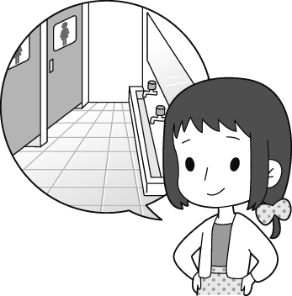
(Ｂ) 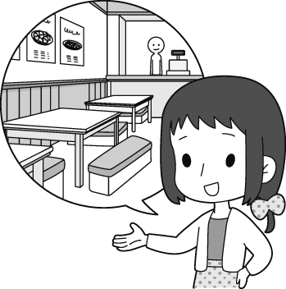
(Ｃ)
答案：(Ａ)
解析：
錄音稿：Tiffany wants to know where the restroom is.
- （ ）
(Ａ) 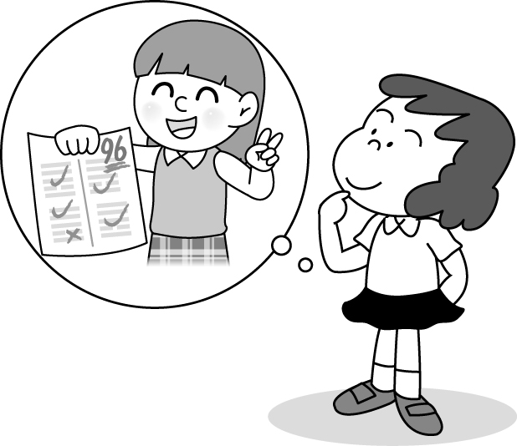
(Ｂ) 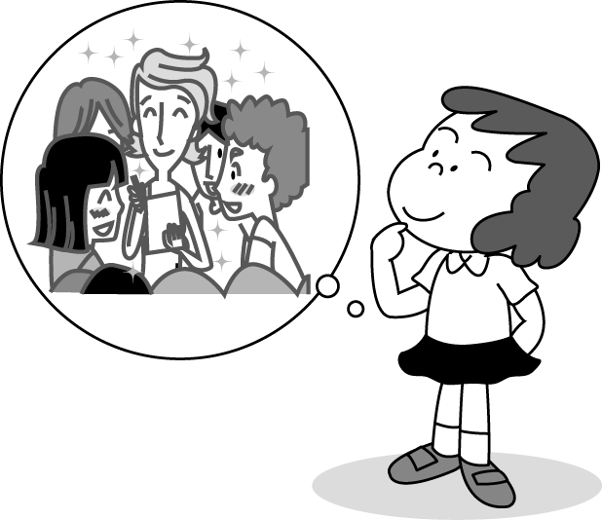
(Ｃ)
答案：(Ｂ)
解析：
錄音稿：Jessica doesn’t know how she can become more attractive.
- （ ）
(Ａ) 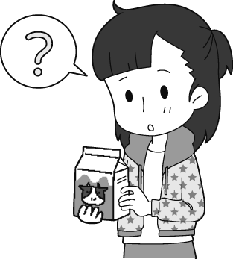
(Ｂ) 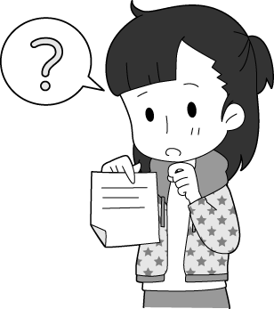
(Ｃ) 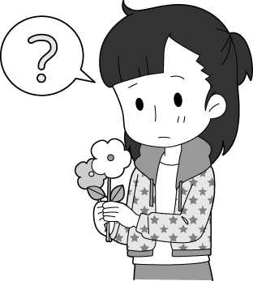
答案：(Ｂ)
解析：
錄音稿：Deborah wants to know who left her the note.
- （ ）
(Ａ)
(Ｂ)
(Ｃ)
答案：(Ｃ)
解析：
錄音稿：M: I am not sure whether they have arrived at the airport.
- 基本問答：根據聽到的內容，選出一個最適合的回應或最適合的問句。
- （ ）
(Ａ) Bats cannot see very well.
(Ｂ) I don’t see anything in the room.
(Ｃ) I noticed a man getting out of a car.
答案：(Ｃ)
解析：
錄音稿：What did you see at that time?
- （ ）
(Ａ) Oh, the picture is really great.
(Ｂ) It was drawn by my best friend, Amy.
(Ｃ) It was sold at a very low price at the market.
答案：(Ｂ)
解析：
錄音稿：There’s a picture on the desk. Whose work is it?
- （ ）
(Ａ) Perhaps not.
(Ｂ) He appears to be sad.
(Ｃ) I won’t do that anymore.
答案：(Ａ)
解析：
錄音稿：Will Mr. Truman come to the office today?
- （ ）
(Ａ) I’m not sure.
(Ｂ) I got a day off last week.
(Ｃ) Yes, Christmas day is on December 25th.
答案：(Ａ)
解析：
錄音稿：Do you get a day off on Christmas?
- （ ）
(Ａ) We can teach him how to drive.
(Ｂ) I think he’s too young to do it.
(Ｃ) He doesn’t know how to row a boat.
答案：(Ｂ)
解析：
錄音稿：I wonder if he is old enough to ride a motorcycle.
- 言談理解：根據聽到的內容，選出一個最適合的答案。
- （ ）
(Ａ) He is full.
(Ｂ) He wants to eat cake later.
(Ｃ) He wants to leave the room.
答案：(Ｂ)
解析：
錄音稿：G: You didn’t finish your meal. Are you full?
B: No, I just want to leave some room for the cake.
Q: When the boy tells the girl, “I just want to leave some room for the cake.” What does it mean?
- （ ）
(Ａ) It is next to the supermarket.
(Ｂ) It is next to the bus stop.
(Ｃ) It is three blocks away.
答案：(Ａ)
解析：
錄音稿：W: Do you know where the nearest restaurant is?
M: Sure. It is two blocks away from here and it’s next to the supermarket.
W: Thank you. Can you tell me where to take the bus?
M: There’s no bus stop here. You can walk there.
W: Okay. Thank you for your help.
Q: Where is the nearest restaurant?
- （ ）
(Ａ) A computer game.
(Ｂ) A comic book.
(Ｃ) A play.
答案：(Ａ)
解析：
錄音稿：W: You have to tell me why you spent so much money today.
B: Well, “Monster Attack” is really exciting, and all of my friends play it on the computer. I really want to play with them.
W: Next time if you need to spend so much, tell me first.
Q: What is “Monster Attack”?
- （ ）
(Ａ) Whether Jason likes animals or not.
(Ｂ) Whether Jason will join the party tonight.
(Ｃ) Whether Jason will agree with them or not.
答案：(Ｂ)
解析：
錄音稿：W: I don’t know whether Jason will attend the party tonight.
M: He’s a party animal, so he won’t miss any chance to go to a party.
W: I can’t agree with you more.
Q: What are they talking about?
- （ ）
(Ａ) No one is smart enough to answer John’s questions.
(Ｂ) The questions are too easy for John.
(Ｃ) Whether John can answer the difficult questions or not.
答案：(c)
解析：
錄音稿：M: Mandy, the questions are too difficult for John to answer. After all, he is only three.
W: Don’t worry about it. He is smart enough to answer them easily.
M: I don’t think so.
Q: What are they talking about?

