新北市立溪崑國民中學109學年度第一學期第三次定期評量 英語科 試題卷
九年級 班 座號 姓名

一、聽力測驗: 30% (每題2分)

(一)、辨識句意：根據聽到的內容，選出符合描述的圖片。
1.（ ）(Ａ) 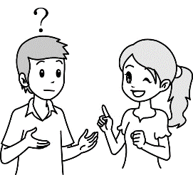 (Ｂ)  (Ｃ) 
2.（ ） (Ａ) 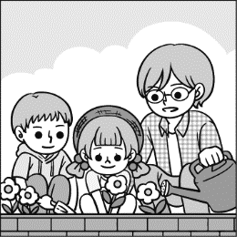 (Ｂ) 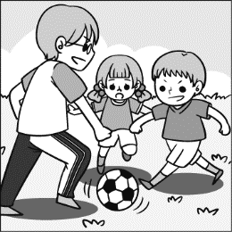 (Ｃ) 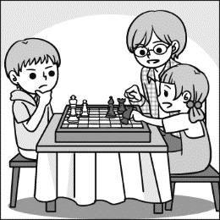
3.（ ）(Ａ) 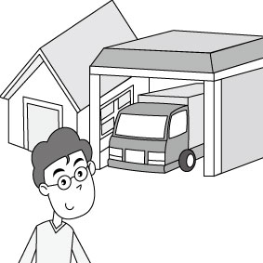 (Ｂ) 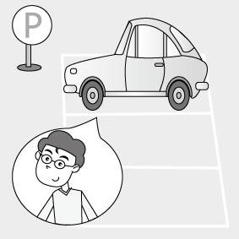 (Ｃ) 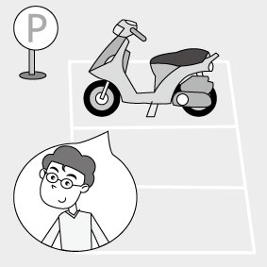
4.（ ）(Ａ) 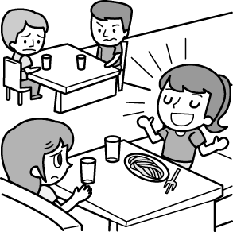 (Ｂ) 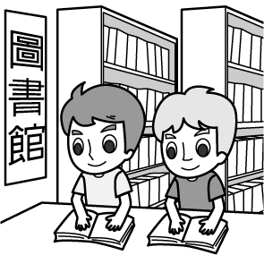 (Ｃ) 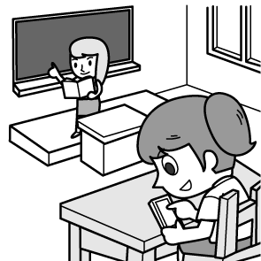
5.（ ）(Ａ) 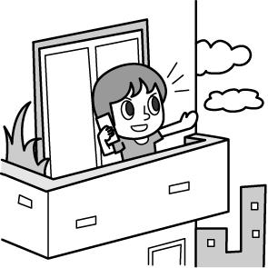 (Ｂ) 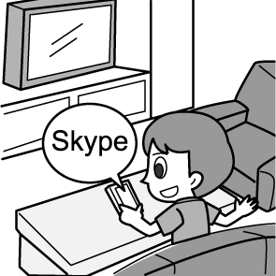 (Ｃ) 

(二)、基本問答：根據聽到的內容，選出一個最適合的回應句。
6.（ ）(Ａ) She drives carefully.
(Ｂ) She’s driving a red car.
(Ｃ) She’s the leader of the club.

7.（ ）(Ａ) You’re very lucky.
(Ｂ) Don’t turn me down.
(Ｃ) Cheer up. Let’s work them out.
8.（ ）(Ａ) She is a friend of mine.
(Ｂ) She bought a coat in the department store.
(Ｃ) No, she is not my sister.
9.（ ）(Ａ) One pound, thanks.
(Ｂ) A pack of forks, thanks.
(Ｃ) Eighty cents.
10.（ ）(Ａ) He pushed me aside.
(Ｂ) I was late for the meeting.
(Ｃ) He likes to share thoughts with us.

(三)、言談理解：根據聽到的內容，選出一個最適合的答案。
11.（ ）(Ａ) Both of them.
(Ｂ) Nobody.
(Ｃ) Their parents.
12.（ ）(Ａ) She is in the red dress.
(Ｂ) She is at the door.
(Ｃ) She is with glasses.
13.（ ）(Ａ) He looks for apartments for the homeless.
(Ｂ) He builds new homes for the homeless.
(Ｃ) He looks for more people to join the program.
14.（ ）(Ａ) It’s the name of a baseball team.
(Ｂ) It’s a store that sells food.
(Ｃ) It’s a market that sells only vegetables.
15.（ ）(Ａ) They are shopping online.
(Ｂ) They are talking online.
(Ｃ) They are looking for information online.

二、綜合測驗: 40% (每題2分)
16.（ ）I have always tried hard to my parents needs, but they never feel satisfied.
(Ａ) arrive (Ｂ) push (Ｃ) upload (Ｄ) meet
17.（ ）She finds in reading. She always spends a lot of time reading books and has a good time.
(Ａ) rock (Ｂ) pleasure (Ｃ) honey (Ｄ) gift
18.（ ）Eating less and exercising more can you getting fat.
(Ａ) lead; to (Ｂ) keep; from (Ｃ) turn; down (Ｄ) turn; on
19.（ ）I don’t think we are suitable (適合) for each other because we don’t have ______ interest. (Ａ) foreign (Ｂ) dull
(Ｃ) successful (Ｄ) common
20.（ ）Kevin wants to become a teacher. He studies very hard to make his dream _________.
(Ａ) come true (Ｂ) work out (Ｃ) pass by (Ｄ) run away
21.（ ）Emma is one of the girls who _______ English well. (Ａ) speak (Ｂ) speaks (Ｃ) speaking (Ｄ) spoken
22.（ ）It started to rain we got home. (Ａ) as long as (Ｂ) as soon as (Ｃ) as fast as (Ｄ) as possible as
23.（ ）A: What’s your hobby? B: I have ______ baking since last year.
(Ａ) set up (Ｂ) dressed up (Ｃ) taken up (Ｄ) cheered up
24.（ ）Victor seldom goes bike riding because he can’t ride a bike, and Bill .
(Ａ) can’t, either (Ｂ) can, too (Ｃ) does, too (Ｄ) doesn’t, either
25.（ ）Ruby isn’t going to Hong Kong, and _____ her parents.
(Ａ) neither; isn’t (Ｂ) neither; is (Ｃ) neither; are (Ｄ) neither; aren’t
26.（ ）When Hailey was very young, she did a lot to help those _________
(Ａ) who needs help (Ｂ) that needs help (Ｃ) which need help (Ｄ) in need
27.（ ）The dress _______ you bought for me is too small ______
(Ａ) that; to put on it (Ｂ) which; put on (Ｃ) that; to put on (Ｄ) which; to put it on
28.（ ）Honey, when we get married, ___________ is yours will be mine.
(Ａ) who (Ｂ) whose (Ｃ) that (Ｄ) what
29.（ ）The book ____________ by Vincent is for sale now.
(Ａ) were written (Ｂ) that were written (Ｃ) which was written (Ｄ) that were writing
30.（ ）Chen Shu-chu, ______________ sells vegetables in Taitung, gave a lot of her money to the poor children.
(Ａ) the one which (Ｂ) a woman who (Ｃ) a man that (Ｄ) x
31.（ ）I can help you find any pictures ______ you want by _______the Internet.
(Ａ) that; surfs (Ｂ) which; surf (Ｃ) which; surfed (Ｄ) that; surfing
32.（ ）Kelly’s mom told her ______ they ______ too poor to have enough money for her to go to college.
(Ａ) that; are (Ｂ) which; are (Ｃ) who; are (Ｄ) x; were
33.（ ）Tom’s father ________ goes mountain climbing every day.
(Ａ) , who is already 70, (Ｂ) who is already 70 (Ｃ) , that is already 70, (Ｄ) that is already 70

34.（ ）Choose the correct sentence.
(Ａ) I have no idea who is the girl in the red dress.
(Ｂ) I have no idea who in red the dress the girl is.
(Ｃ) I don’t know who the girl in the red dress is.
(Ｄ) I don’t know who the girl is in the red dress.
35.（ ）Choose the correct sentence.
(Ａ) Look at the beautiful house there. It’s the house I used to live.
(Ｂ) The house where I used to live is sold out now.
(Ｃ) My parents want to buy a big house in that all my family can live.
(Ｄ) I like the house which have four bedrooms.

三、閱讀測驗:10% (每題2分)
Gods ruled over all things on the Earth in Greece long time ago. December, the goddess who made sure rice, vegetables and other plants would grow, had a beautiful daughter, Persephone. One day, Persephone was playing in the field with December when Hades, the Underworld God, came to the Earth and walked his dog. Hades had never seen such girl as Persephone and he fell in love with her. He soon took her down to the Underworld, but the girl hated there, for she missed the sun.
Back on the Earth, December was too worried about her daughter to take care of plants, so they started dying and nobody had any food to eat. Zeus, the king of all gods, told Hades to let Persephone come home, or people would starve to death. Hades had Persephone eat an apple with special spells so that she could not leave the Underworld forever. She would stay with December for nine months and live with Hades for three months. While Persephone was away, her mom would make the Earth cold and dead. Life would come back once Persephone was home. That’s why we have winter today.
36.（ ）Who makes sure rice, vegetables and other plants would grow?
(A) Persephone (B) December (C) Hades (D) Zeus
37.（ ）Why did Hades take Persephone down to the Underworld?
(A) Because he wanted her to grow rice, vegetables and other plants.
(B) Because he asked her to walk his dog.
(C) Because he wanted to make the Earth cold and dead.
(D) Because he fell in love with her.
38.（ ）Why couldn’t Persephone leave the Underworld forever?
(A) Because she missed the sun.
(B) Because the Underworld is too cold.
(C) Because she ate a spelled apple.
(D) Because December was too worried about her.
39.（ ）What does starve mean?
(A) Hungry. (B) Dark. (C) Worry. (D) Cold.
40.（ ）Which is ” NOT ” true?
(A) Zeus is the king of all gods.
(B) When Persephone was with Hades , her mom would make the Earth cold and dead.
(C) Life would come back once Persephone was with December
(D) Persephone stays with December for nine months and live with Zeus for three months.
四、克漏字測驗: 20% (每題2分)
1.
Jerry and Tom learned a lesson today. This afternoon, their mom asked them __41___ some food. They were happy to help their mom __42__ for dinner. When they arrived at the supermarket, they saw a clerk selling the jeans __43__ very much. The clerk let them __44__ the jeans. They were excited about the jeans and bought them right away.
As it became dark, they decided to go home. When their mom saw them carrying only new jeans __45___ food, she got mad and asked, “Where is our food?” The boys said, “Sorry, we forgot. We’ll go back to the store and get the food now.”
Now, they know they should always go on their missions first, and do other things later. missions任務

41.（ ）(A) buy (B) buys (C) buying (D) to buy
42.（ ）(A) prepared (B) prepare (C) preparing (D) has prepared
43.（ ）(A) that they liked it (B) that they liked (C) that they liked them (D) that they like
44.（ ）(A) try on (B) tries on (C) trying on (D) to try on
45.（ ）(A) and (B) with (C) without (D) besides

2.
Kenny had an ox, ___46___ he had deep feelings for. He vowed not to eat beef in his lifetime, and he asks his family to do the same. He __47___ the ox for 24 years. They used to work together to grow rice and vegetables on the farm. The ox worked very hard to help Kenny ___48___ money to take care of his children. Now Kenny’s sons and daughters have their own family, and only the ox stays with hm.
However, the ox is so old that it needs special care for its rest of life. Instead of selling it to the market, Kenny finds a zoo for his old ox. When the day for the departure came, Kenny dressed up the old ox and __49___ a band to play music for it. The ox didn’t want to move at all until Kenny spoke quietly to it. Then Kenny walked the ox out of his house and couldn’t stop crying all the way. __50___ it’s hard to say goodbye, Kenny thought it was the best way to love his ox.
46.（ ）(A) that (B) it (C) which (D) who
47.（ ）(A) is keeping (B) keeps (C) kept (D) has kept
48.（ ）(A) make (B) making (C) makes (D) made
49.（ ）(A) invites (B) invited (C) has invited (D) is inviting
50.（ ）(A) Because (B) When (C) Though (D) Since

109-1-3 九年級 英語科－解答
1.-5 ACBAA 6-10 CCBAB 11-15 ACBBB
16-20 DBBDA 21-25 ABCDC 26-30 DCDCB
31-35 DDACB 36-40 BDCAD 41-45 DBBAC
46-50 CDABC

