新北市立溪崑國民中學109學年度第一學期第二次定期評量 英語科 試題卷
八年級 班 座號 姓名
- 辨識句意：依據所聽到的內容，選出符合描述的圖片。(每題1分，共5分)
1. | (A) 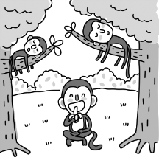 | (B) 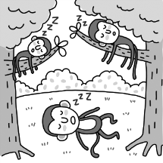 | (C) 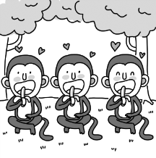
2. | (A) 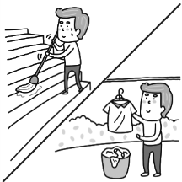 | (B) 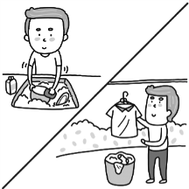 | (C) 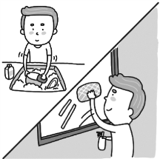
3. | (A) 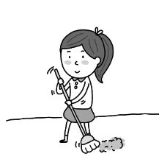 | (B) 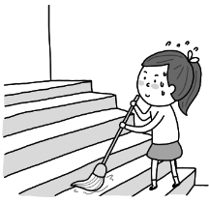 | (C) 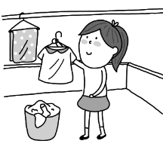
4. | (A) 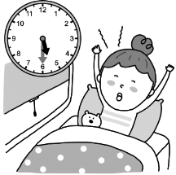 | (B) 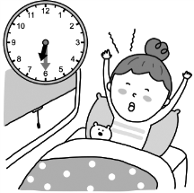 | (C) 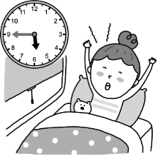
5. | (A) 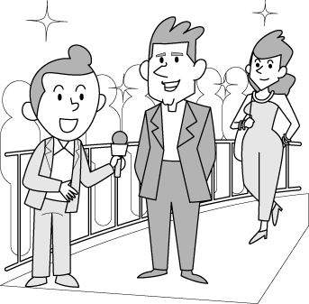 | (B)  | (C) 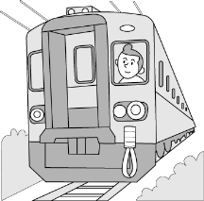
- 基本問答：根據聽到的內容，選出一個最適合的回應或最適合的問句。(每題1分，共5分)
6. | (A) It is half past nine. | (B) At eight o’clock. | (C) I don’t have time, sorry.
7. | (A) No, they weren’t drawing. | (B) Yes, they were sleeping. | (C) No, they were doing homework.
8. | (A) Of course, I always take a business trip to the United States on my own.
8. | (B) Not really. I just practice speaking English for half an hour every day.
8. | (C) I don’t like to staty at home in my free time. I like to travel in the USA.
9. | (A) He drives students to school every morning.
9. | (B) He is good at driving. He can drive very fast on rainy days.
9. | (C) He delivers goods when he is at work.
10. | (A) Yes, enough sleep is good to our health.
10. | (B) Yes, it is very difficult for me to do so.
10. | (C) No, I don’t really need that much sleep.
- 言談理解：根據聽到的內容，選出一個最適合的答案。(每題1分，共5分)
11. (A) He is a good actor. He can play superman very well.
(B) He buys delicious and yummy food for his daughters.
(C) He cleans the house and does housework for their daughters.
12. (A) Frank was making a call during class. (B) Frank didn’t come to school many times.
(C) Frank talked a lot and didn’t listen to his teacher.
13. (A) A good singer. (B) A famous actor. (C) A police officer.
14. (A) He was talking to a man. (B) He was visiting famous places. (C) He was taking a trip in India.
15. (A) The woman saw Ted play the piano last week. (B) Ted practices the guitar every other day.
(C) Ted learns the guitar only for three months.
- 綜合測驗 (選出最適當的答案)：(每題2分，共40分)
16. This cake is delicious. Also, it is in the _____ of an airplane. How special!
(A) salesman | (B) science | (C) shape | (D) secretary
17. Janet just finished school. She has no working _________, so it is hard for her to find a job now.
(A) engineer | (B) experience | (C) end | (D) event
18. The weather was _________ yesterday. It was windy and rainy all day.
(A) difficult | (B) fast | (C) heavy | (D) terrible
19. The baby is smiling during his sleep. Maybe he’s having a happy __________.
(A) fun | (B) PE | (C) dream | (D) lesson
20. Ember: There was a strange ___________ in the bathroom. Did you hear it? Evans: No, I didn’t.
(A) future | (B) past | (C) sound | (D) trial
21. Ivy: I ___________ a hat under the chair. Is it yours? Kevin: Yes. Thank you.
(A) dropped | (B) found | (C) kept | (D) mopped
22. The actor talked about his new movie in the TV __________.
(A) corner | (B) guest | (C) hotel | (D) interview
23. She wants to be a __________ and fights for her country.
(A) fisherman | (B) soldier | (C) truck driver | (D) winner
24. They _________ some fish in the lake and then cooked them over fire.
(A) came | (B) cooled | (C) bought | (D) caught
25. After years of working, Linda finally _________ a top dentist.
(A) asked | (B) believed | (C) broke | (D) became
26. Mr. Morphy is a __________ writer. He has fans around the world. They love his books.
(A) cloudy | (B) mad | (C) ordinary | (D) successful
27. Melisa: Dear, did you see my glasses? I couldn’t find them. Sandra: __________ Did you check your drawer?
(A) Someone took it away. | (B) That’s a lot of fun. | (C) Don’t laugh. | (D) Take it easy.
28. Raven: __________ Richard: That’s Jessica. She’s practicing the piano.
(A) Don’t make fun of me. | (B) What was Jessica doing? | (C) Who can fix my phone? | (D) What’s the sound?
29. Nicolas: __________ Jack: Yes. My son is her student, and he likes her class very much.
(A) Is working with Ms. Wang difficult? | (B) Is Ms. Wang great at teaching children?
(C) Didn’t Ms. Wang stop teaching math? | (D) Is it strange to worry about your kids that much?
30. Ellie: Murphy owns a coffee shop now. _________ Gavin: Same here. He was just a worker not long ago.
(A) Please don’t laugh at him. | (B) The road to success is difficult.
(C) I can’t believe it. | (D) That is a cool idea.
31. Timothy: What’s your plan for this Sunday? Joseph: __________
(A) I tried not to give up my dream to be a doctor. | (B) I want to go shopping with my friends.
(C) I plan to be a mail carrier in the future. | (D) I like my job at the factory.
32. Bill enjoyed __________ a lot, so he joined the dance club.
(A) dance | (B) dancing | (C) to dance | (D) danced
33. Bart was terrible at cooking. But day after day, he kept __________. Now, he is good at it.
(A) practicing | (B) practice | (C) to practice | (D) to practicing
34. Charlie: What were you doing when the window ___________? Annie: I was __________ my hair in my bedroom.
(A) break; drying | (B) breaks; dreaming | (C) broke; drying | (D) breaking; dreaming
35. It was ten past eight, and the workers __________ the new sofa into the garage.
(A) is moving | (B) are moving | (C) was moving | (D) were moving

五、克漏字選擇：(每題2分，共20分)
The Woman At the Bus Stop
I don’t like 36. that much. But a few years ago, I had to drive for about two hours to join my boss’s birthday party. After the event on my way back home, I saw a woman standing at the bus stop. She was hitchhiking to me when she noticed my car. “It is very dangerous 37. a woman 37. at a bus stop on such a cold, dark night.” I thought. So, I stopped 38. her a ride. She quickly opened the door and got in the car. She thanked me for 39. to her. “Where are you going?” I asked her. She showed the screen of her cellphone to me. On the Google Map, I saw an address. “Okay, No. 356, Carolina Street, in Apopka City, in Florida. I got it.” I said to the woman. After fifteen minutes, two police cars with the siren on ran past us and the lady became very scared. A lot of sweat on her face and neck 40. from her face when I took a look at her. However, when I wanted to cool her down, I noticed something strange about her hair. She was wearing a strange wig. Also, she 41. a hand in her bag after the two police cars went past us. “Why is she putting one hand in the bag? Is there something in it?” I thought. To my surprise, I caught a look of a short knife. The woman took the knife again. I felt so worried because she could attack me at any time. I suddenly knew I wasn’t speaking to an ordinary “woman” but a very dangerous “man” and I was in great danger. I didn’t know what to do, but I still tried my best to keep cool. Then I just pulled over. “Why did you stop the car?” she asked me. “Sorry. I am feeling a little under the weather. I need to take a break.” I said and got out of the car. After I left the car, the woman quickly moved to the driving seat and floored it, but the car stopped because I had the anti-theft system on it. She got out of the car and told me 42. . I could see her angry face, but I was still walking away as fast as I could. Then she started 43. to me. I started running. She speeded up and lost “his” wig. And she began shouting something, but I couldn’t hear it. She was so mad, like a hungry lion. After a few seconds of 44. , I was out of breath when finally a car stopped by. I asked the driver to help me because someone was running after and trying to hurt me. However, when I turned back and looked, the man with a wig was gone. How strange! Anyway, it was kind of the driver to bring me to my car and waited for me to get in safely. I left straight away and I called the police. In the end, the police caught the bad guy later that day. When 45. on the sofa in the living room, I saw the dangerous man again on the news channel on TV. I still cannot forget the terrible driving experience and the scary “woman”, but I learned the lesson – I will never give another stranger a drive again.
Dictionary (字典): *hitchhike (v.) 招手搭便車 *siren (n.) 警笛 *anti-theft system 防盜系統
36. | (A) driving | (B) drove | (C) drive | (D) to driving
37. | (A) to; waits | (B) for; waited | (C) to; waiting | (D) for; to wait
38. | (A) offer | (B) to offer | (C) offering | (D) offered
39. | (A) be so kind | (B) I was so kind | (C) being so kind | (D) to be so kind
40. | (A) drops | (B) dropping | (C) was dropping | (D) were dropping
41. | (A) kept | (B) took | (C) held | (D) threw
42. | (A) come back | (B) came back | (C) to come back | (D) coming back
43. | (A) walk | (B) walked | (C) to walking | (D) to walk
44. | (A) run | (B) running | (C) to run | (D) ran
45. | (A) sitting | (B) sit | (C) sat | (D) to sit

六、翻譯：(每題5分，共25分) 注意！！！答案請寫在答案紙上！！！

新北市立溪崑國民中學109學年度第一學期第二次定期評量 英語科 答案卷
八年級 班 座號 姓名
六、翻譯：(每題5分，共25分)
1. 她喜愛為她的YouTube頻道製作影片，所以她希望未來成為知名的YouTube影片製作者。

She enjoys _______________ videos _______________ her YouTube _______________, so she

hopes to become a _______________ YouTuber in the _______________.

2. 成為一名歌手是她的夢想工作，但是當在人群前面唱歌時，她總是很緊張。

_______________ a singer is her _______________ job, but she always gets _______________ in

her _______________ when _______________ in front of people

3. 當那軍人坐了起來並發現那雙紅眼睛時，他完全動彈不得，甚至不能深呼吸。

4. 昨天晚上十一點半的時候，Rokk先生在洗碗盤，而Rokk女士在掛衣服。

5. 高中畢業之後，Stefani試著找唱片公司合作，但是因為她平凡的長相，沒有公司想要她。

(試題完)
Excellent! You finished it.
Remember to check your answers again.
Wish you a good grade!
109-1-2 八年級 英語科－解答
- 辨識句意 5%：(每題1分) 01-05 C B B C A
- 基本問答 5%：(每題1分) 06-10 A C B C A
- 言談理解 5%：(每題1分) 11-15 C C B A C
- 綜合測驗 (選出最適當的答案) 40%：(每題2分)
16-25 C B D C C B D B D D
26-35 D D D B C B B A C D
- 克漏字選擇 20%：(每題2分) 36-45 A D B C C A C D B A
- 翻譯：25% (每題5分)
1. making; for; channel; famous; future
2. Being; dream; butterflies; stomach; singing
3. When the soldier sat up and found the red eyes, he couldn’t move and even take a deep breath at all.
4. Last night at half past eleven, Mr. Rokk was doing the dishes, and Mrs. Rokk was hanging clothes.
5. After high school, Stefani tried to find a record company to work with, but no one wanted her
because of her ordinary looks.

新北市立溪崑國民中學109學年度第一學期第二次定期評量
八年級 英語科 聽力測驗稿
- 辨識句意：依據所聽到的內容，選出符合描述的圖片。
  - At that time, some monkeys were enjoying their bananas on the grass.
  - Patrick has to do a lot of housework. He needs to do the dishes and hang the clothes.
  - After dinner, Selena started to sweep the floor.
  - It’s a quarter to six now. Deborah just woke up.
  - It takes a person a lot of training and hard work before he can interview famous people well.
- 基本問答：根據聽到的內容，選出一個最適合的回應會最適合的問句。
6. Excuse me, Jerry. What time is it?
7. Weren’t the students reading when Mrs. Lin came into the classroom?
8. Why is your English so good, Yuki? Do you stay in the USA for a long time?
9. Vivian, your dad is a truck driver. What does he usually do when he is at work?
10. Is getting enough sleep important for most people?
- 言談理解：根據聽到的內容，選出一個最適合的答案。
11. W1: Daddy, Maggie and I want to say thank you to you right now.
W1&W2: Thank you, Daddy. We love you.
M1: Why did you do so, girls? What happened?
W3: Because you are like a superman. You can do all the housework on your own. Like
sweeping and mopping the floor, washing the clothes and the dishes. You are pretty
powerful.
M2: You’re welcome. Doing housework is a just piece of cake for me.
W1: By the way, you are a great cook, too. You make delicious meals for us almost every day.
You know, my best friend, Nina. She eats out every day because her dad is terrible at
cooking.
M2: Well, in fact, I wasn’t a good cook before. However, I tried my best to learn how to cook
and do everything well because I love you two so much.
Q: Why do the girls thank their father?
12. W: Why was Mr. Lee so mad at Frank this afternoon?
M: He was mad because Frank kept talking in class. Mr. Lee told him many times, but he didn’t
listen.
W: What did Mr. Lee do finally?
M: He asked Frank to stand in the back of the classroom. Also, he made a call to Frank’s parents
and told them to come to school and had a talk about Frank’s problem.
W: That’s too bad. Hope Frank will learn a lesson from it.
Q: Why was Mr. Lee angry?
13. M1: It’s good to have a dream. If I have the dream, I will try my best to make my dream
come true.
M2: So, Will, what is your dream?
M1: My dream is to be a famous actor one day because I love performing and singing in front of
the camera.
M2: Wow…sounds like a really cool job. Maybe I can see you on TV or in a movie pretty soon.
M1: Well, how about you, Leo? What’s your dream job?
M2:I want to be a police officer in the future because of my father. He caught many bad people
and saved a lot of people’s lives.
Q: What does Will want to be in the future?
14. W: Who were you chatting with on your Facebook when I entered our room last night?
M: It was my cousin, Henry. Why did you ask? You met him before.
W: Nothing. I just thought it was a girl. Well, how is he doing now?
M: He is in New York now. He visited many famous landmarks in the USA during his vacation.
Also, he decided to fly to India in two days.
W: That’s so cool! Hold on. You look strange. What’s wrong?
M: I worry about him a lot because of the coronavirus.
W: Hope he is fine.
Q: What was the man doing when the woman came into his room?
15. W: Ted, I saw you play the guitar in the band last week. You look so handsome.
M: Thanks.
W: Do you learn the guitar for a long time?
M: Not really. Only three months. I just practice playing the guitar every day.
W: Only three months? That’s amazing.
Q: Which is true?

