新北市立溪崑國民中學109學年度第一學期第二次定期評量 英語科 試題卷
七年級 班 座號 姓名
一 聽力測驗 30%
A、辨識句意：每題均有三張圖片，請依據所聽到的句子，選出符合描述的圖片(每題2分，共10分)
1. | (A) | 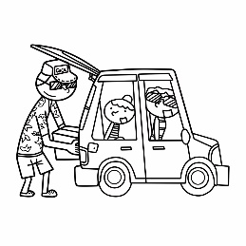 | (B) | 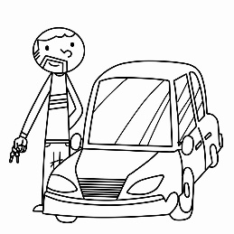 | (C) | 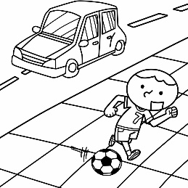
2. | (A) | 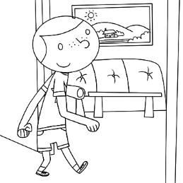 | (B) | 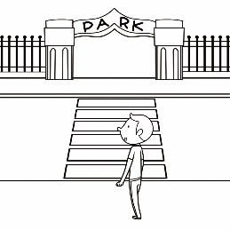 | (C) | 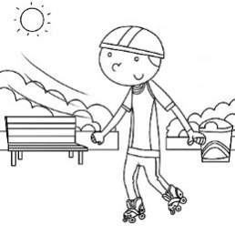
3. | (A) | 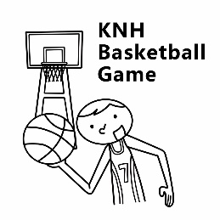 | (B) | 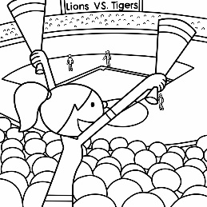 | (C) | 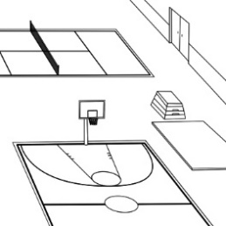
4. | (A) | 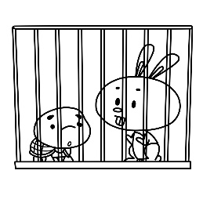 | (B) | 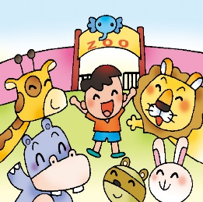 | (C) | 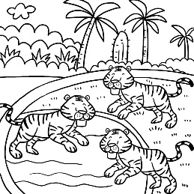
5. | (A) | 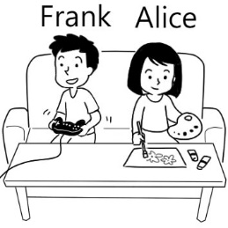 | (B) | 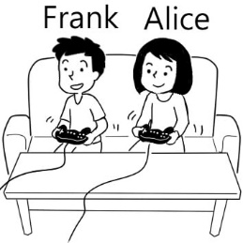 | (C) | 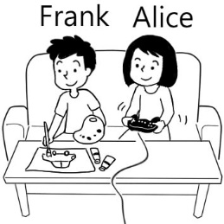

B、基本問答：每題均有三個選項，請依據所聽到的內容，選出一個最適合的回應(每題2分，共10分)
- (A) Where is the green lake? (B) Yes, and it’s behind the castle. (C) No, I’m not in the castle.
- (A) No, it’s magic. (B) No, it’s outside the house (C) No, it’s in the house.
- (A) Is it big or small? (B) You’re wrong again. (C) Cool, It’s next to a lake.
- (A) Yes, it’s behind these mountains.
(B) There are some schools around here.
(C) Yes, there is a junior high school in the mountains.
- (A) Yes, it’s a lot of fun. (B) No, it’s my favorite game. (C) Yes, there is a basketball game.
C、言談理解：每題均有三個選項，請依據所聽到的對話與問題，選出一個最適當的答案(每題2分，共10分)
- (A) In the bathroom. (B) Near the kitchen. (C) In his wife’s house.
- (A) Judy’s picture is in the newspaper. (B) Judy’s eyes are big. (C) Judy’s legs aren’t long.
- (A) The woman’s students are in the library.
(B) Mr. Wang’s whole calss is in South Africa.
(C) The students in the library are from South Africa.
- (A) In a zoo. (B) Near a pond. (C) In the mountains.
- _______
(A) It’s next to the playground. (B) It’s on the sports field. (C) It’s near a gym.

二 綜合測驗
- Kenny is a _______ boy. He is from Japan. (A) five-year-old (B) five-years-old (C) five years old (D) five year old
- A: ________ my cellphone? B: Under your storybook. (A) How is (B) Where are (C) Where is (D) What is
- The toy rabbits on the bed ________ for my sister, Jenny and Lisa. (Ａ) is (Ｂ) are (C) am (D) be
- _______ a beautiful park near your home? (A) Are they (B) Is it (C) Is there (D) Are there
- The pencil box is on the comic book. The comic book is ______ the pencil box. (A) near (B) between (C) next to (D) under
- Vicky: What there in the tree? John: two birds.
(Ａ) is; They’re (Ｂ) are; They’re (Ｃ) is; There are (Ｄ) are; There are
- Alex : Are there ________ fish in the pond? David: Yes, there are ______
(A) any; any (B) any; some (C) some; any (D) a lot; some
- Peter: Is there a gym at your school? Jim: Yes, _______.
(A) there is (B) there’s two (C) there isn’t (D) it is
- Harry : __________ Ron: It’s a magic school.
(A) Where is the place in this photo? (B) Is this place in the photo a magic school?
(C) Is the photo’s place a magic school? (D) What is the place in the photo ?
- This is _________ father. Ben and Cindy are brother and sister.
(A) Ben and Cindy’s (B) Ben and Cindy (C) Ben’s and Cindy’s (D) Ben’s and Cindy
- Choose the right one.
(A) There is some good storybook in the bookstore.
(B) There are fourty-five students in the classroom.
(C) There aren’t any people in the gym.
(D) There is some fish in the pond.
- Peggy: Are there ______ comic books on the desk?
Vivian : No, there is only one comic book on the desk.
(A) a lot (B) not (C) no (D) lots of

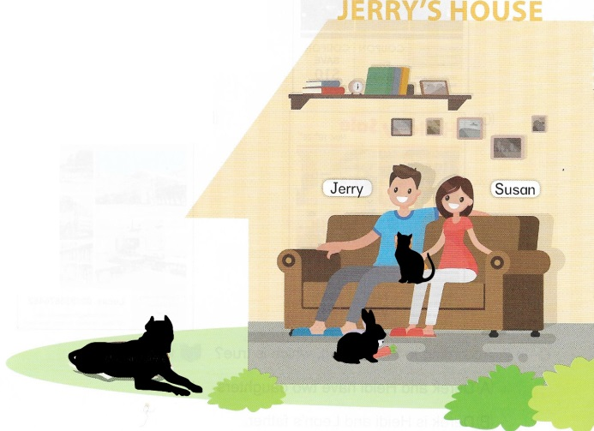
三、克漏字測驗 6%
Welcome to Jerry’s house.
Jerry and Susan love animals very much.
There is a cat ___(28)______ Jerry and Susan.
Look! A rabbit is __(29)____ the sofa.
What’s that ___(30)____ the house?
Oh, it’s their pet dog, Lucky.
- (A) behind (B) between (C) next to (D) near
- (A) in front of (B) on (C) next to (D) under
- (A) next to (B) outside (C) near (D) behind

四、 閱讀測驗 14%
Every year we go to Florida. We like to go to the beach. My favorite beach is called Emerson Beach. It is very long, with soft sand and palm trees. It is very beautiful. I like to make sandcastles and watch the sailboats go by. Sometimes there are dolphins and whales in the water! Every morning we look for shells in the sand. I found fifteen big shells last year. I put them in a special place in my room. This year I want to learn to swim. It is hard to swim, but so much fun! My sister is a good swimmer. She says that she can teach me. I hope I can do it!
* beach沙灘 * palm tree 棕梠樹 * sand 沙 * sailboat帆船
* look for 尋找 * shell 貝殼 * find / found發現 * last year 去年

- What animals do I see in the water? (A) Sharks. (B) Starfish. (C) Dolphins. (D) Dogs.
- How many (有多少)shells did I find last year? (A) Twelve. (B) Five. (C) Fifty. (D) Fifteen.
- What do I want to learn(學習) this year? (A) Swimming. (B) Surfing. (C) Sailing. (D) How to find shells.

My name is Rose. Today is my first day of school. I am a new student. My father drives me to school in the car.
I have a blue school bag. There are a book, a pencil, a ruler and some crayons in my school bag. My lunch box is yellow. I have an apple and a banana in my lunch box. I like fruit.
I am in classroom number two. It is big and has white board. The teacher has a desk and a chair. I have a chair, too. My teacher is very nice. I have to listen to the teacher and I have to be quiet when she speaks. My teacher tells me to sit next to the boy. His name is John. There are twenty students in my class.
My school has different rooms. There are fifteen classrooms, a library, a computer room and a music room. There is also a small playground with swings and a slide. I play with all the girls and boys. I only play in the playground, not in the classroom. I like my new school.
* drive 開車 * crayons 蠟筆 * listen to 聽 * be quiet 安靜
* tell 告訴 * sit 坐 * swing 鞦韆 * slide 溜滑梯

- The best (最好的) title (標題) is ___________
(A) My classmates. (B) My favorite sports. (C) A day at school. (D) Different classes at school.
- What is true (正確的) ?
(A) I am in classroom number 1, and it is small.
(B) My mother drives me to school in the car.
(C) There are seventeen classrooms at my school.
(D) When my teacher speaks, I have to be quiet.
- What is NOT true?
(A) My school bag is blue and my lunch box is yellow.
(B) There are an apple and an orange in my lunch box.
(C) There is a small playground at my school.
(D) I sit next to the boy, John.
- What is not in the school bag?
(A) A marker. (B) A pencil. (C) A ruler. D) A book.
五、文意字彙 14%
(A)請填入完整的單字，每題2分。
1. Our school has a good basketball c_________t. We love to play basketball there.
2. Derek and Tom are in the same class. They are c________tes.
(B) 單字中翻英，每題2分
3.城堡 4.沙發 5. 特別的 6. 毛毯 7. 分鐘

六、整句式翻譯 12%
1. 你的床是又大又軟還是又小又硬呢？ 4%
2. 整個學校都是我們的遊樂場。 2%
3. 事實上，世界各地的房子都不一樣。 3%
4. 我和我的朋友在那裡是為了樂趣，而不是為了成績。 3%

新北市立溪崑國民中學109學年度第一學期第二次定期評量 英語科 答案卷
七年級 班 座號 姓名
五、 文意字彙 14% (每題2分)
1 |  | 2 |  | 3 |  | 4
5 |  | 6 |  | 7

六、 整句式翻譯 12%
1
(4%).
2.
(2%)
3.
(3%)
4.
(3%)

109-1-2 七年級 英語科－解答 74%
一、聽力測驗 (30%) 1-15 ABCBB BBCCA ABCCA
二、綜合測驗 (24%) 16-27 ACBCD CBADA CD
三、克漏字測驗 (6%) 28-30 BAB
四、閱讀測驗 (14%) 31-33 CDA 34-37 CDBA
五、 文意字彙 14% (每題2分)
1 | court | 2 | classmates | 3 | castle | 4 | sofa
5 | special | 6 | blanket | 7 | minute

六、 整句式翻譯 12%
1. | Is your bed big and soft, or is it small and hard? 4%
2. | The whole school is our playground. 2%
3. | In fact, houses around the world are different. 3%
4. | My friends and I are there for fun, not for grades. 3%

新北市立溪崑國民中學109學年度第一學期第二次定期評量
七年級 英語科 聽力測驗稿
一、辨識句意：每題均有三張圖片，請依據所聽到的句子，選出符合描述的圖片(每題2分，共10分)
- CD: Victor is behind the car.
- CD: Eric is outside a park. In fact, he is in front of it.
- CD: The gym is not small. There is a basketball court in it.
- CD: There are some animals at the gate of the zoo.
- CD: There aren’t any pictures on the table.
二、基本問答：每題均有三個選項，請依據所聽到的內容，選出一個最適合的回應(每題2分，共10分)
- CD: Is the green lake near a castle?
- CD: Is your pet, Abby, in the house?
- CD: Welcome to my castle.
- CD: Is there a school in the mountains?
- CD: Is that a fun game?
三、言談理解：每題均有三個選項，請依據所聽到的對話與問題，選出一個最適當的答案(每題2分，共10分)
- CD: M: Who is in the bathroom?
G: My uncle.
M: Oh, your uncle is here. What about your aunt? Is she here, too?
G: Yes, she’s in the kitchen.
Q: Where is the girl’s uncle?
- CD: M: Judy, your picture is in the newspaper.
W: What ?
M: See? It’s here.
W: No, that’s not me. Look. Her eyes are small, and my legs are long and thin.
Q: What is right?
- CD: M: Where are those students in the library from? Africa?
W: Yes, they’re from South Africa.
M: Are they in your class?
W: No, they’re in Mr. Wang’s class.
Q: What is right?
- CD: M: Hmm. This place is nice.
W: It is.
M: Look. Is that a rabbit?
W: Yes, it is. There are a lot of different animals in the mountains.
Q: Where are the man and the woman?
- CD: M: Are there any restrooms around here?
W: Not around here. Go to the playground. There is one next to it.
M: Where is the playground?
W: It’s in front of the sports field.
Q: Where is the restroom?

