新北市立溪崑國民中學109學年度第一學期第一次定期評量 英語科 試題卷
九年級 班 座號 姓名
一、聽力測驗 (30%)

(A) 辨識句意：根據聽到的內容，選出符合描述的圖片。
- (Ａ) 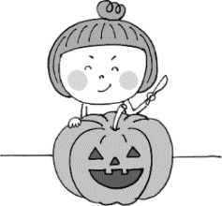 (Ｂ) 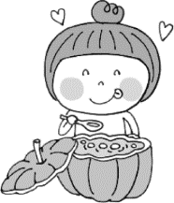 (Ｃ) 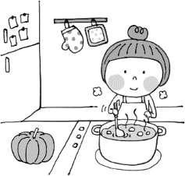
- (Ａ) 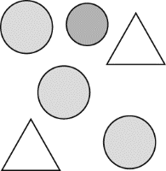 (Ｂ) 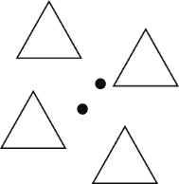 (Ｃ) 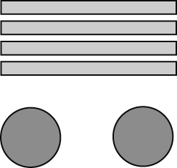
- (Ａ) 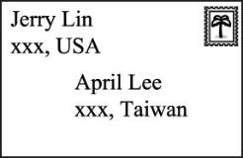 (Ｂ) 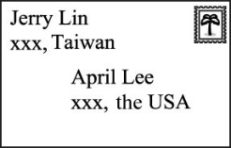 (Ｃ) 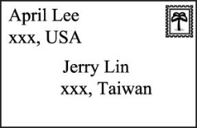
- (Ａ) 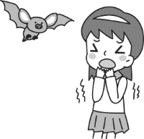 (Ｂ) 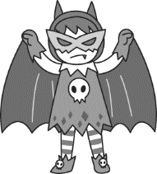 (Ｃ) 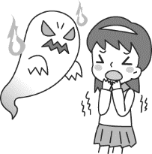
- (Ａ) 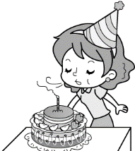 (Ｂ) 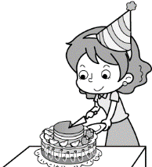 (Ｃ) 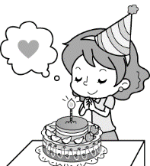

(B) 基本問答：根據聽到的內容，選出一個最適合的回應。

6. (A) No, I found it in my bag. (B) Yes, I’m looking for it. (C) Yes, it’s on my desk.

7. (A) Yes, it’s easy for him. (B) No, the paper frog is scary. (C) No, it’s a piece of cake to him.

8. (A) What is he afraid of? (B) I don’t think so. (C) I think that he’s really tired.

9. (A) You shouldn’t be worried. (B) Watching movies isn’t my cup of tea. (C) I’m afraid to see ghost movies. 10.(A) Your eyes tricked you. (B) There are no dots on the book. (C) You can go trick-or-treating.

(C) 言談理解：根據聽到的內容，選出一個最適合的答案。
11. (A) He doesn’t like water sports.
(B) His mom won’t let him go.
(C) He’s scared of ghosts.
12. (A) The man got goose bumps because of the ghost story.
(B) They are listening to a goose story.
(C) The ghost movie is scary to them.
13. (A) The TV program will be on at 7 p.m.
(B) The woman doesn’t want to watch the TV program with the man together.
(C) The TV program isn’t interesting at all.
14. (A) Peter will go trick-or-treating with Tina.
(B) Peter thinks watching a football game on TV is so boring.
(C) Tina is busy making a Halloween costume.
15. (A) Making delicious Hakka food.
(B) Making oil paper umbrellas.
(C) Visiting the Meinong Hakka Cultural Museum.

二、綜合測驗 (26%)
16. Kaohsiung is a ________ city to Alex because he knows nobody there.
(A) strange (B) certain (C) excellent (D) proud
17. Lulu burned the midnight ________, so she looked tired with dark ________ around her eyes.
(A) lamp：circles (B) oil；triangles (C) oil；circles (D) lamp；rectangles
18. Jack and Rose ________ for 10 years. The have two lovely kids now.
(A) married (B) have married (C) marry (D) have been married
19. Ivy is my best friend. We’ve known each other ________.
(A) in ten years (B) since we studied in elementary school (C) ten years ago (D) for three months last year.
20. Emma：Have you ________ Disneyland? Nancy：No, I ________.
(A) ever gone to；have never (B) ever been to；never (C) ever gone to；never do (D) ever been to；never have
21. Kate：Claire cut her fingers yesterday, ________ she? Sean：Yes, she _______. She cried so sadly.
(A) does；does (B) did；did (C) doesn’t；does (D) didn’t；did
22. Leo is going to Paris with his girlfriend, ________?
(A) isn’t he (B) won’t he (C) isn’t she (D) won’t she
23. Max：Have you ________ out the garbage yet?
Jill：Yes, I ________ it out half an hour ago.
(A) took；taken (B) took；took (C) taken；taken (D) taken；took
24. For students, new and funny things ________ them much more than textbooks.
(A) interest (B) interesting to (C) are interested in (D) interests
25. It looks like it will rain in the afternoon. ________, let’s take an umbrella with us.
(A) So far so good (B) For dear life (C) To have a whale of a time (D) Just to play it safe
26. Mrs. Lin：Leo, just do your best. You don’t need to worry too much about the singing contest.
Leo：I know, but ________
Mrs. Lin：Even if you lose, we will still be proud of you.
- I can’t make heads or tails of it. (B) I can’t help it. (C) I can’t worry about it. (D) I can’t agree with you.
27. Choose the right sentence.
(A) My grandma has died for five years.
(B) Annie seldom wore dresses, didn’t she?
- We are surprised to know that David lost his job.
(D) When have you finished your homework?
28. Choose the wrong sentence.
(A) There is nothing special in the shoe store, is there?
(B) Are you possible to lend me 10,000 dollars?
(C) It has been twenty years since we met in junior high school.
(D) The dancing club really surprises me. I want to join it.

三、克漏字測驗 (12%)
(一)
Amy：Halloween’s just 29 . I’m really excited about it!
John：Halloween is for children, 30 ? I think trick-or-treating is boring.
Amy：I’m 31 trick-or-treating, too. So, this year I’m going to a costume party with Patty. I’m going to dress up as a bat, and Patty’s going to be a cat.
John： 32
Amy：Right！But…at the party, there’ll be a time for telling ghost stories. I think I’ll run away and hide.

29. (A) not my cup of tea (B) showing off (C) moving forward (D) around the corner
30. (A) is it (B) are they (C) isn’t it (D) aren’t they
31. (A) excited about (B) exciting to (C) bored with (D) boring to
32. (A) What a way to celebrate Halloween！ (B) I’ve never heard of it！ (C) It sounds boring. (D) Don’t be scared.

(二)
Teresa ：Mom, are you all right? Here is a dry towel for you. Dry your hair and body first. Is it still raining pretty heavily?
Mrs. Wu：I’ve just come back from the supermarket near our home, but the two-minute walk made my bag, shoes, and pants
all wet and totally dirty.
Teresa ：Oh my! 33 I need sunny days!
Mrs. Wu：I couldn’t agree with you more. 34
Teresa ：Me, either. When can I play basketball with my friends?
Mrs. Wu：Oh! Poor girl!

33. (A) The supermarket near our home is having a big sale.
(B) I enjoyed the rainy days very much.
(C) It has been over one month since the supermarket opened.
(D) It’s rained for more than two weeks.
34. (A) Yesterday I went jogging with your dad.
(B) I’ve stayed home all day since last week.
(C) I haven’t gone jogging since it began to rain.
(D) Don’t go out on rainy days!

四、閱讀測驗 (12%)
(一)

Xpark
New Open!!
★ Business hours (from August 7 to September 30) ：
＊Weekdays：10：00~21：00
＊Weekends：10：00~22：00
★ Ticket price：
＊Adults：550
＊Students：400
＊Elementary school students, and seniors：250
＊Under the age of 6：free
※ While buying a ticket, presentation of your student ID or a certificate that can confirm your age may be requested.
※ Please turn off the flashlight while taking a photo indoors.
※ Please don’t bring outside food and drinks.

presentation 介紹 certificate 證明 confirm 確認

- What does requested mean?
(A) needed (B) ended (C) asked (D) invited
- Mr. and Mrs. Chung and their children are going to Xpark this Saturday. Their son, Ian, is an elementary school student. Their daughter, Tracy, is a two-year-old girl. How much are they going to spend on the tickets?
- NT$1350 (B) NT$1750 (C) NT$1500 (D) NT$ 1900
- Which is true about Xpark?
- Xpark opens for twelve hours on Wednesday.
- If you want to take a photo, remember to turn on the flashlight.
- Seniors have to pay NT$250 for the tickets to Xpark.
- People can’t eat or drink in Xpark.

(二)
People are afraid of COVID-19 because it is a type of coronavirus that is very similar to SARS and MERS. SARS and MERS have killed quite a lot of people around the world. During the SARS outbreak of 2003, Taiwan was among the world- hit territories, along with Hong Kong and southern China. Many people were quarantined and died
around the world.
Due to the experience of fighting against SARS, people know wearing face masks is an important way to protect themselves. We also take a lot of precautions to prevent infection, such as washing hands regularly and avoiding touching eyes, the nose or mouth. Besides, social distancing is deliberately increasing the physical space between people to avoid spreading illness. Staying at least six feet away from other people lessens your chances of catching COVID-19. Most important of all, people who have been exposed to the new coronavirus and who are at risk for coming down with COVID-19 need to practice self- quarantine. Health experts recommend that self- quarantine lasts fourteen days. Two weeks provide enough time for people to know whether or not they will be contagious to other people.
There is currently no vaccine to prevent COVID-19 and also no specific medicine to treat it. Fortunately, Taiwan was the first country to activate epidemic prevention measures against COVID-19. Nowadays, we are contributing to international efforts by sharing how we contained the outbreak, kept our schools and businesses open, and ensured masks for all.

quarantine隔離 precaution預防措施 infection感染 deliberately刻意 lessen減少 expose暴露 recommend建議 contagious傳染性的 come down with染上 vaccine疫苗 activate啟用 epidemic疫情 contain 控制

- What is the best title for the reading?
(A) Taiwan Can Help.
(B) How Taiwan Fight Against COVID-19.
(C) Wearing Face Masks Is Important.
(D) COVID-19 Outbreak Around the World.
- Which is NOT mentioned in the reading?
(A) COVID-19 is similar to SARS and MERS.
(B) Social distancing is a way to avoid spreading illness.
(C) There is specific medicine to treat COVID-19 in Taiwan.
(D) People who are at risk for coming down with COVID-19 need to practice self-quarantine.
- What can we learn from the reading?
- Taiwan is the first country to have vaccine to prevent COVID-19.
- Washing hands regularly and avoiding touching eyes, the nose, or mouth can’t prevent infection of COVID-19.
- Wearing face masks is the only way to protect people from catching COVID-19.
- In Taiwan, we contained the outbreak of COVID-19, kept the schools and businesses open, and ensured masks for all.

新北市立溪崑國民中學109學年度第一學期第一次定期評量 英語科 答案卷
九年級 班 座號 姓名
五、寫出單字的英文 (4%)
41. 信封 42. 語言 43. 正方形 44. 相信
六、依提示作答 (4%)
45. Irene has worked in Xi Kun Junior High School for seventeen years.(依畫線部分造原問句)
46. The coming trip next month is exciting to all of the students. (請用All of the students開頭改寫句子)
七、翻譯 (12%)
47. 對了，你決定好要送Ted堂哥什麼結婚禮物了嗎？
48. 我們的眼睛獲取資訊，讓我們的腦知曉我們所處的世界。
49. 難道你不認為萬聖夜是一個讓所有人玩得開心且發揮創意的時機嗎?
50. Irene從小就對做紙傘有興趣，不是嗎?
五、寫出單字的英文 (4%)(每題1分)
41 | 42 | 43 | 44
六、依提示作答 (4%)(每題2分)
45
46
七、翻譯 (12%) (每題3分)
47
48
49
50
109-1-1 九年級 英語科－解答
- 聽力測驗 (30%)
1 | 2 | 3 | 4 | 5
A | A | B | B | C
6 | 7 | 8 | 9 | 10
C | C | B | B | A
11 | 12 | 13 | 14 | 15
B | A | A | C | A
- 綜合測驗 (26%)
16 | 17 | 18 | 19 | 20
A | C | D | B | D
21 | 22 | 23 | 24 | 25
D | A | D | A | D
26 | 27 | 28
B | C | B
- 克漏字測驗 (12%)
29 | 30 | 31 | 32 | 33 | 34
D | C | C | A | D | C
- 閱讀測驗 (12%)
35 | 36 | 37 | 38 | 39 | 40
C | A | C | B | C | D
- 寫出單字的英文 (4%)(每題1分)
41 | 42 | 43 | 44
envelope | language | square | believe
六、依提示作答 (4%)(每題2分)
45 | How long has Irene worked in Xi Kun Junior High School?
46 | All of the students are excited about the coming trip next month.
七、翻譯 (12%) (每題3分)
47 | By the way, have you decided on Cousin Ted’s wedding gift?
48 | Our eyes get information for our brain to make sense of the world around us.
49 | Don’t you agree Halloween is a time for everyone to have fun and be creative?
50 | Irene has been interested in making paper umbrellas since she was little, hasn’t she?
新北市立溪崑國民中學109學年度第一學期第一次定期評量
九年級 英語科 聽力測驗稿
- 辨識句意：根據聽到的內容，選出符合描述的圖片。
- Vivian is excited about making a jack-o’-lantern.
- There are four circles and two triangles.
- Jerry mailed a letter to me from Taiwan. I’m so happy to hear from him.
- Lucy dressed up as a bat on Halloween.
- Amy is making a wish at her birthday party.

- 基本問答：根據聽到的內容，選出一個最適合的回應。
- Have you found your wallet yet ?
- Making a paper frog is hard for Sam, isn’t it?
- Ken thinks that Halloween is an interesting holiday. What do you think?
- I’m free tonight, David. Are you interested in going to a movie with me?
- I can’t make heads or tails of this picture. The dots on it are moving. Why?

(C) 言談理解：根據聽到的內容，選出一個最適合的答案。
11. M：I heard that Aaron isn’t going surfing this weekend.
W：Really? I thought he liked water sports.
M：He does, but his mom doesn’t want him to go.
W：Why not?
M：It’s Ghost Month.
Q：Why won’t Aaron go surfing this weekend?
- W：This ghost story is really scary.
M：You can say that again. It gives me goose bumps.
W：Me, too. We should not listen to ghost stories at midnight.
Q：Which is true?
- W：That’s quite an interesting TV program, isn’t it?
M：Yes, it is. What time will it be on?
W：It’ll be on at 7 p.m. Want to watch it together?
W：Sure.
Q：Which is true?
- M：Tina, what are you busy doing?
W：Making a costume for Halloween. Peter, do you want to go trick-or treating with me?
M：No way！It’s a boring activity, isn’t it？I don’t like to ask for candy from door to door. I want to
stay home and watch an exciting football game on TV.
Q：Which is true?
- W：We have left Meinong for many years. My grandmother asked us to come back to our town during
the Chinese New Year. This year, many activities will be held, such as tasting delicious Hakka
food, making oil paper umbrellas, visiting the Meinong Hakka Cultural Museum. Grandfather
said that we would be surprised at those interesting activities during the Hakka Culture Festival.
Q：What activity won’t be held during the Hakka Culture Festival?

