新北市立溪崑國民中學109學年度第一學期第一次定期評量 英語科 試題卷
八年級 班 座號 姓名
一、辨識句意：依據所聽到的內容，選出符合描述的圖片(每題2分，10%)
1. (A) 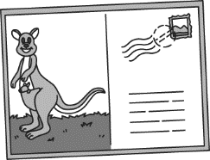 | (B) 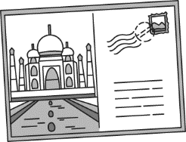 | (C) 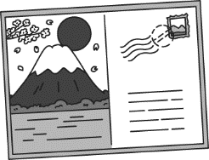
2. (A)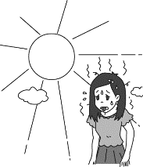 | (B) 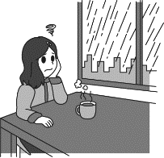 | (C) 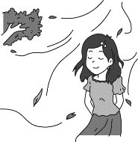
3. (A) 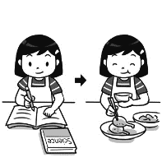 | (B) 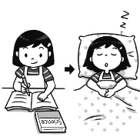 | (C) 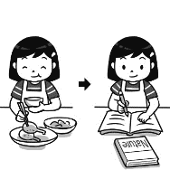
4. (A) 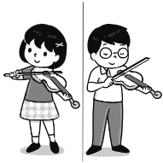 | (B) 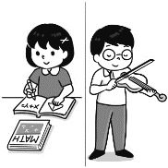 | (C) 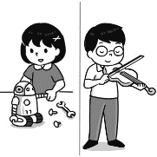
5. (A) 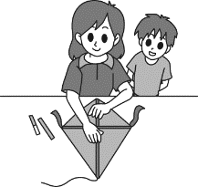 | (B) 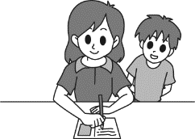 | (C) 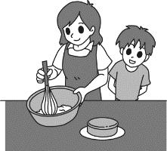

二、基本問答：根據聽到的內容，選出一個最適合的回應或最適合的問句。(每題1分，5%)
6. | (A) It is mine. My dad bought it for me as my birthday gift.
 | (B) It is very cold outside. Come on in.
 | (C) Will you join me next time?
7. | (A) It is rainy today, so don’t forget to bring an umbrella.
 | (B) I like the weather in Taipei.
 | (C) No, it is windy.
8. | (A) Yes, the book was very boring.
 | (B) Not really. It was a good book.
 | (C) Yes, I did. He told me he wanted to read it this weekend.
9. | (A) I went there by car.
 | (B) I called my parents first.
 | (C) There were so many people in the airport.
10. | (A) He called my teacher. | (B) He was mad at me. | (C) Because I was late.

三、言談理解：根據聽到的內容，選出一個最適合的答案。(每題1分，5%)
11. | - Kevin’s uncle is kind. | (B) Kevin’s jacket is very warm. | - Kevin’s favorite color is red.
12. | (A) The pool. | (B) The mountains. | (C) The department store.
13. | (A) He couldn’t find his shoes. | (B) There was a lot of rain. | (C) He didn’t catch the school bus.
14. | (A) He is Joy’s father. | (B) He is Joy’s doctor. | (C) He is Joy’s teacher.
15. | (A) PE. | (B) Math. | (C) History.
四、綜合測驗：(每題2分，34%)
16. Emma: umbrella is it? Sherry: It’s Ann’s. She forgot to take it home.
(A) What (B) Where (C) Which (D) Whose
17. How the old man is! He smiled and said “go die” to me. I was really mad at him.
(A) strange (B) kind (C) heavy (D) windy
18. Apples are good for your . An apple a day keeps the doctor away.
(A) company (B) trial (C) designer (D) health
19. Liz has music class tomorrow, so she needs to take her to school for a talent show.
(A) snowboard (B) violin (C) jacket (D) festival
20. A: What are you ? B: My iPad. It was on the dining table this morning.
(A) looking at (B) looking for (C) looking after (D) looking up
21. Be careful with the plates and glasses. Don’t them.
(A) learn (B) fall (C) drop (D) mean
22. My grandparents went on a . They were in America for ten days and had a lot of fun!
(A) trip (B) fact (C) gift (D) postcard
23. Mr. Lai started his first job as a computer . He was good at program coding. （編寫程式）
(A) engineer (B) guest (C) winner (D) robot
24. Ms. Lin was busy teaching a new lesson, we didn’t have a test today.
(A) Because; so (B) Because; × (C) ×; because (D) So; ×
25. This Moon Festival, we moon cakes and pomelo hats. It was a wonderful evening.
(A) eat; make (B) ate; make (C) eat; made (D) ate; made
26. Who you with and who you call last night?
(A) did; did (B) were; did (C) did; were (D) were; were
27. Mary: John, don’t touch the comic book. It’s not .
John: Of course it’s . Look! My name is on it.
(A) mine; yours (B) his; hers (C) ours; theirs (D) yours; mine
28. Can you give ?
(A) the card for me (B) it of me (C) me it (D) me the card
29. For many office workers in Taiwan, having a cup of coffee is a good way to a new day.
(A) start (B) end (C) open (D) pull
30. No one ever（曾經） one day the coronavirus（新冠病毒）would hit all over the world.
(A) heard (B) thought (C) finished (D) held
31. Ann: there lots of snow in Japan in winter? Sue: Yes. It a lot there in winter.
(A) Is; snows (B) Are; snowed (C) Do; is snowy (D) Does; snows
32. you use the bathroom, you should wash hands.
(A) Before (B) After (C) When (D) So
五、克漏字選擇：(每題2分，16%)
(一)
Good morning, everyone. Welcome to today’s weather report. Typhoon Rosa is coming close to Taiwan, and it may come 33 heavy rain and strong winds. Now, let’s take a look at today’s weather in Taiwan.
There is 34 all day on the whole island, so don’t forget your umbrellas. In Hualien and Taitung, the 35 may come out for a short time in the morning. Rosa is coming very 36 . Please be careful because 37 . Also, be safe and do not go to the beach or mountains. This is Jenny Liu for today’s report. See you next time.

33. | (A) of | (B) to | (C) for | (D) with
34. | (A) rain | (B) clouds | (C) sun | (D) winds
35. | (A) clouds | (B) sun | (C) rain | (D) snow
36. | (A) late | (B) soon | (C) early | (D) heavy
37. | (A) it is too hot now |  | (B) the weather is strange
 | (C) Rosa is right here in Taiwan |  | (D) the rain and wind can be very strong

(二)
Gary: Hello. 38
Mom: Who’s speaking?
Gary: It’s Gary, Nina’s friend from the school club. May I speak to her, please?
Mom: I’m sorry. Nina’s not in. 39
Nina: Mom, I’m here! Who’s calling?
Mom: Well…it’s Gary from your school club. Hello, Gary. Nina is here now. Please hold on.
Nina: 40 What’s up, Gary?
Gary: I designed a video game. Maybe you can come over and take a look.
Nina: That’s cool! Let me ask my mom first. Talk to you later.
Gary: OK. Bye.

38. | (A) May I speak to Mom? | (B) Is Nina there?
 | (C) Can I talk to Jolin, please? | (D) May I have your name, please?
39. | (A) Maybe in an hour. | (B) Hold on a minute.
 | (C) Please call back later. | (D) Please wait a minute.
40. | (A) Is Gary there? | (B) Hello. Can I talk to Gary?
 | (C) This is Nina speaking. | (D) You have the wrong number.
六、閱讀測驗：(每題1分，6%)
(一)

Hi, everyone. Today’s English class is about homonyms. Before we talk about homonyms, let’s read a story first.

It was a cold and rainy night. Jasper was on his way home. There was an old man walking in front of him. “Watch out!” said Jasper to the old man when he saw a car. But, it was too late. The car hit the old man, and he lost his left arm and left leg. A few weeks later, Jasper saw the old man on the street again. “Hey, are you okay?” Jasper walked to the old man. “Well, I am all right now,” said the old man. He showed Jasper his right arm and right leg.

In the story, the word, right, has two different meanings. One is “fine” or “correct,” and the other is “on the right hand side.” When two words have the same spelling but different meanings, we call them homonyms. Isn’t it interesting?

41. What do we know from the story?
(A) The old man died. | (B) Jasper’s car hit the old man.
(C) The weather that night was nice. | (D) The old man only has one arm and one leg now.
42. Which uses homonyms?
a. What do you call hot snow? Water.
b. Why wasn’t the moon hungry? Because it was full.
c. Your left brain has nothing left, and your right brain has nothing left.
d. What goes up when the rain comes down? An umbrella.
e. Why does every girl hate the sun? Because it is not cool.
(A) a, b, c | (B) c, d, e | (C) b, c, e | (D) b, d, e

(二)

Sunny Smiles Summer Camp 2020 – Bigger, Better, Together
Daily Schedule
Times |  | Monday to Friday
Mornings | 07:30 – 08:00 | Wake up – Make your bed, Brush your teeth, & Wash your face  Be prepared & Get ready for a new day!
Mornings | 08:00 – 09:00 | Breakfast – Enjoy your special camp meal
Mornings | 09:00 – 10:30 | Team Activity – Work together with your friends & Win the first place
Mornings | 10:45 – 12:15 | Dance Class – Practice makes perfect, & You can be a good dancer!
Afternoons | 12:15 – 13:30 | Lunch – Enjoy your delicious camp meal
Afternoons | 13:30 – 14:00 | Games – Have fun with your friends & Know them better
Afternoons | 14:00 – 15:30 | Swim Class – Let’s play in the water & Cool down your body
Afternoons | 15:30 – 15:45 | Snack Time – Chocolate Cakes, Homemade Cookies, or Ice Cream
Afternoons | 15:45 – 17:15 | Movie Time – Watch Into the Wild on Monday, The Great Outdoors on Tuesday,  Carry on Camping on Wednesday, Earnest Goes to Camp on Thursday,  Sleepaway Camp on Friday
Afternoons | 17:15 – 18:15 | Sport Class – Basketball on Monday, Wednesday, and Friday  Soccer on Tuesday and Thursday
Evenings | 18:15 – 19: 30 | Dinner – Enjoy your yummy camp meal
Evenings | 19:30 – 21:30 | Evening Program – Special guests are coming for you!
Evenings | 21:30 – 22:00 | Cleaning Time – Do the Dishes and your laundry
Evenings | 22:00 | Lights out – Time for Bed
Evenings | * The summer camp is for students from ten to fifteen years old.  * Always wear a mask during the summer camp. Keep yourself safe from COVID – 19.  * NT$500 for each person after June 15th. You can all get a 10% discount by signing up with friends.  * For early birds who sign up by June 15th, just NT$400 for each person.
43. Stan wants to join this summer camp with his friends, John and Joe. How much money do they need to pay in total if they
sign up for it on June 16th?
(A) NT$ 1,080 (B) NT$ 1,200 (C) NT$ 1,350 (D) NT$ 1,500
44. Why do they always need to wear a mask during the summer camp? spread 散佈; 傳播
(A) They need to see a doctor. (B) They look cool with a mask.
(C) They can keep themselves safe from bullying. (D) Masks help stop the coronavirus from spreading.
45. Who CAN’T go to the summer camp? college 大學； graduate 畢業
(A) Amy, an 11-year-old girl. (B) Bella, who will take college entrance exam next year.
(C) Calvin, in the eighth grade of junior high. (D) Derek, who just graduated from elementary school.
46. Which is NOT TRUE?
(A) Students have to wash their dishes and clothes by themselves.
(B) They learn how to dance and play basketball with friends every day.
(C) On Thursday, students can enjoy the movie, Earnest Goes to Camp.
(D) In the afternoon, students can have some sweet food, like cakes or cookies.

七、翻譯：(24%) 注意: 請寫在答案紙上!!!

新北市立溪崑國民中學109學年度第一學期第一次定期評量 英語科 答案卷
八年級 班 座號 姓名
七、翻譯：(24%) (每格1分)
1. 我媽媽總是在我生日這天為我做個大蛋糕。(2%)
My mom always a big cake me on my birthday.
2. 我們的老師，賈伯斯女士，是一位台灣電玩遊戲比賽的四屆冠軍。(2%)
Our teacher, Ms. Jobs, is a winner of the Taiwan Video Game .
3. 今天，臺北天氣多雲風大，但是臺南暖和且陽光普照的。(4%)
Today, it is and in Taipei, but it is and in Tainan.

4. 我是個遊戲迷，而且電腦科學是我最愛的科目。(3%)
5. 加入我們足球社團，你就可以有朝一日成為像 Messi 的足球球員。(4%)
6. 我們的課程一點都不難, 而且我們的老師們會用有趣的方式教學。(4%)
7. 每年我們會帶兩位學生免費參加前往倫敦遊戲嘉年華之旅。(5%)

109-1-1 八年級 英語科－解答
聽力測驗
一、辨識句意：(每題2分，10%) ACACA
二、基本問答：(每題1分，5%) AACBB
- 言談理解：(每題1分，5%) ACBCA
- 綜合測驗：(每題2分，34%) DADBB CAABD BDDAB AB
- 克漏字：(每題2分，16%) DABBD BCC
- 閱讀：(每題1分，6%) DC CDBB
七、翻譯：(24%) (每格1分)
1. makes for
2. four-time Contest
3. cloudy windy warm sunny
4. 我是個遊戲迷，而且電腦科學是我最愛的科目。(3%)
I am a (big) fan of games, and computer science is my favorite subject.
5. 加入我們足球社團，你就可以有朝一日成為像 Messi 的足球球員。(4%)
Join the (our) soccer club, and you can be a soccer player like Messi one day.
6. 我們的課程一點都不難, 而且我們的老師們會用有趣的方式教學。(4%)
Our lessons are not difficult at all, and our teachers teach in a fun way.
7. 每年我們會帶兩位學生免費參加前往倫敦遊戲嘉年華之旅。(5%)
Every year, we take two students on a trip to the London Game Festival for free.

新北市立溪崑國民中學109學年度第一學期第一次定期評量
八年級 英語科 聽力測驗稿
一、辨識句意：(每題2分，10%)
- Jenny sent Tony a postcard from Australia the day before yesterday.
- W: My favorite season is fall because it is cool but very comfortable.
- Cindy does her science homework before she has dinner.
- M: Judy’s favorite club is the robot design club and mine is the violin club.
- M: Aunt Judy made me a kite this morning.
二、基本問答： (每題1分，5%)
- That’s a nice blue snowboard. Whose is it?
- What’s the weather like in Taipei today?
- Did you give the book to David two days ago, Leo?
- What did you do when you got to the airport the day before yesterday?
- What happened after your dad spoke to your teacher?
三、言談理解： (每題1分，5%)
- W: Why are you in a red jacket, Kevin? I remember you hate that color.
M: Yeah…but my jacket is not warm enough, so my uncle gives his jacket to me.
W: That’s very kind of him.
Q: Which is true?
- W: How’s the weather in summer in Vancouver, Michael?
M: It is hot there, just like in Taiwan.
W: What do you guys usually do on hot days?
M: In Vancouver, we usually go to the pool or the mountains.
W: But for me, I like to go to the department store.
Q: Where does the woman like to go in summer?
- W: What happened to your new shoes, Jerry?
M: They were wet. Before I came back home, it rained a lot outside. And I didn’t bring an umbrella with me. I couldn’t find a place to hide.
W: That’s terrible.
Q: What happened before Jerry arrived home?
- M: Hi, may I speak to Joy, please.
W: Who’s calling?
M: This is Mr. Chen from XiKun Junior High School. I am her home room teacher. Because she is not at school, I make a phone call to check what happened.
W: Sorry, Mr. Chen. This is Joy’s mom. She is not feeling well today. I am going to take her to the doctor. Thanks for calling.
M: No problem. Take care.
Q: Who is Mr. Chen?
- W: OK, class. Before we start, let’s do some exercises. First, put your hands on your legs like this. Now, put your hands on your feet. Please be careful when you do this. Don’t hurt your back.
Q: What class may the woman be teaching?

