新北市立溪崑國民中學109學年度第一學期第一次定期評量 英語科 試題卷
七年級 班 座號 姓名
一 聽力：30％(每題2分)
(一) 辨識句意：請依據所聽到的句子，選出符合描述的圖片10%
1.
(A)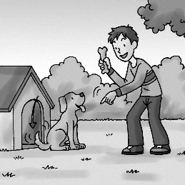 (B)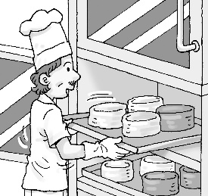 (C)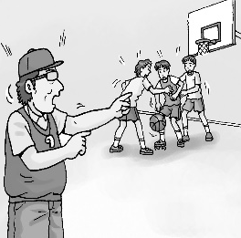
2.
(A)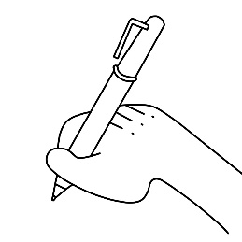 (B)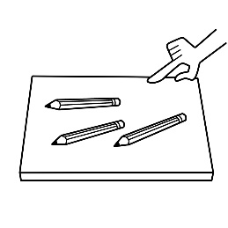 (C)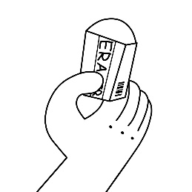
3.
(A)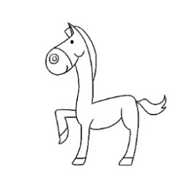 (B)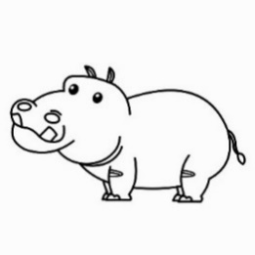 (C)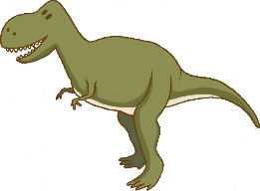
4.
(A)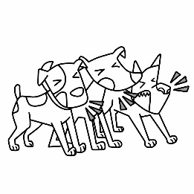 (B)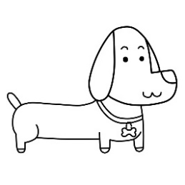 (C)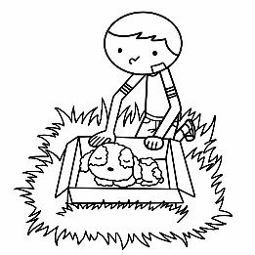
5.
(A)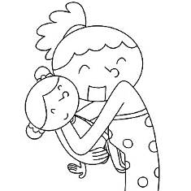 (B)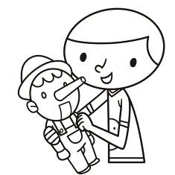 (C)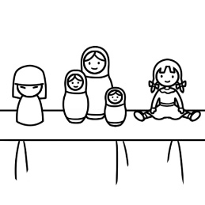
(二) 基本問答：請依據所聽到的內容，選出一個最適合的回應10%
6. (A) Is he your brother? (B) She is a nurse. (C) He’s my cousin, David.
7. (A) Yes, he’s short. (B) Yes, he’s a tall man. (C) Yes, his brother is tall.
8. (A) It’s a toy for you. (B) Yes, the box is big. (C ) They are pens and pencils.
9. (A) I’m from Taiwan. (B) I’m sixteen years old. (C) She is from Japan.
10.(A) They’re tigers. (B) I like lions, too. (C) They’re not in my house.

(三) 言談理解：請依據所聽到的對話與問題，選出一個最適當的答案10%
11. (A) The cup is for the man.
(B) The man is the woman’s father.
(C) The cup is for the man’s father.
12. (A) In a zoo.
(B) At a school.
(C) In a park.
13. (A) Amy is a nurse.
(B) Amy is a doctor.
(C) Amy is the man’s friend.
14. (A) A birthday card.
(B) Shoes.
(C) Some beautiful cups.
15. (A) They have mice at home.
(B) The black rabbit is the girl’s pet now.
(C) Their pets are a mouse and a rabbit.
二 綜合選擇(選出最適合的答案)：28％(每題2分)
16. My dog, Lucky, _______ fourteen years old. _______ old.
(A) is; Its (B) are; It’s (C) am; He’s (D) is; It’s
- A: Who is that thin girl? B: _______
(A) She is ten years old. (B) He is thin. (C) Yes, she is my sister. (D) She is Mary.
- A: Hello! I’m Lisa, _______ B: Nice to meet you, too.
- how are you? (B) good morning. (C) nice to meet you. (D) how do you do?
- Jason: _______ Melody: Yes, I am. Nancy is my student.
(A) Is Nancy your student? (B) Are you a teacher? (C) Who is Nancy? (D) Are you Nancy’s classmate?
- Leo: _______ are the kangaroos _______? Ray: Australia.
(A) Where; from (B) What; from (C) Who; for (D) Where; for
- Look at the picture. Two _______ are in the park.
(A) mouse (B) foxs (C) sheep (D) woman
- Derek: Is the book new? Tim: _______ It is an old book.
(A) No, it isn’t. (B) Yes, it is. (C) No, he isn’t. (D) Yes, this is.
- A: What are these? B: ________ (A) It is a tiger. (B) These are tomatos. (C) They are mice. (D) These are brushs.
- This is ________rabbit. _______name is Bunny.
(A) May; Its (B) May’s; Its (C) May; She (D) May’s; It’s
- A: Is Debby ________English teacher? B: Yes, she is beautiful ________ young.
- a; and (B) an; an (C) the; a (D) an; and
- A: How’s it going? B: ________
- Pretty good. (B) You’re welcome. (C) Good morning. (D) See you soon.
- The boy is my younger brother. ________ name is Andy.
- Her (B) He’s (C) She’s (D) His
- ________ son is thin and tall. (A) Alex’s and Tina (B) Alex’s amd Tina’s (C) Alex and Tina (D) Alex and Tina’s
- Lisa: ________ B: They are my brother’s robots.
(A) Are those robots? (B) What are those? (C) Who is your brother? (D) What is it?

三 閱讀理解：18％(每題2分)
(一)
(Line 1)  (Line 3)  (Line 5)  (Line 7)  (Line 9)  (Line 11) | The Learner  Two plus two is twenty-three.  It’s not, you say? Oh no, poor me.  Two plus two is…seventy-eight?  I’ll get it right if you’ll just wait.  Two plus two is…forty-one?  Wrong again? This is no fun.  Two plus two…is…thirty-two?  Adding seems so hard to do.  Two plus two…I think…is…four?  That’s right? Hurray!  Let’s add some more.
30. What is the poem(詩) about?
(A) Doing math. (B) Telephone numbers. (C) Someone’s age. (D) Money.
31. Which pair of words are NOT rhymed(押韻)?
(A) Lines 1 and 2: three, me.
(B) Lines 3 and 4: eight, wait.
(C) Lines 5 and 6: one, fun.
(D) Lines 9 and 10: four, Hurray.
32. What is two plus two?
(A) Twenty-three. (B) Seventy-eight. (C) Thirty-two. (D) Four.
33. How old is the writer probably? (可能)
(A) 2. (B) 6. (C) 12. (D) 15.
(二)
What animal is it?
I live in Africa.
I am yellow and brown.
I eat leaves.
I have a long neck.
34. ________
I can swim and dive.
I have two legs.
I have wings.
I quack.
35. ________
34. What animal is it? (A) Koala. (B) Bear. (C) Lion. (D) Giraffe.
35. What animal is it? (A) Mouse. (B) Duck. (C) Sheep. (D) Koala.
~背面尚有題目~
(三)
Miss Chen: Tim, please tell everyone in this class something about yourself to help us understand you.
Tim: I studied(讀) at a small junior high school in Taoyuan before I came to Taipei. My dad is a doctor, and my mom is a housewife. I also have a ten-year-old brother.
Miss Chen: Good. Welcome here. Eric, would you please show Tim around and help him know this school more?
Eric: No problem. That’s my pleasure.
Miss Chen: Tina, please wipe the desk for Tim. The desk is too dirty.
Tina: Sure.
Tim: Thank you, Miss Chen and my dear classmates. I think I will love my new life here.
show …around帶..四處看看 pleasure 榮幸 wipe 擦拭
36. Where is Tim studying now? (A) At an elementary school. (小學) (B) In Taoyuan. (C) In Taipei. (D) At his home.
37. What is Miss Chen doing?
(A) She is asking Tim’s classmates to help him.
(B) She is teaching English in the classroom.
(C) She is telling Tim what he can’t do in the classroom.
(D) She is showing Tim around at school.
38. How many persons are there (有多少人) in Tim’s family? (A) Three. (B) Four. (C) Five. (D) Six.
以下為非選擇題，請在答案卷上作答 24%
四 單字測驗:12％（每題2分）
中翻英
1.雙親之一________ 2.丈夫________ 3.農夫________
文意字彙
4. The ghost (鬼) in the movie is very s y.
5. There are (有) many p e in the gym.
6. My mom is preparing(準備) dinner in the k n now.
五 翻譯:12％ (每題3分)
- 不會吧！這些照片好酷喔。
- 對某些人而言，我們是熊科動物。
- 那張照片裡的動物呢？
- 你爸爸是醫生嗎? 不，他不是，他是廚師。

試題結束!

新北市立溪崑國民中學109學年度第一學期第一次定期評量 英語科 答案卷
七年級 班 座號 姓名
非選擇題24%
四 單字測驗 12％（每題2分）
1 | 2 | 3 | 4 | 5 | 6

五 翻譯12% （每題3分）
1.
2.
3.
4.

試題完! Good Luck!

109-1-1 七年級 英語科－解答
一、聽力測驗30% (每題2分)
1~5 CABCC 6~10 CBCAB 11~15 AABCB
二、綜合選擇(選出最適合的答案) 28% (每題2分)
16~20 DDCBA 21~25 CACBD 26~29 ADDB
三、閱讀理解：18％ (每題2分)
30~33 ADDB 34~35 DB 36~38 CAB
四、單字測驗:12％（每題2分）
1 parent | 2 husband | 3 farmer | 4 scary | 5 people | 6 kitchen
五 翻譯:12％ (每題3分)
- No way! These pictures are cool.
- In some people’s eyes, we’re in the bear family.
- What about the animal in that picture?
- Is your father a doctor? No, he isn’t. He is a cook.

新北市立溪崑國民中學109學年度第一學期第一次定期評量
七年級 英語科 聽力測驗稿

錄音稿：
（一）辨識句意：請依據所聽到的句子，選出符合描述的圖片
1. Uncle Larry is a PE teacher at a junior high school.
2. This is my new pen. It’s my birthday gift.
3. Hi, I am Chubby. My legs are short.
4. The dog in the box is cute.
5. These dolls are cute. Where are they from? 答案：(C) (A) (B) (C) (C)

（二）基本問答：請依據所聽到的內容，選出一個最適合的回應
6. Who is this young man?
7. Is the man at the door tall?
8. What are those in the big box?
9. Where are you from, Irene?
10. I like lions. What about you?
答案：(C) (B) (C) (A) (B)

（三）言談理解：請依據所聽到的對話與問題，選出一個最適當的答案
11. M: What is in the box?
W: It’s a tea cup.
M: Is it for your father?
W: No, honey, it’s for you.
Q: What is right?
12. W: The rabbits are cute. And I like the foxes. They are beautiful. What about you?
M: I like these koalas. See? They are cute.
Q: Where are the man and the woman?

13. M: Lily, who is that girl?
W: She is my good friend, Amy.
M: Is she a nurse, too?
W: No, she is a doctor.
Q: What is right?
14. M: This is for you, Lisa.
W: What is it? Shoes?
M: Open it.
W: Wow. These cups are beautiful.
M: Happy birthday!
Q: What is the birthday gift?

15. G: I want that, Dad.
M: The mouse? No way! No mice at home.
G: Hmm. What about that black rabbit?
M: OK. A rabbit is fine. Let’s have it.
Q: What is right? 答案：(A) (A) (B) (C) (B)

