新北市立溪崑國民中學108學年度第二學期第三次定期評量 英語科 試題卷
八年級 班 座號 姓名

第一部分:聽力測驗(30%)

(I)辨識句意：根據聽到的內容，選出符合描述的圖片。
- (Ａ) 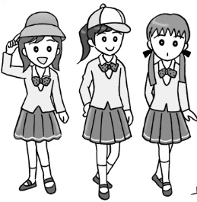 (Ｂ) 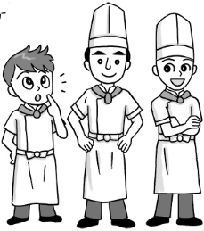 (Ｃ) 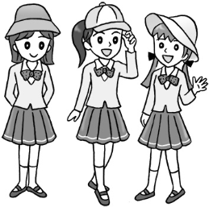
- (Ａ) 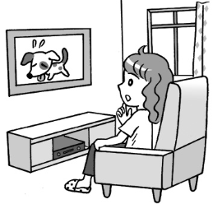 (Ｂ) 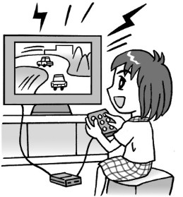 (Ｃ) 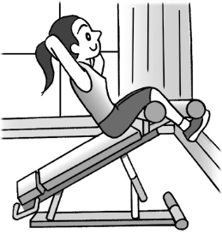
- (Ａ) 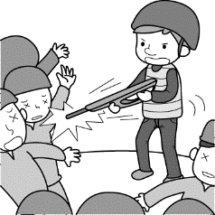 (Ｂ) 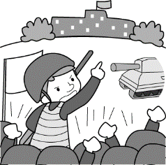 (Ｃ) 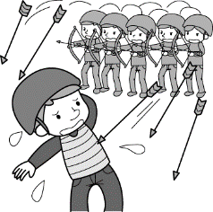
- (Ａ) 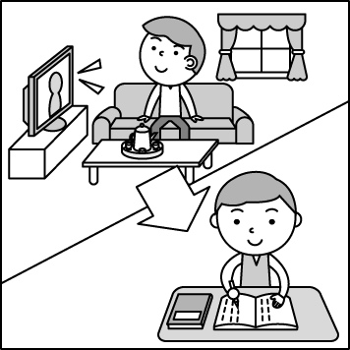 (Ｂ) 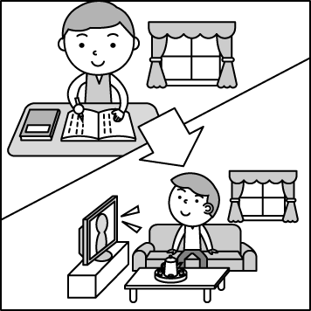 (Ｃ) 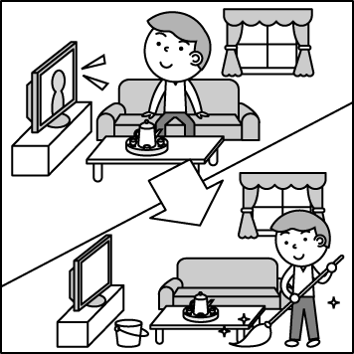
- (Ａ) 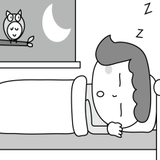 (Ｂ) 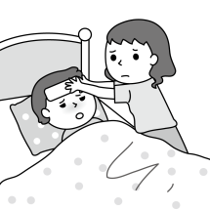 (Ｃ) 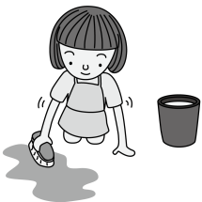

(II)基本問答：根據聽到的內容，選出一個最適合的回應句。
- (Ａ)Ma’am, here is the menu.
(Ｂ)Of course, our service is the best.
(Ｃ)Oh, sorry. Let me get you a clean one.
- (Ａ) I’d like some toast with butter.
(Ｂ) I’d like tomatoes, cheese, and lettuce, please.
(Ｃ) No, I don’t want to eat sandwich.
- (Ａ) I think so too.
(Ｂ)It touched my heart.
(Ｃ)That’s so evil of you to do so.
- (Ａ)Morning is the best time of the day.
(Ｂ)School plays an important part in my life.
(Ｃ)I enjoy sharing everything with my classmates.
- (Ａ)Screaming too loudly will make you get into trouble.
(Ｂ)Oh, I was watching a zombie movie then.
(Ｃ)Sorry, I didn’t help you sweep the floor.

(III)言談理解：根據聽到的內容，選出一個最適合的答案。
- (Ａ)They will go to a Japanese restaurant.
(Ｂ)They will celebrate Halloween together.
(Ｃ)The man wants to join them.
- (Ａ)The woman needs to buy some pens.
(Ｂ)The woman wants to have the bubble tea.
(Ｃ)The woman wants to get the drink before she goes to the stationery store.
- (Ａ) She couldn’t run fast.
(Ｂ) She had a cold.
(Ｃ)She forgot to rest and drink water.
- (Ａ)A notebook.
(Ｂ)An eraser.
(Ｃ)Some pencils.
- (Ａ)He has to work day and night.
(Ｂ)He needs to stay at the factory until night.
(Ｃ)He should do the housework for his mother.
第二部分:綜合測驗 (46%)
- The little girl drank her juice with a _____.
- fork (B) straw (C) tip (D) knife
- I _____ the English test today. I only got 58.
  - passed (B) led (C) failed (D) saved
- Mother sounded happy when we talked on the phone. I could feel joy in her _____.
  - respect (B) service (C) meaning (D) voice
- Mrs. Wu: Do you know _____of our daughter’s friends?
Mr. Wu: No. Only _____ of them.
  - any ; some (B) one ; a few (C) both ; two (D) all ; some
- If you always try to find out what goes wrong _____ making a mistake, you won’t easily make the same one again.
  - after (B) before (C) until (D) though
- All of the juice on the table _____free. Help yourselves.
  - are (B) were (C) is (D) was
- People usually won’t believe something is true _____ they see it with their own eyes.
  - before (B) although (C) when (D) until
- Maggie: These shoes are pretty, but my toes need more room. Do you have _____ ones?
Clerk: Sorry, but we just sold out the last pair. Would you like to try on large ones?
  - common (B) medium (C) real (D) correct
- Waiter: _____
Grey: With a little milk but no sugar, thanks.
  - May I take your order now, sir?
  - How did you like the steak?
  - When can you finish your meal?
  - How would you like your coffee, sir?
- When the police officer _____ the door, he _____ nobody but some yellow roses on the ground.
  - was opening ; saw (B) opened ; saw (C) was opening ; will see (D) opened ; was seeing
- Leo: Paula, will you see Carl tomorrow?
Paula: I’m not sure. Not all our classes are the same tomorrow.
Leo: That’s ok, but _____ you see her, have her call me.
  - although (B) after (C) if (D) before
- Father: Honey, we can’t enter the house. I can’t find my key.
Mother: You must _____ it in the car.
  - order (B) respect (C) leave (D) lead
- _____ of the students went home early on that day. Only a few of them practiced playing volleyball on the playground.
  - One (B) Some (C) Each (D) Most

- How did you like the last part of the movie?
  - It’s so mean.
  - It was about friendship.
  - You really touched my heart.
  - I didn’t like to see the princess die in front of the prince.
- If you see a new word when you read, _____.
  - look them up for yourself
  - try to guess its meaning
  - give it a try
  - look carefully at it
- To tip or not to tip, _____.
  - there is no need to do so in some countries
  - you don’t need to do any homework on the tipping culture
  - you’ll surely have a wonderful time in other countries
  - that is not an easy question
- My daughter never cleans up her bedroom _____ she’s over twenty.
  - but (B) , although (C) though (D) , until
- Much of _____.
  - the cakes taste terrible
  - beef comes from the US
  - us were very tired
  - it is cheap
- Amy’s mother is a doctor, and her father is _____.
  - the other (B) another (C) one (D) other
- You have to keep quiet during the whole time of the test. So, Please raise your hand now _____ you have any questions.
  - if (B) after (C) until (D) although
- Some of my friends like buying things on the Internet, and _____ like doing shopping in the department store.
  - the others (B) others (C) another (D) the other
- Choose the correct sentence.
  - Marking important points when Tony studies helps him memorize better.
  - To think about it on your own, you’ll learn it much better.
  - By memorizing new words, why don’t you carry word cards with you and read them often?
  - Going over the article again, and you will learn better.
- Choose the wrong sentence.
  - Take a map with you when going to a place for the first time.
  - Wash your hands first before touching any food.
  - The lion died right away when shooting an arrow into the heart of the lion.
  - Dad will bring me a gift when he comes back from Japan next Monday.

第三部分:閱讀測驗(24%)
How often do you buy bottled water or drinks? Three times a week? Every day? Here is something you should know about PET bottles.
One study says that about 40% of people in the country buy bottled water or drinks at least once a day. What do they do with the PET bottles? Do they throw them away or recycle them right after drinking the water or drinks? 39. They reuses the bottles. Some may even use them for more than four days! “This can harm their health because the bottles will become poisonous,” Dr. Henry Chen of Hsin-hsin Hospital said.
Dr. Chen also pointed out that it is wrong to 40. , which usually get very hot under the sun. If bottled water or drinks are stored there, they are not safe to drink because the PET bottles will release dioxins.
He also said that when going out, 41. . When you are thirsty, there is always water around to drink. In this way, you do not need to buy bottled water or drinks. It saves you money and keeps you healthy.
( poisonous有毒的 dioxin戴奧辛)
- (A)It is right to do so.
(B) Most people do not.
(C) What about you?
(D)Don’t drink too much bottles water.
- (A)put bottled water or drinks in cars or backpacks
(B)buy bottled water or drinks
(C)go out in hot weather
(D)drink drinks with a lot of sugar
- (A)use your money well
(B)remember to drink more water
(C)walk as much as possible
(D)bring your own water bottle

Freeters are people between the age of 15 and 34 who don’t have work or only work part-time after leaving school. It is a combination of the English word “free” and the German word “Arbeiter” (worker) and first appeared in Japan around 1987. Some people believe that the Japanese part-time job magazine From A created the word.
Many freeters live for free with their parents and don’t need to worry about making enough money to buy food, clothing, or their own apartment.
Among them, some freeters choose not to work after high school or college although there are quite a few jobs waiting for them. Some make money by working at convenience stores, supermarkets, restaurants, or other low-paying jobs. With low income, they find it hard to start a family.
Although in Japan most parents don’t feel it bad to have their children live with them, freeters bring some problems. One of them is that if these freeters don’t marry, there will be fewer babies in Japan. This will make its birth rate even lower and its aging problem worse.
(combination結合 college大學 income收入 birth rate出生率 aging老化)
- Which is true about freeter?
  - It came from English.
  - People started to use the word more than 20 years ago.
  - It first appeared in Japanese newspaper.
  - It was first used in Germany.
- What does them mean?
  - The parents.
  - The freeters.
  - The problems.
  - The children.
- Which of the following is true?
  - Not all freeters take a job.
  - Freeters make a lot of money.
  - Freeters are welcomed by Japanese people.
  - Freeters need to pay their parents for living with them.

On the first page of his book Gifts of Time that he sent to Herbert Murphy, Fred Epstein wrote, “…you’re my favorite teacher of all time. I will always remember your kindness when I was a struggling fifth-grade student at Riverdale. I will always remember you.” There is a story behind these words.
When Fred was in first grade, he was found to have reading and writing problems. For example, he could not write his e’s right. His e’s was all written as ə’s. Also, he could not understand simple math. To him, adding two and two was difficult. Because of these learning problems, Fred hated to go to school. This worried his parents a lot.
However, when he was in fifth-grade, things changed. One day, after class, Mr. Murphy, his teacher, showed him his test paper. Seeing it, Fred hung his head because every answer was wrong. He thought Mr. Murphy would say something bad to him, but he didn’t. He told Fred that he knew Fred could answer all the questions right. Then he asked Fred to go over the test one more time and “say” the answers instead of writing them down. Fred got all the questions correctly. Mr. Murphy smiled and gave him a passing grade.
During that years, Mr. Murphy tried his best to help Fred. He taught Fred ways to learn and remember words more easily. Also, he often told Fred how smart he was and that all would be well for him. Fred started to like to go to school. The time he spent after school with Mr. Murphy became the happiest moment of his day.
Although Fred had trouble reading, he had excellent memory, which helped him in school in some way. Later he studied medicine and become a doctor for children. Like Mr. Murphy, Fred chose to be someone who cold light up others’ life.
（instead of取代）
- What happens to struggling students?
  - They sleep in class.
  - They have a hard time in learning.
  - They fight with their teachers.
  - They do not follow the rules of the school.
- What do we learn about Fred Epstein from the reading?
  - He stopped going to school because he had learning problems.
  - His parents were worried about him because he often got sick.
  - He never liked school by 5th grade because he did not like the teachers.
  - He chose to become a doctor because he wanted to help others.
- After Mr. Murphy got the book, he wrote a letter to Fred. Which is most likely to be found in the letter?
  - …I still remember all the fights we had. I didn’t kick you out oh school because only by keeping you in school could I teach you to tell right from wrong…
  - …you know why I gave you less homework back then? Because I knew you needed to spend more time with your. parents…
  - …The best thing about being a teacher is that a teacher could change someone’s life. Thank you for letting me know I did. it…
  - …You were also my favorite student, a fast reader and good writer. Most important of all, you had a kind heart, always. ready to help others…

The way to celebrate high school graduation is quite different from country to country. In Sweden, students always wear sea-captain caps and meet up at school. When they are walking out of their school in a group, their family hold a sign with the student’s name and a child’s picture on it. The toys on the neck from family can be a race because 48. . Then they will stand in the back of a truck, drive around the town and celebrate the day.
In Argentina, the family of the students find out the time of the final test and wait outside. Without gifts or flowers, they throw eggs or anything sticky to them. Luckily, 49. because they know there will be the sticky things. Like other countries in Europe, students in Germany have to spend around a year more studying for the leaving-school test. In the hope of passing it, 50. . Some are even with funny pictures. After that, there will be a party. The girls have to wear dresses and the boys have to wear ties. Students can go with their friends or go by themselves. Parents and teachers can join it and celebrate together, too!
（graduation畢業 sea-captain船長 sticky黏的）
- (A) the student with the most toys will win a prize
(B) this way, they can throw away the old toys
(C) the toys play an important part in their life
(D) the students can still carry them when they grow up
- (A) students are able to carry the eggs and cake home
(B) students often get angry and ask their family to stop
(C) everyone lives a happy life together
(D) students always wear old clothes and happily take the “gift”
- (A) difficult questions about math, English, and science will be on the test
(B) they go to libraries with their friends and try their best to get good grades
(C) they often make T-shirts with the year of leaving and some cheering words on them
(D) they go to the temple like Chinese and pray for getting high grades on the test
108-2-3 八年級 英語科－解答
1. ACBBC 6. CBACB 11.ACBAC 16. BCDDA 21. CDBDB
26. CCDDB 31. DCDBA 36. AACBA 41. DBCAB 46. DCADC

新北市立溪崑國民中學108學年度第二學期第三次定期評量
八年級 英語科 聽力測驗稿

辨識句意：根據聽到的內容，選出符合描述的圖片。
1.答案：(Ａ)
錄音稿：Two of Miss Chen’s students wear hats.
2.答案：(Ｃ)
錄音稿：I spent the whole afternoon working out.
3.答案：(Ｂ)
錄音稿：He led many soldiers to attack a small country.
4.答案：(Ｂ)
錄音稿：After Kevin finished his homework, he watched TV.
5.答案：(Ｃ)
錄音稿：G: Although I felt tired last night, I still helped Mom do a lot of housework.

基本問答：根據聽到的內容，選出一個最適合的回應句。
6.答案：(Ｃ)
錄音稿：Excuse me, one of our knifes is dirty. I think your service is poor.
7.答案：(B)
錄音稿：What would you like in your sandwich, sir?
8.答案：(Ａ)
錄音稿：Hurting the animals is doing something mean.
9.答案：(Ｃ)
錄音稿：What’s the best part of your school life?
10.答案：(Ｂ)
錄音稿：What were you doing when I swept the floor? Why did you shout so loudly?

言談理解：根據聽到的內容，選出一個最適合的答案。
11.答案：(Ａ)
錄音稿：M: Are you guys going to celebrate Halloween?
W: Yes, we are going to “Fridays”.
M: Fridays? What do you mean?
W: Oh, it is an American restaurant. The food there is delicious and the price is not too high.
M: Sounds like a nice restaurant. So can I join you?
W: Sure.
Q: Which is not true?
12.答案：(Ｃ)
錄音稿：W: Excuse me, where can I get bubble tea around here?
M: There is one at the corner of the street. I go there pretty often.
W: Great. But before I get the drink, I need to go to the stationery store to buy some pens.
M: Okay.
Q: Which is not true?
13.答案：(B)
錄音稿：B: How do you feel after you took the medicine?
G: I couldn’t be better! My nose isn’t running, my cough stops, and I don’t have a sore throat.
B: Sounds great! But you still have to take a rest and drink much water.
Q: What happened to the girl before she felt better?
14.答案：(Ａ)
錄音稿：G: Please buy a notebook at Tess on your way home. I need it to take notes in my English class.
B: No problem. I need some erasers and pencils, too.
G: Although you need erasers, don’t buy too many. Please buy only one, OK?
Q: What does the girl need in her English class?
15.答案：(Ｃ)
錄音稿：W: Dear Sam,
Although you are very tired after school, you still need to help Mom with the housework. She works all day in the shoe factory, and she must also feel tired. I have to work day and night in the supermarket to make more money for our family. Please be a good boy and nice to our family.
Lucy
Q: What does Sam need to do for his family?

