新北市立溪崑國民中學108學年度第二學期第二次定期評量 英語科 試題卷
八年級 班 座號 姓名
一、聽力測驗:30% (每題2分)

(一)、根據聽到的內容，選出符合描述的圖片。
1.（ ） (Ａ) 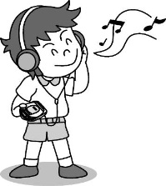 (Ｂ) 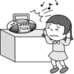 (Ｃ) 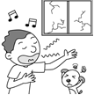
2.（ ） (Ａ) 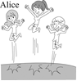 (Ｂ) 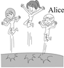 (Ｃ) 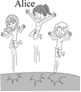
3.（ ） (Ａ) 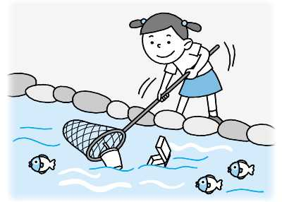 (Ｂ) 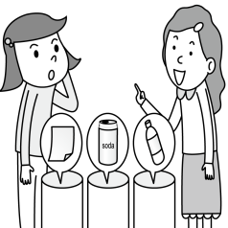 (Ｃ) 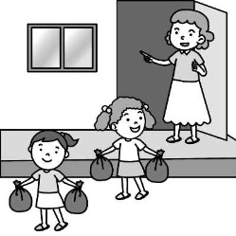
4.（ ） (Ａ) 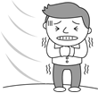 (Ｂ)  (Ｃ) 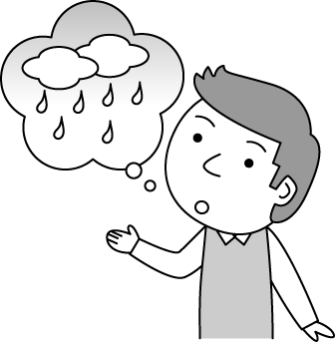
5.（ ） (Ａ) 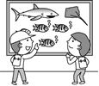 (Ｂ) 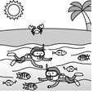 (Ｃ) 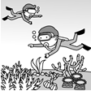

(二)、根據聽到的內容，選出一個最適合的回應句。
6.（ ）(Ａ) Yes, she passed the test.
(Ｂ) She didn’t like math at all.
(Ｃ) She did pretty well.
7.（ ）(Ａ) Cheer up. Don’t get sad.
(Ｂ) I’m so excited about that.
(Ｃ) Let’s hurry up then.
8.（ ）(Ａ) Oh, I’m going shopping, and I want to reduce trash.
(Ｂ) We have to use water wisely.
(Ｃ) It’s not easy to me.
9.（ ）(Ａ) You can say that again.
(Ｂ) Yes, everyone is in trouble.
(Ｃ) That’s right. It’s very difficult.
10.（ ）(Ａ) I think so, too.
(Ｂ) So where is the underwater world?
(Ｃ) That’s right. We shouldn’t go out.

(三)、根據聽到的內容，選出一個最適合的答案。
11.（ ）(Ａ) He couldn’t play baseball well.
(Ｂ) He couldn’t find a good doctor.
(Ｃ) He hurt his shoulder.
12.（ ）(Ａ) Jacob ran in the relay race for Samuel.
(Ｂ) Samuel wasn’t at his place because he went to the relay race.
(Ｃ) Jacob was taking a rest at his place because he didn’t feel well.
13.（ ）(Ａ) Say sorry.
(Ｂ) Keep quiet.
(Ｃ) Talk to the baby.
14.（ ）(Ａ) Have the woman keep water in the bathroom.
(Ｂ) Use the water wisely.
(Ｃ) Plant flowers in the yard.
15.（ ）(Ａ) A whale.
(Ｂ) A zebra.
(Ｃ) A horse.
二、綜合測驗:30% (每題2分)
16. ( ) Earth is the only ________ we can live on, so we should try our best to protect it.
(Ａ) plant (Ｂ) planet (Ｃ) picture (Ｄ) plane
17. ( ) Josh tripped and fell during the PE class and hurt his right . He can’t walk fast for a few days.
(Ａ) knee (Ｂ) nail (Ｃ) neck (Ｄ) finger
18. ( ) There is an MRT station near his house, so it’s for him to go to work.
(Ａ) convenient (Ｂ) clear (Ｃ) careful (Ｄ) wise
19. ( ) Be when you walk across the street. Watch out for the cars.
(Ａ) polite (Ｂ) honest (Ｃ) careful (Ｄ) strong
20. ( ) You should think before doing anything, or you will . (Ａ) quickly; try your best
(Ｂ) terribly; take my place (Ｃ) loudly; agree with me (Ｄ) carefully; make a wrong decision
21. ( ) Would you walk ? You are in my way and I’ll be for work. (Ａ) quicker; late
(Ｂ) quick; lately (Ｃ) quickly; lately (Ｄ) more quickly; late
22. ( ) Could you help me the computer ? I am not good at it.
(Ａ) look; for (Ｂ) to throw; away (Ｃ) set; up (Ｄ) took; out
23. ( ) Mom didn’t me TV because I got bad grades in math test.
(Ａ) let; to watch (Ｂ) lets; watched (Ｃ) lets; watch (Ｄ) let; watch
24. ( ) My mom me to clean my room. (Ａ) made (Ｂ) asked (Ｃ) enjoyed (Ｄ) had
25. ( ) Jack is _________ student in my class. He does everything ___________.
(Ａ) carefully; carefully (Ｂ) more careful; careful (Ｃ) the most carefully; carefully
(Ｄ) the most careful; carefully
26. ( ) The little poor whale just couldn’t tell food ______ trash, so it ate the plastic bags and then died.
(Ａ) about (Ｂ) with (Ｃ) for (Ｄ) from
27. ( ) It is so hot here. Please _______ the fan. (Ａ) open (Ｂ) turn on (Ｃ) close (Ｄ) turn off
28. ( ) A: Your dress is so beautiful. Where did you buy it? B: I didn’t buy it. I made it .
(Ａ) mine (Ｂ) myself (Ｃ) for my brother (Ｄ) of my own
29. ( ) We went hiking in the mountains and saw lots of butterflies _______ beautifully.
(Ａ) dancing (Ｂ) danced (Ｃ) to dance (Ｄ) were dancing
30. ( ) I won’t be late for the party, and my sister .
(Ａ) will, too (Ｂ) is, too (Ｃ) won’t, either (Ｄ) isn’t, either
三、克漏字測驗:10% (每題2分)
John: Is it true that there is not enough water for us to use this year?
Mary: Yes! There was 31 rain this year than last year, and we neeed to drink and cook with water. We take a shower and wash clothes with it. We also water farms and gardens with it.
John: It seems that we need lots of water. But there are several rivers in Taiwan, right?
Mary: That’s right. But many of the rivers are polluted, and they are too short to keep water.
John: Too bad. How do we 32 water?
Mary:We can take quick shower instead of bath. 33 the faucet right away when you don’t use it. Don’t throw 34 into a river, a pond or a lake.
John: Let’s use water more 35 , and we can have enough water.
Mary: Sure. Also hope that God always gives us enough rain.
usage 用量 faucet 水龍頭 instead of 取代
（ ）31. (Ａ) little (Ｂ) few (Ｃ) fewer (Ｄ) less
（ ）32. (Ａ) live (Ｂ) save (Ｃ) drink (Ｄ) take
（ ）33. (Ａ) Throw away (Ｂ) Take off (Ｃ) Turn off (Ｄ) Set up
（ ）34. (Ａ) garbage (Ｂ) fish (Ｃ) rocks (Ｄ) air
（ ）35. (Ａ) heavily (Ｂ) happily (Ｃ) badly (Ｄ) wisely

四、閱讀測驗:10% (每題2分)
We usually think Africa is a hot and dry place. Unlike Taiwan, Africa doesn’t have four distinct seasons. In fact, Africa does not only have a hot and dry climate.
Take Malawi for example. The coldest time is only 4 degrees Celsius. Each year from November to May, there is a lot of rain for six months during the wet season. In the past, Malawians waited for the first rain to come so they could loosen the soil and plant their crops. Two weeks later when the rainy season came, the roots were deep and the crops grew well.
However, in recent years the global climate change has upset the natural process. Malawians do not know when the rainy season will come. If they plant the seeds too early, the seeds will dry out. But if they plant the seeds too late, the rain will wash away the seeds and people will have no food to eat.
Malawi’s climate problems seem very far away from us, so what we can do? In fact, if we protect the environment to make the Earth’s climate more stable, we can help the farmers of Malawi return to a normal life.
distinct 明顯的 climate氣候 loosen 鬆開 soil 土壤 crops 農作物 roots根 stable穩定 recent 近來的 process過程 normal 正常的

（ ）36. What month is the rainy season? (Ａ) August. (Ｂ) June. (Ｃ) March. (Ｄ) October.
（ ）37. When the Malawians plant their crops?
(Ａ) Before the rainy season. (Ｂ) During the rainy season. (Ｃ) After the rainy season. (Ｄ) We don’t know.
（ ）38. What would happen if the Malawians plant too early?
(Ａ) The plants will grow well.
(Ｂ) The seeds will dry out.
(Ｃ) The seeds will be wash away.
(Ｄ) People will have more food to eat.
（ ）39. How can we help the farmers of Malawi return to a normal life?
(Ａ) We can help them plant seeds.
(Ｂ) We can help them lossen the soil.
(Ｃ) We can give them a lot of food.
(Ｄ) We can protect the environment to make the Earth’s climate more stable.
（ ）40. Which is true?
(Ａ) Africa has four distinct seasons like Taiwan.
(Ｂ) Africa only has a hot and dry climate.
(Ｃ) Malawians know when the rainy season will come.
(Ｄ) The global climate change affects(影響) the lives of farmers in Malawi.

五、填入正確的動詞形式:5% (每格1分)
41. The old man asked his daughter 41 （bring）a pair of chopsticks to him.
42. Sally helped me 42 （wash）my car.
43. His mother often makes him 43 (clean) his room.
44. We should make it a habit 44 （turn）off the light when we leave the room.
45. When the earthquake hit, we all 45 (feel) the house shaking.

六、依題示改寫句子:6% (每題2分)
46、Joyce jumps 50 meters high. Emma jumps 70 meters high. (用high比較級合併兩個句子)
47、Melissa has to get up before seven. (用must改寫句子)
48、Miss Chang is writing a book./The book is about Miss Chang. (用反身代名詞合併句子)

七、翻譯:9% (每題3分)
49、最後，我們班輸掉接力賽，而且一些同學哭得很傷心。(...end...)
50、這些父母看到他們的小孩在舞台上跳舞非常的開心。
51、我們的英文老師要我們大聲唸出這些字。(...have...)

【試題結束】

新北市立溪崑國民中學108學年度第二學期第二次定期評量 英語科 答案卷
八年級 班 座號 姓名
五、填入正確的動詞形式:5% (每格1分)
41 |  | 42 |  | 43
44 |  | 45

六、依題示改寫句子:6%(每題2分)
46
47
48

七、翻譯:9%(每題3分)
49
50
51

108-2-2 八年級 英語科－解答
一、聽力測驗:30% (每題2分)
1-5 CCBAB 6-10 CCAAA 11-15 CABBB
二、綜合測驗:30% (每題2分)
16-20 BAACD 21-25 DCDBD 26-30 DBBAC
三、克漏字測驗:10% (每題2分)
31-35 DBCAD

四、閱讀測:10% (每題2分)
36-40 CABDD

五、填入正確的動詞形式:5% (每格1分)
41 | to bring | 42 | (to) wash | 43 | clean
44 | to turn | 45 | felt
六、依題示改寫句子:6% (每題2分)
46 | Emma jumps higher than Joyce.
47 | Melissa must get up before seven.
48 | Miss Chang is writing a book about herself.
七、翻譯:9%(每題3分)
49 | In the end, our class lost the relay race, and some classmates cried sadly.
50 | These parents are very happy to see their kids (children) dance/dancing on the stage.
51 | Our English teacher had/has us read these words out loud (loudly).

新北市立溪崑國民中學108學年度第二學期第二次定期評量
八年級 英語科 聽力測驗稿

(一)、根據聽到的內容，選出符合描述的圖片。
1. A4040217 錄音稿：The boy sings terribly.
2. A4040224 錄音稿：No one can jump higher than Alice.
3. A4050299 錄音稿： My mom made me sort the trash.
4. A4060376 錄音稿：I can feel the cold wind blowing all the way.
5. A4060379 錄音稿：They went snorkeling and saw many fish swimming.

(二)、根據聽到的內容，選出一個最適合的回應句。
6. A4040238 錄音稿：How did Jennifer do on her math test?
7. A4040254 錄音稿：We are almost late for the movie.
8. A4050320 錄音稿：Why do you bring a shopping bag with you?
9. A4050324 錄音稿：Saving the earth is everyone’s job.
10. A4060393 錄音稿：The weather is so nice today. Let’s not stay inside.

(三)、根據聽到的內容，選出一個最適合的答案。
11. A4040271
錄音稿：W: Are you OK, John?
M: Not really. I hurt my shoulder while I was playing baseball.
W: Poor you. Did you go to see the doctor?
M: Yes, I did. And he told me I had to take more rest.
Q: What’s wrong with John?
12. A4040279
錄音稿：G: Did Samuel run in the relay race?
B: No. He still did not feel well, so Jacob took his place.
Q: Which is true?
13. A4050349
錄音稿：W: Don’t speak so loudly, Eric. The baby is sleeping.
B: Oops! I’m sorry.
Q: What does the woman make Eric do?
14. A4050351
錄音稿：W: Why do you keep the water in the bathroom? It’s not clean.
M: I keep it to water the plants and flowers in my yard.
W: Sounds great. We can also save much money.
Q: What does the man do to save the Earth?
15. A4060431
錄音稿：M: Mom, what’s that animal? It looks like a horse, but it looks just more special. I like its black and white colors and I enjoy looking at it walking slowly and beautifully.
W: Take a look at the sign, Robin. It can tell you many things about it.
M: OK! Let’s get closer.
Q: What animal does Robin see?

