新北市立溪崑國民中學108學年度第二學期第二次定期評量 英語科 試題卷
七年級 班 座號 姓名

一 聽力測驗30%
壹、辦識句意 :根據聽到的內容，選出正確的圖片代碼 。10%
- (Ａ) 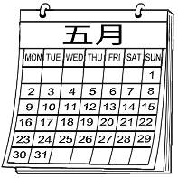 (Ｂ) 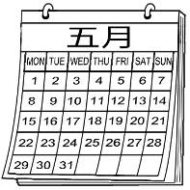 (Ｃ) 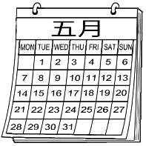

- (Ａ)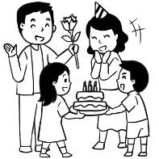 (B) 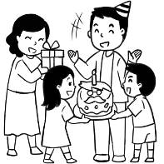 (C) 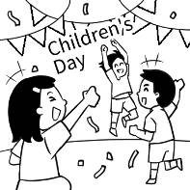

- (A) 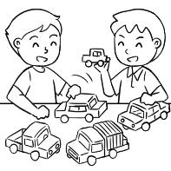 (B) 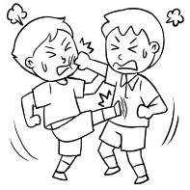 (C) 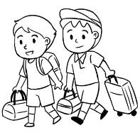

- (Ａ) 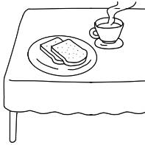 (B) 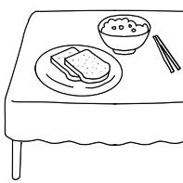 (C) 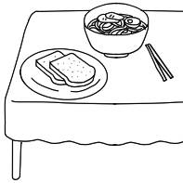

- (Ａ) 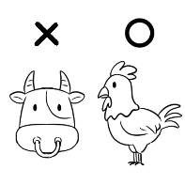 (B) 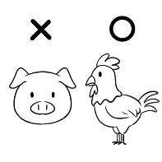 (C) 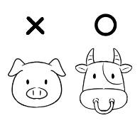

貳. 基本問答：請依據所聽到的內容，選出一個最適合的回應。10%
6. (A) It’s Sunday. (B) It’s May 10. (C) It’s a good day.
7. (A) We eat moon cakes. (B) Once in a blue moon. (C) Don’t waste your food.
8. (A) Is it in March? (B) It’s a big festival. (C) I don’t know. Let’s check it out.
9. (A) We need half a box. (B) We can collect some paper. (C) It makes about 20 pieces of paper.
10. (A) It’s eight p.m. (B) About eight hours. (C) Almost every Monday.

參. 言談理解：請依據所聽到的對話與問題，選出一個最適當的答案。10%
11. (A) The man. (B) The woman. (C) The man’s grandpa.
12. (A) It’s on January 24. (B) The boy likes it very much. (C) It’s the girl’s favorite festival.
13. (A) It’s on August 8. (B) It’s on the third Sunday of June. (C) It’s on the third Sunday of August.
14. (A) Eggs. (B) Chicken. (C) Noodles.
15. (A) Forty-four. (B) Twenty-two. (C) Twenty-four.

二 綜合測驗40％
16. Can I please ten days from school? (A) take ; of (B) make ; out (C) take ; off (D) get ; to
17. Holi is the Indian New Year. Everyone _____ in the streets with colorful _____. (A) play ; powders (B) plays ; powders
(C) fight ; power (D) is fighting ; power
18. The holiday is around moon March. (A) the first ; on (B) the full first ; of (C) the first full ; in
(D) the one full ; for
19. We put it on a and dry it ___ the sun. (A) street ; on (B) screen ; in (C) plate ; around (D) clothes ; of
20. Water can ____away bad luck___ them. (A) wish ; for (B) throw ; to (C) work ; of (D) wash ; for
21. A: Is it March 8 today? B: Yes. Hey, isn’t your house-warming party coming? Isn’t it March 12?
A: That’s right. (Ａ) × ; × (Ｂ) on ; on (Ｃ) × ; on (Ｄ) on ; ×
22. We have an English test the morning ___April 22. (Ａ) on ; of (Ｂ) in ; in (Ｃ) at ; on (Ｄ) × ; for
23. There are two on the table. (Ａ) glass of water (Ｂ) cup of green tea (Ｃ) bags of apples (Ｄ) cans of chocolates
24. Put the gifts in the box first and then wrap(包裝) . (Ａ) the ; them (Ｂ) the ; it (Ｃ) × ; them (Ｄ) × ; it
25. Today is . (Ａ) April twelve (Ｂ) on April twelfth (Ｃ) twelfth of April (Ｄ) April 12
26. A: juice do they need at the party? B: They need juice. (Ａ) How many ; fifteen
(Ｂ) How much ; fifteen (Ｃ) How many ; fifteen bottles of (Ｄ) How much ; fifteen bottles of
27. A : the month after September August? B : No, August ______ before September.
(Ａ) Does ; comes (Ｂ) Is ; come (Ｃ) Is ; comes (Ｄ) Does ; is
28. Claire buys bread, but she doesn’t buy chicken. (Ａ) some ; any (Ｂ) any ; some (Ｃ) some ; some
(Ｄ) any ; any
29. I look forward to _____ you all. (Ａ) get to know (Ｂ) get to knowing (Ｃ) getting to know (Ｄ) getting to knowing
30. A : is there? B : There three bags. (Ａ) How many bags of flour ; is (Ｂ) How much salt ; are
(Ｃ) How much juice ; is (Ｄ) How many bottles of milk ; are
31. A : Do you have any ? B : Yes. How many do you want? (Ａ) bread (Ｂ) bowls and plates
(Ｃ) pumpkin soup (Ｄ) black tea and coffee
32. Let’s bring cake and cookies ___ the party. (Ａ) any ; for (Ｂ) lots ; in (Ｃ) a lot ; at (Ｄ) some ; to
33. Can Chinese New Year _____ January or February? (Ａ) be in (Ｂ) is on (Ｃ) do at (Ｄ) does of
34. A: Today is Mom’s birthday. Maybe we can cook for her. B: That’s a good idea. _____ (Ａ) Let’s get dirty. (Ｂ) Let’s get in. (Ｃ) Let’s get our hands clean. (Ｄ) Let’s get our hands dirty.
35. A : ____ do we have? B : Not too much. Only an hour. (Ａ) What time (Ｂ) How many times (Ｃ) When
(Ｄ) How much time

三 閱讀選擇 10%

Bill eats a lot every day. He has fried chicken, a rice ball, and one cup of milk tea for breakfast. For lunch, he eats fried chicken, hamburgers, and one can of cola. In the evening, he eats a plate of fried rice, fried noodles, and a can of cola. He is getting fat. His brother, John, tells Bill, “You are sick. You have to see a doctor.” The doctor says, “You can’t eat that much food. Don’t eat hamburgers, fried chicken, or cola for breakfast, lunch, or dinner. They are not good for your health. Drink more water and eat more fruit.” Bill listens to the doctor and does what he says. He hopes he can lose weight (減重)and look thin.

36. What can Bill have for breakfast now? (Ａ) Fried chicken. (Ｂ) Fruit. (Ｃ) Hamburgers. (Ｄ) Cola.
37. Which is true（正確的）? (Ａ) John eats a lot, too. (Ｂ) Bill is thin before he sees a doctor. (Ｃ) John is a doctor.
(Ｄ) Bill can’t drink cola now.

38. Susan buys（買）two notebooks and three comic books. How much are they?
(A) NT$45. (B) NT$75. (C) NT$105. (D) NT$120.
39. Lucy has six hundred dollars. What CAN’T he buy in the store?
(A) He can’t buy a basketball and a doll. (B) He can’t buy a telephone and a notebook.
(C) He can’t buy a doll and a comic book. (D) He can’t buy a comic book, a doll, and a basketball.
40. All the comic books are 20% off（折扣）. If（假如）Brian buys five, how much are they?
(A) NT$30. (B) NT$72. (C) NT$120. (D) NT$90.

四. 依提示作答 4%
41. His daughter has a baseball game on October tenth. (依劃線部分造原問句)
42. The tall boy eats one slice of beef every day. (依劃線部分造原問句)
五. 翻譯 16% (每題4分)

43. 巴西(Brazil)人會穿上白色衣服祈求得到和平，穿上彩色內衣褲祈求不同願望。
44. 各國的新年慶祝活動有所不同，但它們有個共通點。
45. 換句話說，一缸人類排泄物產生的氣體可讓這輛公車行進三百公里。(數字用英文寫)
46. 信不信由你，一些地方的人們會用動物的糞便來蓋房子和造紙。

(試題結束)

新北市立溪崑國民中學108學年度第二學期第二次定期評量 英語科 答案卷
七年級 班 座號 姓名
四. 依提示作答 4%
41.
42.

五. 翻譯 16% (每題4分)
43.
44.
45.
46.

108-2-2 七年級 英語科－解答

1.C B A B B 6.B A C A B 11.C B B C B 16.C B C B D

21.C A C D D 26.D C A C B 31. B D A D D 36. B D D B C
四. 依提示作答 4%
41. What date/When does his daughter have a baseball game?
42. How many slices of beef does the tall boy eat every day?
五. 翻譯 16% (每題4分)

43. People in Brazil wear white clothes for peace and colorful underwear for different wishes.
44. New Year celebrations are different from country to country, but they have one thing
in common.
45. In other words, the bus can travel three hundred kilometers with a tank of gas from human waste.
46. Believe it or not, people in some places build houses and make paper with animals’/animal poop.

新北市立溪崑國民中學108學年度第二學期第二次定期評量
七年級 英語科 聽力測驗稿
一、辦識句意 :根據聽到的內容，選出正確的圖片代碼
1. May 13 is on a Sunday this year.
2. Peter’s family is celebrating Father’s Day.
3. Mike and Thomas are playing with toy cars.
4. Can I have a bowl of rice and two slices of bread, please?
5. We don’t like pork. Let’s have some chicken.
二、基本問答：請依據所聽到的內容，選出一個最適合的回應
6. What’s the date today?
7. What do you do during Moon Festival?
8. How do people celebrate the New Year in India?
9. How much paper do we need for the game?
10. How much sleep do you get every day?
三、言談理解：請依據所聽到的對話與問題，選出一個最適當的答案
11. M: Ms. Lin, can I take half a day off today?
W: Why? Is everything OK?
M: Yes, all is well. I’m just taking my grandpa to the doctor.
W: No problem.
Q: Who is going to the doctor?
12. What date is Chinese New Year?
G: It’s on January 25.
B: Wow, it’s just around the corner. I can’t wait. It’s my favorite holiday.
G: Really? That’s not my favorite. My favorite holiday is Moon Festival.
Q: Which is right about Chinese New Year?
13. Nick, do you celebrate Father’s Day on August 8 in the US?
B: No, we celebrate it on the third Sunday of June.
G: What date is it this year?
B: It’s on June 21.
Q: When is Father’s Day in the US?
14. W: I’m going to the market. Do you need anything?
M: Please get some chicken. We don’t have any.
W: That’s it? How about noodles?
M: No. We have enough noodles. But I need eggs. Please get some eggs, too.
W: No problem.
Q: What doesn’t the man need?
15. M: Teacher Patty, how many students do you have in your class?
W: I have forty-four students. And half of the students are girls.
M: Wow, that’s a big class.
W: That’s right.
Q: How many girls does Teacher Patty have in her class?

