新北市立溪崑國民中學108學年度第二學期第三次定期評量 英語科 試題卷
七年級 班 座號 姓名
一、聽力測驗 30%
A. 辨識句意
1. (A) 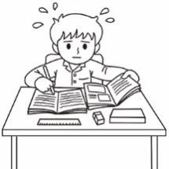 (B) 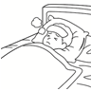 (C) 
2. (A) 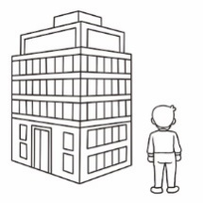 (B) 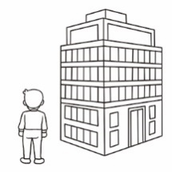 (C) 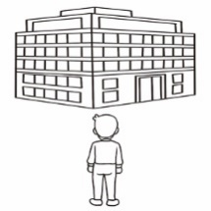
3. (A) 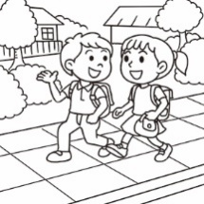 (B) 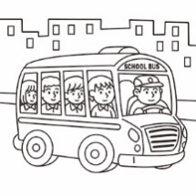 (C) 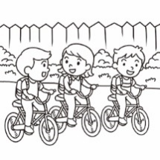
4. (A) 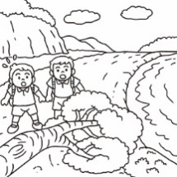 (B) 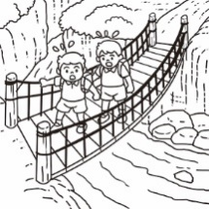 (C) 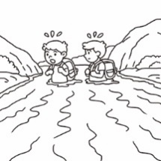
5. (A) 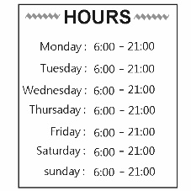 (B) 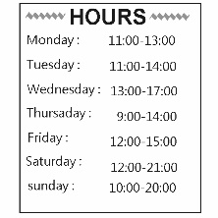 (C) 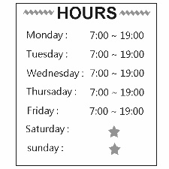

B. 基本問答
6. (A) You bet. (B)Thank you. (C) No pain, no gain.
7. (A) Yes, he’s always hungry. (B) Yes, he’s usually wrong. (C) No, he’s never hungry.
8. (A) Take Bus 712. (B) I get it. Thank you. (C) Let’s ask the woman over there.
9. (A) It’s along the river. (B) We’re finally here. (C) Let’s look at the map.
10. (A) Thanks for your time. (B) Always be on time. (C) That must be hard.

C. 言談理解
11. (A) Six thirty. (B) Seven thirty. (C) Eight thirty.
12. (A) On foot. (B) By metro. (C) By bike.
13. (A) She doesn’t like lunch. (B) She always gets up late on weekends.(C) She doesn’t eat at home.
14. (A) They usually visit their friends on the weekend.
(B) They seldom go out on the weekend.
(C) They never have plans for their weekends.
15. (A) It’s next to the fish shop.
(B) It’s between the toy store and the flower shop.
(C) It’s between the fish shop and the toy store.

二、語法測驗 46%
16. A:My father often ______ our dog in his free time. He loves to play with it.
B:What does your father teach it ?
A:Tug of war. They always have fun.
(A) swims (B) sports (C) cheers (D) trains ( 請繼續作答 )
17. Do you ______ about the water problem? Many people around the world need clean water.
(A) reporter (B) blood (C) sweat (D) notice
18. A: It’s too bad. I can’t find the way to the Taipei Children’s Amusement Park.
B: There are many ways to the park. You may need a ______. Here you go.
(A) map (B) bank (C) sleigh (D) carpet
19. You guys need to walk ______ the park, and you can get to the movie theater on time.
(A) cross (B) through (C) back (D) block
20. A:There aren’t any clouds in the sky and it’s a sunny day today. Let’s ____ in the mountains.
B: It’s awesome! Let’s go!
(A) horse (B) stop (C) hike (D) hurt
21. A: I can’t play games with you now because I need to ____ all my homework before ten o’clock.
B: Cheer up! You can make it!
(A) care (B) straight (C) waterfall (D) finish
22. Victor always trains for many hours a day, from early morning to late evening. We all think he is a great _____.
(A) magic (B) member (C) athlete (D) theater
23. Anita is a _____ student, and she can always get trophies. Nothing can stand in her way.
(A) hard-working (B) senior (C) wrong (D) tears
24. I don’t always have rice for dinner. My mom cooks different kinds of food every day, and I _____ have noodles.
(A) always (B) sometimes (C) seldom (D) usually
25. I _____ go to school on foot every day, but sometimes Mom drives me to school.
(A) always (B) sometimes (C) seldom (D) usually
26. Peter never goes to a movie on the weekday. He _____ to a movie on weekends.
(A) seldom goes (B) usually goes (C) is always going (D) always goes
27. _____ play with friends on the street. It’s too dangerous.
(A) Never (B) Always (C) Don’t always (D) Don’t never
28. There are students playing sports in the park on the weekend. _____students play basketball, and _____ play volleyball.
(A) Others ; some (B) Some ; another (C) Some ; others (D) Others ; the other
29. A: How often do your family go out for dinner?
B: We don’t go out for dinner too often. We usually go out _____.
(A) from time to time (B) once a month (C) on weekdays (D) from Friday to Sunday
30. A: Joe seldom gets up early in the morning. Is ____ late for school?
B: Yes, he _______.
(A) usually he; usually is (B) he often; often (C) sometimes he; sometimes(D) he sometimes; sometimes is
31. A: I am so hungry and I need some food. Can you show me the way to the night market?
B: Sure. Walk across the bridge. Then turn ____right and you can see the night market _____ left.
(A) X ; on the (B) X ; X (C) on the ; X (D) on the ; on the
32. In many sports, people often care about the trophies, but they seldom know the athletes’ ____. Let’s cheer for them.
(A) hard work (B) hard-working (C) work hard (D) hard working
33. There are many ways to school. Some kids _____a horse ; some kids _____ sleighs.
(A) ride ; ride on (B) ride on ; ride (C) ride on ; ride on (D) ride ; ride
34. Mom: What do you want for your breakfast?
Jason: Hamburgers.
Mom: Why do you eat hamburgers so often? You eat hamburgers almost _____. You _____ eat anything else.
Jason: That’s right. I like them very much.
(A) every day ; always (B) another day ; usually (C) every two days ; seldom (D) twice a week ; don’t seldom
35. Oscar: Mom, ________ I ________ my homework now? I want to watch a magic show on TV.
Mom: It’s late and you have to get up very early tomorrow. Finish it before ten o’clock. Don’t waste your time.
Oscar: I see.
(A) do ; must (B) must ; do (C) must ; have to (D) must ; doing
( 請繼續作答 )
36. Jeff: How do you go to the library? I need to study for the final exam.
Lisa: We often take ________ there. Are you coming with us?
(A) a bike (B) by metro (C) a bus (D) the train to
37. Reporter: The life of an athlete is never easy. Do they give up ?
Amanda: _______. They always work hard.
(A) No, they never don’t.
(B) No, they don’t always.
(C) No, they never.
(D) No, they never do.
38.The shop is open around the clock. What does “ around the clock” mean?
(A) All day and all night.
(B) Be safe and have a nice day.
(C) Where there’s a will, there’s a way.
(D) Believe it or not.

三、克漏字 14%
(A)
Jeff: Excuse me. How can I get to Xing-Ren Night Market?
Mia: Walk along Bao-An Street 39 three blocks, and you can see it 40 Sun- Duo Road and Bao-An Street.
It’s 41 Sun-Duo Senior High School.
Jeff: Thanks a lot. By the way, can I go there 42 bus?
Mia: Yes. Go down this road and you can see the bus stop.
Jeff: 43 . I can find it. Thanks a lot.
39. (A) for (B) at (C) from (D) along
40. (A) on the right side (B) in the corner (C) on the corner of (D) in back of
41. (A) cross from (B) get across (C) across from (D) go across
42. (A) in a (B) take a (C) by a (D) by
43. (A) Let’s check it out (B) No problem (C) Tell me more (D) Isn’t it awesome?

(B)
( Winter vacation is coming. Alice is ready to go home for the New Year. )
Alice : Mom, the New Year is around the corner. I am going home next Friday.
Mom : Great! 44
Alice : No, I’m taking a train. Can you pick me up at the train station?
Mom : No problem. What time?
Alice : I’m not sure. 45 , you know.
Mom : Why not take a bus?
Alice : No. Buses are too slow and the stop is also too far from home.
Mom : Okay. Let me know the time and see you then. I love you.
44. (A) Are you taking a bus?
(B) Is the station near here?
(C) Are you coming home on a train?
(D) Are there many different ways ?
45. (A) I am on my way home.
(B) Don’t be afraid to fail. Be afraid not to try.
(C) No pain, no gain.
(D) It’s never easy to get tickets.

( 請繼續作答 )

四、閱讀測驗 10 %
Dad : Lucy, it’s 7:40. You are late for school.
Tim : Can you give me a ride? I go to school on foot every day, and it’s really tiring.
Dad : Well... I am very busy this morning. The school is only two blocks away.
Tim : Come on! It’s so hot today and I sweat a lot.
Dad : Ok. Wait for a second. Let me take you to school after I finish my breakfast.
46. What do we know about Lucy?
(A) She is really tiring now. (B) She is late for school.
(C) She rides a bike to school every morning. (D) She is making breakfast for her mom.
47. What does give me a ride mean?
(A) 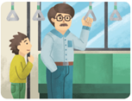 (B) 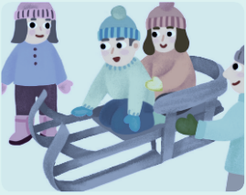 (C) 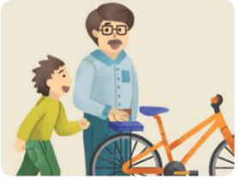 (D) 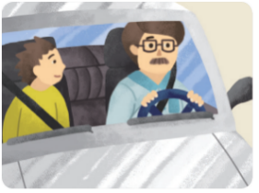

Coronavirus

Lots of people stop working and going to school because of coronavirus 2019. The longer winter vacation doesn’t mean a good thing. However, this disease has caused many deaths around the world.
This word, corona, means crown in Latin. Under a microscope, these viruses look like crowns. That’s the reason why people call COVID-19 as the name of this disease. This coronavirus is a newly-discovered virus. In some parts of the world, it has made over nine million people sick. According to the report, over four hundred thousand people lose their lives because of COVID-19.
A lot of symptoms are similar to flu, such as dry cough and fever. Most get better with rest and medical treatment. Senior people or those who already have health problems are more likely to get sicker with coronavirus. With fewer cases in kids, it doesn’t mean you don’t need to take care of yourself.
There are some things you can do:
1. Wash hands more OFTEN at least 20 seconds by using soap and clean water
2. Sanitize hands with at least 60% alcohol after using public toilets and touching any public objects.
3. Avoid touching your face, mouth, nose and eyes.
4. Cover your mouth and nose with tissue or masks when sneezing and coughing.
5. Avoid contacting with people who are sick. In other words, it’s the best to stay at home if you feel sick.
6. Clean and disinfect surfaces and objects that people touch a lot.
Coronavirus can affect anyone, no matter where you come from. If you or anyone you know feel sick, don’t be afraid to ask for help. What’s the most important: Please Wash Your Hands! Let’s get our hands dirty.
virus 病毒 crown皇冠 disease疾病 flu流感 symptom徵兆 public 公共的 spread 擴散
48. Which is NOT correct?
(A) Coronavirus gets its name from a Latin word.
(B) It’s easy to catch coronavirus by touching public objects.
(C) Symptoms of having coronavirus are like flu.
(D) Kids don’t catch coronavirus.
49. Who may likely get sicker with coronavirus?
(A) Sandy, 12 years old, is in good health.
(B) Brian, 26 years old, always likes to keep things clean.
(C) Jeff , 65 years old, often goes to see a doctor.
(D) Anna, 34 years old, seldom catches a cold.
50. What CAN’T help stop coronavirus from spreading?
(A) Wash hands after using public toilets.
(B) I feel sick, so I should wear a mask.
(C) My friend and I share food with the same chopsticks.
(D) I should use tissue to cover my nose when I cough. ( 試題結束 )

108-2-3 七年級 英語科－解答

1-5 AAAAC
6-10 BABCC
11-15 BCBAB
16-20 DDABC
21-25 DCABD
26-30 DACBD
31-35 AAACB
36-40 CDAAC
41-45 CDBAD
46-50 BDDCC

新北市立溪崑國民中學108學年度第二學期第三次定期評量
七年級 英語科 聽力測驗稿
一、聽力測驗 30%
A. 辨識句意
1. There’s a lot of hard work at senior high school. Mike always studies hard at home.
2. The bank is on your left.
3. The kids go to school on foot.
4. The students are going to school, but the big tree is standing in their way.
5. The restaurant opens from Monday to Friday, but never opens on weekends.
B.基本問答
6. Another great win. You rock.
7. Mike really eats a lot of food at lunch.
8. Walk down for two blocks. The hotel is on the right.
9. Where is the bike shop?
10. We run, jump rope and then swim for three hours.
C.言談理解
11. B: Wow, Amy, you’re so early today. It’s only 6:30. Isn’t the party at seven thirty?
G: Yes. I just need some help from Jane for the food and drinks.
B: Jane is coming here at 8:00. Well, I can help you.
G: That’s great! Thank you. Let’s get our hands dirty.
Q: What time is the party?
12. B: Emma, does your brother walk to school?
G: No, he usually rides a bike to school.
B: What about on rainy days?
G: He can take the metro on rainy days.
Q: How does Emma’s brother usually go to school on sunny days?
13. B: Do you always have lunch at home on weekends?
G: No, I seldom do.
B: You usually eat out?
G:No. I never get up before 1:00 p.m. on weekends.
Q: What does the girl mean?
14. G: Dad, can we visit Grandma and Grandpa this month?
M: No, sorry. They’re seldom at home on the weekend.
G: Why?
M: They usually visit their friends, and they sometimes travel to other countries.
Q: What is right about the girl’s grandma and grandpa?
15. W: Excuse me. How can I get to the Money Bank?
M: Money Bank….Oh, can you see the fish shop over there?
W: Yes.
M: Go straight down to the fish shop and turn right.
Then you can see the bank between the toy store and the flower shop.
W: Oh, I see. Thank you.
Q: Where is the Money Bank?

