新北市立溪崑國民中學108學年度第二學期第一次定期評量 英語科 試題卷
八 年級 班 座號 姓名
一、 聽力測驗:(每題兩分) 30%

(一) 辨識句意：根據聽到的內容，選出符合描述的圖片。

1. (A) (B) (C)
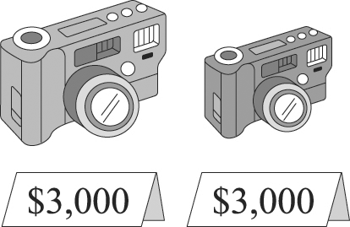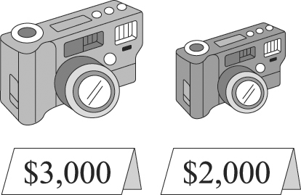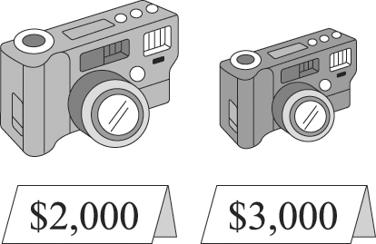

2. (A) (B) (C)
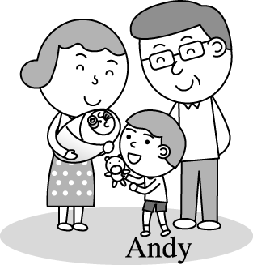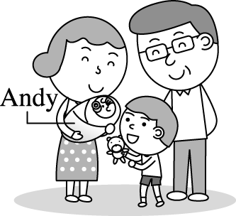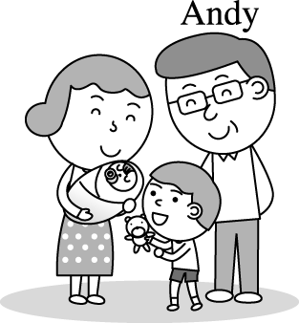

3. (A) (B) (C)
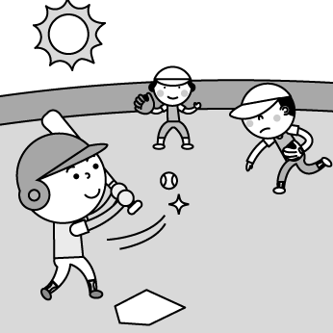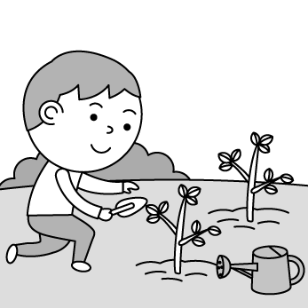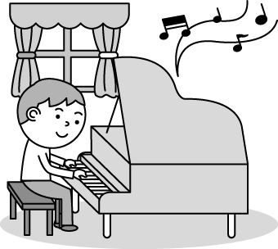
4. (A) (B) (C)
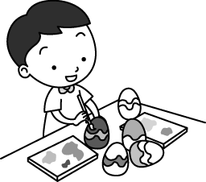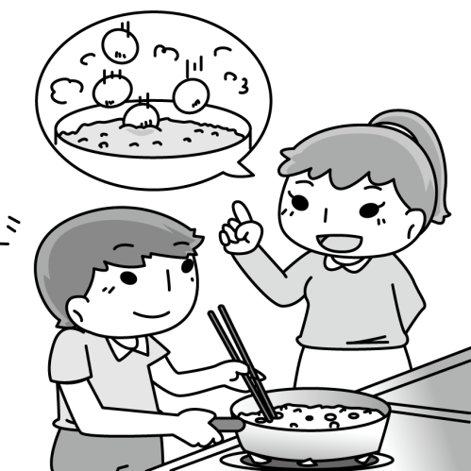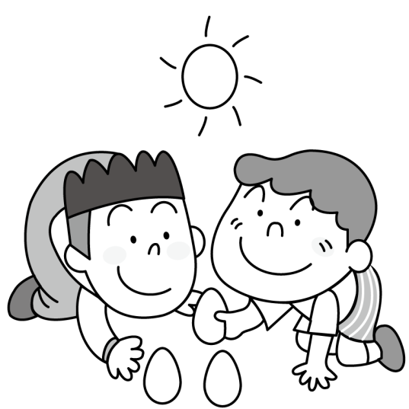

5. (A) (B) (C)
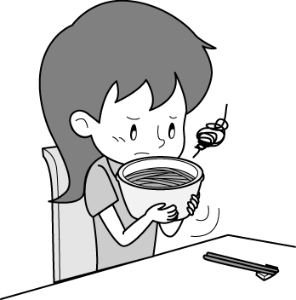 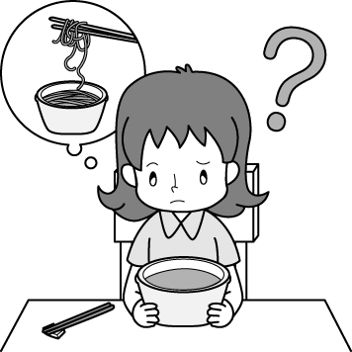 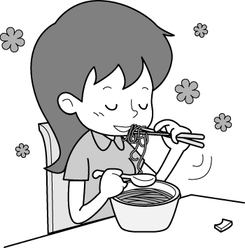

(二)基本問答：根據聽到的內容，選出一個最適合的回應句。

6. (A)It is the best drink for me, too. (B)I don’t how to grow oranges. (C)It is good to have some soup, too.
7. (A)I will never look like you. (B)I like both my parents. (C)I look like my dad.

8. (A)We can play basketball at the park. (B)You can edit photos with it. (C)We can listen to music with it.

9. (A)I’d like an MP3 player. Can I take a look at that one?
(B)The purple CD player is heavier than that gray one.
(C)Nice to meet you, too. I’ll buy it for you.

10. (A)It’s getting prettier. (B)It sounds beautiful. (C)It’s a good idea.

(三)言談理解：根據聽到的內容，選出一個最適合的答案。

11. (A)The Mac. (B)The apple watch. (C)The iPhone.

12. (A)People like winter very much. (B)The news about weather. (C)The beautiful snow.

13. (A)The red one. (B)The gray one. (C)He doesn’t know.

14. (A)Go to church. (B)Paint eggs. (C)Have an Easter egg hunt.

15. (A)He exercises only once a week.
(B)He has snacks every meal.
(C)He is busy working and doesn’t have much time to exercise.

二、 綜合測驗(每題2分)30% (選出最合理的答案 )
16. The meat-free day at my school is on Monday. We only eat ________ every Monday.
(A)pots (B) vegetables (C)vinegars (D)candy

17. Mary is taller than _______ in her class. (A) all the boy (B) all the other boys (C) any other boy (D) all the boys

18. John has 5 million dollars, but Sam only has 100 thousand dollars. Sam has _____ money than John.
(A)more (B)fewer (C)less (D)last

19. To cook the fish soup, you have to ______ some water first. Then put the fish in the water for about ten minutes.
(A)chat (B)smell(C)boil (D)hurry up

20. The motorcycle is _________ than the bicycle.
(A)very expensive (B)much expensive (C) expensive very much (D) much more expensive
21. Frank is more _______ than his roommate. (A)special (B)smart (C)busy (D)easy

22. We don’t have to go to school because tomorrow is a _________. (A) Easter (B)ground (C) holiday (D)church

23. Please look at my eyes. My left eye is not as big as my right _________. (A)it (B)them (C)ones (D)one

24. The show was wonderful last night, so everyone stood up and _________. (A)clapped (B)felt(C)smelled(D)crazy

25. In the family Tina is ____________ of the two sisters. (A)the prettiest (B)the prettier (C)pretty (D)prettier

26.You told a lie. That is ___________ you. (A)honest of (B) honest for (C) not honest for (D) not honest of

27.Hugh: I bought the computer at the store. Sam: All the computers at the store are not _________. You bought it
at ______ prices. (A)on sale; low (B)on sale; high (C)in sale; low (D)in sale; high

28.____________ is more important than health, so we should go to bed early.
(A)Everything (B)Nothing(C)Anything (D)One thing

29. I don’t like this story. It ________ interesting. (A)sounds (B)sound (C)don’t sound (D)doesn’t sound

30. Ken is so rich. He ________ a lot of houses. (A)owns(B)grows(C)rolls(D)pours

三、閱讀測驗(每題2分) 10%
(一)
The tomato is from South America. When the tomato came to Europe, people did not eat it. Doctors said it would make them sick. So people just grew tomatoes because they looked nice.
Now people from all over the world eat tomatoes. Tomatoes are used in sauce, soup, juice, and ketchup. The tomato is very good for you. Only a tomato leaf or stem will make you sick.
People do odd things with tomatoes. People grow tomatoes in space. There is a big tomato fight every year in Spain. A long time ago, people will throw a bad tomato when they saw a show they did not like.
In Canada, many tomatoes are grown on big farms. The farms bring in poor people from far away to help grow tomatoes. Without these workers, the farms couldn’t run. But the workers do not get much money. Canada does not let the workers stay here. Many people say this is not fair.
Most farms pick tomatoes before they ripe. They last longer this way. But these tomatoes do not taste as good. So lots of people grow their own tomatoes.
Grow Your Own Tomatoes
Tomatoes that you grow are better than tomatoes that you buy. You can grow tomatoes inside if you do not have a garden.
You need
Tomato seeds
A big pot (50cm deep)
Potting soil. (many big food shops sell this)
A window
Add water. The soil must always be a bit wet. Seeds like to be warm. Put your pot in a warm place. It does not need sun yet.
The plant will grow above the soil. Put the plant by a window. The plant will need four hours of sun a day. You can tie the stem to a stick to help the plant stay up. Always keep the soil a bit wet.
Pick the tomatoes when they are the same red color top to the bottom. Enjoy!
ripe成熟; soil泥土; odd奇怪; stem莖; suggest建議; garage車庫
31. What happened when the tomato first came to Europe?
(A)It was welcomed.
(B)People grew it for food.
(C)People did not like it.
(D)Doctors suggested people eat tomatoes for good health.

32. What is something tomatoes are NOT used? (A)Soup. (B)Juice. (C)Ketchup. (D)Cake.

33. When you are growing your own tomatoes, where should you put the plant and how much sunlight will it need?
(A)You should put it in the kitchen and it will not need direct sunlight.
(B)It needs to be in the garage with sunlight all day.
(C)It needs to be outside.
(D)You should put it by the window and it will need 4 hours of sunlight per day.

(二)
Hello, friends! My name’s Ken. I’m 14 years old and I live in a small town in Britain with my mom, dad and my sister, Emily. Spring is here now and I’m very happy because of it. But now, I want to tell you what we do in Britain at Easter.
Easter is in spring and people celebrate the resurrection of Jesus Christ. Easer starts on good Friday in Britain. My mom makes hot cross buns and we eat them for tea. We usually have Easter projects at school. Last year we made colorful hats, called Easter bonnets. This year we are going to design a basket full of painted Easter eggs. It will be a great fun!
On Easter Sunday morning we have a big breakfast. After breakfast we all go to church. When we get home, we give each other chocolate eggs. (Kids get the biggest ones) Then we play “Easter egg hunt”. My parents hide some Easter eggs in the garden and Emily and I look for them. We love playing it.
We have roasted lamb with veggies for lunch. In the afternoon, aunts and uncles come over for tea. We have Easter cupcakes, cakes and delicious tea. After tea we usually go for a walk together.
I like Easter because it is a great family festival and there is no school for two weeks! : )
resurrection復活; project方案，計畫

34. What are the traditional food at Easter? (A)Crosses. (B)Cross buns.(C)Milk tea.(D)Easter bonnets.

35. Which is true?
(A)Easter is in summer.
(B)Children make Easter bonnets this year at school.
(C)Ken likes doing Easter projects.
(D)Easter egg hunting means that children eat chocolate eggs.

四、寫出形容詞的原級、比較級、和最高級(每題1分) 6%
原級 | 比較級 | 最高級
cheap | cheaper | cheapest
many/much | 1 | 2
3 | less | 4
5 | 6 | worst

五、依提示改寫句子(每題2分)6%
1. The birthday cake tastes delicious. (依畫線部分造原問句)
________________________________________________________

2. Kevin’s room is big . My room is small. (以開頭Kevin’s room，用比較級合併句子)

________________________________________________________

3. For Simon, English is more difficult than all the other subjects. (用最高級改寫)
________________________________________________________

六、翻譯：(每格1分；翻譯句子一句3分)18 %
這學校的整個活動對學生們是新的一種體驗
The whole 1 at the school is a new 2 of 3 for the students.

這支智慧型手機很難操作嗎? 一點都不會。它用起來像智慧型手機一樣。
Ken: Is the smartwatch difficult 4 use?
Clerk: Not 5 . It 6 like a smartphone.

我喜歡這葡萄汁。不加任何其他東西，就只有葡萄。他們採用當季最新鮮的葡萄。
I love the grape juice. They don’t 7 anything 8 , just grapes. They use the freshest grapes of the
9 .

10.這位歌手漸漸變得越來越受年輕人的歡迎了。(----be + Ving----)
____________________________________________________________

11.事實上，他真的不滿意他新相機的照片品質。
____________________________________________________________

12.昨天早上林老師(Mr. Lin)把所有的學生叫過來，給他們一個特別的任務。
_____________________________________________________________

【試題結束】

新北市立溪崑國民中學108學年度第二學期第一次定期評量 英語科 答案卷
八年級 班 座號 姓名
四、寫出形容詞的原級、比較級、和最高級(每題1分)6 %
1 |  | 2 |  | 3
4 |  | 5 |  | 6

五、依提示改寫句子6%(每題2分)
1
2
3

六、翻譯18%(每格1分；句子一句3分)
1 |  | 2 |  | 3
4 |  | 5 |  | 6
7 |  | 8 |  | 9
10
11
12

108-2-1 八年級 英語科－解答
一、聽力測驗 30%
1~5 BCBAC 6~10 ACCAB 11~15 ABACC
二、綜合測驗30%
16~20 BDCCD 21~25 ACDAB 26~30 DBBDA

三、閱讀測驗10%
31~35CDDBC

四、寫出形容詞的原級、比較級、和最高級(每題1分)6 %
1. more 2. most 3. little
4. least 5. bad 6. worse

五、依提示改寫句子(每題2分)6 %
1. How does the birthday cake taste?

2. Kevin’s room is bigger than mine.

3. For Simon, English is the most difficult subject of all.

六、翻譯：(每格1分；翻譯句子一句3分)18 %
1. activity 2. kind 3. experience 4 . to 5. at all
6. works 7. add 8. else 9. season

10. The singer is becoming/ getting more and more popular with young people.

11. In fact, he is not really happy with the picture quality of his new camera.

12. Mr. Lin called for all the students and gave them a special task yesterday morning.

新北市立溪崑國民中學108學年度第二學期第一次定期評量
八年級 英語科 聽力測驗稿

一、辨識句意：根據聽到的內容，選出符合描述的圖片
1.答案：(B)
錄音稿：The big camera is more expensive than the small one.

2.答案：(C)
錄音稿：Andy is the oldest in his family.
3答案：(B)
錄音稿：Jackson has green fingers.

4.答案：(A)
錄音稿：The boy painted some eggs.
5.答案：(C)
錄音稿：The noodles tasted yummy.

二、基本問答：根據聽到的內容，選出一個最適合的回應句
6.答案：(A)
錄音稿：Orange juice is my favorite drink and I have some every day.

7.答案：(C)
錄音稿：Who do you look like, your dad or mom?

8.答案：(C)
錄音稿：What can we do with a CD player?

9.答案：(A)
錄音稿：Good afternoon, sir. How may I help you?

10.答案：(B )
錄音稿：How do you like this song?

二、言談理解：根據聽到的內容，選出一個最適合的答案。

11.答案：(A)
錄音稿：M: Wow, you bought a lot of things last week. An apple watch, an iPhone, and a Mac. They all cost a lot. Which one is the most expensive of all?
W: Let’s me see.
M: Hmm... the watch is more expensive than the cell phone. And the watch is cheaper than the Mac.
W: Oh... I see.
Q: Which one is the most expensive of all?

12.答案：(B)
錄音稿：M: Another cold day! I can’t stand the cold weather outside. It snows a lot.
W: It must be the coldest winter in the past ten years.
M: It’s reported that it is getting even colder next week.
W: Oh my goodness!
Q: What are they talking about?

13.答案：(A)
錄音稿：M: Is the gray jacket more expensive than the red one?
W: Yes, it is.
M: Then I’ll take the cheaper one.
W: OK, no problem.
Q: Which color of the jacket does the man take?

14.答案：(C)
錄音稿：B: What are you going to do on Easter?
G: We’re going to paint eggs. After that, we’ll go to the church.
B: Won’t you have an Easter egg hunt?
G: Why not? It’s the most interesting activity on Easter for us. We can’t wait for it.
Q: Which is the most interesting activity on Easter for the girl?

15.答案：(C)
錄音稿：W: What’s wrong with you, Albert? You look much heavier than before.
M: I am busy working and I seldom exercise. I always eat snacks between meals.
W: No wonder! But I think it is important to exercise at least three times a week. You should lose weight.
M: Ok, for my health, I think I should do that. Thank you for telling me.
Q: Why does Albert look heavier than before?

PS: READ TWICE念兩遍

