新北市立溪崑國民中學108學年度第二學期第一次定期評量 英語科試題卷
七年級 班 座號 姓名
一 聽力測驗(30%)
A辨識句意 : 根據聽到的句子，選出符合描述的圖片(8%)
- 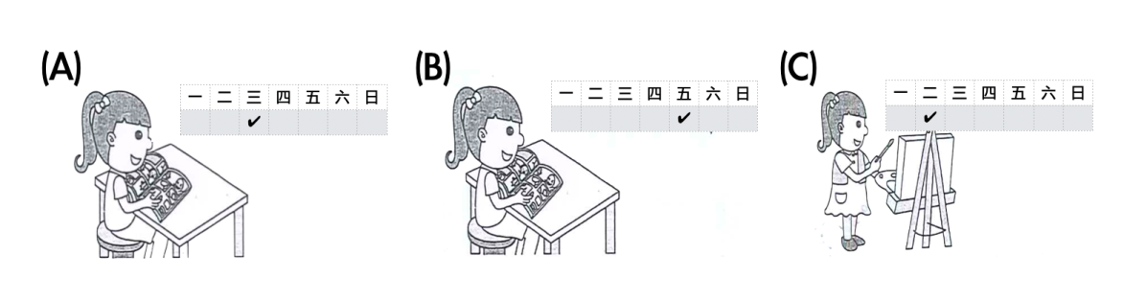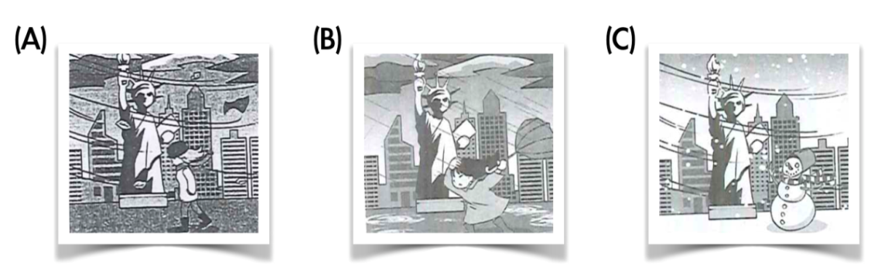

- 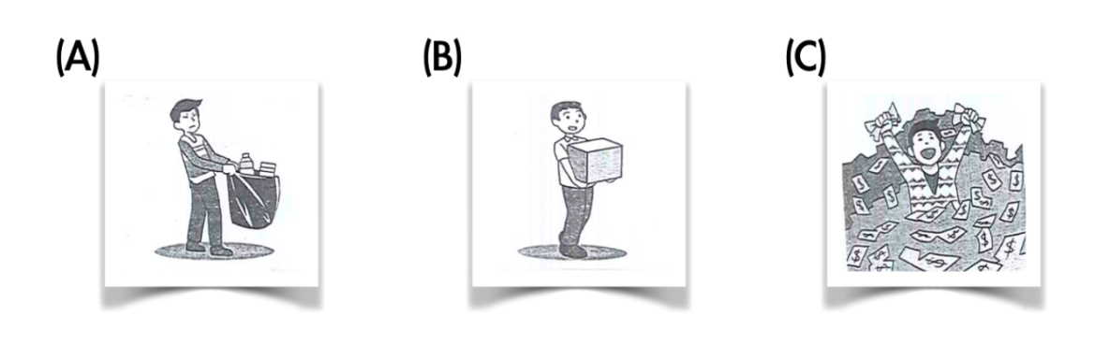
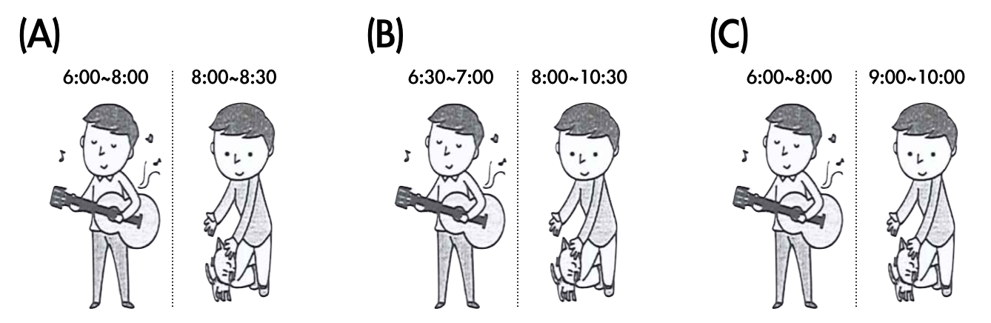
B. 基本問答：根據聽到的內容，選出合適的回應。(12%)
- (A) No sweat. (B) And then? (C) You bet.
- (A) Cool! Let’s go to the museum. (B) Really? I can’t wait for that day. (C) Wow! Tell me more .
- (A) I want to book two rooms for one night. (B) I want to book a table for two tonight. (C) Can I take a look at the hotel?
- (A) No. I like it very much. (B) No. There is no TV show. (C) No. I do it once in a blue moon.
- (A) It’s hot and rainy. (B) It’s not cold this month. (C) No, it’s snowy, not sunny.
- (A) Wow! It’s so smart. (B) Of course. Go with it. (C) Really? I don’t like it.
C. 言談理解：根據聽到的內容，選出最適合的答案。(10%)
- (A) The class today and their new art teacher. (B) The boy’s favorite teacher at school. (C) The new teacher.
- (A) They are talking about their trip. (B) Eason has a trip on the weekend. (C) Lucy and her family have a trip to Kaohsiung.
- (A) Wednesday to Saturday. (B) Thursday to Sunday. (C) Monday to Wednesday.
- (A) Monday. (B) Saturday. (C) Sunday.
- (A) Tuesday. (B) Monday. (C) Thursday.
二、綜合測驗 (28%)
- Tommy uses chopsticks well, but his sisters , so they usually with spoons. (A) does; use (B) doesn’t; eat (C) don’t; eat (D) are; use
- Emma: snow in Taiwan in winter?
Eason: Yes. some snow only in high mountains.
(A) Is it; It’s (B) Does it; There is (C) Is the weather; It’s (D) Do you have; There are
- 選出正確句子:
(A) I drink coffee Friday night. (B) There are hundreds of people here. (C) You or she are in Taipei. (D) There is rain a lot here in summer.
- Max: rainy here in summer?
Sam: Yes. lots of rain here in summer.
(A) Is there; We have (B) Is it; There are (C) Is it; We have (D) Is there; It’s
- Tom: Does Lucy a lot of homework every day?
Betty: Yes, she a lot of homework every day.
(A) do; do (B) do; does (C) do; is doing (D) does; do
- Leo: What day is the meat-free day at your school? Brad: It’s . (A) every weekend (B) Wednesday (C) from Friday to Sunday (D) on Friday
- 選出正確句子:
(A) What hotel are you staying ? (B) The chair is made of ice. (C) A: What are you looking at? B: My watch. It is gone. (D) He is not enough old for the job.
- 選出正確句子:
(A) Don’t throw away it. (B) I chat with my brother about the computer games. (C) The weather rains a lot here. (D) There are two thousands students in the gym.
- Joe: your brother ready for the history test?
Joy: I don’t know.
(A) Does (B) Do (C) Isn’t (D) Be
- Alex: Who those people and ?
Cindy: Mr. White .
(A) helps; shows them around; does (B) help; carry things for them; do (C) talks; shows them around; does (D) can welcome; check it out; can’t
- Here an e-mail Luke. Let’s read it . (A) are; from (B) has; to (C) have; from (D) is; from
- Peter: What your parents do?
Linda: My dad is a policeman and my mom is a housewife.
(A) can (B) don’t (C) are (D) do
- Alex: Do you know the story about Taj Mahal?
Betty: No. Let’s read the book and .
(A) look for (B) find out more (C) fall down (D) check it in
- Jane doesn’t like pig blood cake , but her sister . (A) likes (B) is (C) do (D) does

三 題組 (12%)
A
People like to make all sorts of artwork. In India, they make pretty cloth. They use a stamping tool to make the cloth look pretty. They put the ink into the stamp and stamp onto the cloth to make it look pretty. They use the stamp over and over and over. In Ivory Coast, they make masks. They use the wood from a tree to carve a mask. In Kenya, they make baskets. They use long grass to make the basket. In Japan, they make things out of paper. They fold the paper into pretty shapes. Paper folding is called origami. In China, they make things out of cloth. They use cloth to make their kites. In Peru, they make pretty belts. They weave yarn in out to make the belts. In Mexico, they make pretty cups from clay. They shape the cups, bake them and then paints them. In Alaska, they carve animals from stones. carve雕刻 weave 編織 clay 黏土
- In , people make masks out of trees. (A) Ivory Coast (B) Alaska (C) Mexico
- Origami means . (A) stone carving (B) cup painting (C) paper folding
- Which is “ NOT ” true? (A) In India, people make pretty cloth with stamps. (B) In China, people use cloth to make their kites. (C) In Alaska, people make pretty cups from clay.
B
The natives of Peru and Bolivia have a special custom for a baby. They celebrate the baby’s first haircut with a fiesta. At the fiesta there is lots of food, music, and dancing.
The parents do not cut the baby’s hair for a few years. They invite relatives and friends to the fiesta. On this special day the baby sits on a high chair like a king or a queen. Then the godmother separates the baby’s hair into locks. The number of the locks is the same as the number of guests at the fiesta. The godmother then ties each lock with a pretty ribbon.
The godfather cuts the first lock. He also says what gift he is giving. The gifts may be an animal, a piece of land, or a lot of money. After him, each guest cuts off a lock and makes a gift of money. The money can pay for the fiesta, or the parents can save the money for the baby’s future. custom習俗 separate分 lock一股，一縷
- Who separates the baby’s hair into locks? (A) The baby’s grandfather (B) The baby’s godmother (C) the baby’s parents
- Which is true? (A) The godfather ties each lock with a ribbon. (B) The number of the locks is the same as the number of guests. (C) Parents don’t cut the baby’s hair for a few months.
- What is a fiesta? (A) A party. (B) A show. (C) A concert.
四 文意字彙 (8%)
- Jack: My dog can dance and catch a ball. Lisa: Wow! That’s a e .
- There are 23 m n people in Taiwan.
- A n comes after summer.
- I need some v rs to help with the work.
五 寫出正確動詞形式(6%)
- Tom, (open) the door.
- Look! The robot (scan) the boy’s face
- My brother, Tom, (study) hard .
六 依提示改寫 (4%)
- I get up at six o’clock every morning. (造原問句)
- Peter plays baseball with Eason. (造原問句)
七 翻譯(12%)
- 同時，世界上有許多人沒有乾淨的水。
- 在展示間的每樣東西幾乎都是由鹽所製成的。 ( They…)
- 他每天晚上和他媽媽講視訊電話嗎?
- 隔年春天，這間旅館以特殊風格的房間再次營業。

新北市立溪崑國民中學108學年度第二學期第一次定期評量 英語科 答案卷
七年級 班 座號 姓名
四 文意字彙 (8%)
36 | 37 | 38 | 39

五 寫出正確動詞形式(6%)
40 | 41 | 42

六 依提示改寫 (4%)
43

44

七 翻譯(12%)
45

46

47

48

108-2-1 七年級 英語科－解答

- 聽力測驗(30%)
1-5 BCAAC 6-10 CBCAB 11-15 CBACA
二、綜合測驗 (28%)
16-20 CBBCB 21-25 DBBCA 26-29 DDBD
三題組 (12%)
30-35 ACCBBA
四文意字彙 (8%)
36 awesome 37 million 38 Autumn 39 volunteers
五 寫出正確動詞形式(6%)
40 open 41 is scanning 42 studies
六依提示改寫 (4%)
43 What time do you get up every morning?
44 Who does Peter play baseball with?
七 翻譯(12%)
45 At the same time, many people around the world don’t have clean water.
46 They build almost everything in the showroom with salt.
47 Does he have a video call with his mother every night?
48 The next spring, the hotel opens again with rooms of special styles.

1-5 BCAAC 6-10 CBCAB 11-15 CBACA 16-20 CBBCB 21-25 DBBCA 26-30 DDBDA
31-35 CCBBA
36 awesome 37 million 38 Autumn 39 volunteers 40 open 41 is scanning 42 studies
43 What time do you get up every morning?
44 Who does Peter play baseball with?
45 At the same time, many people around the world don’t have clean water.
46 They build almost everything in the showroom with salt.
47 Does he have a video call with his mother every night?
48 The next spring, the hotel opens again with rooms of special styles.

新北市立溪崑國民中學108學年度第二學期第一次定期評量
七年級英語科聽力測驗稿

- 聽力測驗(30%)

A辨識句意 : 根據聽到的句子，選出符合描述的圖片(8%)
- I read comic books every Friday.
- It is snowy in New York.
- He carries a heavy bag.
- What do you do after work?
I play the guitar for two hours and play with my cat for thirty minutes.
B. 基本問答：根據聽到的內容，選出合適的回應。(12%)
- The weather is the key. Am I right? (A) No sweat. (B) And then? (C) You bet.
- There is a new bookstore near the museum. (A) Cool! Let’s go to the museum. (B) Really? I can’t wait for that day. (C) Wow! Tell me more .
- Yummy Restaurant. How may I help you? (A) I want to book two rooms for one night. (B) I want to book a table for two tonight. (C) Can I take a look at the hotel?
- Don’t you like to go to the movies? (A) No. I like it very much. (B) No. There is no TV show. (C) No. I do it once in a blue moon.
- What is the weather like this week? (A) It’s hot and rainy. (B) It’s not cold this month. (C) No, it’s snowy, not sunny.
- Does the robot show me around? (A) Wow! It’s so smart. (B) Of course. Go with it. (C) Really? I don’t like it.
C. 言談理解：根據聽到的內容，選出最適合的答案。(10%)
- B: What day is it?
G: It’s Thursday.
B: Oh, no. We have music class today.
G: Isn’t music your favorite subject?
B: Yes. But I don’t like the new teacher.
G: Come on. She is nice and beautiful.
Q: What are they talking about?
(A) The class today and their new art teacher. (B) The boy’s favorite teacher at school. (C) The new teacher.

- W: What are you doing, Eason?
M: My family and I have a trip to Kaohsiung this weekend. I am looking for a hotel there.
W: I know a new hotel with a special style. Let me show you.
M: Thank you, Lucy.
Q: Which is true?
(A) They are talking about their trip. (B) Eason has a trip on the weekend. (C) Lucy and her family have a trip to Kaohsiung.

- W: Garden Hotel. How can I help you?
M: Can I book two rooms for three nights?
W: You bet. We have rooms from Thursday to Sunday. Is that ok ?
M: Hmm, how about from Wednesday to Saturday?
W: Ok. No problem.
M: Thank you.
Q: What day does the man book rooms at Garden Hotel?
- Wednesday to Saturday. (B) Thursday to Sunday. (C) Monday to Wednesday.

- M: It’s lunch time. Let’s go to Yummy Restaurant.
W: No. It doesn’t open today.
M: What day does it open?
W: It opens from Monday to Saturday.
M: How about Happy Restaurant?
G: OK. Let’s go.
Q: What day is today?
(A) Monday. (B) Saturday. (C) Sunday.

- B: What day is it today?
G: It’s Tuesday.
B: Oh my god! It’s the meat-free day again!
G: I like meat a lot. I can’t have it for lunch today.
B: Can’t we have the vegetable-free day?
Q: What day don’t they have meat for lunch?
(A) Tuesday. (B) Monday. (C) Thursday.

