新北市立溪崑國民中學108學年度第一學期第三次定期評量 英語科 試題卷
九年級 班 座號 姓名
一 聽力測驗 20%
(一)、辨識句意：每題均有三張圖片，請依據所聽到的句子，選出符合描述的圖片(每題2分，共6分)
- (A)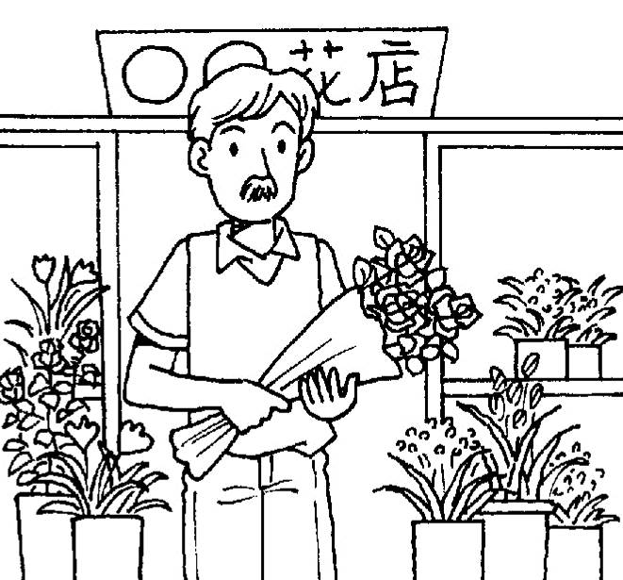 (B)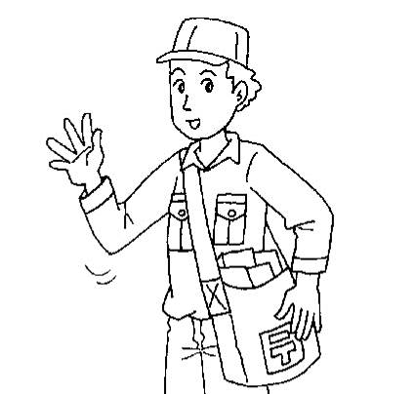(C)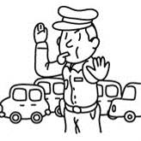
- (A)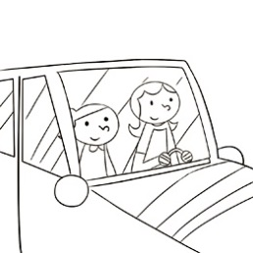 (B)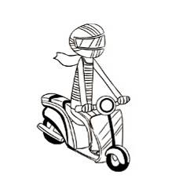(C)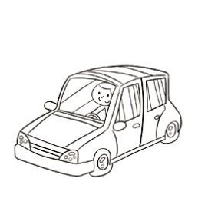
- (A)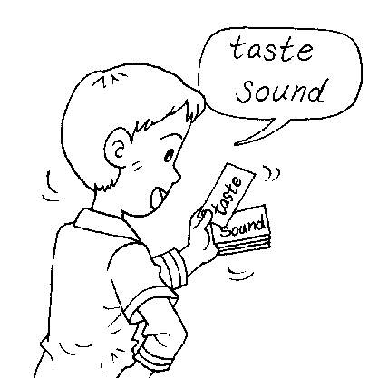 (B)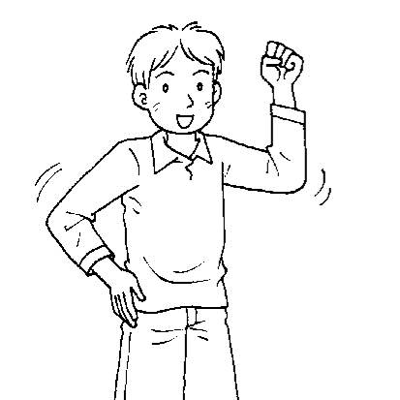(C)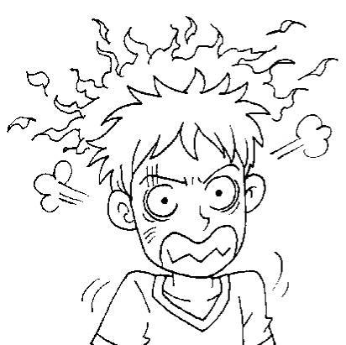
(二)、基本問答：每題均有三個選項，請依據所聽到的內容，選出一個最適合的回應(每題2分，共6分)
- (A) Here, I have a picture of my idol.
(B) Of course not, the singer is my idol.
(C) Not at all. I want to make a difference in the world.
- (A) You can make it a habit.
(B) You can make fewer copies.
(C) You can begin with taking stairs.
- (A) She likes to play with dolls.
(B) That’s Mr. Chen’s daughter.
(C) Mr. Chen took her to the museum.
(三)、言談理解：每題均有三個選項，請依據所聽到的對話與問題，選出一個最適當的答案(每題2 分，共8分)
- (A) The woman took away the man’s wallet.
(B) The man talked to the woman in his room this morning.
(C) The man’s wallet is somewhere in the woman’s room.
- (A) It cannot run far.
(B) It cannot run fast.
(C) It runs on biogas.
- (A) She thinks Tina is too stressed out.
(B) She doesn’t think Tina will let her down.
(C) She thinks Tina is the apple of her eye.
- (A) Mr. Wu is a foreigner that can speak Chinese well.
(B) The foreigner they’re talking about can speak Chinese.
(C) Mr. Wu doesn’t know the foreigner they are talking about.
二 綜合測驗 42%
11. Patty is so angry now. Maybe a glass of ice tea can ________ her _______.
(A) rise above (B) cool down (C) break down (D) blow up
12. Jenny, you should face and ______ the problems between you and your mom.
(A) deal with (B) light up (C) knock down (D) push around
13. Mike finds great _______ in baseball. He wants to be a baseball player.
(A) type (B) pleasure (C) straw (D) hobby
14. Tina goes jogging every morning. She has kept this ______ since she was twenty.
(A) chalk (B) design (C) habit (D) rock
15. The ________ couldn’t find the address, so he didn’t deliver the letter.
(A) lawyer (B) police officer (C) farmer (D) mail carrier
16. Jenny : I failed the Math test again. ___________
Derek : Cheer up ! I can teach you Math after school.
(A) My life has hit rock bottom. (B) Never say never.
(C) I can make a difference. (D) I was born this way.
17. Do you know who ______ ?
(A) is the boy wearing a blue jacket
(B) the boy wearing a blue jacket
(C) the boy is wearing a blue jacket
(D) the boy wearing a blue jacket is
18. ________ a lot of water when you catch a cold is a good way to help you get well soon.
(A) Drink (B) Drinking (C) By drinking (D) Drunk
19. There are ______ of toy cars, but you can only choose one as your birthday gift.
(A) one dozen (B) two dozens (C) dozens (D) many dozens
20. The ______ news is about a traffic accident ______ happened in Hualian last night.
(A) surprised ; what was (B) surprising ; what (C) surprised ; that was (D) surprising; that
21. The smartphone is too expensive, I don’t have enough money. Do you have ________ ?
(A) something cheaper (B) anything cheaper (C) cheaper something (D) cheaper anything
22. I think ______ is exciting to watch ball game at the gym ______ is full of people.
(A) that ; which (B) it ; where (C) that ; where (D) it ; which
23. The handsome guy _______ Tina is talking to is her English teacher.
(A) that (B) she (C) which (D) what
24. The little girl with big eyes will keep waiting _______ her grandfather comes.
(A) before (B) when (C) until (D) since
25. The books _______ borrowed from the library ______ put away by my grandmother.
(A) which ; were (B) that were ; were (C) that was ; was (D) that ; was
26. My brother enjoy reading the comic books ______________.
(A) Ms. Chen gave to him (B) are written in simple English
(C) which has colorful pictures (D) that writer is an Ameican
27. In the library, you can read books _________ .
(A) which you interested. (B) is interesting to you (C) that interests you (D) that you are interested in
28. 選出正確的句子
(A) One of the boys who Leo is playing basketball looks like my brother.
(B) The department store where we used to visit has become more and more popular.
(C) One of the old houses over there that built long time ago belongs to Jessie’s uncle.
(D) We learned from the TV news that EXO was coming to Taiwan the next day.
29. 選出正確的句子
(A) People who live in these buildings can use fewer energy to light up their house.
(B) I like the one has the bright blue sky and the unusual rocks.
(C) The kind of gas is made from waste water, and drivers that use biogas can park their cars first in the city.
(D) Over three-quarter of Stockholm’s cars and buses are run on biogas.
30. 選出錯誤的句子
(A) Rita looks beautiful in the heavy coat.
(B) The man with a bow tie is Mr. Huang, who just came back from Japan.
(C) The dictionary is made from used paper.
(D) Kelly likes to read books about history.
31. 將”that”填入最適當的空格中。
(i) The fact is_____ she doesn’t have enough money to buy the car.
(ii) My father,_____ exersices every day, is very healthy.
(iii) He is the first man _____ reaches the top of the mountain.
(iv) _______ Linda is going to move to Kaohshiung is true.
(A) (B) (C) (D)
三、克漏字選擇 10% (32-36)
When you wake up in the morning, what is the first thing you want to smell? A. Flowers in a flower pot. B. A cup of coffee. C. A delicious breakfast on a big plate. D. A bottle of essential oil.
Answer A You’re a person who doesn’t like to fight with (32) . You wait until they cool down and then try to deal with them. However, it’s important for you to speak up and let people know ___(33)___ before things start to slide.
Answer B Your emotions go up and down like a seesaw. You are happy one minute, but the next you are sad, mad, or worse. This emotional drama is bad for your health. You can solve it __(34)____ exercising every day and eating a healthy diet.
Answer C You think your close friends are the ones ___(35)____. However, when they do something that you don’t like, you stop __(36)____ to them. This is not wise because you may end up with no friends at all. You’d better open your mind and find common ground with them.

32. (A) others (B) other (C) another (D) the others
33. (A) that you feel (B) what you feel (C) which you feel (D) how you feel
34. (A) from (B) by (C) in (D) on
35. (A) who understands you the most (B) who understand you the most
(C) which understand you the best (D) understand you the best
36. (A) to talk (B) being talk (C) talking (D) talks
四、閱讀測驗 28% (37-50)
(一)
What do people mean when they say languages are “alive”? Well, they mean that languages are always changing. Take English for example. Every year, there are new words, while some fall out of use. Today, many of these new words come from technology. Modern technology is changing quickly and so we need to come up with new ways to talk about new things.
Some new words are old ones that take on a new meaning. For example, the word “troll” means a kind of creature. But now we use this word to refer to a person who posts comments in Facebook groups only to make others angry. Other new words come from old ones but they look a little different, like “selfie,” which comes from the word “self.” A selfie is a photo of you that is taken by yourself. it is popular because it is convenient to use smartphones to take pictures.
Other new words are borrowed from other languages. For example, “emoji” comes from Japanese, “e” means “picture” and
“moji” means “character. Emojis are little pictures that we include in Facebook or text messages. Some popular emojis include happy faces, thumbs up, and hearts. As you can see, words are changing with time and culture, just like us. That’s why languages are as alive as we are.

alive 有生命的 creature 生物 refer to 指稱 comment 評論
character 字 include 使包含於…裡面 thumb 拇指

37. What is the main idea of the article ?
(A) People use English words differently in different countries.
(B) Languages are always changing and many new words come from technology.
(C) English is difficult to learn because it has words from other languages such as Japanese.
(D) The best way to study English is to use online dictionaries, which have many new words.
38. What does come up with mean in the reading?
(A) run into (B) give up (C) think of (D) go across
39. Which of the following is an example of using an emoji?
(A) Drawing a picture that looks like a word.
(B) Using the word arigato, which means “thank you” in Japanese.
(C) Saying the word app, the short form for “application.”
(D) Typing :( to tell your friend that you are not happy.
(二)
As the public cares more about the environmental impact of single-use plastic, more families are starting to live plastic-free.
Bettina Maidment campaigns to get rid of single-use plastic in town in east London. Her family lives plastic-free with zero-waste. First, she used glass bottles to keep her milk. Then, she started using bamboo toothbrushes, bought food from local shops, and made homemade cleansers. Last, food is stored in glass jars.
Kiran Harrison started to go plastic-free when her son was born. “Nappies are the no.1 offender,” she says. So she uses ones made from cloth. Her tip for people who want to do the same: Make the change little by little, so it becomes a habit.
Waleed Akhtar used to drink bottled water every day, but now carries a reusable water bottle. “There are so many small decisions to make every day about reducing your damage to the planet, “Akhtar says.

local 地方的 damage 損壞 environmental 環境的
nappies 尿布 campaign 發起運動 offender 罪犯

40. What is true about Bettina Maidment ?
(A) Her son was just born.
(B) She drank milk from cans.
(C) She started a campaign to reduce plastic.
(D) She usually goes shopping at department stores.
41. When did Kiran Harrison start to live plastic-free?
(A) When she had a baby at home.
(B) When she make her own cleanser.
(C) When she put her sandwich in a plastic bag.
(D) When she started to carry a reusable water bottle.
42. Which of the following statements can best describe (描述) Waleed Akhtar’s daily life?
(A) He makes his own soap.
(B) He stores his food in big glass jars.
(C) He drinks water from his reusable bottle.
(D) He keeps some bottled water in his kitchen.
43. What does tip mean in this reading?
(A) top. (B) advice. (C) prize. (D) warming.
44. What can you do if you also want to live plastic free?
(A) Store your food in glass jars.
(B) Keep your food in plastic bags.
(C) Use nappies for your new-born baby.
(D) Buy your soap and shampoo from local shops.
(三)
Don’t you ever think it isn’t easy to talk with your parents when you have some problems ?
Here are some tips for how to talk with them.
Try to start your talk with something interesting. This will make talking easier. For example, ask your parents how their day is and how their work is.
Make it clear what you want to tell your parents. If they have their own idea, let them finish their talking and don’t interrupt them. Show them respect by listening to them carefully, and look them in the eye. And also ask them to listen to you without interrupting your talk.
Be honest ! Life is wonderful when your parents believe what you say. If your parents don’t understand, you have to explain things to them again or in a different way.
When you finish the talk, thank them for listening. It will let them know this is important for you. If you feel like there are still things to talk about, ask them to talk with you another day.

interrupt 打斷 ; 中止 respect 尊敬 explain 解釋

45. How do we start talking with our parents ?
(A) Ask them how they are today. (B) Ask them about their ideas first.
(C) Show them how you love them. (D) Give them a nice present.
46. What should we do when our parents have some different ideas ?
(A) Ask them not to talk again. (B) Don’t talk with them anymore.
(C) Ask them to listen to our ideas. (D) Let them keep talking
47. What should we tell our parents when we finish the talk?
(A) Tell them we are interested in what they have done for us.
(B) Tell them we feel glad because they listened to us.
(C) Tell them we are worried about what they have done for us.
(D) Tell them we are proud of what they have shared with us.
(四)
What happens when you get scared? When something moves during the night, or a door suddenly closes, it often makes us jump. This reaction comes from your fear. Do you like it? In fact, being frightened can be good for you.
Fear exercises your brain, which gives different kinds of hormones for happiness, says Dr. Margee Kerr, who studies fear. It also helps to make a hormone that helps people become closer with one another. For example, if you’re at a haunted house with some friends, that experience can make your friendship better. “Watch people walking out of a haunted house, and you’ll see lots of smiles and high fives,“ Kerr says.
There are also studies which show that being scared can help a person face difficult work. Things like talking in front of your class or acting in a school play can make you have butterflies in your stomach. But the experience of being scared helps to make you stronger. “You become more comfortable with fear, and so you’re better able to deal with it when things get more difficult,” Kerr says.
Though some fear may be healthy, it’s important to remember that people experience fear in different ways. Kerr notes that kids who are younger than seven can’t tell what is real and what isn’t, so seeing something scary might not be good for their mind.

reaction 反應 fear恐懼 brain 大腦 hormone 賀爾蒙 haunted 鬧鬼的

48. Which of the following best shows the meaning of “frightened” in the reading ?
(A) Tina won a game and her friends all cheered for her.
(B) Eric’s pet dog got sick and the doctor told him it would be all right.
(C) Janet was taking a shower when she saw a spider on the floor.
(D) Steve opened the door and his family and friends shouted, “Happy birthday!”
49. What is the reading mainly about ?
(A) How being scared could sometimes do us good.
(B) Why we could get scared by different things.
(C) How you can make friends by scaring them.
(D) Why we can’t let a six-year-old watch scary movies.
50. What do we know from the reading ?
(A) We should get scared more often, so we could feel happier in our life.
(B) If we look at fear in a different way, we could make the most of it.
(C) If we are never scared by anything, it’s not possible to act in a play.
(D) Dr. Margee Kerr had been scared many times to find out the fun truth.

108-1-3 九年級 英語科－解答
- A | - A | - C | - B | - C | - B | - C | - A | - A | - B
- B | - A | - B | - C | - D | - A | - D | - B | - C | - D
- B | - D | - A | - C | - B | - A | - D | - D | - C | - C
- B | - A | - D | - B | - B | - C | - B | - C | - D | - C
- A | - C | - B | - A | - A | - D | - B | - C | - A | - B

國中 英語科 考試卷 ___年 ___班 座號：___ 姓名：__________
一、辨識句意：每題均有三張圖片，請依據所聽到的句子，選出符合描述的圖片(每題2分，共6分)
- 《腳本區》
CD: Tom wanted to be a lawyer, but finally he became a shopkeeper.
《題目區》
(A) (B)(C)
《答案區》
答案：A
- 《腳本區》
CD: My teacher said that she saw my brother sit in the car beside the driver when she was on the way to school today.
《題目區》
(A)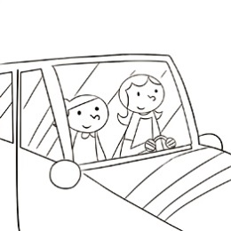 (B)(C)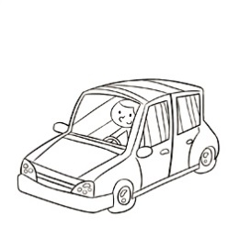
《答案區》
答案：A
- 《腳本區》
CD: After hearing the news, Eric became like a “volcano.”
《題目區》
(A) (B)(C)
《答案區》
答案：C
二、基本問答：每題均有三個選項，請依據所聽到的內容，選出一個最適合的回應(每題2分，共6分)
- 《腳本區》
CD: You have played the song for a dozen times. Aren’t you bored?
《題目區》
(A) Here, I have a picture of my idol.
(B) Of course not, the singer is my idol.
(C) Not at all. I want to make a difference in the world.
《答案區》
答案：B
- 《腳本區》
CD: I really want to become thin, but I don’t have time to exercise.
《題目區》
(A) You can make it a habit.
(B) You can begin with taking stairs.
(C) You can make fewer copies.
《答案區》
答案：B
- 《腳本區》
CD: Who is the girl Mr. Chen played with last night?
《題目區》
(A) She likes to play with dolls.
(B) That’s Mr. Chen’s daughter.
(C) Mr. Chen took her to the museum.
《答案區》
答案：B
三、言談理解：每題均有三個選項，請依據所聽到的對話與問題，選出一個最適當的答案(每題2分，共8分)
- 《腳本區》
CD: Woman: Larry! I just tidied up this room.
Man: I’m sorry. I’m looking for my wallet.
Woman: How could you be so sure that it’s in my bedroom?
Man: After I got home this morning, I came straight here to talk to you. It must be somewhere in your room.
Question: Which is true?
《題目區》
(A) The woman took away the man’s wallet.
(B) The man’s wallet is somewhere in the woman’s room.
(C) The man talked to the woman in his room this morning.
《答案區》
答案：B
- 《腳本區》
CD: Man: Is that the scooter which runs on electricity?
Woman: Yes, it is. I bought it last month.
Man: Cool. But I heard this kind of scooter doesn’t run fast.
Woman: Well, as you know, it cannot store much energy to run far, but it can surely run as fast as ordinary scooters.
Question: What is true about the woman’s new scooter?
《題目區》
(A) It cannot run far.
(B) It cannot run fast.
(C) It runs on biogas.
《答案區》
答案：A
- 《腳本區》
CD: Woman: Tina has done her best. She might do better next time.
Man: You sound like Tina doesn’t have any chance to win the contest.
Woman: It’s a fact. Singing should be fun, but Tina cares about winning the contest too much.
Question: What does the woman think of Tina?
《題目區》
(A) She thinks Tina is too stressed out.
(B) She doesn’t think Tina will let her down.
(C) She thinks Tina is the apple of her eye.
《答案區》
答案：A
- 《腳本區》
CD: Woman: Do you know Mr. Wu’s wife is a Japanese?
Man: Yes, I do. I’ve talked to her a few times. She is a very polite and nice lady.
Woman: I thought she was a Taiwanese. She looks like one. And she speaks Chinese well.
Man: That’s because she has learned Chinese for many years.
Question: Which is true?
《題目區》
(A) Mr. Wu is a foreigner that can speak Chinese well.
(B) The foreigner they’re talking about can speak Chinese.
(C) Mr. Wu doesn’t know the foreigner they are talking about.
《答案區》
答案：B

