新北市立溪崑國民中學108學年度第一學期第三次定期評量 英語科 試題卷
八年級 班 座號 姓名
一、 聽力測驗:(每題兩分) 30%

(一) 辨識句意：根據聽到的內容，選出符合描述的圖片。

1. | (A) | (B) | (C)
 | 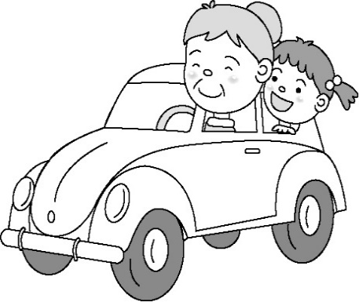 | 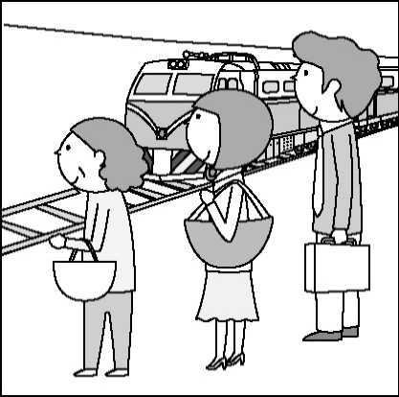 | 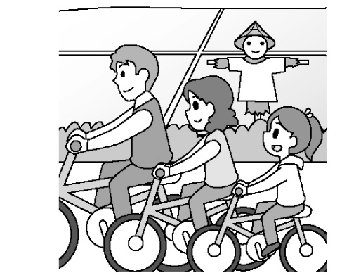

2. | (A) | (B) | (C)
 | 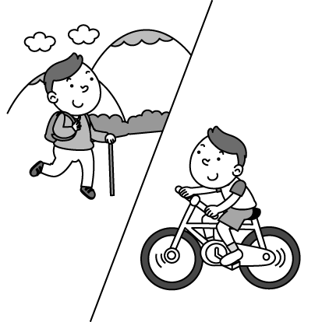 | 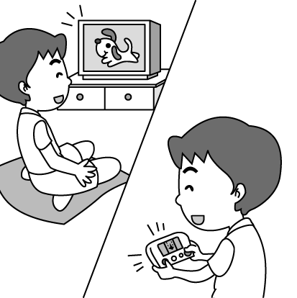 | 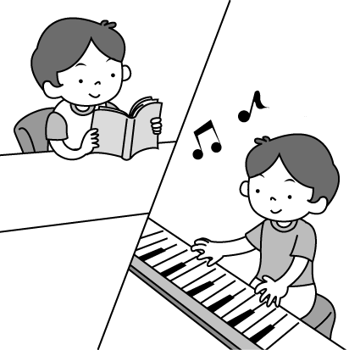

3. | (A) | (B) | (C)
 | 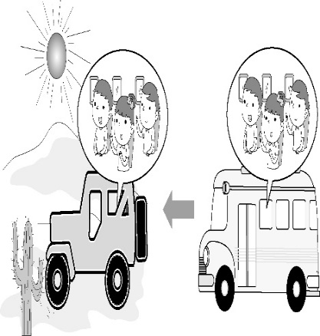 | 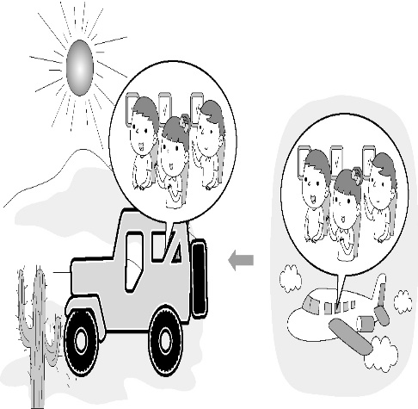 | 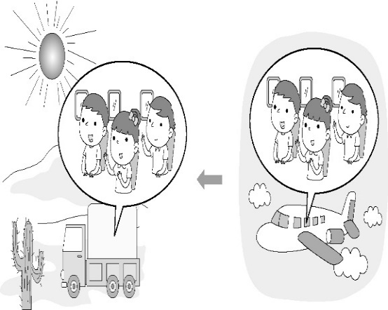

4. | (A) | (B) | (C)
 | 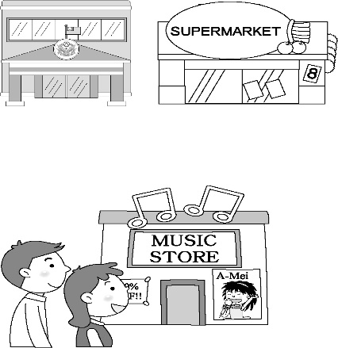 | 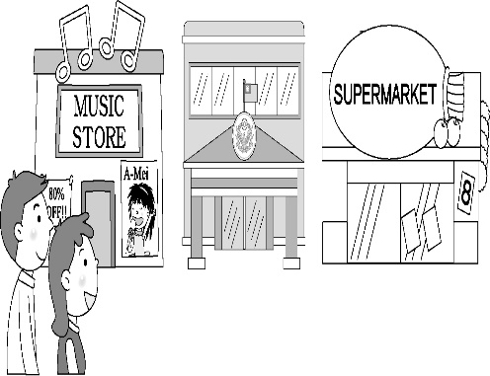 | 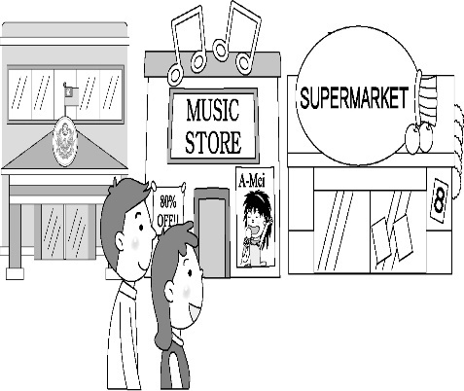

5. | (A) | (B) | (C)
 | 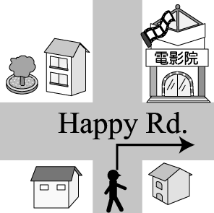 | 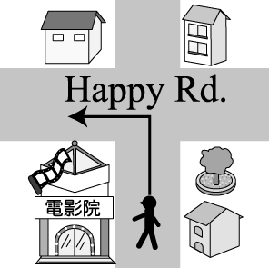 | 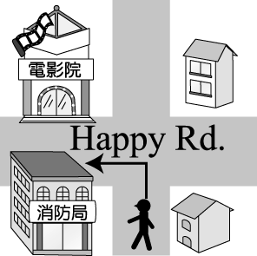

(二)基本問答：根據聽到的內容，選出一個最適合的回應句。
6. (A) You’re right. The blue skirt looks good on Joyce.
(B) Well, pink isn’t Joyce’s favorite color.
(C) Joyce wears a sweater today.

7. (A) It is at 7:30 every morning.
(B) My mom goes there with me.
(C) I usually walk to school.

8. (A) She’s tired. She can’t take a train.
(B) She will drive her new car there.
(C) Her husband will go there with her.

9. (A) In two years.
(B) About three hundred dollars.
(C) About one hour.

10. (A) There isn’t a train station here.
(B) Turn right on Fifth Street and walk down the street for about ten minutes.
(C) The railway station is near a hospital.

(三)言談理解：根據聽到的內容，選出一個最適合的答案。

11. (A) Wupa Bong is the man’s store on the Internet.
(B) The woman will sell water bottles on the Net.
(C) The man will buy one water bottle for his father.

12. (A) On a plane. (B) On a ship. (C) On a train.

13. (A) The woman.
(B) Both of them.
(C) The man.

14. (A) Across from a bank.
(B) Between the train station and the bank.
(C) Two blocks away from the railway station.

15. (A) In Soho House.
(B) In an MRT station.
(C) In an airport.

二、 綜合測驗:(每題兩分) 50%
16. The student _____ 20000 dollars for the computer _____ his pocket money yesterday.
(A) spent with (B) took; on (C) paid; with (D) cost; with

17. My grandmother loves ________ so much. She has many flowers and trees in her garden.
(A) plants (B) planes (C) tacos (D) postcards

18. I love the pants, but _____ ______ me a lot of money.
(A) it; costs (B) they; costs (C) it; cost (D) they; cost

19. There are not many ________ in Taipei city. It is hard for me to park there.
(A) parking lots (B) banks (C) post offices (D) bookstores

20. The _____ of the cellphone in the department store is too high, so I don’t want to buy it.
(A) color (B) price (C) photo (D) turn

21. There ___________ a professional(職業的) baseball game in Taichung this evening. Do you want to watch the game with me?
(A) will have (B) is going to have (C) will be (D) will be having

22. Don’t you see the police officer ____ your left? (A) at (B) in (C) with (D) on

23. It is so cold today. You need to put on the _________.
(A) photo (B) sweater (C) T-shirt (D) tie

24. A: How much money do you have? B: I have ________ dollars.
(A)forty thousand (B) forty thousands (C)forty thousands of (D) forty thousand of

25. A: Our motorcycle _________. B: Let’s go to Grandfather’s house _______.
(A) break down; by foot (B) break down; on foot (C) broke down; by foot (D) broke down; on foot

26. It is hard for people to live in the ______ because it is very hot and dry there.
(A) desert (B) playground (C) bank (D) station

27. _____ do I get to the department store? B: Go straight _____ 3 blocks. It is across from the park.
(A) What; for (B) How; in (C) What; in (D) How; for

28. A: How many feet do _______ have? B: They have six feet. (A) insects (B) goats (C) ducks (D) spiders

29. Please take a ______ with you, or you will get ______ in Tokyo.
(A) map; lose (B) map; lost (C) trip; miss (D) trip; missed

30. Steve has a big dream. He wants to be a captain(機長). He hopes he can __________ in the future.
(A) drive a bus (B) take a bus (C) take an airplane (D) fly an airplane

31. The man ________ 3300 dollars ______ the shoes last year.
(A) took; to (B) spent; in (C) took; on (D) spent; on

32. Will you _______ the HSR (高鐵) to Taichung? Yes, I’ll go there ________.
(A) take; by the HSR (B) take; by HSR (C) get; by the HSR (D) get; by HSR

33. Sam ________ Japan to visit his friend in 4 days. He is so happy.
(A) will go to (B) is going (C) is going to go (D) will be going to

34. Tim works in a fire station. He often saves many people’s ________. (A) life (B) lifes (C) live (D) lives

35. The children from age 6 to 12 in Taiwan need to go to __________.
(A) movie theater (B) elementary school (C) junior high school (D) supermarket

36. My brother likes ______ on Saturdays because he loves the sea very much.
(A) to go climbing mountain (B) going mountain climbing (C) to go surfing (D) going surving

37. A: How long did it _____ you ______ ice cream? B: It took us only 20 minutes.
(A) spend; making (B) spend; to make (C) take; making (D) take; to make

38. I was late for school, so my father ______ me to school. (A) rides (B) rode (C) drives (D) drove

39. There is a supermarket _____ the corner _____ Lake Road and First street.
(A) on; with (B) on; of (C) in; with (D) in; of

40. The girls are so ________. They need to _____ for some drinks.
(A) thirsty; shop (B) thirsty; get to (C) tired; get to (D) sweet; shop

三、克漏字: (每題兩分) 10%

Tina’s birthday 41 . Her family and friends 42 a surprise party for her. Her grandmother will make Tina’s favorite dishes. Her mom will make a big chocolate cake, and her dad 43 some drinks. How about Tina’s grandpa and brother? What will they do? They will make a birthday card. Sally will come to the party, too. Peter will play the violin and Jenny will play the piano 44 Tina. Everyone will sing a song to Tina. 45 to be a wonderful party

41. (A) is coming (B) was coming (C) come (D) came

42. (A) planed (B) planned (C) are planning (D) were planning

43. (A) make (B) makes (C) will make (D) is making

44. (A) for (B) to (C) off (Ｄ)on

45. (A) It will be (B) It’s going (C) It is (D) It was

四、閱讀測驗:(每題兩分) 10%

(一)
People are very busy these days, so they seldom cook. This becomes a problem because home cooking provides a chance for family members to sit together around the table and share their experience of life. For some people, having meals may be the only time everyone sees one another at the same time.
Home cooking is also a way of showing love to each other. Parents make food for their children to show they care about them. Sometimes, parents would like to spend time baking cookies or cake, and ask their children to help and have fun together. In this way, they can make healthy food and spend time with each other.
Next time when you see your mom or dad cooking, try to help and join them. Maybe you will have a wonderful cooking experience.

provide提供; would like to 想要; less較少的
46. Why is home cooking important?
(A) Because people can spend less when they eat at home.
(B) Because parents can spend more time working.
(C) Because everyone can do the housework.
(D) Because it brings family together.
47. Why do people seldom cook now?
(A) They are busy with work.
(B) Parents don’t bake cookies now.
(C) People love to go to restaurants.
(D) It’s a way of saving money.

(二)
Hi! My name is Leona. I’m thirteen and I live with my parents and my little sister.
I adore my weekends. I never get up very early; I usually stay in bed until 11 o’clock in the morning. It’s great to know that you don’t need to be in a hurry. My mom has already prepared yummy breakfast and we talk a little about our home deeds. I like to help her in the kitchen: sweep the floor, wash the dishes, and water the flowers.
At noon we all have lunch, and after it I’m busy with cleaning up. Then I have a lot of free time at my disposal. I send
e-mail to my friends; talk with some of them using Facebook. Then we meet, play together or go to the movies. We like this time.
My family usually spends Sundays together. We often visit our grandparents. We help them in the garden. In the afternoon I do my homework for the next week. Sometimes we go to the park all together, sit on the grass there and listen to the birds. At home we often play different games or discuss some interesting questions. It’s a pity that weekends are so short.

adore崇敬，愛慕; in a hurry匆忙地; deed事情，行為; disposal安排，處置; discuss討論

48. Where does Leona help her mom? (A) In the garden. (B) On the grass. (C) In the living room. (D) In the kitchen.

49. What does Leona NOT do on weekends?
(A) She listens to the birds. (B) She prepares breakfast. (C) She waters the flowers. (D) She does homework.

50. Which is true? (何者為正確?)
(A) Leona doesn’t live with her family.
(B) Leona often visits her uncle on weekends.
(C) Leona thinks that her weekends are too short.
(D) Leona usually gets up at about 11p.m. on weekends.

試題結束

108-1-3 八年級 英語科－解答
一、聽力測驗
1~5 BABCC 6~10 ACBCB 11~15 ACCAB
二、綜合測驗
16~20 CADAB 21~25 CDBAD 26~30 ADABD 31~35 DBADB 36~40 CDDBA

三、克漏字:
41~45ACCAB

四、閱讀測驗
46~50 DADBC

新北市立溪崑國民中學108學年度第一學期第三次定期評量
八年級 英語科 聽力測驗稿
一、 聽力測驗:(每題兩分)
(一) 辨識句意：根據聽到的內容，選出符合描述的圖片。
1：
They are going to Taitung by train.

2：
He enjoys hiking and biking.

3：
They took a plane to Los Angeles, and then drove a jeep to the desert.

4：
There is a music shop between the police station and the supermarket here. Let’s get some CDs.

5：
Turn left on Happy Road, and you’ll see the movie theater on your right.

(二)基本問答：根據聽到的內容，選出一個最適合的回應句。
6：
Joyce looks good in the blue skirt. What do you think?

7：
How do you go to school every morning?

8：
Is Sandy going to Kaohsiung by car or by bus, Henry?

9：
How long did it take you to clean the room?

10：
How can I get to the train station from here?

(三)言談理解：根據聽到的內容，選出一個最適合的答案。

11：
W: What are those? Are they socks?
M: No, they are bags for water bottles. I made them.
W: You are so great, but why did you make so many?
M: I want to sell them at Wupa Bong on the Net.
W: Can I get one first? My father may need one at work.
M: Why not? This is for you. Free!
Q: What can we know from the talk?

12：
M: Wow! Look! The trees, houses, and everything are passing by!
W: Yes. It’s great to look at everything out of the windows!
M: Please take some pictures with the camera. Q: Where are they?

13：
W: There are two ways to get to New York City: by plane or by ship.
M: I think it is fast to fly there; I don’t like to take a ship.
W: Unlike you, I like to take a ship and enjoy looking at the beautiful sea.
Q: Who likes to go to New York City by airplane?

14：
W: Excuse me. How do I get to the MRT station?
M: Go straight for two blocks, and you’ll see a railway station. Turn left at the station, and you can see the MRT station on your right. It’s across from a bank.
Q: Where is the MRT station?

15：
M: Excuse me. Is Soho House near here?
W: Not really. It’s six blocks away from here.
M: Then which line can I take?
W: Orange Line, and you can get off at Fun Station.
Q: Where are the man and the woman?

PS: READ TWICE念兩遍

