新北市立溪崑國民中學108學年度第一學期第三次定期評量 英語科 試題卷
七年級 班 座號 姓名
第一部分:聽力測驗 30%

一、辨識句意：根據聽到的內容，選出符合描述的圖片。
1. (A) (B) (C)
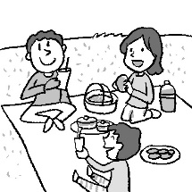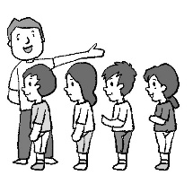

2. (A) (B) (C)
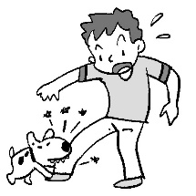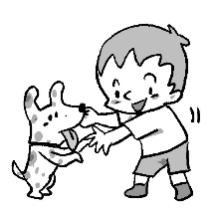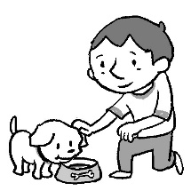
3. (A) (B) (C)

4. (A) (B) (C)
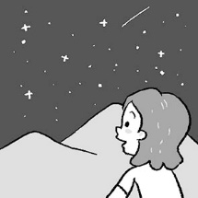
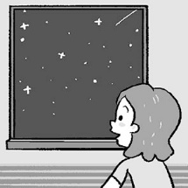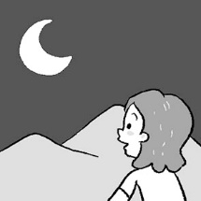

5. (A) (B) (C)
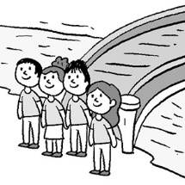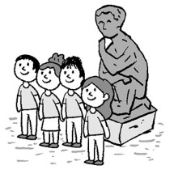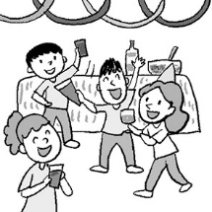

二、基本問答：根據聽到的內容，選出一個最適合的回應。
6. (A)He is in the museum. (B)His sister, Susan, is. (C)He is taking a selfie.
7. (A)Yes, he is in the kitchen. (B)He drinks bubble milk tea. (C)He is cooking dinner.
8. (A)No problem. (B)I’m in trouble. (C)What can you do?
9. (A)Yes, you can. (B)Yes, you are. (C)Yes, it is.
10. (A)I’m having beef noodles. (B)Great! Everything is fine. (C)You can do anything.

三、言談理解：根據聽到的內容，選出一個最適合的答案。
11. (A)Fly. (B)Dance. (C)Swim.
12. (A)They are talking about school. (B)They are talking about water. (C)They are talking about helping the Earth.
13. (A)She is playing pinball. (B)She is drinking bubble milk tea. (C)She is playing ring toss.
14. (A)The girl can’t run fast. (B)Today is cool. (C)The drinks are hot.
15. (A)Johnny is sleeping in the living room. (B)Mrs. Wang is in the kitchen. (C)Elsa is not at home now.


第二部分: 單題 40%
16. Look at the picture. The snowman is __________ .
(A)melting (B)painting (C)talking (D)freezing

17. My father has a big family to ___________.
(A)try (B)feed (C)hunt (D)attack
18. A: Can you help me to move the table?
B: No ________.
(A) picture (B)place (C)cookie (D)problem
19. There are many people _________ at the counters because all things are on sale in Showtime Live Sulin Store.
(A)showing around (B)lining up (C)taking a walk (D) working hard
20. The two _______ in front of the school’s library are cute artworks.
(A)plazas (B)selfies (C)bridges (D)statues
21. Meg’s parents live in Taipei, but she studies in Tainan. So she talks on ___________ with them every day.
(A)a video call (B)a night market (C)a talent show (D)a snack bar
22. A:What is that in your hand?
B:BBQ corn. Would you like to _______________?
(A)watch out (B)make a cake (C)go on a picnic (D)take a bite
23. It’s cold _______. Put on your school jacket.
(A)outside (B)near (C)inside (D)behind
24. People in the Solomon Islands are losing their home because the sea level is ____________.
(A)telling (B)taking (C)rising (D)attacking
25. We can _______ the lights to save the Earth.
(A)paint (B)look for (C)turn off (D)turn on
26. Zack, the hero in DC Comics, can run fast like a __________.
(A)flash (B)member (C)star (D)ticket
27. The baby is sleeping, but his brother and sister ___________.
(A)don’t (B)can’t (C)isn’t (D)aren’t
28. Everyone at the party ____________ fun and _________ photos now.
(A) is having; takes (B)is having; taking (C)having; taking (D)are having; taking
29. Look! Some kids ___________ pinball, and some kids are playing ring toss.
(A)are playing (B)are eating (C)play (D)eat
30. Lucy: _______ is Dad doing in the kitchen? Paul: He ___________ dinner for us.
(A)How; is cooking (B)What; cooks (C)Where; is cooking (D)What; is cooking
31. Jane: Can we see a rainbow after the rain? Bruce: Yes,______________.
(A)we can’t (B)we can (C)we aren’t (D)we are
32. I am sorry, _______ I can’t go to see the movie with you. I have much homework to do.
(A)or (B)and (C)but (D)X
33. Let’s _________ cloth shopping bag to save the Earth.
(A)don’t use (B)use (C)to use (D)using
34.選出錯誤的句子。
(A)You are in trouble. (B)Captain Brave is looking for more members.
(C)A goose can’t fly for a long time, but it can swim underwater. (D)Is Ann and Grace talking on the phone?
35.選出正確的句子。
(A)A snake can’t walk or run. (B)What can the dog, Lucky, doing?
(C)There are many people picnic around the plaza. (D)My grandpa is sitting on the sofa and read newspapers.

第三部分:克漏字選擇 16%
A.
Dear Daniel,
How are you 36 ?
I’m sorry. I 37. to your birthday party tonight because my sister 38. in the hospital. I have to take care of her after school. I called you ten minutes ago, but you didn’t answer the phone. Maybe you were busy preparing for the party then.
Happy 14th birthday!
Meg
36. (A)doing (B)do (C)going (D)go
37. (A)can go (B)can’t go (C)am going (D)go
38. (A)can (B)be (C)are (D)is

B.
Sean: Hi, Kaycee! This is my new robot.
Kaycee: How cool! 39.
Sean: It can talk and sing. It can even help you with your homework.
Kaycee: Wow! 40. Can it jump?
Sean: No, it can’t. But it can catch a ball. You can play sports with it.
39. (A)What is it doing? (B)What can it do?
(C)Can it talk and sing? (D)Is it talking and singing?
40. (A)It cannot walk (B)It can do so many things.
(C)Do something. (D)It can dance.

C. 根據前後文，將下列(A)(B)(C)選項填入41~43的空格中
(A)Let’s all give a helping hand. (B)Make every day Earth day. (C)There is just one Earth.
41.
There are trees, rivers, and mountains.
People and animals all share the land.
42.
Don’t use plastic bags. Plant more trees.
Make a better home for you and me.
Recycle things. Don’t throw them away. plant 種植 make 做；製作 plastic 塑膠的
43. better 更好的 more 更多的 throw away 扔掉

第四部分: 閱讀測驗 14%
A.
There are forty students in Class 724. Of the students, 40% students can play volleyball, 30% can play basketball, 5% can swim, four students can roller-skate, and six students can play frisbee.
- 16 students can ________
(A)play volleyball (B)play basketball (C)swim (D)roller-skate
45. __________ of the students can play frisbee.
(A)30% (B) 40% (C) 10% (D)15%

B.
The popular band, Maroon 5, is having a tour with the famous singer, Meghan Trainor. All their fans can’t wait for the amazing concerts. Here is the schedule for their tour.
5/30 Saturday | 5/31 Sunday | 6/28 Sunday | 8/14 Friday | 8/21 Friday
Chula Vista, CA, US | Phoenix, AZ, US | Toronto, Canada | Vancouver, Canada | Los Angeles, US
North Island Credit Union Amphitheatre | Ak-Chin Pavilion | Budweiser Stage | Rogers Arena | Banc of California Stadium
band樂團 concert 演唱會 schedule 行程表 amazing 令人讚嘆的
46.When is the concert in Toronto, Canada?
(A)May 30 (B)June 28 (C)August 21 (D)May 31
47. Which is true?
(A)Fans can see Maroon 5 in Los Angeles, US.
(B)Fans can go to the concert on Monday.
(C)Fans in Taiwan can see the concert.
(D)Fans in the US can go to the concert on Budweiser Stage.

C.
Chimei Museum
No. 66, Sec. 2,Wenhua Rd., Rende Dist., Tainan City 71755, Taiwan
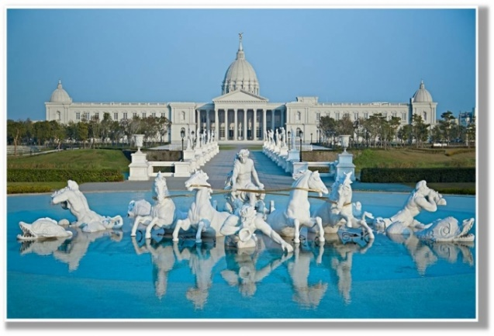
General Visitor Information: +886 (06) 2660808
E-mail: cmm@chimeimuseum.org

Opening time: 9:30-17:30
Closed on : Wednesdays
Chinese Lunar New Year’s Eve and Chinese New Year’s Day
Other days announced by the Museum

Tickets
General Admission: NT $200
Discount Ticket: NT $ 150 Available for students from age 7 to 22, and senior citizens aged 65 and above.
Free Admission: Tainan residents (with a valid ID), Children aged 6 and under, persons with a valid handicap certificate and one companion visiting together, and students holding Tainan City Student ID, and tour guides holding identification passes issued by Tourism Bureau, M.O.T.C. Republic of China, Taiwan. valid 有效的 companion 同伴 issue 發佈
48.Which is true?
(A)Everyone can visit Chimei Museum for free.
(B)Citizens aged 65 and under are free to visit the Museum.
(C)My grandpa is a Tainan resident. He can go to the Museum for free.
(D)Two junior high school students have to pay NT$400 for the tickets to the Museum.
49.Which is not true?
(A)The opening hour is from 9:30 to 17:30.
(B)Chimei Museum is closed on Wednesdays.
(C)You can visit the Museum on Chinese New Year’s Day.
(D)Chimei Museum is in Tainan.
D.
Eating Pig Blood Cake
My friend and I,
The street food in Taiwan.
We don’t eat much.
Sounds and looks strange,
Thinking of what is in it,
pork blood, sticky rice, and soy broth
rolled around in peanut flour,
and topped with cilantro.
My friend and I,
We don’t eat much.

sticky黏的 soy broth醬汁 flour粉 cilantro 香菜
50.What can we know about the speaker?
(A)The speaker enjoy the food. (B)The speaker eats the food a lot.
(C)The speaker wants to make the food at home. (D)The speaker thinks the food is strange.

試題結束
Happy Winter Vacation

108-1-3 七年級 英語科－解答
- C | - A | - C | - B | - C
- B | - C | - A | - A | - B
- B | - C | - A | - A | - C
- A | - B | - D | - B | - D
- A | - D | - A | - C | - C
- A | - D | - B | - A | - D
- B | - C | - B | - D | - A
- A | - B | - D | - B | - B
- C | - A | - B | - A | - D
- B | - A | - C | - C | - D

