新北市立溪崑國民中學108學年度第一學期第二次定期評量 英語科 試題卷
八年級 班 座號 姓名
第一部分:聽力測驗 30%
- 辨識句意：根據聽到的內容，選出符合描述的圖片。

- (Ａ) 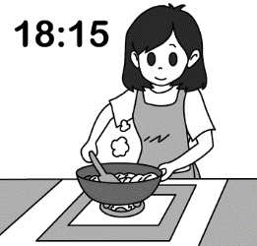 (Ｂ) 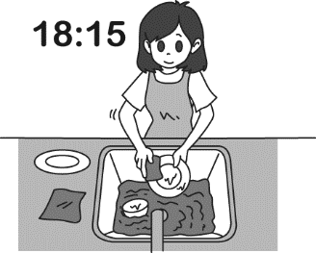 (Ｃ) 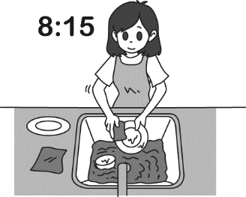
- (Ａ) 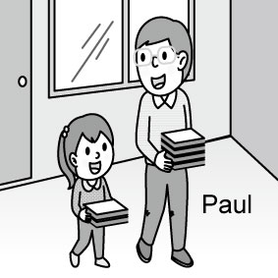 (Ｂ) 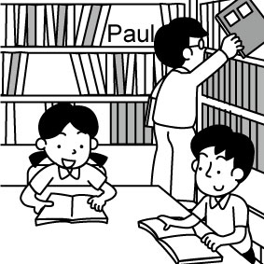 (Ｃ) 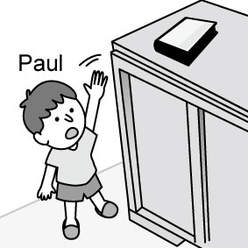
- (Ａ) 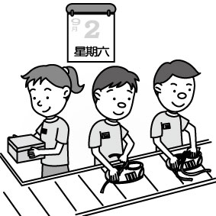 (Ｂ) 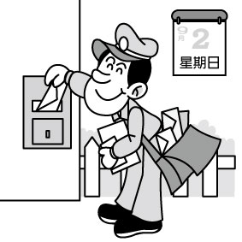 (Ｃ) 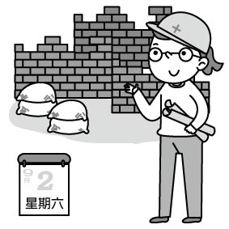
- (Ａ) 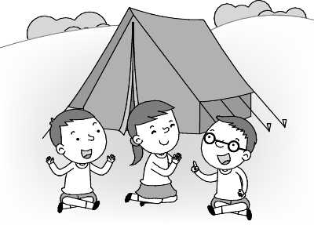 (Ｂ) 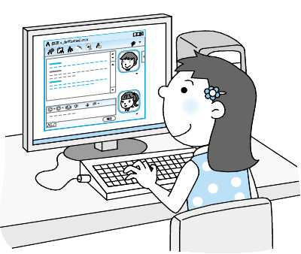 (Ｃ) 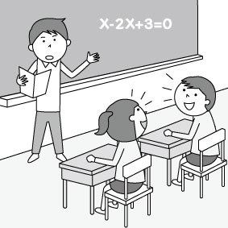
- (Ａ) 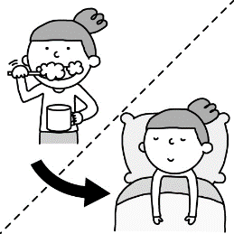 (Ｂ) 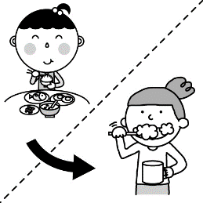 (Ｃ) 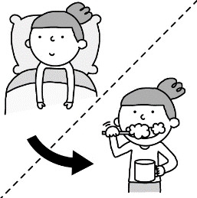

二、基本問答：根據聽到的內容，選出一個最適合的回應。
6. (A)Yes, I did. The English class was interesting. (B)You bet. That’s great. (C)No, I didn’t enjoy the film.
7. (A) Don’t worry. You just need to keep practicing.
(B) What about you? Do you want to be a volleyball player?
(C) Yes, you play volleyball really well.
8. (A) I am hanging the clothes. (B) He was doing the dishes. (C) I was cleaning my bedroom.
9. (A) I have a great idea. (B) He didn’t go there because he was sick. (C) I still have a high fever.
10. (A) It may be somewhere in the living room. (B) Please take it with water. (C) You need to take it three times a day.

三、言談理解：根據聽到的內容，選出一個最適合的答案。

11. (A) At school. (B) At a restaurant. (C) In the kitchen.
12. (A) She tells a joke to the boy.
(B) She thinks it is not easy for the boy to be a math teacher.
(C) She wants to play sports with the boy.
13. (A) Patty didn’t sleep well last night. (B) Patty’s dad will drive her to school. (C) Patty got up at 8:07.
14. (A) He loves his job and he works hard. (B) He got help from other people. (C) He started to work at a young age.
15. (A) The Donation Day. (B) The Thanksgiving Day. (C) The Double Ten Day.

第二部分: 單題 40%
- With this indoor ________, you’ll have an eye on your home. (A)mat (B)shape (C)caution (D)security camera
- After watching the movie Annabelle, I was _________ and couldn’t sleep well at all the whole night.
(A)exciting (B)surprised (C)scared (D)interesting
- The teacher has a good memory. She can _________ her students’ names in one class.
(A)catch (B)memorize (C)decide (D)keep
- Steve Jobs was a successful American __________, and was named the most powerful person in business by Fortune magazine in 2007. (A)businessman (B)police officer (C)mail carrier (D)actor
- He and his team __________ many good ideas, and now they have their own company.
(A)dreamed of (B)looked for (C)came up with (D)cool down
- My younger brother is a big __________ for my parents. They don’t know what to do with him.
(A)sore throat (B)headache (C)flu (D)cough
- The coat was expensive, but I bought it at ________ of price. (A)pose (B)half (C)hospital (D)campfire
- Collecting Bii’s CDs and posters _______ my hobby. I have many of them.
(A)is (B)are (C)have (D)has
- Nick and Helen are twins, but they are in __________ classes. (A)perfect (B)difficult (C)weak (D)different
- To be a _________ singer, Kai needs to practice singing and dancing for long hours every day.
(A)pretty (B)generous (C)terrible (D)popular
- Mom and Dad talked about ________ to Fei’s farewell concert tour.
(A)went (B)go (C) going (D)to go
- My mom couldn’t __________ her cellphone, so I help her __________.
(A)look for; find it (B)find; look it for (C)look for; look for it (D)find; look for it
- Honey, our daughter __________ a cute kitten when we walked past a pet shop. Let’s get it for her birthday.
(A)eyes (B)is eyeing (C)was eyeing (D)to eye
- My grandma likes _________ up early and _________ dancing at the park.
(A)to get; went (B)getting; going (C)get; go (D)get; going
- Sam wants ________ a cook because he ___________ cooking.
(A)to be; is good at (B)being; is afraid of (C)to be; is poor at (D)X; thinks of
- Why ___________ so much trash everywhere on the floor? _______ is important to keep the classroom clean.
(A)are there; This (B)is there; It (C)is; That (D)are; He
- Playing computer games or playing basketball ______ a lot of fun. (A)is (B)are (C)has (D)have
- My classmate, Ken, __________ hurt last Tuesday, and his leg still __________ a lot now.
(A)got ; hurts (B)were; hurts (C)was; hurt (D)get; hurt
- It’s only ten o’clock. Didn’t you plan to __________ until noon?
(A)go to bed (B)go to the hospital (C)take out the trash (D)study at the library
- _____________ lots of water every day because _________ enough water is important.
(A)Remember to drink; drinking (B)Remember to drink; drink
(C)Remember drinking; to drink (D)To remember drinking; to drink

第三部分:題組 14%
A.
Dr. Sue cares a lot about not only others’ health but also his own. 36. To him, it’s important to have regular meals and eat healthy food every day. Dr. Su controls his weight in two ways: 37. As a doctor, he is too busy to go to the gym. He exercises by getting off the bus one or two stops early and walking the rest of the way to his office. Besides, he doesn’t eat too much. He never goes to an all-you-can-eat restaurant and always wears a tight belt. By wearing a tight belt, he can remind himself to 38. if he feels the belt is a little too tight. When it comes to weight control, Dr. Su thinks exercising is better than eating less.
- (A)He wants his family to be healthy. (B)He controls his weight carefully.
(C)He takes Joy Vitamins every day. (D)He makes some changes for his health.
- (A)changing bad habits and taking some medicine (B)enjoying good food and getting enough sleep
(C)skipping meals and eating junk food (D)exercising and not eating too much
- (A)take a rest (B)take some advice (C)hit the sack (D)stop eating

B.
On November 12, 2018, Stan Lee passed away at the age of 96. It was a sad day for fans of superheroes everywhere. He was an American comic book writer, editor, producer and publisher, as well as the former president and chairman of Marvel Comics. In collaboration with other artists at Marvel, he created Spiderman, the Fantastic Four, X-Men, the Avengers, Iron Man, the Hulk, Thor, and many other classic, well-known comic characters. He was recognized as America’s Father of Comic Book Heroes.
As you know, many well-known Marvel Comics have been successfully adapted for the silver screen. A number of the actors playing Stan Lee’s characters have become symbols of superheroes. However, do you know that Stan Lee also appeared briefly in many films based on Marvel Comics? See if you can play the game of “Where is Stan Lee” next time you watch one of these movies! collaboration 合作
- What does passed away mean?
(A) created (B) appeared (C) died (D) based
- Which is not true about Stan Lee?
(A)He was an actor. (B)He created Iron Man and Spiderman.
(C)He left his fans forever. (D)He liked to play the game of “Where is Stan Lee”.
C.
Sleepwalking is also known as somnambulism or noctambulism. Literally, sleepwalking means to walk while asleep. Getting out of bed and walking around while still sleeping is the most common sleepwalking sign. Despite its name, sleepwalking is more than just walking. However, sleepwalkers may also sleeptalk or just sit up in bed and go through repeated motions, such as rubbing their eyes or fussing with their pajamas.
No matter what sleepwalkers do during sleepwalking, though, it's unlikely that they'll remember what they have done. Although their eyes are open, they don’t see the same way they do when they’re awake. This may last from 30 seconds to 30 minutes. Sleepwalking itself isn’t dangerous. But sleepwalkers may be in danger. Because they aren’t awake and may not realize what they’re doing, such as walking down stairs or climbing up trees. Therefore, it’s also a good idea to keep windows doors locked.
- Which is not true?
(A)Sleepwalking is also called somnambulism. (B)A sleepwalker may walk outside while he is asleep.
(C)A sleepwalker won’t remember what he has done. (D)A sleepwalker may just walk while asleep.
42. Why may a sleepwalker be in danger?
(A)Because he knows what he has done while asleep. (B)He may be sick because of rubbing his eyes.
(C)He may fall from trees and get hurt. (D)He may put himself in danger because of sitting up in bed.

第四部分: 依提示作答 8% (每題2分)
- Ken was taking out the trash at a quarter to eight last night.(依畫線部分造原問句)
- It is wonderful to take a hot bath on a cold day.(用Taking 開頭改寫句子)
- singing/dancing/be interesting.(依照提示字序造直述句)
- They talked and laughed. (將at that time置入，改寫句子)

第五部分: 翻譯 8% (每題2分)
- 讓我們拭目以待。
- 我很抱歉跟爸媽說謊。
- 生病真是糟糕。
- 他一天睡8小時。

~試題結束~

新北市立溪崑國民中學108學年度第一學期第二次定期評量 英語科 答案卷
八年級 班 座號 姓名
第四部分: 依提示作答 8% (每題2分)
43.
44.
45.
46.

第五部分: 翻譯 8% (每題2分)
47.
48.
49.
50.

108-1-2 八年級 英語科－解答
- A | - C | - B | - C | - A | - B | - A | - C | - C | - A
- C | - B | - A | - A | - B | - D | - C | - B | - A | - C
- B | - B | - A | - D | - D | - C | - D | - C | - B | - A
- B | - A | - A | - D | - A | - B | - D | - D | - C | - D
- D | - C

第四部分: 依提示作答 8% (每題2分)
- What was Ken doing at a quarter to eight last night?
- Taking a hot bath on a cold day is wonderful.
- Singing and dancing are interesting.
- They were talking and laughing at that time.

第五部分: 翻譯 8% (每題2分)
- 讓我們拭目以待。 Let’s wait and see.
- 我很抱歉跟爸媽說謊。 I am sorry for lying to my parents.
- 生病真是糟糕。 It’s terrible to be sick.
- 他一天睡8小時。 He sleeps eight hours a day.

新北市立溪崑國民中學108學年度第一學期第二次定期評量
八年級 英語科 聽力測驗稿

一、辨識句意：根據聽到的內容，選出符合描述的圖片或符合圖片的描述。
1. Linda was preparing food at a quarter after six yesterday evening.
2. Paul is not tall enough to get the book.
3. The mail carrier needs to work on Sundays.
4. To chat with your classmate in class is not good.
5. It’s important for you to brush your teeth before you go to bed.

二、基本問答：根據聽到的內容，選出一個最適合的回應或最適合的問句。
6. Did you enjoy my magic trick?
(A)Yes, I did. The English class was interesting.
(B)You bet. That’s great.
(C)No, I didn’t enjoy the film.

7. I want to play in the volleyball game, but I don’t play volleyball well.
(A) Don’t worry. You just need to keep practicing.
(B) What about you? What do you want to do?
(C) Yes, you play volleyball really well.
8. I was reading at nine last night. David, what were you doing at that time?
(A) I am hanging the clothes.
(B) He was doing the dishes.
(C) I was cleaning my bedroom.

9. Why didn’t you go to school? What’s wrong?
(A) I have a great idea.
(B) He didn’t go there because he was sick.
(C) I still have a high fever.

10. I can’t find my medicine! Where can it be?
(A) It may be somewhere in the living room.
(B) Please take it with water.
(C) You need to take it three times a day.

三、言談理解：根據聽到的內容，選出一個最適合的答案。
11. G: Jerry, what were you doing at 6 p.m. last night?
B: I was helping my parents in the kitchen. What about you, Susan?
G: I was having dinner with my family at a new restaurant.
Q: Where was Jerry at six last night?
- At school.
- At a restaurant.
- In the kitchen.
12. B: I want to be a math teacher in the future.
G: Are you kidding me?
B: Of course not! I’m serious.
G: But you are not good at math at all. You are good at sports. Why not think of being a sports teacher.
Q: What does the girl mean?
(A) She tells a joke to the boy.
(B) She thinks it is not easy for the boy to be a math teacher.
(C) She wants to play sports with the boy.

13. Mom: Patty, time to get up! You’re going to be late for school?
Girl: Oh no! It’s already eight after seven.
Mom: What were you doing last night? Did you sleep well?
Girl: I was having a bad dream and couldn’t sleep well.
Mom: Poor you. I’ll drive you to school.
Girl: Thanks, Mom.
Q: Which is true?
- Patty didn’t sleep well last night.
- Patty’s dad will drive her to school.
- Patty got up at 8:07.

14. Mr. Wang is a reporter. He started to work at the newspaper office at the age of twenty-five. He works about 14 hours a day, but he never says no to his job. He loves being a reporter because he learns a lot from interviewing other people. He is a great reporter after many years of hard work.
Q: How did Mr. Wang become a great reporter?
- He loves his job and he works hard.
- He got help from other people.
- He started to work at a young age.

15. Dear all, listen carefully, please. Now we are here to give thanks for the happiness of gathering together today. We give thanks for the food prepared by loving hands. We give thanks for health and strength. Thank you for loving us and being with us right where we are.
Q: What day might today be?
(A) The Donation Day.
(B) The Thanksgiving Day.
(C) The Double Ten Day.

