新北市立溪崑國民中學108學年度第一學期第一次定期評量 英語科 試題卷
八年級 班 座號 姓名
一、聽力測驗: 30% (每題2分)

(一)、辨識句意：根據聽到的內容，選出符合描述的圖片。
- （ ）
(Ａ) 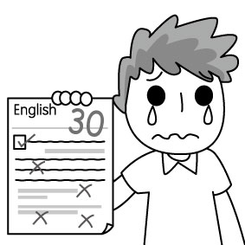 (Ｂ) 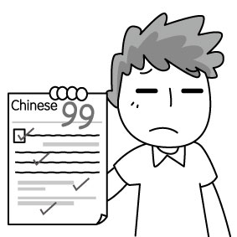 (Ｃ) 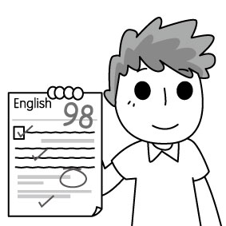
- （ ）
(Ａ) 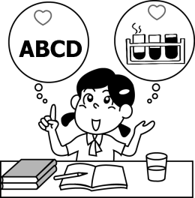 (Ｂ) 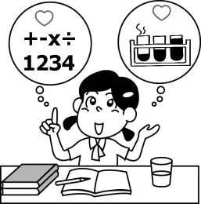 (Ｃ) 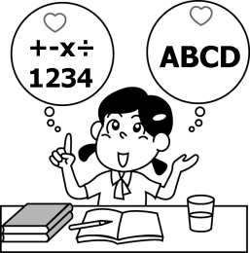
- （ ）
(Ａ) 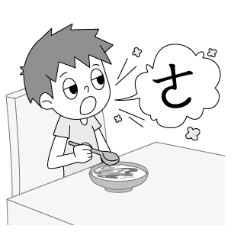 (Ｂ) 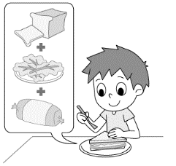 (Ｃ) 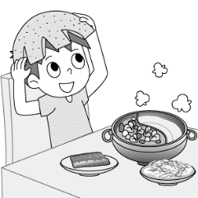
- （ ）
(Ａ) 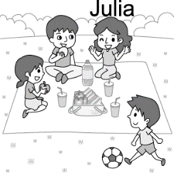 (Ｂ) 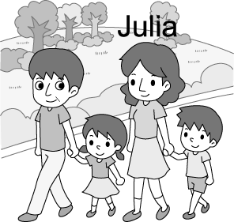 (Ｃ) 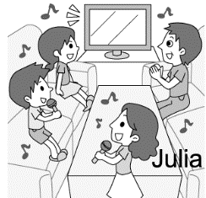
- （ ）
(Ａ) 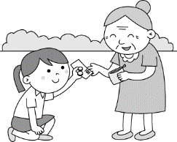 (Ｂ) 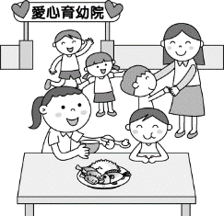 (Ｃ) 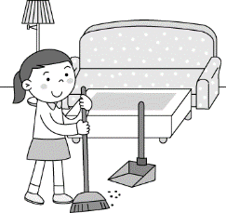

(二)、基本問答：根據聽到的內容，選出一個最適合的回應。
6. （ ）(Ａ) I walk my dog every day.
(Ｂ) I watched a baseball game on TV.
(Ｃ) Yes, I did my homework last night.
7. （ ）(Ａ) I don’t like science. I’m not a smart student.
(Ｂ) Sure. I like it very much. It’s my favorite subject.
(Ｃ) I’m not an elementary school student.
8. （ ）(Ａ) Poor you!
(Ｂ) Let’s ask her.
(Ｃ) That’s a good idea.
9. （ ）(Ａ) Yes, it was great.
(Ｂ) You bet. It was a wonderful trip.
(Ｃ) Nothing special. I just stayed at home and did my homework.
10.（ ）(Ａ) We can donate some money to them.
(Ｂ) They can give food to them.
(Ｃ) We can go swimming with them.

(三)、言談理解：根據聽到的內容，選出一個最適合的答案。
11. （ ）(Ａ) Allen went out last weekend.
(Ｂ) Allen played table tennis with Jim.
(Ｃ) Allen did his homework at home.
12. （ ）(Ａ) Karen didn’t bring her umbrella with her.
(Ｂ) Karen danced in the rain.
(Ｃ) Yesterday was a sunny day.
13. （ ）(Ａ) He is an American.
(Ｂ) He is going to a party at Stone Park on Moon Festival.
(Ｃ) He gets together with his family very often.
14. （ ）(Ａ) The woman is selling the books to the man.
(Ｂ) The woman is generous and kind to the children.
(Ｃ) The big box is from the children.
15. （ ）(Ａ) Kevin needs a new cap because his cap is too old.
(Ｂ) Kevin needs a new cap because he doesn’t like his red cap.
(Ｃ) Kevin doesn’t have any caps, so he needs one.
二、單選題: 30% (每題2分)
16. ( ) On Moon Festival, we visited Taipei 101 and watched the full moon from the 91st floor through the _______. (A) pomelos (B) moon cakes (C) binoculars (D) campfire
17. ( ) Mr. Wang is so ________. He donated a lot of money to the children’s home.
(A) surprise (B) generous (C) cheap (D) poor
18. ( ) Don’t touch the dog, because it might ________ you. (A) spot (B) drop (C) toss (D) attack
19. ( ) Kevin doesn’t eat _________. He eats only vegetables and fruits. ( A) mate (B) floor (C) meat (D) vest.
20. ( ) The weather is so nice, let’s play _______ on the beach. (A) glove (B) exercise (C) PE (D) volleyball
21. ( ) Alex didn’t _______ computer games in the past, but now he _________ them.
(A) plays; like (B) played; liked (C) played ; likes (D) play; likes
22. ( ) A: Mom, Jason’s shoes are too small, and ________ are too old. Mom: Okay. Let’s buy some shoes tonight.
(A) my (B) your (C) mine (D) theirs
23. ( ) A: Dad, did you _________ a birthday present for me? Dad: Of course. Here you are.
(A) give (B) buy (C) send (D) toss
24. ( ) The party yesterday ________ fun. It was a pity you didn’t join us. We __________ a lot of fun then.
(A) had; had (B) had; was (C) was; was (D) was; had
25. ( ) Jane: Did you get up early this morning? Tina: No, my brother gets up early every day, but I never ________ . (Ａ) did (Ｂ) is (Ｃ) do (Ｄ) was
26. ( ) Patty is a _________ dancer. She dances _________. (A) good; good (B) well; well (C) well; good (D) good; well
27. ( ) Ryan went to the doctor, so he ________ to school last Friday. (A) doesn’t go (B) goes (C) went (D) didn’t go
28. ( ) A: Robin was in the hospital last week. ____________ B: He had a car accident.
(A) What did he do? (B) What happened to him? (C) Where was he? (D) When was it?
29. ( ) A: Did you enjoy the karaoke contest? B: _____________. I had a great time.
(A) You bet. (B) You are pulling my leg. (C) Are you sure? (D) No, you didn’t.
30. ( ) A: The dog can do many tricks. B: __________ A: It can jump rope, catch a ball and sing with the music. (A) What’s up? (B) How old is it? (C) Like what? (D) Why not?
三、克漏字測驗: 10% (每題2分)
Last night, my girlfriend Alice ___31____ to me, “I ___32___ get married with a man that always smells like a cigarette. “I was not surprised to hear this because she ___33____ me to quit smoking last month. “I want to leave you and find someone else that never smokes,” said Alice. I begged her to stay and promised that I ____34____ stop ___35___. However, she didn’t listen to me. After she left, I started to cry, “Who can help me?” I looked helplessly around and found that I was not alone. A pack of cigarettes was right beside me. cigarette香菸；beg 乞求；helplessly 無助地; promise 承諾
(背面尚有題目)
31. ( ) (A) says (B) is saying (C) say (D) said
32. ( ) (A) can (B) can’t (C) might (D) am not
33. ( ) (A) asks (B) asked (C) ask (D) is asking
34. ( ) (A) won’t (B) wouldn’t (C) never (D) would
35. ( ) (A) smoke (B) to smoke (C) smoking (D) smoked
四、閱讀測驗: 10% (每題2分)
Mary Lee
Mary Lee was born in Gee’s Bend, Alabama in 1935. Her parents were poor and they had 16 children to rise. Life was hard for almost all families in her hometown.
Winter in Gee’s Bend was very cold. Luckily, the women there were good at quilting. They didn’t have money to buy new cloth, so they used old pants, shirts, and towels to make quilts for their family. Many of the quilts were not only warm but also pretty.
Mary Lee’s mother taught her to quilt when she was a little girl. She learned quickly and could soon make quilts. However, after she got married in1955, she had eight children and worked long hours making uniforms. She had little time to make quilts. In 1992, she retired. She had more time to quilt. Her life is never the same again.
Mary Lee is very smart. She gets her design ideas from the world around her. Her quilts are quite different from others. Her special quilts are very popular, and they usually cost thousands of dollars each because people think of them as art.
For more than ten years, Mary Lee has worked hard to let the world know more about quilting. She often appears on TV or in the newspaper. Her hard work has made more people know her hometown and love its quilts. Also, people’s lives in her hometown are getting better. The future is bright for family in Gee’s Bend.
rise 扶養； cloth 布料； quilt 被褥，縫被子； retire 退休； bright 光明的
36. ( ) How was the weather in winter in Gee’s Bend? (A) It was warm. (B) It was rainy. (C) It was hot. (D) It was cold.
37. ( ) What were the women in Gee’s Bend good at? (A) They quilted well. (B) They liked swimming. (C) They could sing many songs. (D) They were good at making money.
38. ( ) Who taught Mary Lee to quilt? (A) The women in Gee’s Bend. (B) She learned by herself.
(C) Her mother taught her. (D) She learned it from the TV or newspaper.
39. ( ) When did Mary Lee retire? (A) 1935. (B) 1955. (C) 1992. (D) We don’t know.
40. ( ) Which is NOT true about Mary Lee?
(A) Her parents were very poor.
(B) She worked long hours making quilts to raise her children.
(C) She worked hard for more than ten years to let the world know more about quilting.
(D) Her hard work makes people’s lives in her hometown get better.
五、依題示改寫句子: 8% (每題2分)
1. He ate four bowls of rice because he was very hungry. (依畫線部分造原問句)
2. Their skirts are new. Her skirt is old. (用Their開頭並用所有格代名詞合併兩個句子)
3. The man wrote his son a letter. (把a letter改成代名詞it改寫句子)
4. Jay waved to his parents ten minutes ago. (依畫線部分造原問句)
六、翻譯: 12% (每題3分)
1. 幸虧有你們，Alex有了一個很棒的慶生會。
2. 我在一個美國的科學營裡學了很多。
3. 某件很糟糕的事發生了，所以我沒贏得任何獎。
4. 我們可以藉由聽英文歌曲學好英文。

~試題結束~

新北市立溪崑國民中學108學年度第一學期第一次定期評量 英語科 答案卷
八年級 班 座號 姓名
五、依題示改寫句子: 8% (每題2分)
1
2
3
4

六、翻譯: 12% (每題3分)
1
2
3
4

108-1-1 八年級 英語科－解答
一、聽力測驗
1-5 C A B A A 6-10 B B A C A 11-15 C A B B A
二、單選題
16-20 C B D C D 21-25 D C B D C 26-30 D D B A C
三、克漏字測驗
31-35 D B B D C
四、閱讀測驗
36-40 D A C C B
五、依題示改寫句子: 8% (每題2分)
1 | Why did he eat four bowls of rice?
2 | Their skirts are new, but hers is old.
3 | The man wrote it to his son.
4 | What did Jay do ten minutes ago?
六、翻譯: 12% (每題3分)
1 | Thanks to you, Alex had a great birthday party.
2 | I learned a lot at a science camp in America.
3 | Something terrible happened, so I didn’t win any prize (anything) .
4 | We can learn English well by listening to English songs.

新北市立溪崑國民中學108學年度第一學期第一次定期評量
八年級 英語科 聽力測驗稿

一、辨識句意：根據聽到的內容，選出符合描述的圖片。
1.The boy is happy because he does well on the English test.
2.English and science are Patty’s favorite subjects.
3.Andy is making a sandwich.
4.Julia went on a picnic with her family last weekend.
5.It’s so kind of Susan to help the old lady.

二、基本問答：根據聽到的內容，選出一個最適合的回應。
6.What did you do yesterday evening?
7. Are you good at math?
8. I didn’t pass the science test.
9.What did you do on Moon Festival?
10. How can we help the poor?

三、言談理解：根據聽到的內容，選出一個最適合的答案。
11.G: Allen, did you play table tennis with Jim last weekend?
B: No, I was busy. I just stayed at home to do my worksheet.
Q: Which is true about Allen?
12.M: Why did Karen run in the rain?
W: She ran because she didn’t bring her umbrella with her.
Q: Which is true?
13.M: I don’t like Moon Festival because I can’t get together with my family in Taiwan.
W: You can have a good time with my family. We are having a big party at Stone Park tonight. Let’s watch the moon and enjoy a fun time together.
M: Wow! My first Moon Festival in America.
Q: Which is true about the man?
14.M: Who are the picture books in the big box for?
W: They are for the children at the Children’s Home.
M: That’s very kind of you.
Q: Which is true?
15.W: Kevin, what do you want for your birthday?
M: I want a new cap.
W: Why? Your red cap is cool.
M: Yes, it is. But it is too old.
Q: Why does Kevin need a new cap?

