新北市立溪崑國民中學108學年度第一學期第二次定期評量 英語科試題卷
七年級 班 座號 姓名
- 聽力測驗(30%)
- 辨識句意 : 根據聽到的句子，選出符合描述的圖片(8%)
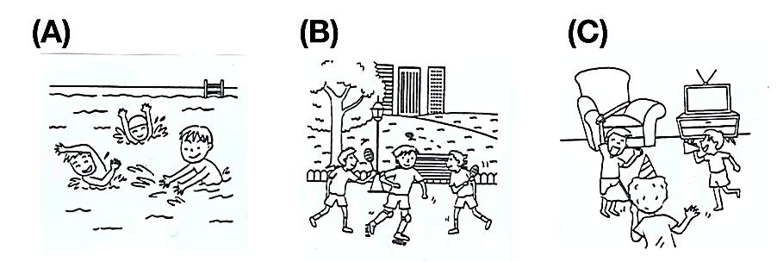
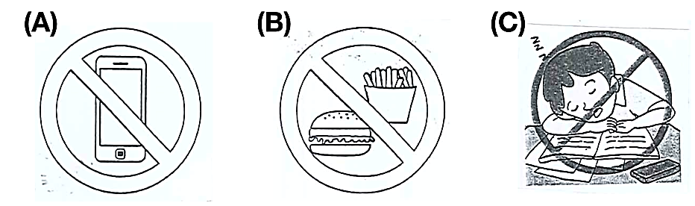
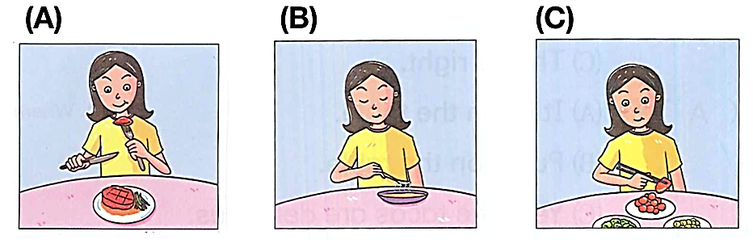
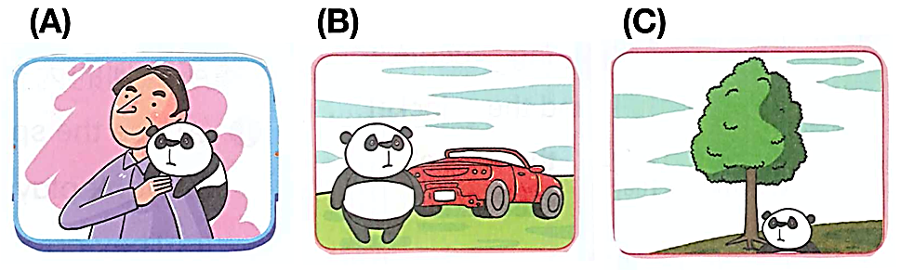
B. 基本問答：根據聽到的內容，選出合適的回應。(12%)
- (A) Just give it a shot. (B) OK. I’m fine. (C) Yes, it’s a piece of cake.
- (A) They are some books. (B) It is a book. (C) There is a pin.
- (A) It is in the living room. (B) They are on the table. (C) They are from Tommy.
- (A) They are on the table. (B) OK. Let’s get the ball rolling. (C) Bingo! They are in Italy.
- (A) Let’s try again. (B) Where is the parrot? (C) Really? Let’s take a look.
- (A) They are so nice. (B) You are so kind. (C) I love parrots.
C. 言談理解：根據聽到的內容，選出最適合的答案。(10%)
- (A) No. He is at home. (B) Yes, he is in the classroom. (C) No. He is in the garage.
- (A) Yes, there are. (B) No. There are five. (C) No. There are four.
- (A) Peter. (B) Peter’s grandpa. (C) Peter’s sister.
- (A) Yes, they are. (B) No. They are on TV. (C) No, they are not.
- (A) There is a small garden in his house. (B) The garden is in front of the garage. (C) There are no flowers in the garden.
- 綜合測驗 (30%)
- touch the box.
(A) Not (B) No (C) Isn’t (D) Never
- A: Are there pins in the box? B: Yes, there are .
(A) a; any (B) any; one (C) one; two (D) any; some
- My father’s cellphone is .
(A) on the desk in the room (B) in the room on the desk (C) in the living room on the sofa (D) in the desk on the room
- The ball game is Double Ten Day, 9 a.m. 10:30 p.m.
(A) in; at; at (B) on; from; to (C) in; at; on (D) on; from; and
- Let’s go to the zoo and .
(A) give it a shot (B) be fun (C) it’s fine (D) have fun
- Don’t bring drinks. They are .
(A) some; on I (B) some; for me (C) any; on me (D) any, for I
- 選出正確的句子:
(A) Let’s play the knife. (B) There’re not any hippos in the zoo. (C) The teacher is coming. Let’s no talk. (D) I love you all.
- 選出正確的句子:
(A) My dad is fun at the party. (B) Where’s your father? He’s in there. (C) Let’s talk to the girl about the game.
(D) What are you doing? I’m doing well.
- Please run shout in the classroom.
(A) not; and (B) don’t ; and (C) no; and (D) don’t; or
- A: Are there two hippos in the zoo? B: .
(A) Yes, they are (B) Yes, there is (C) Yes, there are (D) No, they are not
- angry. Let’s do it again.
(A) Be (B) Don’t (C) Please (D) Don’t be
- A: What is the boxes? B: It’s something Japan.
(A) in; for (B) between; from (C) on; to (D) in; from
- 選出正確句子:
(A) Tom, don’t sit on the desk, please. (B) Tom, please, don’t open the box. (C) Please don’t talk in class Mary.
(D) Don’t run , Mary, please.
- A: Here are many beautiful pictures. Let’s . B: OK.
(A) take a look at it (B) taking a look (C) take a look at them (D) not take a look at it
- A: B: Yes, they are on the table.
(A) Aren’t the books on the table? (B) How are the books? (C) Where are the books? (D) What are the books?
- 題組(16%)
A
There are many kinds of plants. A plant cannot live without water. They are alike in some ways. A plant cannot live without light. Some plants have roots. Some plants have leaves. Some plants have stems. Some plants have flowers. The roots of a plant help it stay in the ground. The roots also help the plant get water from the ground. The green leaves use light from the sun to make food. This food helps the plant grow. The stem of a plant helps it get water. The stem takes water from the roots to the leaves and flowers. Some plants have flowers. The flowers make seeds. New plants can grow from flower seeds.
root根 without 沒有 stem莖 ground地面
- help a plant get water.
(A) The roots (B) The flowers (C) The seeds (D) The leaves
- The green leaves use light from the sun to .
(A) make food (B) take water (C) grow flowers (D) stay in the ground
- Which is true? （何者正確？）
(A) The stem takes water to the roots. (B) All plants have flower seeds. (C) The root helps the plant stay in the ground.
(D) A plant can live without water.
B
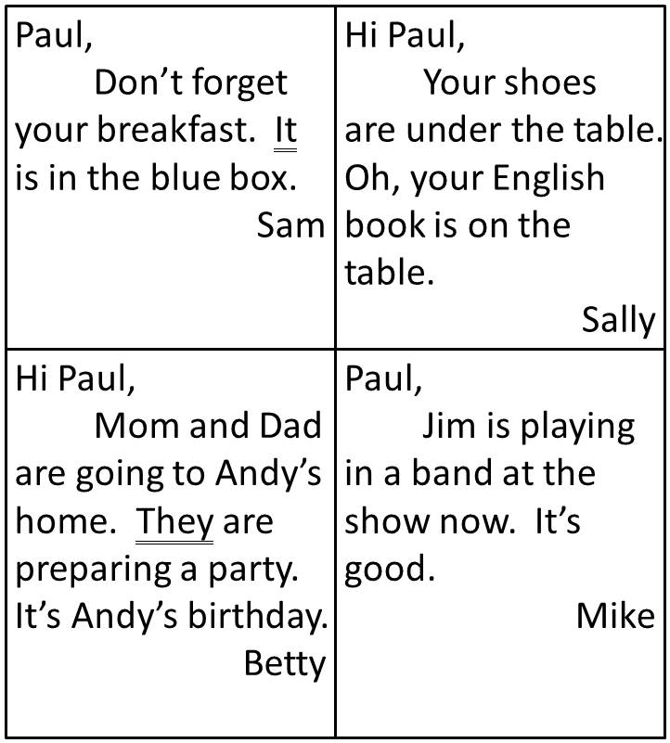
- Who are “they”?
(A) Betty and Andy. (B) Betty’s mom and dad. (C) Sally and Paul. (D) Mike and Paul.
- What is “it”?
(A) The box. (B) The party. (C) The English book. (D) The breakfast.
- Which is true?
(A) The breakfast is in the blue box. (B) Paul’s shoes are on the chair. (C) Mike is playing in the band.
(D) The birthday party is for Betty.
C
Students, listen to me. We are on the way to Happy Zoo. Please follow the rules on the bus. One, don’t run. Two, don’t talk loudly. Three, don’t litter. Our lunch is at Jungle House. It is behind the gate. And don’t forget your homework. Take a photo or draw a picture of your favorite animals. Come back to the bus at 15:00. Don’t be late.
- What is “it”?
(A) The zoo. (B) The bus. (C) The restaurant. (D) The lunch.
- Which is true?
(A) The students are at the zoo now. (B) There are five rules on the bus. (C) The bus is late.
(D) The students have homework.
- 文意字彙 (8%)
- What a s e! The gifts are so great!
- Ben is a smart and h g student. His grades are very good.
- The cake is so d s. I like it .
- Let’s i e Peter to our house.
- 依提示改寫 (4%)
- There is a hippo under the tree. (依畫線部分造原問句)
- Tina is kind to her classmates. (以Tina…為句首，改成祈使句)
- 整句式翻譯(12%)
- 順道一提，下次帶些來自你國家的菜餚。
- 桌上的那些墨西哥捲餅是給我的哥哥的。
- 歡迎你到我家參加派對。
- 我的夾克在浴室裡，而不是在箱子後面。

新北市立溪崑國民中學108學年度第一學期第二次定期評量 英語科 答案卷
七年級 班 座號 姓名
四 文意字彙 (8%)
39 | 40 | 41 | 42

五 依提示改寫 (4%)
43
44

六 整句式翻譯(12%)
45
46
47
48

108-1-2 七年級 英語科－解答
- 聽力測驗(30%)
01-05 CCABA
06-10 CBBCC
11-15 AACCB
二、綜合測驗 (30%)
16-20 DDABD 21-25 CDCDC 26-30 DBACA
三 題組 (16%)
31-35 AACBD 36-38 ACD
四 文意字彙 (8%)
39 surprise 40 hard-working 41 delicious 42 invite
五依提示改寫 (4%)
43 What is there under the tree? (2%)
44 Tina, be kind to your classmates. (2%)
六翻譯(12%)
45 By the way, bring some dishes from your country next time.
46 The (Those) tacos on the table are for my brother.
47 You are welcome to my house for the party.
48 My jacket is in the bathroom, not behind the box.

新北市立溪崑國民中學108學年度第一學期第二次定期評量
七年級英語科聽力測驗稿
- 聽力測驗(30%)
- 辨識句意 : 根據聽到的句子，選出符合描述的圖片(8%)
- We have fun at the party.

- Don’t sleep in class.

- I have the steak with my fork and knife .

- Where is the panda? It’s in front of the car.
B. 基本問答：根據聽到的內容，選出合適的回應。(12%)
- It’s not easy to eat the beef noodles with chopsticks. (A) Just give it a shot. (B) OK. I’m fine. (C) Yes, it’s a piece of cake.
- What is there on the sofa in the living room? (A) They are some books. (B) It is a book. (C) There is a pin.
- Where are the gifts for Betty? (A) It is in the living room. (B) They are on the table. (C) They are from Tommy.
- Let’s write some cards to the friends in Italy. (A) They are on the table.(B) OK. Let’s get the ball rolling. (C) Bingo! They are in Italy.
- There is a parrot on Tim’s shoulder. (A) Let’s try again.(B) Where is the parrot? (C) Really? Let’s take a look.
- I love monkeys. They are so cute. What about you? (A) They are so nice. (B) You are so kind. (C) I love parrots.
C. 言談理解：根據聽到的內容，選出最適合的答案。(10%)
- W: Ben, where is your brother, Leo? Is he at school?
M: No. He is in his bedroom.
W: How about your parents? Are they in the bedroom, too?
M: No, they aren’t. They are in the garage.
Q: Is Ben’s brother at school?
  - No. He is at home.(B) Yes , he is in the classroom. (C) No. He is in the garage.
- W: Hey, listen to me. There are some rules for you. Don’t eat, don’t run and don’t shout in the classroom.
Q: Are there three rules for the students?
(A) Yes, there are . (B) No. There are five. (C) No. There are four.

- My name is Peter. My mom and dad are in the living room. My grandpa is in the bathroom. My sister is at school. Where am I ? I’m in my bedroom.
Q: Who is not at home?
  - Peter. (B) Peter’s grandpa. (C) Peter’s sister.

- W: Pete, look at the panda on TV! Isn’t it cute?
M: Yes, it is.
W: Let’s go to the zoo today. OK?
M: OK.
Q: Are the boy and girl in the zoo?
  - Yes, they are. (B) No. They are on TV. (C) No, they are not.

- M: Welcome to my house.
W: Thank you , Billy. Wow, how big your garden is. The flowers are so beautiful.
M: Thanks.
W: Show me your new car.
W: OK. The garage is behind the garden. Let’s go.
Q: Which is true about Billy’s house ?
(A) There is a small garden in his house. (B) The garden is in front of the garage. (C) There are no flowers in the garden.

