新北市立溪崑國民中學108學年度第一學期第一次定期評量 英語科 試題卷
七年級 班 座號 姓名
一 聽力測驗30%
一、聽力(辨識句意)-根據聽到的內容，選出正確的圖片代碼：10%
1. (A)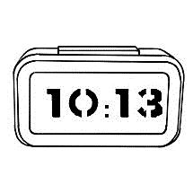 (B)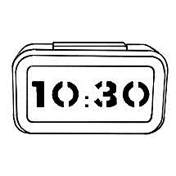 (C)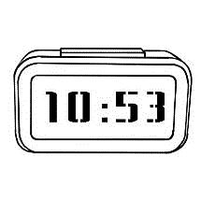

2. (A)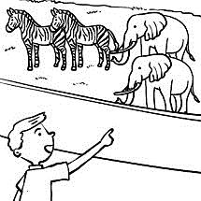 (B)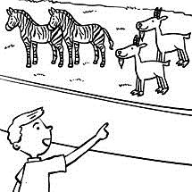 (C)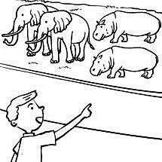

3. (A)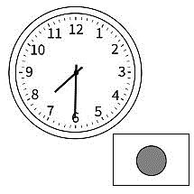 (B)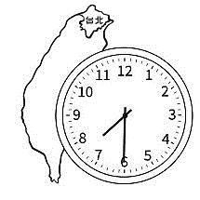 (C)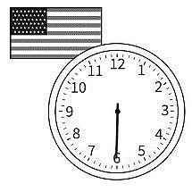

4. (A)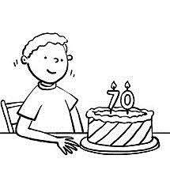 (B)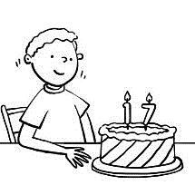 (C)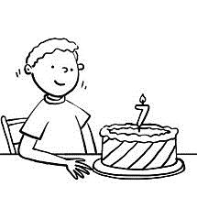

5. (A) (B)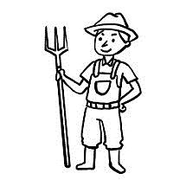 (C)

二、聽力(基本問答)-根據聽到的內容，選出合適的回應：10%
6. (A) Yes, he is. (B) No, she is short. (C) Yes, he is very strong.
7. (A) She’s my sister. (B) She’s from India. (C) She’s 19 years old.
8. (A) It’s five thirty. (B) It’s 2020-1234. (C) That is my phone.
9. (A) Me, too. (B) I’m fine. (C) I’m from Taiwan.
10. (A) Yes, I’m really into it. (B) You are a smart cookie. (C) Right. Ten more points for you.

三、聽力(言談理解)-根據聽到的對話內容與問題，選出正確的答案：10%
11. (A) Eleven. (B) Twelve. (C) Thirteen.
12. (A) It is a bird. (B) It is a duck. (C) It is a goose.
13. (A) The boy’s mom is a doctor. (B) The boy’s mom is a teacher. (C) The boy’s mom is a housewife.
14. (A) Jack’s sister. (B) Amy’s sister. (C) Lucy’s friend.
15. (A) Tina is a doctor. (B) Tina is from India. (C) Tina is Sandy’s friend.

二 綜合測驗 38％
16. Welcome ____ our show. Are you ready ____ the game? (Ａ) to ; to (Ｂ) to ; for (Ｃ) for ; at (Ｄ) of ; in
17. Jeremy Lin is a ____NBA basketball player（選手）. (Ａ) big (Ｂ) old (Ｃ) famous (Ｄ) clean
18. A: _____ B: He’s fine. Thanks. (Ａ) How is your father? (Ｂ) How’s your mother?
(Ｃ) What’s your sister’s name? (Ｄ) Who is your sister?
19. Sasha is my ____. ____ mother is my wife. (Ａ) daughter ; Her (Ｂ) sister ; She (Ｃ) aunt ; He (Ｄ) cousin ; His
20. A: Where___ the farmer from? B: ____ from Japan. (A) are ; I’m (B) are ; They’re (C) is ; He’s (D) is ; You’re
21. Look___ this photo. The woman in it ___ my grandmother. (Ａ) in ; is (Ｂ) at ; is (Ｃ) for ; are (Ｄ)from ; am
22. A: ____ are three and five? B:____. (Ａ) Who ; Six (Ｂ) What ; Eight (Ｃ) How ; Seven (Ｄ) Where ; Nine
23. Joe: You are ____. Betty: Thank you. (Ａ) a piece of cake (Ｂ) short and fat (Ｃ) old and ugly (Ｄ) a smart cookie
24. A: Is Ken Mr. and Mrs. Lin’s grandson? B: ____ (A)Yes, they are. (B)Yes, he is. (C)No, you are not. (D)No, it is not.
25. A: What ____ those? B: They’re ____. (A) are ; leaf (B) are ; leaves (C) is ; rabbits (D) is ; a rabbit
26. A: ____ is it? B: It is ____ orange. (A) How ; a (B) Who ; an (C) What ; an (D) Where ; a
27. ___ teacher, Mr. Trump,____ very nice. (Ａ) I ; am (Ｂ) My ; is (Ｃ) He ; are (Ｄ) His ; be
28. A: Is that ___ actress young? B: No. She’s ___ actress. (Ａ) a ; an old (Ｂ) × ; old (Ｃ) a ; old (Ｄ) × ; an old
29. This is ___ uniform, and that is ____ umbrella. (Ａ) a ; a (Ｂ) an ; a (Ｃ) an ; an (Ｄ) a ; an
30. My father is not at home ____ morning, but he is at home ____ night. (Ａ) in; in (Ｂ) in the; in (Ｃ) in; at (Ｄ) in the; at
31. A: What ____ is it? B: It’s ____ o’clock. (A) year ; twenty (B) X ; eleven ten (C) time ; eleven (D) day ; thirteen
32. A: ____ your phone number? B: ___ 2686-9727. (Ａ) Is ; It’s (Ｂ) Are ; They’re (Ｃ) What’s ; × (Ｄ) What are ; They’re
33. A: What are ___ parents ? B: ___ are clerks. (A) this ; They (B) their ; It (C) your ; They (D) they; Those
34. A: How ___ is your brother? B: He’s three ____. (A) time ; years old (B) day ; old (C) tall ; year old (D) old ; years old

三 閱讀測驗 8%

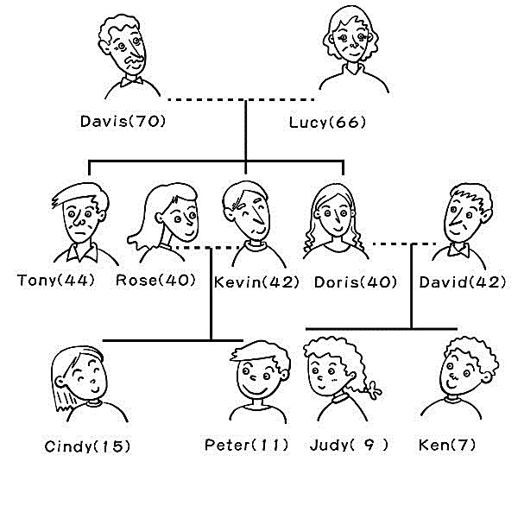

35. Who are brother and sister?
(A) Kevin and Rose. (B) David and Doris. (C) Tony and Doris. (D) Ken and Cindy.
36. Who are cousins?
(A) Tony and Rose. (B) Kevin and Doris. (C) Peter and Judy. (D) Cindy and Peter.


Hello Lily,
Happy Postcrossing! I am Allen. I am 35 years old and I am a tour guide from Taiwan. I am in London now. Big Ben is a famous landmark in London, the UK. Big Ben tells the time every quarter. On the New Year’s Day, people listen to the bell sounds from Big Ben. They are happy. The bell sounds tell them: “The New Year is coming.”

37. What is the short story about? (A) It is about a clock. (B) It is about a man. (C) It is about the UK. (D) It is about time.
38. Where is Allen from? (A) Taiwan. (B) The UK. (C) On the New Year’s Day. (D) Big Ben.

四. 字母大寫改小寫、小寫改大寫6%
39.. AMAZING 40. STUPID 41. housewife

五. 依提示作答 6%
42. Yes, my brother is late for school. (依劃線部分造原問句)
43. These are angry birds.（將複數句改為單數句）
44. That small mouse is not dirty.（將單數句改為複數句）

六. 翻譯 12%
45. 這個皇后和她丈夫的故事非常感人。
46. 我們的朋友來自世界各地。
47. 大腳怪很強壯並且毛茸茸的，但它不是熊。
48. 它的顏色在一天中會有所不同。

新北市立溪崑國民中學108學年度第一學期第一次定期評量 英語科 答案卷
七年級 班 座號 姓名
四. 字母大寫改小寫、小寫改大寫6%
39. |  | 40. |  | 41.

五. 依提示作答 6%
42.
43.
44.

六. 翻譯 12%
45.
46.
47.
48.

108-1-1 七年級 英語科－解答
一.聽力測驗30%
1 BABBA 6 AABAA 11 CCCBC
二.綜合測驗38%
16 BCAAC 21 BBDBB 26 CBDDD 31 CCCD
三.閱讀測驗8%
35 C 36 CAA
四. 字母大寫改小寫、小寫改大寫6%
39. amazing 40. stupid 41. HOUSEWIFE
五. 依提示作答 6%
42. Is your brother late for school?
43. This is an angry bird.
44. Those small mice are not dirty.
六. 翻譯 12%
45. The story of the queen and her husband is very touching.
46. Our friends are from all over the world.
47. Bigfoot is strong and hairy, but it is not a bear.
48. Its colors are different during the day.

新北市立溪崑國民中學108學年度第一學期第一次定期評量
七年級 英語科 聽力測驗稿
一、聽力(辨識句意)-根據聽到的內容，選出正確的圖片代碼：
- It is ten thirty.
- Those are elephants and zebras.
- It’s seven thirty in Taiwan.
- Tony is seventeen years old.
- Ted is a tour guide.

二、聽力(基本問答)-根據聽到的內容，選出合適的回應：
- Is Amy’s brother tall?
- Who’s that girl?
- What’s your phone number?
- I’m sixteen years old. How about you?
- That’s a very touching story.

三、聽力(言談理解)-根據聽到的對話內容與問題，選出正確的答案：

B: How old are you, Jane?
G: I’m thirteen years old. What about you and your brother?
B: I’m twelve years old, and my brother is eleven years old.
G: My sister is eleven years old, too.
Q: How old is Jane?

W: Look at the picture. What is this?
M: Is it a bird?
W: No, it is not.
M: Is it a duck? Wait! It’s a goose!
W: Yes. You are right!
Q: What is in the picture?

B: Is your mom a doctor?
G: No, she’s a teacher. How about your mom?
B: She’s a housewife.
G: That’s cool.
Q: Which is right?

B: Amy, the picture on the postcard is beautiful!
G: Thank you, Jack.
B: Is it from your friend?
G: No, it’s from my sister, Lucy.
Q: Who is the postcard from?

B: Sandy, is your friend, Tina, from India?
W: No, she is from Japan.
B: Wow! Is she a doctor?
W: No, she is a nurse.
Q: Which is right about Tina?

