新北市立溪崑國民中學108學年度第一學期第二次定期評量 英語科 試題卷
九年級 班 座號 姓名
一、聽力測驗30%
(一)辨識句意：每題均有三張圖片，請依據所聽到的句子，選出符合描述的圖片(每題2分，共10分)
- (A)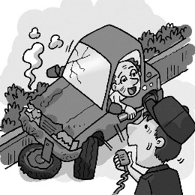 (B)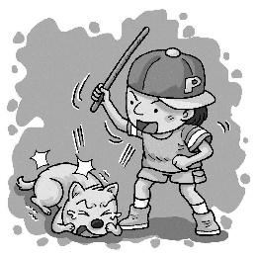 (C)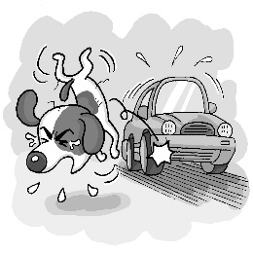
- (A)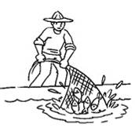 (B)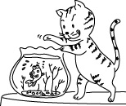 (C)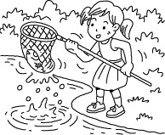
- (A)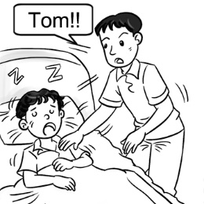 (B)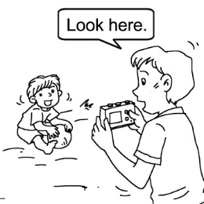 (C)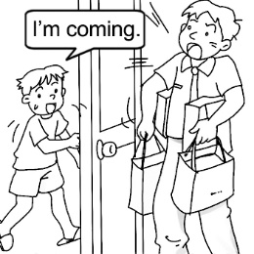
- (A)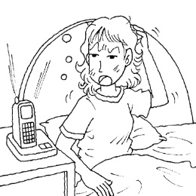 (B)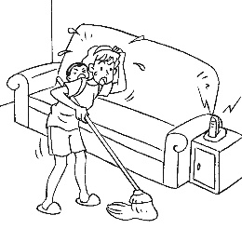 (C)
- (A)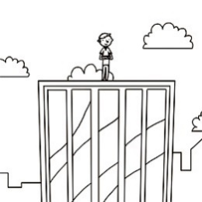 (B)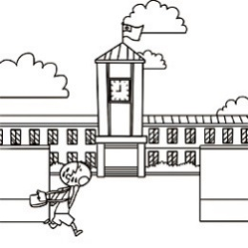 (C)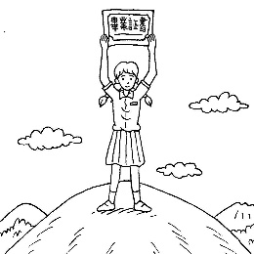
(二)基本問答：每題均有三個選項，請依據所聽到的內容，選出一個最適合的回應(每題2分，共10分)
- (A) Without a doubt.
(B) Yes, the tool is useful.
(C) Would you lend me a hand?
- (A) Yes, it’s convenient for him.
(B) No, his cellphone is off.
(C) Yes, I’ve got some information from the workers.
- (A) Then, you need to study more poems.
(B) Your dream is to become a fashion designer.
(C) Then, going to a vocational school might be a good choice for you.
- (A) You are right. The room is too dark to see anything clearly.
(B) My designer says that looking pale has become fashion these days.
(C) I am so worried about the trip that I haven’t had a good sleep for a week.
- (A) Then, wear the vest instead.
(B) You’d better take the gloves with you.
(C) You look pale because you’ve caught a cold.
(三)言談理解：每題均有三個選項，請依據所聽到的對話與問題，選出一個最適當的答案(每題2分，共10分)
- (A) Liz’s house was on fire.
(B) Helen is in the hospital now.
(C) The woman couldn’t reach Liz.
- (A) He was saved by Justin.
(B) He was found by Justin.
(C) He was kicked by Justin.
- (A) The man has already set up a Facebook account.
(B) The man didn’t invite anyone to the party on Facebook.
(C) The man does not feel like seeing the woman tonight.
- (A) Many people were killed by Raymond Wu.
(B) Raymond Wu has been caught in the hotel.
(C) Someone called to give information about Raymond Wu.
- (A) The twelfth floor.
(B) The thirteenth floor.
(C) The fourteenth floor.

二、綜合測驗30%
16. Taking the MRT is the most way to get around Taipei.
(A) missing (B) information (C) convenient (D) similar
17. I saw a cloud of thick on my way home yesterday. I don’t know what happened.
(A) circle (B) smoke (C) mark (D) wall
18. In the 1990s, once people the beepers going off, they would go and find a phone to call back.
(A) reached (B) made (C) knocked (D) noticed
19. Jane looks tired and a little , her lips are pale ,too. She had better go to see a doctor now.
(A) tidy (B) spirit (C) weak (D) dark
20. His cellphone by a friend of a few hours ago.
(A) was found ; his (B) was found ; him (C) found ; him (D) has been found ; his
21. A:When should the puppy ? B:My mom always feeds it .
(A) feed ; many times (B) feed ; twice a day (C) be fed ; four hours ago (D) be fed ; every four hours
22. The thief was seen the building more than once before the police caught him.
(A) enter (B) entered (C) to enter (D) has entered
23. My best friend’s birthday is coming. Do you know ? I have no idea ?
(A) what does she like ; who to ask for help (B) what she likes ; what to buy
(C) what she likes ; how to do it (D) what does she like ; what to do
24. Meg has green fingers. She tells me when I grow plants.
(A) what is needed (B) what do I need (C) what can I do (D) how is needed
25. A: We to tidy up our classroom every morning by our teacher. Do you know for ?
B: For your good health , of course.
(A) asked ; what is it (B) have asked ; what it is (C) are asked ; why it is (D) are asked ; what it is
26. Don’t worry about tomorrow. Seize the day and thank for what you have right now.
(A) what happened (B) what’s happened (C) what will happen (D)what was happening
27. At the age of 60 , the words on the newspaper are small for me read. I need my reading glasses.
(A) so ; that (B) too ; to (C) not ; enough to (D) not only ; but
28. The Korean group , Twice , is popular thousands of fans are crazy for them.
(A) so ; that (B) such ; that (C) too ; that (D) enough ; that
29. I wonder on the final exam. I should study harder before it’s too late.
(A) can I do well (B) whether will I do well (C) whether can I do well (D) if I can do well
30. Harry Potter is a great movie I’ve seen it many times.
(A) so ; that (B) such ; that (C) too ; to (D) enough ; that

三、克漏字測驗10%
The 2019 Nobel Prize in Chemistry has (31) to three scientists —John B.Goodenough, M. Stanley Whittingham and Akira Yoshinofor —for their work in developing lithium-ion batteries. John Goodenough is (32) a Nobel prize at the age of 97. The Li-ion battery can store energy from renewable sources like the wind ,sun and water, which open up new possibilities (33) global warming.
Austrian writer Peter Handke won the 2019 Prize in Literature. The 2018 Prize in Literature , announced this year as well , went to Polish writer Olga Tokarczuk.
MIT’s Abhijit Banerjee and Esther Duflo, and Havard’s Michael Kremer won the 2019 Nobel Prize in Economics for their creative study about reducing and solving the problems of being (34) in some countries like India, Ethiopia and Kenya. Their study has been a great help to those children who are out of school because of poverty.
Chemistry 化學 lithium-ion batteries 鋰電池 Literature 文學 Economics 經濟
31.(A) give (B) gave (C) be given (D) been given
32.(A) the oldest ever winner of (B) a very young winner of
(C) behind the winner of (D) like the winner of
33.(A) stopped (B) to stop (C) stopping (D) stop
34.(A) so mean (B) too powerful (C) very generous (D) extremely poor
35. Which is NOT a renewable source according to the reading ? (A) wind (B) water (C) oil (D) sun

四、閱讀測驗10%
(一)
Mutualism
In science class, Mr.Chen shows this picture to students.
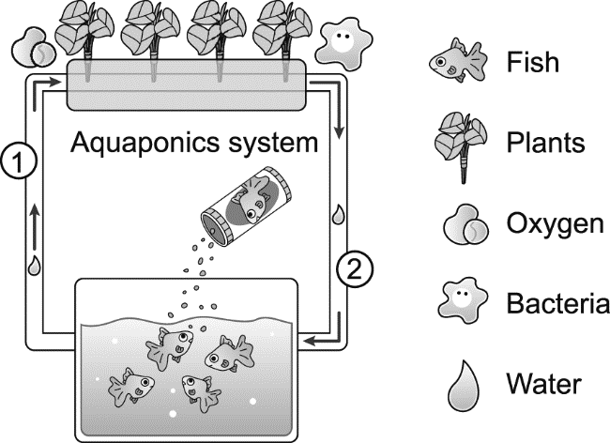 Mutualism 共生 Oxygen 氧氣 bacteria 細菌 fertilizer 肥料

36. What is this picture about?
(Ａ) How to raise fish. (Ｂ) How to give free food to fish.
(Ｃ) How fish and plants can help each other. (Ｄ) How plants can get big.
37. During the class, Mr. Chen talks to his student about this picture.
The bacteria can change the waste of fish into fertilizer for the plants. The plants can filter water for the fish, so the fish can live in clean water...
Based on the talk, what is in 1 and 2 ?
(Ａ) 1＝waste of fish ; 2＝bacteria (Ｂ) 1＝waste of fish ; 2＝clean water
(Ｃ) 1＝clean water ; 2＝waste of fish (Ｄ) 1＝clean water ; 2＝nutrition

(二)
The First Vaccine By Leila Pereira
Most people don’t like getting ‘needles’, or ‘shots’. They are scary and their painful prick can even make an adult cry. But the vaccine is one of the most important discoveries in the world. For over 220 years, vaccines have protected people from diseases that would kill them. Today, vaccines continue to save millions of lives all around the world.
In 1796, a man named Edward Jenner made the first smallpox vaccine, and it changed everything. Jenner was a scientist and he learned something very interesting after watching some milkworkers. Those who had caught the cowpox disease from the cows did not catch smallpox later on in life. He thought, “if the body has fought something before, it remembers how to fight it in the future, and the person doesn’t get sick!” So he set out to make the vaccine, a safer way for our bodies to learn how to fight disease.
To make the vaccine, Jenner used a virus called ‘vaccinia’, which is a poxvirus similar to smallpox, but less harmful. When it was time for vaccination, the needle was dipped in the vaccine solution and used to scratch the skin many times in a few seconds.
smallpox 天花 prick 刺；扎 cowpox 牛痘 poxvirus 痘病毒 solution 溶劑 vaccine 疫苗
38.How have vaccines saved millions of lives?
(A) The painful prick scares away disease.
(B) They help kill all the viruses in people’s bodies.
(C) They help choose the strong by killing the weak.
(D) They help protect people from diseases.
39. What did Edward Jenner learn from milkworkers?
(A) That they were very arraid of their jobs.
(B) That if they caught cowpox before, they didn’t catch smallpox.
(C) That they could help him have fresh milk every da y.
(D) That they could help him make a kind of medicine.
- What did Edward Jenner use to make the first vaccine?
(A) He used a poxvirus less harmful than the smallpox virus.
(B) He used a milkworker’s virus.
(C) He used a cowpox virus.
(D) He used a poxvirus more harmful than the smallpox virus.

以下答案請寫在答案卷上
五、整句式翻譯20%
1. 臉書可以是個很便利的工具，如果它被睿智地使用的話。
2. 他們用不同方式來得到好運並驅逐惡運。
3. 當你站在本壘並揮棒時，你不知道你是否將擊出全壘打。
4. 或許你只是太煩惱而不能清楚地思考，但是你應該傾聽你內心的聲音。

新北市立溪崑國民中學108學年度第一學期第二次定期評量 英語科 答案卷
九年級 班 座號 姓名
五、整句式翻譯:20％ (每題 5分)
1
2
3
4

108-1-2 九年級 英語科－解答
一~四
1 | 2 | 3 | 4 | 5 | 6 | 7 | 8 | 9 | 10
C | A | C | B | C | A | B | C | C | A
11 | 12 | 13 | 14 | 15 | 16 | 17 | 18 | 19 | 20
B | C | B | B | A | C | B | D | C | A
21 | 22 | 23 | 24 | 25 | 26 | 27 | 28 | 29 | 30
D | C | B | A | D | C | B | A | D | B
31 | 32 | 33 | 34 | 35 | 36 | 37 | 38 | 39 | 40
D | A | B | D | C | C | B | D | B | A

五 、整句式翻譯:20％ (每題5分,段落給分)
1 | Facebook can be a very convenient tool if it is used wisely.
2 | They use different ways to have good luck and to keep away bad luck.
3 | When you stand at home base and swing your bat, you don’t know if you’re going to hit a home run (or not).
4 | Maybe you’re simply too worried to think clearly, but you should listen to the voice inside your heart.

新北市立溪崑國民中學108學年度第一學期第二次定期評量
九年級 英語科 聽力測驗稿
一、辨識句意：每題均有三張圖片，請依據所聽到的句子，選出符合描述的圖片(每題2分，共10分)
- 《腳本區》
CD: The poor dog was hit by a car when it crossed the road.
《題目區》
(A)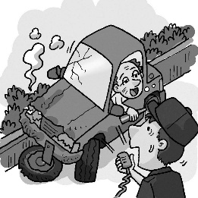 (B)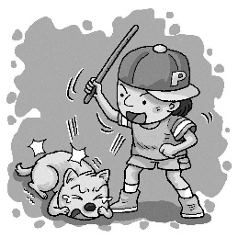(C)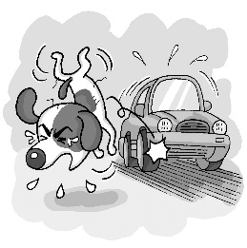
《答案區》
答案：C
- 《腳本區》
CD: The fish were caught by a strong fisherman.
《題目區》
(A) (B)(C)
《答案區》
答案：A
- 《腳本區》
CD: Tom is lending a hand to his father.
《題目區》
(A)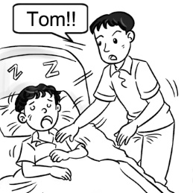 (B)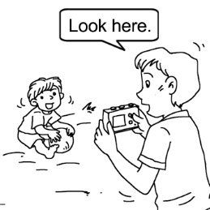 (C)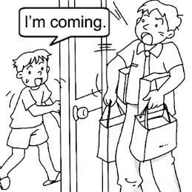
《答案區》
答案：C
- 《腳本區》
CD: Cindy has gotten too busy to answer the phone.
《題目區》
(A)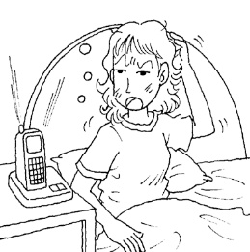 (B)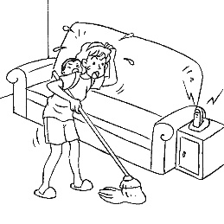(C)
《答案區》
答案：B
- 《腳本區》
CD: To celebrate graduating from the school, the student climbed to the top of the mountain.
《題目區》
(A)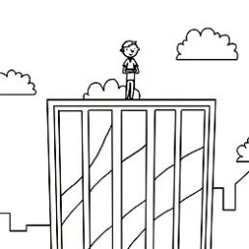 (B)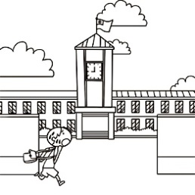(C)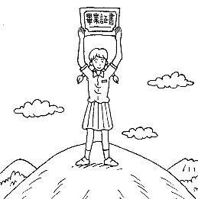
《答案區》
答案：C
- 基本問答：每題均有三個選項，請依據所聽到的內容，選出一個最適合的回應(每題2分，共10分)
6.《腳本區》
CD: Do you really believe that working hard pays well?
《題目區》
(A) Without a doubt.
(B) Yes, the tool is useful.
(C) Would you lend me a hand?
《答案區》
答案：A
7.《腳本區》
CD: Haven’t you reached the owner of the factory?
《題目區》
(A) Yes, it’s convenient for him.
(B) No, his cellphone is off.
(C) Yes, I’ve got some information from the workers.
《答案區》
答案：B
8.《腳本區》
CD: I want to take more hands-on classes and learn new skills.
《題目區》
(A) Then, you need to study more poems.
(B) Your dream is to become a fashion designer.
(C) Then, going to a vocational school might be a good choice for you.
《答案區》
答案：C
9.《腳本區》
CD: The dark circles under your eyes have become even more serious.
《題目區》
(A) You are right. The room is too dark to see anything clearly.
(B) My designer says that looking pale has become fashion these days.
(C) I am so worried about the trip that I haven’t had a good sleep for a week.
《答案區》
答案：C
10.《腳本區》
CD: A: Hey! Don’t forget your coat.
B: Do I have to wear the coat? It’s not that cold outside.
《題目區》
(A) Then, wear the vest instead.
(B) You’d better take the gloves with you.
(C) You look pale because you’ve caught a cold.
《答案區》
答案：A
- 言談理解：每題均有三個選項，請依據所聽到的對話與問題，選出一個最適當的答案(每題2分，共10分)
11.《腳本區》
CD: Man: Liz, your favorite show is on. Where are you going?
Woman: Helen was sent to the hospital.
Man: Why? What happened?
Woman: She dropped a hot pot of soup and was badly burned.
Man: Oh, I’ll go with you.
Question: Which is true?
《題目區》
(A) Liz’s house was on fire.
(B) Helen is in the hospital now.
(C) The woman couldn’t reach Liz.
《答案區》
答案：B
12.《腳本區》
CD: Girl: What’s wrong with your knee?
Boy: I was bullied by Justin yesterday. He kicked me in the knee. It hurts a lot.
Girl: What? I can’t believe it. I am going to tell Ms. Lee right away.
Boy: Please don’t do that. If you tell Ms. Lee, Justin will pick on me again.
Question: What happened to the boy?
《題目區》
(A) He was saved by Justin.
(B) He was found by Justin.
(C) He was kicked by Justin.
《答案區》
答案：C
13.《腳本區》
CD: Man: Yvonne, what brings you here?
Woman: Why do you ask? I saw on your Facebook that you are throwing a party tonight. Am I not welcome?
Man: No, I mean you’re very welcome any time. Just the truth is I don’t even have a Facebook account.
Question: Which is true?
《題目區》
(A) The man has already set up a Facebook account.
(B) The man didn’t invite anyone to the party on Facebook.
(C) The man does not feel like seeing the woman tonight.
《答案區》
答案：B
14.《腳本區》
CD: Man: Someone called and said Raymond Wu was seen checking into Red Hotel.
Woman: Good. Maybe this information can finally lead us to catch the guy.
Man: I hope so, too. This Raymond Wu has killed many people. He must be caught as soon as possible.
Question: Which is NOT true?
《題目區》
(A) Many people were killed by Raymond Wu.
(B) Raymond Wu has been caught in the hotel.
(C) Someone called to give information about Raymond Wu.
《答案區》
答案：B
15.《腳本區》
CD: Man: Hi, I’m David Lee. I live on this floor.
Woman: Hi, my name is Sunny Leone. I live right above you. I just moved in.
Man: Welcome, Sunny. So, you live on the thirteenth floor. I heard that the view from there is great, isn’t it?
Question: Which floor does David live on?
《題目區》
(A) The twelfth floor.
(B) The thirteenth floor.
(C) The fourteenth floor.
《答案區》
答案：A

