新北市立溪崑國民中學108學年度第一學期第一次定期評量 英語科 試題卷
九年級 班 座號 姓名
一、 聽力測驗 30%
(一) 辨識句意: 每題均有三張圖片，請依據所聽要的句子，選出符合描述的圖片
- (A)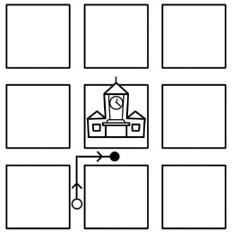 (B)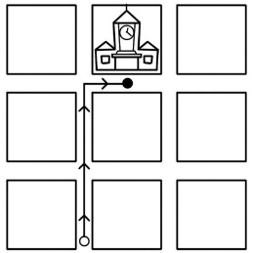 (C)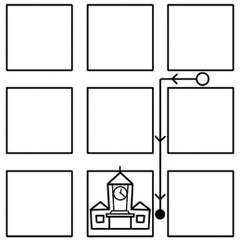
- (A)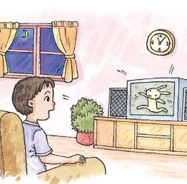 (B)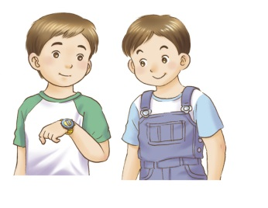 (C)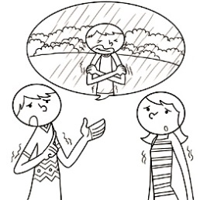
- (A)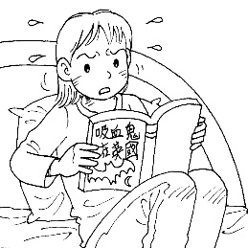 (B)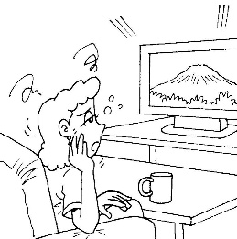 (C)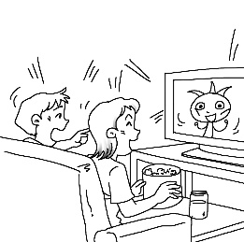
- (A)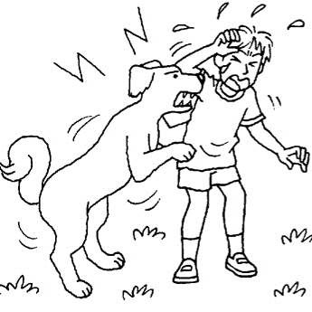 (B)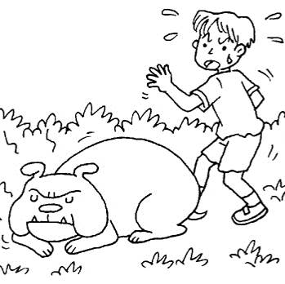 (C)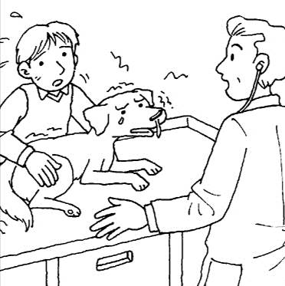
- (A)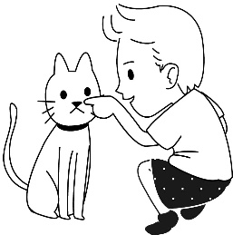 (B)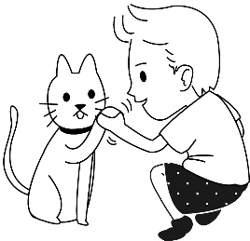 (C)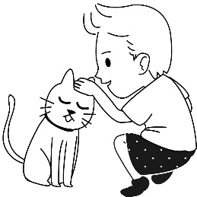

(二) 基本問答 ：每題均有三個選項，請依據所聽到的內容，選出一個最適當的回應
- (A) You’ve eaten it up. This one is mine.
(B) Why do they shape the dough into a flower?
(C) I’m OK with it, but I can’t put up with the smell.
- (A) No. He even hasn’t finished it.
(B) No. He could not become lazy.
(C) No. He did not check out the clock.
- (A) Yes, I think he is in serious trouble.
(B) Yes, he made his point loud and clear.
(C) Yes, he is not only kind but also helpful.
- (A) He’s bored with the trip tomorrow.
(B) He’s surprised at the trip tomorrow.
(C) He’s excited about the trip tomorrow.

- (A) No. It was quite boring.
(B) It was not an ordinary party.
(C) Yes, I felt excited to go there.
(三) 言談理解 ：每題均有三個選項，請依據所聽到的對話與問題，選出一個最適當的答案
- (A) It’s a country with beautiful beaches.
(B) It’s closer to Taiwan than America.
(C) It’s a vacation spot. The man often visits.
- (A) The woman has broken his heart.
(B) He has fallen in love with the woman.
(C) He will have a better life without the woman.
- (A) She is surprised to know about it.
(B) She is tired of dancing all the time.
(C) She is not interested in the party.
- (A) Their new neighbor is helpful.
(B) Their new neighbor is unhappy.
(C) Their new neighbor is noisy.
- (A) The Wangs are going to sell their house.
(B) The Wangs have enough money to buy a bigger house.
(C) The woman doesn’t think the Wangs are friendly.

二、 綜合測驗 30%
16. Sherry is a(n) ______ girl. She won’t do anything bad, like cheating people.
(A) clear (B) wild (C) healthy (D) honest
17. Today is just another ________ day. There is nothing special.
(A) ordinary (B) careless (C) thirsty (D) helpful
18. My sister owns the car. It doesn’t ________ me.
(A) lead to (B) put up with (C) belong to (D) go through
19. I think ______ is more fun to go shopping with my friends than with my family.
(A) that (B) there (C) one (D) it
20. Some of the students wore uniforms, and ________ wore sports clothes in our school.
(A) other (B) others (C) another (D) the others
21. Mom seldom let me play too many computer games when I was young _________ ?
(A) didn’t she (B) wasn’t I (C) did she (D) was I
22. Let’s eat out tonight, _______ ?
(A) will you (B) shall we (C) won’t you (D) all right
23. Don’t spend too much time _______ comic books, __________ ?
(A) to read; do you (B) reading ; will you (C) to read ; will you (D) reading ; won’t you
24. ______ that my best friend and his girlfriend broke up. They ________ for ten years.
(A) It’s surprised ; had dated (B) It was surprising ; have dated
(C) It’s surprising ; dated (D) It has been surprising ; date
25. They will be _________ see so many flowers in the garden.
(A) excited to (B) exciting to (C) excite (D) excited about
26. My brother has to finish his report this evening, _______ ?
(A) hasn’t he (B) has he (C) doesn’t he (D) does he
27. My brother _______ to drive _____ more than one month.
(A) has learned ; for (B) has learned ; since (C) is learning ; for (D) learned ; since
28. 選出正確的句子
(A) After a exciting day, he felt excited.
(B) Miss Lee is a bored teacher. I feel boring in her class.
(C) The first time Peggy met her favorite singer, she looked exciting.
(D) The snake was so scary ; the girl got scared.
29. 選出正確的句子
(A) Catherine is in New York at the moment. She has been here for three days.
(B) Jeremy has gone to Japan for ten years, and he’ll be back in a few days.
(C) Derek has been to Kenting for several times, and he’ll visit there again next week.
(D) Mr. Wang has been a teacher since he moves to the town.
30. 選出正確的句子
(A) Eating a lot of fruit and vegetables if you want to keep healthy.
(B) Eating a lot of fruit and vegetables keeps you healthy.
(C) To keep healthy, eating a lot of fruit and vegetables.
(D) To eat a lot of fruit and vegetables, you can keep healthy.

三、克漏字選擇 (31)-(35) 10%
Have you ever ___(31)_____ World Oceans Day (WOD)? The idea for WOD came from a meeting at the United Nations in 1992. It’s not a public holiday, but people around the world now celebrate this special day on June 8 every year. Oceans cover 70% of our planet. They were once____(32)______ fish and plants, but now they are___(33)___ serious trouble. Garbage, oil spills, and overfishing have made the number of ocean fish and plants __(34)____ than before. If we don’t___(35)_____ the clock and __(35)__ the problem, a lot of sea life will be gone soon.
31. (A) heard from (B) heard of (C) heard about (D) heard with
32. (A) fill with (B) full with (C) rich in (D) busy with
33. (A) in (B) of (C) at (D) to
34. (A) much more low (B) much more lower (C) a little low (D) much lower
35. (A) hit ; fix (B) bit ; face (C) heat ; face (D) beat ; fix

四、閱讀測驗 10%
Japan does not have enough workers, which caused over 30,000 businesses to close down in 2018. Japan has made new policies to make it easier for Japanese businesses to hire workers from abroad.
The lack of workers is affecting convenience store chains like 7-11 and Family Mart. Without extra labor to keep them open, many of Japan’s 7-11 and Family Marts may be forced to stop 24-hour service. Over 260 Family Marts in Tokyo, Akita, and Nagasaki have already had to cut back hours.
So, Japan’s convenience store chains are looking for new employees from abroad. Japan’s convenience store chains are considering young Taiwanese jobseekers, who can speak Japanese and want to live and work in Japan, as a possible source of reliable labor. The convenience store culture is similar in both countries and Japanese companies think Taiwanese workers are flexible and hard-working.
Over the past five years, the number of Taiwanese’s living in Japan has doubled-with an increase of over 10,000. Taiwanese people going to Japan will likely increase in the next few years. So, young Taiwanese jobseekers who are interested in Japanese culture or language can consider applying for a job at a convenience store in Japan.

policy 政策 labor 勞工 force 強迫 cut back 減少 employee 員工
jobseeker 求職人員 reliable 可靠的 flexible 有彈性的 increase 增加 apply for 申請

36. Why did many businesses close down in 2018 ?
(A) Their service was good.
(B) There were not enough workers.
(C) They could not speak Japanese.
(D) There were too many workers..
37. Where did Family Mart cut hours ?
(A) Tokyo, Taipei, and Nagasaki.
(B) Tokyo, Akita, and Tainan.
(C) Taichung, Akita, and Nagasaki.
(D) Tokyo, Akita, and Nagasaki.

38. Who would be suitable (適合) to work at a Japanese convenience store?
(A) Someone who likes Japanese culture and can speak Japanese.
(B) Someone who likes Japanese culture but can’t speak Japanese.
(C) Someone who doesn’t like Japanese culture and can speak Japanese.
(D) Someone who doesn’t like Japanese culture and can’t speak Japanese.
In Taiwan, most junior high school students have to wear uniforms to school. Students want to know why they should do so and why they can’t wear their own clothes to school.
Some students don’t think uniforms are beautiful. They don’t want to wear the same clothes as others. If they wear their own clothes, they can look special and more beautiful or handsome. However, they will spend more time on clothes than the schoolwork, or they will ask their parents to buy more clothes for them.
Some students think wearing uniforms is great. First, they don’t have to worry which clothes they should wear to school. Second, their parents don’t need to buy too many clothes for them. Third, others will know they are students when they wear uniforms. At school, teachers can know if strangers go into their school. Fourth, they think that their uniforms look beautiful and special and that they are different from other school uniforms.
What’s your opinion? Which do you think students should wear to school, uniforms or casual clothes.
if 是否 opinion 看法 casual clothes 便服

39. Why do some students want to wear their own clothes?
(A) They want to look more special and prettier in their own clothes.
(B) They can make clothes by themselves.
(C) They don’t need to buy uniforms.
(D) Their parents buy too many clothes for them.
40. Which is true if students wear uniforms to school?
(A) Teachers can’t know who their students are.
(B) Parents have to prepare more beautiful clothes for their children.
(C) Students won’t spend too much time choosing the clothes.
(D) They can get higher grades on test.
五、 整句式翻譯 20% (每題 5 分)
41. 自二十世紀初以來，幸運籤餅變得普及，它們在美國一直是中式餐廳一項有趣的特色。
42. 至於吃藍起士的方式，單吃是普遍的方式。
43. 有些人喜歡跟其它食物一起吃藍起士，因為它增添了它們的風味。
44. 藉由慶祝世界海洋日，人們不僅學到很多關於海洋的事，也開始讓它們更乾淨。

新北市立溪崑國民中學108學年度第一學期第一次定期評量 英語科 答案卷
九年級 班 座號 姓名
五、整句式翻譯 20% 每題5分

41.
42.
43.
44.

108-1-1 九年級 英語科－解答
一、ACBBC CACCA BBACB
二、DACDD CBBCA CADAB
三、BCADD
四、BD AAC

五、整句式翻譯 每題5分
41. Fortune cookies have been an interesting feature of Chinese restaurants in the USA since they became common in the early 1900s.
42. As for the ways to eat blue cheese, it is common to have it by itself.
43. Some people like to eat blue cheese with other foods because it adds a strong flavor to them.
44. By celebrat ing WOD, people not only learn a lot about oceans but also start to make them cleaner.

國中 英語科 考試卷 ___年 ___班 座號：___ 姓名：__________
一、辨識句意：每題均有三張圖片，請依據所聽到的句子，選出符合描述的圖片(每題2分，共10分)
- 《腳本區》
CD: I’m going to visit the junior high school. It’s in the center of the map.
《題目區》
(A) (B)(C)
《答案區》
答案：A
- 《腳本區》
CD: The boy just went through a hard time.
《題目區》
(A) (B)(C)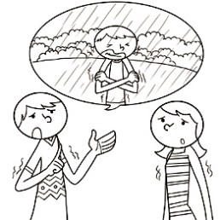
《答案區》
答案：C
- 《腳本區》
CD: Cathy doesn’t feel interested in anything. She’s having a boring day.
《題目區》
(A) (B)(C)
《答案區》
答案：B
- 《腳本區》
CD: The boy is scared he may wake up the dog.
《題目區》
(A) (B)(C)
《答案區》
答案：B
- 《腳本區》
CD: The boy is touching his pet on the head.
《題目區》
(A) (B)(C)
《答案區》
答案：C
二、基本問答：每題均有三個選項，請依據所聽到的內容，選出一個最適合的回應(每題2分，共10分)
- 《腳本區》
CD: I don’t like the taste of the stinky tofu.
《題目區》
(A) You’ve eaten it up. This one is mine.
(B) Why do they shape the dough into a flower?
(C) I’m OK with it, but I can’t put up with the smell.
《答案區》
答案：C
- 《腳本區》
CD: Raymond did not beat the clock to finish the job, did he?
(A) No. He even hasn’t finished it.
(B) No. He could not become lazy.
(C) No. He did not check out the clock.
《答案區》
答案：A
- 《腳本區》
CD: How is your new neighbor? Is he kind?
《題目區》
(A) Yes, I think he is in serious trouble.
(B) Yes, he made his point loud and clear.
(C) Yes, he is not only kind but also helpful.
《答案區》
答案：C
- 《腳本區》
CD: Why does Tommy look so happy today?
(A) He’s bored with the trip tomorrow.
(B) He’s surprised at the trip tomorrow.
(C) He’s excited about the trip tomorrow.
《答案區》
答案：C
- 《腳本區》
CD: I saw you leave the party early. Didn’t you like it?
(A) No. It was quite boring.
(B) It was not an ordinary party.
(C) Yes, I felt excited to go there.
《答案區》
答案：A
三、言談理解：每題均有三個選項，請依據所聽到的對話與問題，選出一個最適當的答案(每題2分，共10分)
- 《腳本區》
CD: Woman: Have you ever been to Guam before?
Man: No, never. It belongs to America, but it’s near Taiwan, right?
Woman: Yes, you’re right. How about going there together this summer vacation?
Man: Sounds great. I’ve always wanted to visit a place with beautiful sea and beaches.
Question: Which is true about Guam?
(A) It’s a country with beautiful beaches.
(B) It’s closer to Taiwan than America.
(C) It’s a vacation spot. The man often visits it.
《答案區》
答案：B
- 《腳本區》
CD: Woman: I’m going back to my country tomorrow.
Man: So soon? Will I ever see you again?
Woman: I don’t know. What’s your heart telling you?
Man: Hmm. A life without you? It would be like being in the dark.
Question: What does the man mean?
(A) The woman has broken his heart.
(B) He has fallen in love with the woman.
(C) He will have a better life without the woman.
《答案區》
答案：B
- 《腳本區》
CD: Boy: I’m so excited about the party later. It’s going to be fun!
Girl: What are you talking about? What party?
Boy: Don’t you know that there will be a dance party at school?
Girl: Really? I really don’t know anything about it! I’ll have to call my mom before she comes to pick me up.
Question: How does the girl feel about the party?
(A) She is surprised to know about it.
(B) She is tired of dancing all the time.
(C) She is not interested in the party.
《答案區》
答案：A
- 《腳本區》
CD: Man: I really don’t like our new neighbor.
Woman: I don’t either. He makes a lot of noise at night.
Man: He is not only noisy but also dirty.
Woman: Yeah. He always puts his garbage on the street.
Question: Why DON’T the man and the woman like their new neighbor?
(A) Their new neighbor is helpful.
(B) Their new neighbor is unhappy.
(C) Their new neighbor is noisy.
《答案區》
答案：C
- 《腳本區》
CD: Man: The Wangs have sold their house, haven’t they?
Woman: Yes, they sold it a week ago. Mr. Wang has made a lot of money, so he is able to buy a bigger house. They will move away next week.
Man: That means we will have new neighbors soon.
Woman: Yes, you’re right. I hope they will also be friendly to us.
Question: Which is true?
(A) The Wangs are going to sell their house.
(B) The Wangs have enough money to buy a bigger house.
(C) The woman doesn’t think the Wangs are friendly.
《答案區》
答案：B

