新北市立溪崑國民中學107學年度第二學期第三次定期評量 英語科 試題卷
八年級 班 座號 姓名
【聽力測驗】
- 辨識句意：每題均有三張圖片，請依據所聽到的句子，選出符合描述的圖片。
1 | (A) 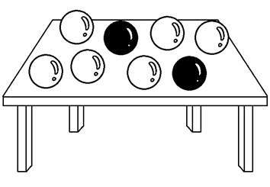 | (B) 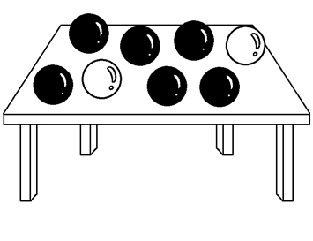 | (C) 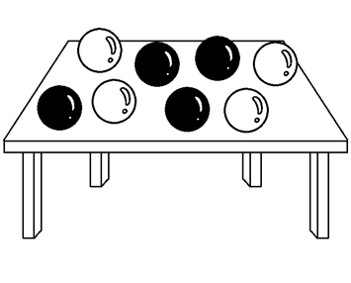
2 | (A) 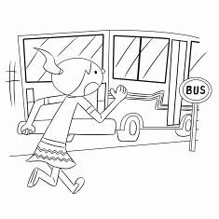 | (B) 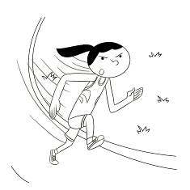 | (C) 
3 | (A)  | (B) 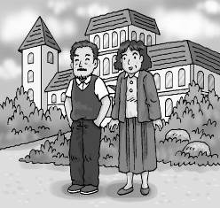 | (C) 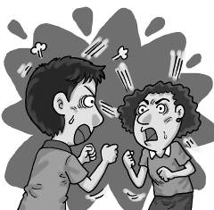
4 | (A) 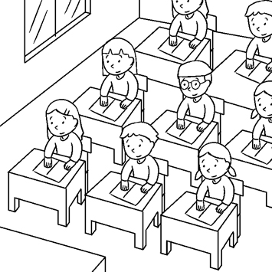 | (B) 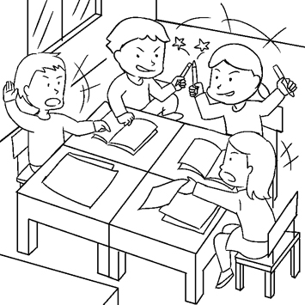 | (C) 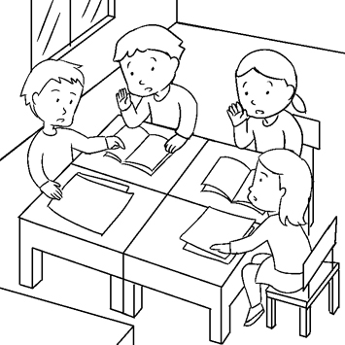
5 | (A) 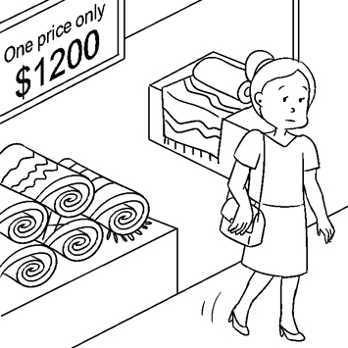 | (B) 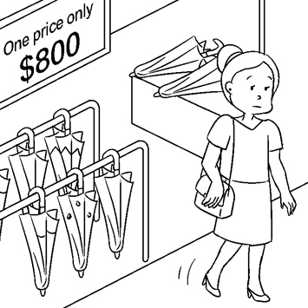 | (C) 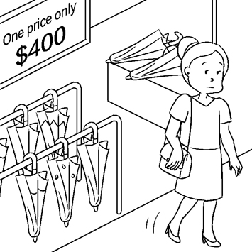
- 基本問答：每題均有三個選項，請依據所聽到的句子內容，選出一個最適合的回應。
6. | (A) Ken did. He did it slowly. | (B) Ken finished it happily.
 | (C) Ken did. He finished it only two hours.
7. | (A) I see. Try not to get yourself in trouble again.
 | (B) Don’t you understand the meaning of the words?
 | (C) OK. Let’s move your seat to the front of the classroom.
8. | (A) OK. Let’s change it to fried chicken. | (B) Great. It will become the best hit of all time.
 | (C) Good idea. Let’s put stinky tofu on the menu.
9. | (A) You’ll have to face the music. | (B) You’ll have a chance of getting good grades.
 | (C) Then, could you help me with science?
10. | (A) You can drop out. | (B) Do it again next time.
 | (C) You’d better go and tell her.
- 言談理解：每題均有三個選項，請依據所聽到的對話及問題，選出一個最適合的答案。
11. | (A) They’re calling the police. | (B) They’re taking action to save some old trees.
 | (C) They’re cutting down some old trees.
12. | (A) He always looks unhappy. | (B) He’s an elementary school student now.
 | (C) He was a lovely boy when he was little.
13. | (A) It is a common idea. | (B) She does not like it.
 | (C) It is fresh.
14. | (A) Its price is just right. | (B) It is too expensive for its quality.
 | (C) It is not expensive at all.
15. | (A) Yes, Helen will help him out. | (B) No, Helen turned him down.
 | (C) Sure. Helen will go with her cousin.
- 單題：
- of the teachers in our junior high school have worked here longer than Bill; only Louis and Jack started working here
before him.
(A) All (B) Most (C) Some (D) Few
- Kelly: What does free mean?
Sally: If you shop on this online store for over NT$699, you don’t have to pay extra(額外的) money for delivering(運送).
(A) shipping (B) sale (C) quality (D) couch
- My little son is six years old. He will start school soon.
(A) elementary (B) junior high (C) senior high (D) vocational
- All of the money on the sofa mine, so please don’t take away.
(A) are; them (B) are; ones (C) is; one (D) is; it
- One of my brothers to be a soldier.
(A) want (B) is (C) are (D) wants
- Most people have different feelings for their mothers at different .
(A) ages (B) peace (C) lines (D) hits
- Keep the orange juice in the , or it will go bad easily in this hot weather.
(A) refrigerator (B) washing machine (C) fan (D) tape recorder
- Mr. and Mrs. Brown some hard times when they first started living together, but they got through them.
(A) experienced (B) experimented (C) expensive (D) mastered
- It’s usually cold on the plane, so you can cover yourself with a .
(A) blanket (B) castle (C) machine (D) program
- She didn’t tell the truth. She us.
(A) cost (B) cheated (C) spent (D) paid
- Is it for Janice to dress up in five minutes? She is going to be late for an interview.
(A) cheap (B) possible (C) modern (D) fashionable
- students are marching across the campus and shouting , “ Bullying stops here.” How about joining them?
(A) Five hundred; angry (B) Five hundreds; angrily (C) Hundreds of; angry (D) Hundreds of; angrily
- The way to sell your house of course is to do it yourself. However, you may much time on it.
(A) cheapest; cost (B) lowest; cost (C) cheapest; spend (D) lowest; spend
- Although they are twins, their different ways of will still make them act differently.
(A) meaning (B) thinking (C) bullying (D) hard-working
- Good can catch customers’ eye. And they can help sell products.
(A) machines (B) advertisements (C) recorders (D) beauty
- Crossing the river us lots of time because the bridge was blocked.
(A) cost (B) spent (C) took (D) waste
- Which sentence is different from others?
(A) My dad spent a lot of money on the new car. (B) My father paid lots of money for the new car.
(C) It cost my dad a lot to buy the new car. (D) It took my dad lots of time to buy the new car.
- 題組：
Know more about bullying…
- What is Bullying?
Bullying is when someone is being hurt either by words or actions 33 , usually more than once, feels bad because of it, and has
a hard time stopping what is happening to them.
- Where Does Bullying Happen?
Bullying can happen anywhere. It can occur in your neighborhood, while going to school, at school, and while on-line.
School bullying happens 34 . Students should 35 from their parents or teachers, and here are three “dos”.
- Care about your classmates more because sometimes they are afraid to tell.
- 36 There’s a big difference between informing facts and telling secrets. Informing is to keep victims away from troubles.
- Accompany victims. Having empathy is the key to help victims out, and try to 37 .
We should always do something to stop bullying and make our school a better place to study in. We have rights: the right to tell
someone, the right to feel safe and the right to stop the bullying.
neighborhood 鄰近地區 while 當… inform 通知 victim 受害者 accompany 陪伴 empathy 同理心
33. (A) on purpose (B) in peace (C) in that case (D) by accident
34. (A) of all time (B) on time (C) from now on (D) all the time
35. (A) stand out (B) ask for help (C) take away (D) take it hard
36. (A) Speak of the devil. (B) Stand up for bullying.
(C) Report bullying to teachers. (D) Let it be.
37. (A) put yourself in others’ shoes (B) pick on others
(C) agree with bullies (D) drop out of school

Build me a son, O Lord,
who will be strong enough to know when he is 38 ,
and brave enough to face himself when he is afraid;
one who will be 39 and unbending in honest defeat,
and humble and gentle in victory.
Build me a son whose wishes will not take the place of deeds;
a son who will know Thee……
and that to know himself is the foundation stone of knowledge.
Build me a son whose heart will be clear,
whose goal will be high,
a son who will master himself before he seeks to master 40 men;
one who will reach into the future, yet never forget the 41 .
And after all these things are his,
add, I pray, enough of a sense of humor,
so that he may always be serious, yet never take himself too 42 .
--By General Douglas MacArthur (extracted from A Pray For Son麥帥為子祈禱文)
unbending 不屈服 defeat 失敗 humble and gentle 謙遜溫和
deeds 實際行動 foundation stone 基石 humor 幽默

38. (A) possible (B) mean (C) weak (D) few
39. (A) proud (B) modern (C) lovely (D) free
40. (A) other (B) another (C) others (D) the others
41. (A) bathtub (B) action (C) peace (D) past
42. (A) bully (B) seriously (C) early (D) lonely

（Line 1）  （Line 6）  （Line 11） | Goodbye, Papa, please pray for me  I was the black sheep of the family  You tried to teach me right from wrong  Too much wine and too much song  Wonder how I get along  Goodbye, Papa, it's hard to die  When all the birds are singing in the sky  Now that the spring is in the air  Little children everywhere  When you see them I'll be there  We had joy, we had fun  We had seasons in the sun  But the wine and the song  Like the seasons all have gone  --By Rod McKuen (extracted from Seasons In the Sun)
wonder 想知道 get along 過活 gone 消逝
43. What is the tone(語調) of the song?
(A) Nervous. (B) Exciting. (C) Lovely. (D) Regretful.
44. Which pair of words are NOT rhymed(押韻)?
(A) Lines 1 and 2: me, family. (B) Lines 6 and 7: die, sky.
(C) Lines 9 and 10: everywhere, there. (D) Lines 12 and 13: sun, song.
45. What does the writer NOT mention(提到) at paragraph(段落) 1?
(A) He always got into trouble when he was teens. (B) His father used to be his teacher at school.
(C) He fooled around by drinking too much wine. (D) His dad was worried about him at his young age.
46. Why does the writer say goodbye to Papa?
(A) He is going to leave this world. (B) He is going to graduate from school.
(C) He is going to leave his hometown. (D) He is going to be in jail(坐牢).

(Figure 1)
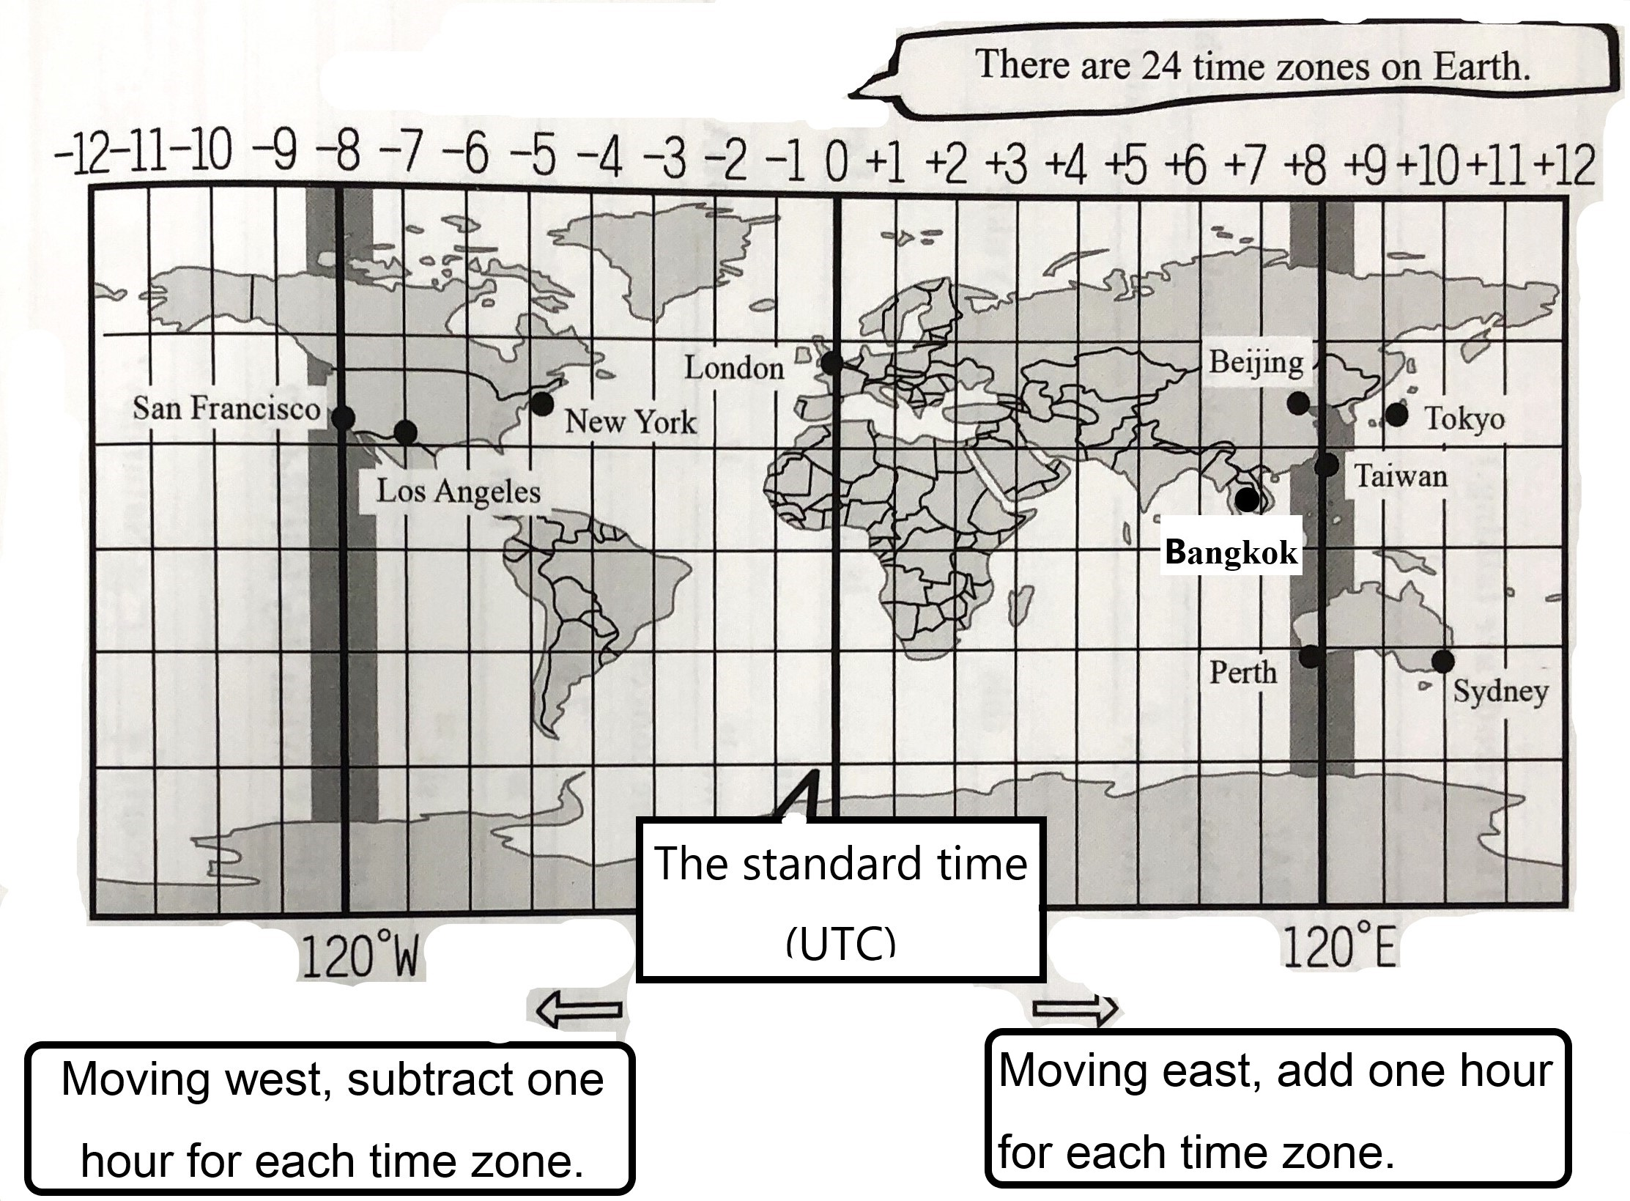
(Figure 2)

Departure Arrival ( Local Time)
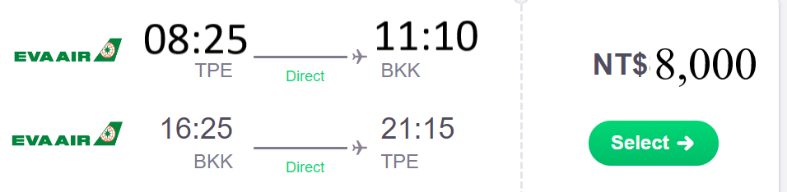

A round ticket
for each person


Today is Thursday, January 30th. Melissa and Joseph are taking a trip to Bangkok, Thailand. Please see Figure 1~2 and answer the following questions.
47. The flight leaves Taipei at 8:25. What time is it now in Thailand?
(A) 7:25 (B) 8:25 (C) 9:25 (D) 16:25
48. The flight will arrive at Bangkok at 11:10 A.M. local time. How long will it take to fly from Taipei to Bangkok?
(A) 2 hours 55 minutes. (B) 2 hours 45 minutes. (C) 4 hours 45 minutes (D) 3 hours 45 minutes.
49. How much do they pay for the plane tickets in total?
(A) 16,000 (B) 14,400 (C) 12,800 (D) 25,600
50. There will be an Adele concert in Los Angeles at 8 P.M. of February 1st. If Melissa and Joseph want to watch the Adele live
concert on the Internet, what date and what time in Thailand will the concert begin?
(A) At 10 A.M. of February 2nd. (B) At 10 A.M. of February 1st.
(C) At 6 A.M. of February 1st. (D) At 6 A.M. of February 2st.

107-2-3 八年級 英語科－解答
聽力 1-15
1 | B | A | C | C | B
6 | C | C | A | A | C
11 | B | C | C | B | B
單題 16-32
16 | D | A | A | D | D
21 | A | A | A | A | B
26 | B | D | C | B | B
31 | C | D
題組 33-50
33 | A | D | B | C | A
38 | C | A | A | D | B
43 | D | D | B | A
47 | A | D | B | A

電腦讀卡用
1-5 | B | A | C | C | B
6-10 | C | C | A | A | C
11-15 | B | C | C | B | B
16-20 | D | A | A | D | D
21-25 | A | A | A | A | B
26-30 | B | D | C | B | B
31-35 | C | D | A | D | B
36-40 | C | A | C | A | A
41-45 | D | B | D | D | B
46-50 | A | A | D | B | A

新北市立溪崑國民中學107學年度第二學期第三次定期評量
八年級 英語科 聽力測驗稿
107-2-3 八年級 英語科－聽力測驗
- 辨識句意：每題均有三張圖片，請依據所聽到的句子，選出符合描述的圖片。
- Most of the balls on the table are black. B
- If the girl wants to get on the bus, she’d better run faster. A
- It’s hard for Mr. and Mrs. Lee to forgive each other now. C
- The students are working in groups. They’re quiet and hard-working. C
- After Julia looked at the price, she walked away because she didn’t want to spend more than five hundred dollars on an umbrella. B
二、基本問答：每題均有三個選項，請依據所聽到的句子內容，選出一個最適合的回應。
- Who finished the report the fastest? C
- Ken did. He did it slowly.
- Ken finished it happily.
- Ken did. He finished it only two hours.

- Mr. Wang, I can’t see any of the words on the blackboard clearly. C
- I see. Try not to get yourself in trouble again.
- Don’t you understand the meaning of the words?
- OK. Let’s move your seat to the front of the classroom.

- We should change the menu. Few people like stink tofu here. A
- OK. Let’s change it to fried chicken.
- Great. It will become the best hit of all time.
- Good idea. Let’s put stinky tofu on the menu.

- I didn’t pass the science test. I got a 53. My parents will be very angry. A
- You’ll have to face the music.
- You’ll have a chance of getting good grades.
- Then, could you help me with science?

- I broke one of Mom’s favorite cups. What can I do? C
- You can drop out.
- Do it again next time.
- You’d better go and tell her.
三、言談理解：每題均有三個選項，請依據所聽到的對話及問題，選出一個最適合的答案。
- Boy: Judy, hurry to the south gate of the market! Some people are going to cut down the old trees there.
Girl: What?! They can’t do that. Those trees are over five hundred years old. Many people grew up with them.
Boy: So we must stop them.
Girl: OK. You go first. I’m going to call my family and friends to go there.
Q: What are the boy and girl doing? B
- They’re calling the police.
- They’re taking action to save some old trees.
- They’re cutting down some old trees.

- Man: Mr. Brown’s son, Kevin, changes a lot.
Woman: What do you mean?
Man: He was a lovely boy and always smiled at me when he saw me. But he became different after he got into senior high school. Yesterday he didn’t even look at me when we met at the gate.
Woman: Well, people change when they grow up. So, don’t take it hard.
Man: I won’t. I just miss the elementary school boy.
Q: Which is true about Kevin? C
- He always looks unhappy.
- He’s an elementary school student now.
- He was a lovely boy when he was little.

- Man: I’m thinking about making a TV program.
Woman: Interesting! What is it about?
Man: About losers and their life experience.
Woman: Will people like it?
Man: Maybe. Most TV programs are about successful people. But losers can also teach lessons.
Woman: I agree. Just do it. It’s so different and will be popular, I believe.
Q: What does the woman think of the man’s idea? C
- It is a common idea.
- She does not like it.
- It is fresh.

- [On the phone]
Man: Hello, is this Nice Bath?
Woman: Yes. How may I help you?
Man: I want to return a bathtub. I bought it last Monday, but it broke on Sunday. I can’t believe it! It cost me NT$4,000! Isn’t a bathtub like this too expensive?
Woman: Sir, it’s not expensive at all. A better one costs more. We have other bathtubs, and they cost more than NT$10,000. They’ll never break.
Man: In that case, mine is really cheap. Well, I don’t need a bathtub like this. Please come get it. I want my money back soon.
Q: What does the man think of his new bathtub? B
- Its price is just right.
- It is too expensive for its quality.
- It is not expensive at all.

- Mike: Helen, your cousin is on the basketball team, right?
Helen: Yes. Then why ask?
Mike: OK. Is it possible to get free tickets for the game this Sunday?
Helen: Sorry, Mike. I can’t help you with that.
Q: Does Mike have a chance to get free tickets for the game this Sunday? B
- Yes, Helen will help him out.
- No, Helen turns him down.
- Sure. Helen will go with her cousin.

