新北市立溪崑國民中學107學年度第二學期第二次定期評量 英語科 試題卷
九年級 班 座號 姓名
一、聽力測驗 (每題2分，共30分)
第一部分：辨識句意 請依據所聽到的句子，選出符合描述的圖片。


( ) 1. (A) (B) (C)
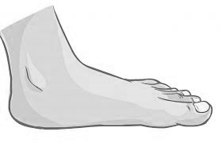

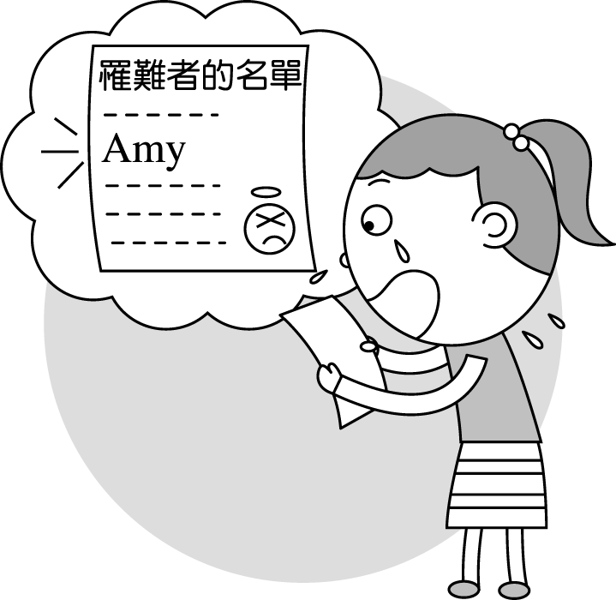
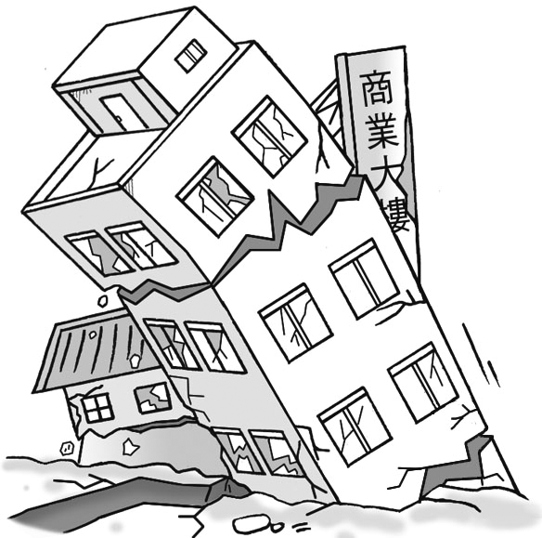
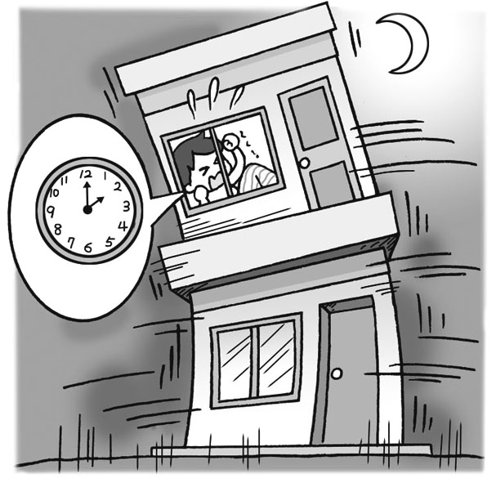
( ) 2. (A) (B) (C)

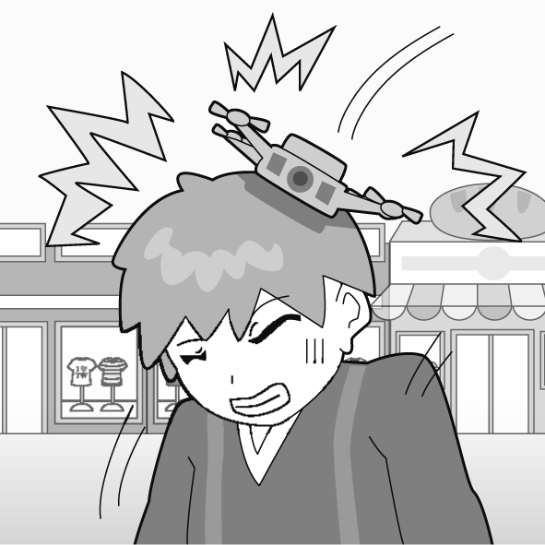
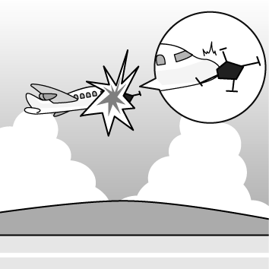
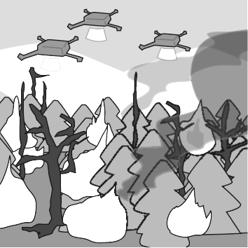
( ) 3. (A) (B) (C)

第二部分：基本問答 請依據所聽到的內容，選出一個最適合的回應。
( ) 4. (A) I am doing my homework. (B) I feel as sick as a dog. (C) Yes, I don’t feel so good today.
( ) 5. (A) I think he’s just too tired. (B) No one cares about him. (C) He died in the car accident.
( ) 6. (A) How about February? (B) OK. I have time on Christmas. (C) Cool! July is my first choice.
( ) 7. (A) There is a fly in the computer. Can’t you see it?
(B) The program is using too much memory and slowing down the running of the computer. You need to fix it.
(C) Bugs can be found in the garden. Go get some now.
( ) 8. (A) I think you have a cold. (B) Oh, no! Let’s go to the hospital now. (C) You are dead meat!
( ) 9. (A) Maybe you can find a part-time job to make more money.
(B) You should buy some more baskets.
(C) Don’t bite the hands that feed you.
( ) 10. (A) Yes, he is working in the hospital. (B) I’m afraid not. He’s too lazy to go to the hospital.
(C) I guess so. Maybe we should pay him a visit.

第三部分：言談理解 請依據所聽到的對話或短文內容，選出一個最適合的答案。
( ) 11. (A) A bad habit of hers. (B) Strange people she met in Taiwan. (C) Her experience in a foreign country.
( ) 12. (A) Jessica. (B) Wayne. (C) Spencer.
( ) 13. (A) Because she has to practice the piano. (B) Because of the noise from her neighbor.
(C) Because she wants to watch a TV show.
( ) 14. (A) He agrees. (B) He doesn’t believe her. (C) He has to check if she is right.
( ) 15. (A) Preparing students for tests. (B) Selling video games to kids. (C) Helping students to learn English.
二、選擇題 (每題2分，共30分)
( ) 16. The computer I’ve just bought comes with a software ________, like Windows, Microsoft Office, PDF Reader…and so on.
- company (B) package (C) engineer (D) game
( ) 17. Mr. Lin was very angry because his house was sold by his daughter without his _______. When he found out the fact, he
decided to hire (僱用) a lawyer to get his house back.
(A) agree (B) mind (C) knowledge (D) accident
( ) 18. We always pay our grandparents a _______ during Chinese New Year. Before we go to their place, my mom always spends
lots of money buying lots of fruit and cookies as gifts for them.
(A) bill (B) holiday (C) notice (D) visit
( ) 19. A: My cellphone doesn’t work. What happened?
B: Oh, that was an accident. I found it in the washing machine after I finished washing the clothes. I forgot to check if there
was anything in the pockets of the clothes.
A: You are so _____! That’s an NT$50,000 iPhone! And you just drowned it!
(A) dead (B) much (C) die (D) lazy
( ) 20. Linda cried happy tears when she heard John said on their wedding, “ Linda Wagner, I take you to be my wife: to have and
to hold from this day forward, for better or for worse, for richer or poorer, in sickness and in health, in joy and in _______,
to love and to cherish, and to be faithful to you alone, as long as we both shall live.
(A) happiness (B) pain (C) sorrow (D) angry
( ) 21. Joyce and Kevin like to watch movies in a movie theater, but they are very busy. They can only spend their free time there
_______.
(A) sometime (B) from time to time (C) in no time (D) many times
( ) 22. Since Buzz moved to the UK, I haven’t _______ him for a long time.
(A) looked up (B) heard of (C) checked out (D) heard from
( ) 23. The bear was caught in the trap (陷阱) which the hunters ______ in the forest a few days ago.
(A) set up (B) put on (C) dealt with (D) let out
( ) 24. He’s never too lazy to clean up his bedroom, _______?
(A) is he (B) isn’t he (C) has he (D) hasn’t he
( ) 25. ________ doing exercise every day is good for your health, isn’t it?
- What (B) By (C) It’s (D) That
( ) 26. The cat ______ belonged to Jack. Jack’s dad found it on the street when it was almost dead.
(A) which Tom is holding it (B) whose tail was missing
(C) about whom they were talking (D) which killed in the car accident
( ) 27. Although I’ve known Kevin for more than a year, I still have no idea ______.
- what does he like (B) how to talk with him (C) who are his friends (D) where he would live
( ) 28. I haven’t heard from Joey for ages. We _____ fun learning the violin from Master Lo before he moved to the States.
- have (B) were having (C) have had (D) had had
( ) 29. A: Why does your brother look so sad? Is he crying now? B: Well, he has to let out all his sorrow because he was
______ again by the girl he likes.
- taken away (B) thrown away (C) put down (D) turned down
( ) 30. The coffee shop ______ was knocked down in an earthquake.
(A) where they liked very much (B) whose coffee was famous for
(C) that my mom often goes there (D) where they used to have a date

三、克漏字選擇 (每題2分，共20分)
【31~35】
In the past, people did strange or dangerous things to be included in Guinness World Record. There are 31 . Here are a few. One man set a record for 32 . 33 man set a record by wearing 70 socks on one foot. There’s more! An American kicked himself on the head 57 times, and a man kept 109 bees in his mouth for 10 seconds. 34 However, for the health and safety of people, Guinness World Record has dropped some of the records 35 . It has also set some rules to keep people from trying to set dangerous records.
include 包括 Guinness World Record 金氏世界紀錄 set 創下(紀錄)
( ) 31. (A) a number of strange people (B) dozens of examples
(C) not many amazing records (D) a few records to be broken
( ) 32. (A) blowing a whole noodle out of his nose (B) walking in the park
(C) driving to his office every day for a week (D) eating noodles as lunch with his friends
( ) 33. (A) Another (B) Other (C) The other (D) The others
( ) 34. (A) What are these crazy records? (B) How were these records broken?
(C) What crazy records they are! (D) How crazy records they are!
( ) 35. (A) that are too difficult to set (B) that are too dangerous to do
(C) that are funny and interesting (D) that do no good to the world

【36~40】
Squids and octopuses can be confusing because they both have jelly-like bodies and swim around using a lot of arms. Some people might see a squid and call it an octopus. Others might see them 36 way around. Squids and Octopuses are head-footed animals that live in salt water in warm areas. They both have eight arms that they use to catch their prey. They do not 37 like other fish do. They use jet propulsion to move about in the water. They move by sucking water into a muscular sac and shooting it out. They can swim in any directions and change directions very quickly. So it is not easy to tell which is which. But there are clear differences between the two.
The body structures of squids and octopuses are different. Octopuses have no internal skeletons. They do not even have an outer shell to protect them. But they do have a beak that looks like a bird’s beak. You have probably seen it on an octopus that has been dried. Octopuses use this beak to 38 . This is a good way to get away when they are being chased by predators.
A squid’s body is inside a shell that can protect it. This shell is called a mantle, and it has two fins, one on each side. Squids can also change colors to hide from predators. Their skin is covered in chromatophores and change colors to 39 .
Though both squids and octopuses live in salt water, the areas where they live are different. For this reason, 40 is also different. We can find octopuses living alone in dens at the bottom of the sea. They eat small organisms that live on the seafloor. Squids, on the other hand, live in the open ocean and eat fish and shrimps. They can live alone or in schools with other squids.

prey獵物 jet propulsion噴射推進 muscular 肌肉發達的 sac 囊 structure 構造
internal 內部的 beak 喙 predator 掠食者 chromatophore色素體 organisms 生物，有機體

( ) 36. (A) other (B) another (C) the other (D) no other
( ) 37. (A) use their arms (B) swim (C) change directions (D) look
( ) 38. (A) pass through narrow spaces between rocks (B) catch small fish as their food
(C) fly like a bird (D) work as a hard shell
( ) 39. (A) swim faster (B) fight their predators (C) become stronger (D) match its environment
( ) 40. (A) where they live (B) how they stay safe (C) what they eat (D) what they do

四、閱讀測驗 (每題2分，共20分)
【41~42】
Pluto was found in 1930. It used to be the ninth planet in the solar system until the IAU changed it on August 24, 2006.
Many astronomers argued about whether to call Pluto a planet or not. Some thought that it was too small to be called a planet—it is even smaller than the Moon. So, at a meeting in 2006, the astronomers decided to take Pluto off the list of planets in our solar system.
solar system 太陽系 astronomer 天文學家 argue 爭論
Now, there are eight planets in the solar system. But if you are a fan of Pluto, don’t worry. Astronomers sometimes change the rules. Perhaps they will change their mind at the next meeting. Who knows?

( ) 41. What is the best title for the reading?
(A) The Nine Planets. (B) A Planets or Not? (C) The Solar system. (D) Pluto and the Moon.
( ) 42. Why is Pluto NOT a planet?
(A) Most astronomers don’t like it. (B) It is not part of the solar system.
(C) It does not move around the sun. (D) It is not big enough to be a planet.

【43~46】
Marco Polo
Though it is not certain, people say that Marco Polo was born in Venice, Italy, in 1254. The stories about his travels may not all be based on fact. But this is what we know about Marco Polo.
His father was a rich businessman who did business with people in the Middle East. His mother died young, and he was raised by his aunt and uncle. He was well-educated and was good at doing business. In 1271, Marco Polo started on a journey to Persia and then went to China.
Three years later, in 1274, Marco Polo reached China and met the Emperor Kublai Khan. The emperor liked young Marco Polo and allowed Marco Polo to represent him on missions throughout China. For seventeen years, Polo traveled in and around China. He even learned to speak the language.
In 1295, a year after the death of Kublai Khan, Marco Polo returned to Venice with jewels and treasures. Soon after his return, he fought in a war in Venice and was taken prisoner during battles. While in prison, he told his story about his travels in China to a fellow prisoner. The prisoner listened and wrote the story down. The story Marco Polo told was made into a book and published.
Europeans were fascinated by what they read about the land to the east. His adventures included stories of the Silk Road, the holy city of Jerusalem, the mountains of the Hindu Kush, the Gobi Desert, and many more. He told about splendid cities with palaces that had walls decorated with silver and gold.
There is some debate on whether Marco Polo actually reached China. Some scholars think that he could have heard stories about China on his journeys. They have noticed that Marco Polo did not mention certain customs that were common in China at that time. However, supporters of his book say that he could not have learned details about paper money and salt production just by hearing about them. Either way, Marco Polo's stories raised interest in China and in Europe and inspired other explorers.
certain 確定的 well-educated 受良好教育的 journey 旅程 allow 允許 represent 代表 mission 任務 jewel 珠寶 prisoner 囚犯 battle 戰役 fellow 同伴的 publish 出版 fascinate深深吸引 adventure 冒險 holy 神聖的 splendid壯麗的 palace 宮殿 decorate 裝飾 debate 辯論 scholar 學者 custom 風俗習慣 supporter 支持者 detail 細節

( ) 43. What is the story mainly about?
(A) The life of Marco Polo, who lost his father. (B) The cultural differences between Europe and China.
(C) Marco Polo, who traveled from Europe to Asia. (D) Marco Polo, who captured many prisoners during a war.
( ) 44. What did Marco Polo's father do for a living?
(A) He was an emperor. (B) He was a prisoner of war. (C) He was a sailor. (D) He was a businessman.
( ) 45. Why did Marco Polo represent the Emperor Kublai Khan on missions?
(A) Marco Polo spoke good Chinese. (B) The emperor took a liking to the young Marco Polo.
(C) Marco Polo visited China as a representative of Italy. (D) Marco Polo passed a test in China to represent the emperor.
( ) 46. Marco Polo reached China and met the _______ Kublai Khan.
(A) Emperor (B) Employee (C) Empire (D) Employer

【47~50】
The Komodo Dragon
We have seen and read stories about dragons. But do dragons really exist? About a hundred years ago, Komodo dragons were seen in Indonesia's Lesser Sundra Islands for the first time. These dragons neither breathe fire nor fly. Komodo dragons are in fact lizards. They are the largest living lizards in the world. They can be as long as 3.13 meters and weigh as much as about 166 kilograms.
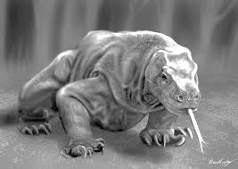
Komodo dragons are some of the hungriest predators in the world. They can eat almost any animals from small rabbits to cows. The Komodo dragon can eat nearly 80% of its weight. Komodo dragons use camouflage and extreme patience to hunt prey. They will stay in one spot for hours and wait for a goat, deer, or anything else tasty.
Komodo dragons can see as far as 300 meters, but the objects have to be moving. Their hearing range is smaller than that of humans, so they cannot hear low- or high-pitched sounds. Because Komodo dragons have poor vision and hearing, they rely mostly on their sense of smell when hunting. They can detect smell like a snake. Komodo dragons use their forked tongues to test the air for nearby prey. When they walk, they move their heads from left to right to sense the direction of their prey
Even if a prey animal gets away from a Komodo dragon after being bitten, it is not safe. The saliva of Komodo dragons has bacteria that are deadly to their prey. Komodo dragons can follow their prey until the bacteria take effect. But the bacteria do not seem to affect other Komodo dragons. When Komodo dragons are wounded from fighting each other, they do not die from the bacteria. Scientists are looking for what is in the dragons' blood that keeps them unharmed from the bacteria.
Komodo dragons are endangered animals because they live in only one area of the world. Hunting is also a reason why there are very few of them still alive. Even though strict laws have been put in place against hunting Komodo dragons, hunting is still going on.
exist 存在 lizard 蜥蜴 predator 掠食者 camouflage偽裝 range 範圍 pitch 音高 vision 視力 rely依賴 detect 偵測 prey 獵物 saliva 唾液 bacteria 細菌 wound 受傷

( ) 47. What is the main idea of the story?
(A) Komodo dragons are the largest and the hungriest dragons.
(B) Komodo dragons are endangered because of dry weather.
(C) Komodo dragons catch their prey by using their excellent eyesight.
(D) Endangered Komodo dragons are large, hungry, and deadly.
( ) 48. What does a Komodo dragon use to test the air for prey nearby?
(A) Its tongue. (B) Its head. (C) Its saliva. (D) Camouflage.
( ) 49. Because __________, Komodo dragons cannot hear low- or high-pitched sounds.
(A) they live in one area of the world (B) they move their heads from left to right
(C) they use camouflage and extreme patience (D) their hearing range is smaller than that of humans
( ) 50. Which of the following is endangered?
- Dinosaurs. (B) Snakes. (C) Pandas. (D) Bacteria.

107-2-2 九年級 英語科－解答
1 | 2 | 3 | 4 | 5 | 6 | 7 | 8 | 9 | 10
A | B | A | B | A | C | B | B | A | C
11 | 12 | 13 | 14 | 15 | 16 | 17 | 18 | 19 | 20
C | C | B | A | C | B | C | D | A | C
21 | 22 | 23 | 24 | 25 | 26 | 27 | 28 | 29 | 30
B | D | A | A | D(送) | B | B | D | D | D
31 | 32 | 33 | 34 | 35 | 36 | 37 | 38 | 39 | 40
B | A | A | C | B | C | B | A | D | C
41 | 42 | 43 | 44 | 45 | 46 | 47 | 48 | 49 | 50
B | D | C | D | B | A | D | A | D | C

新北市立溪崑國民中學107學年度第二學期第二次定期評量
九年級 英語科 聽力測驗稿
第一部分：辨識句意 請依據所聽到的句子，選出符合描述的圖片。
1. The detective noticed the footprints the thief left in the house.
2. At around two o’clock last Wednesday, the building where Amy lived was knocked down in the earthquake.
3. Accidents caused by drones happen quite often now because they are not used carefully. However, drones can do something dangerous for us, like putting out forest fires.
第二部分：基本問答 請依據所聽到的內容，選出一個最適合的回應。
4. How are you doing today?
5. It’s so noisy outside, but Jason is dead to the world. What’s wrong with him?
6. Let’s take a trip to Europe sometime in the middle of the year. What do you think?
7. The computer program doesn’t work very well, but I can’t find any bugs in it.
8. Mom, something is stuck in my throat. It hurts!
9. I really want to be an actor, but I don’t want to put all my eggs in one basket. What should I do?
10. I’ve heard that Peter is terribly sick and has to stay in the hospital for some time. Is that true?
第三部分：言談理解 請依據所聽到的對話或短文內容，選出一個最適合的答案。
11. (W): The first time I saw people there eat with their hands, I was really surprised! People in
Taiwan and many other countries won’t do it. However, after a few days, it was not strange to
me anymore. And guess what? I did as they did.
Question: What is the woman talking about?
12. (W) Now, let’s clean our apartment together. Spencer, please mop the floor. Wayne, you clean the
windows. And Jessica, you take all the garbage out.
(B): But, Mom, I’m short. And some windows are too high for me.
(W): OK, then. Spencer, you clean the windows, and Wayne will mop the floor.
Question: Who’s going to clean the windows?
13. (M): Sabrina, you’ve watched TV for more than one hour. Aren’t you going to have a test tomorrow?
(G): Yes, Dad. I’ll go to my room when the girl next door stops playing the piano. She plays so badly
that I can’t study at all.
Question: Why is the girl NOT studying for her test?
14. (W): Would you please take the bread we just bought out of the brown bag and put it in a glass box?
(M): Why?
(W): The newspaper says the brown bag makes the bread go bad faster. The bakery wants people to
go back sooner.
(M): Hmm… another bakery trick!
Question: What does the man think of the woman’s words?
15. (W): Welcome to E-game! We have quite a few games for you to play online. Have trouble
remembering new words? Try King of Words and learn 1,200 words in a fun way! Are you interested in learning English songs? We have more than a thousand with videos for you to sing along. Have fun learning English with us!
Question: What is E-game for?

