新北市立溪崑國民中學107學年度第二學期第一次定期評量 英語科 試題卷
九年級 班 座號 姓名
一、聽力測驗：30%
I. 辨識句意 : 根據聽到的內容，選出符合描述的圖片
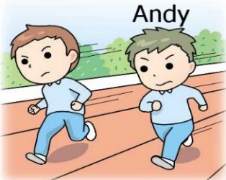
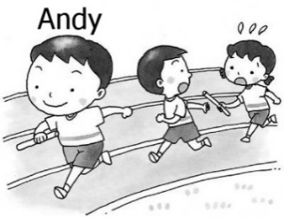
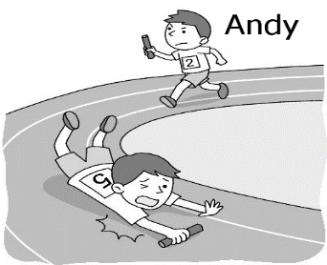
1. (Ａ) (Ｂ) (Ｃ)

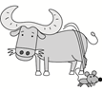

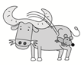
2. (Ａ) (Ｂ) (Ｃ)

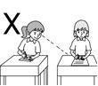
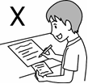
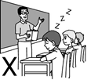
3. (Ａ) (Ｂ) (Ｃ)


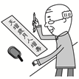
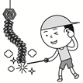
4. (Ａ) (Ｂ) (Ｃ)

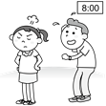
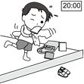
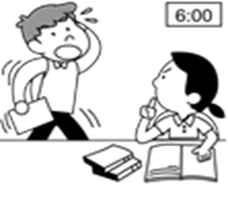
5. (Ａ) (Ｂ) (Ｃ)

II. 基本問答: 依據聽到的內容，選出最適合的回應
6. (Ａ) There are a lot of kangaroos and koalas in Australia.
(Ｂ) I had lived there for ten years before I moved to Taiwan.
(Ｃ) I know that December is a hot month here.
7. (Ａ) They need to be treated well.
(Ｂ) They don’t need to take the MRT.
(Ｃ) Yes, they do, except for guide dogs.
8. (Ａ) Yes. You can go exercising, and do something you like.
(Ｂ) You should study harder to get a better grade.
(Ｃ) Well, I sleep for twelve hours a day.
9. (Ａ) I spend a lot of money on gas each month.
(Ｂ) There’s one on the corner of Park Street and Beach Road.
(Ｃ) The gas station is newly opened.

【背面尚有試題】

10. (Ａ) Yes. This way I can find it when I lose it.
(Ｂ) Yes. It’ll be trained at school.
(Ｃ) Yes, so I can teach it good manners.
III. 言談理解: 根據聽到的對話內容與問題，選出正確的答案
11. (Ａ) Both of them have held a contest.
(Ｂ) The woman hasn’t held a contest, but the man has.
(Ｃ) Neither of them have held a contest.
12. (Ａ) In a test room.
(Ｂ) In a temple.
(Ｃ) In a playground.
13. (Ａ) She is having a hard time breathing.
(Ｂ) She has fallen and hurt her feet.
(Ｃ) She is lost and can’t find her way to the hospital.
14. (Ａ) Something is bugging the boy.
(Ｂ) The woman will talk to the boy’s teacher.
(Ｃ) The boy is wasting his talent.
15. (Ａ) He has been bored for many years.
(Ｂ) He is blind.
(Ｃ) He wants to lead Bruce to many places.

二、請依題意選出最適當的答案：34 %
16. Hens can lay eggs, but __________ can’t.
(A) geese (B) ox (C) roosters (D) snakes
17. The meeting __________ at noon today. Don’t be late.
(A) will hold (B) will be held (C) had held (D) is held
18. I saw a kid ____________ up and down on the sofa.
(A) hopping (B) bugging (C) drowning (D) breathing
19. A: Is the woman over there your __________? B: Yes, she’s my aunt.
(A) relative (B) performance (C) secretary (D) artist
20. Not only Paul but also Jane _______ the piano well. They are both good at it.
(A) play (B) are playing (C) had played (D) plays
21. Can you stop talking? Just _________ to me.
(A) let out (B) laugh off (C) breathe out (D) lend an ear
22. Try to be _________ about your future. Always look on the bright side.
(A) responsible (B) respect (C) positive (D) helpful
23. The naughty boy needs to be taught some __________.
(A) rights (B) manners (C) gas (D) power
24. _______ Jeff ______ Tom ate the pie. One of them did it.
(A) Either ; or (B) Neither ; nor (C) Not only ; but also (D) Both ; and
25. Amy: Does the new cellphone _________ you? Betty: Yes, I bought it yesterday.
(A) make sure (B) belong to (C) leave for (D) except for
26. Bill __________ for ten years at this company before he went to Australia.
(A) has worked (B) was worked (C) had worked (D) would work
27. The police will keep the money until somebody _______ it.
(A) steals (B) claims (C) wastes (D) repeats
28. Susan __________ the dog in the park when the accident ___________.
(A) was walking; happens (B) walked; was happened
(C) was walking; happened (D) has walked; happened
29. Andy said that he _________ many couplets already.
(A) has pasted (B) was pasted (C) pasted (D) had pasted

30. We watched the show before ___________ dinner.
(A) had (B) have (C) had had (D) having
31. The French fries in the plate _____________ by us later.
(A) is going to be eaten (B) will eat (C) are going to be eaten (D) is eaten
32. A: Is it true that the famous restaurant is going to close?
B: _______________
(A) Not at all. (B) Not to my knowledge. (C) You can say that again. (D) Not yet.
三、克漏字選擇及閱讀測驗：18 %
33. the front line of Taiwan, Kinmen has played an important part in 34. Taiwan safe. Its history makes this island so popular. There are many special things that you should never miss when you take a trip to Kinmen.
The first one is the Wind Lion God, which 35. in Kinmen. It’s believed that it can keep people
36. evil spirits. Although people who live in Kinmen live hard lives, they are still optimistic. They work hard and make many famous things. For example, the kitchen knives which are made from bomb shells are very sharp. Also, there is a kind of sticky peanut candy that almost everyone will buy when they visit Kinmen. Remember 37. some candy, knives, or toys in the shape of the Wind Lion God as souvenirs for your friends or family.
33. (A) To (B) As (C) From (D) Besides
34. (A) keep (B) kept (C) keeping (D) to keep
35. (A) is common seen (B) are common seen (C) commonly see (D) is commonly seen
36. (A) of (B) to (C) from (D) out
37. (A) to buy (B) buy (C) buying (D) bought
When another old cave is discovered in the south of France, it is not usually news. Rather, it is an ordinary event. Such discoveries are so frequent these days that hardly anybody pays heed to them. However, when the Lascaux cave complex was discovered in 1940, the world was amazed. Painted directly on its walls were hundreds of scenes showing how people lived thousands of years ago. The scenes show people hunting animals, such as bison or wild cats. Other images depict birds and, most noticeably, horses, which appear in more than 300 wall images, by far outnumbering all other animals.
Early artists drawing these animals accomplished a monumental and difficult task. They did not limit
themselves to the easily accessible walls but carried their painting materials to spaces that required climbing steep walls or crawling into narrow passages in the Lascaux complex. Unfortunately, the paintings have been exposed to the destructive action of water and temperature changes, which easily wear the images away. Because the Lascaux caves have many entrances, air movement has also damaged the images inside. Although they are not out in the open air, where natural light would have destroyed them long ago, many of the images have deteriorated and are barely recognizable. To prevent further damage, the site was closed to tourists in 1963, 23 years after it was discovered.
☆ordinary 一般的 ☆accomplish 完成 ☆accessible 可接近的 ☆deteriorate 惡化
38. In line 2, the words pays heed to are closest in meaning to _______.
(A) affects
(B) watches
(C) buys
(D) notices
39. According to the passage, which animals appear most often on the cave walls?
(A) Birds.
(B) Horses.
(C) Bison.
(D) Wild cats.

【背面尚有試題】
40. Why was painting inside the Lascaux complex a difficult task?
(A) It was completely dark inside.
(B) The caves were full of wild animals.
(C) Painting materials were hard to find.
(D) Many painting spaces were difficult to reach.
41. Which title best summarizes the main idea of the passage?
(A) Hidden Prehistoric Paintings
(B) Exploring Caves Respectfully
(C) Wild Animals in Art
(D) Determining the Age of French Caves

………………………………………………………………………………………………………………
※ 將以下的答案寫在答案欄中
四、依提示作答：6 %
42. Sherry said, “I have been to Japan twice.” (改寫成間接引述句)
43. John didn’t clean the house, and his sister didn’t, either. (用Neither…nor…改寫句子)
44. The woman stole the money. The shopkeeper was talking to me. (用While開頭連接兩句)
五、翻譯：12 %
45. 最後但同樣重要的是，將壓力轉為正面的力量並充分善用。
46. 許多研究顯示現代青少年的壓力跟大人一樣多。
47. 當終點線近在眼前時，老鼠一心只想著求勝。
48. 現在有一部關於一位律師為動物爭取權益的新電影。

【試題結束】

新北市立溪崑國民中學107學年度第二學期第一次定期評量 英語科 答案卷
九年級 班 座號 姓名
四、依題示作答：6 %
42. ________________________________________________________________________
43. ________________________________________________________________________
44. ________________________________________________________________________

五、翻譯：12 %
45. ________________________________________________________________________
46. ________________________________________________________________________
47. ________________________________________________________________________
48. ________________________________________________________________________

107-2-1 九年級 英語科－解答
一、聽力測驗：30 %
BACAC BCABA CBAAB
二、請依題意選出最適當的答案：34%
CBAAD DCBAB CBCDD CB
三、克漏字選擇及閱讀測驗：18 %
BCDCA DBDA

107-1-2 九年級 英語科－解答
四、依提示作答：6 %
42. Sherry said (that) she had been to Japan twice.
43. Neither John nor his sister cleaned the house.
44. While the shopkeeper was talking to me, the woman stole the money.

五、翻譯：12 %
45. Last but not least, turn stress around and make the most of it.
46. Many studies show (that) the stress (which) modern teenagers have
is as much as adults do .
47. When the finish line was in sight , Rat was only thinking about winning.
48. There's a new movie about a lawyer who fights for animal rights.

新北市立溪崑國民中學107學年度第二學期第一次定期評量
九年級 英語科 聽力測驗稿
一、聽力測驗：
I. 辨識句意 : 根據聽到的內容，選出符合描述的圖片
1. Andy is ahead of the other runners.
2. The rat is hopping off the ox’s back.
3. You shouldn’t copy other’s answers; that’s cheating!
4. Mr. Lin pasted spring couplets on the wall.
5. Jason promised that he would arrive at 6:00 p.m. on the dot, but he didn’t appear until 8:00 p.m.
II. 基本問答: 依據聽到的內容，選出最適合的回應
6. It seems that you know a lot about Australia, Judy.
7. Dogs need to be kept in bags or cages on the MRT, don’t they?
8. Do you have any tips on dealing with stress?
9. We are running out of gas. Where is the nearest gas station?
10. Does your cat have a microchip?
III. 言談理解: 根據聽到的對話內容與問題，選出正確的答案
11. M: Have you held a contest before?
W: No. What about you?
M: Me neither.
Q: Which is true?
12. M: Hi, Linda. Why are you here now?
W: I came to pray for help to pass my English test. How about you?
M: I just came with my grandmother. She believes the god here.
W: What did she pray for today?
Q: Where might the conversation take place?
13. M: Hurry! Let’s take Lora to the hospital!
W: Oh no. Her lips have turned blue. I think she’s not getting enough air!
Q: What is wrong with Lora?
14. M: Something is bugging me.
W: I can lend you an ear anytime.
M: I want to be an artist. But my parents don’t agree. They think being an engineer is better.
W: Don’t waste your talent. You’re good at creating beautiful things. I’ll talk to your parents.
Q: Which is true?
15. M: Dear diary,
After years of waiting, Bruce, the guide dog, will live with me. He can help me with a lot of
things in my daily life, be the listener when I am bored, and be my best friend. I am really
thankful for him.
Q: Which is true about the man?

