新北市立溪崑國民中學111學年度第一學期第三次定期評量 英語科 試題卷
九年級 班 座號 姓名
一、聽力測驗：30%
I. 辨識句意：每題均有三張圖片，請依據所聽到的句子，選出符合描述的圖片
1. (A) 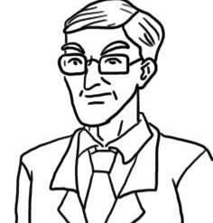 (B)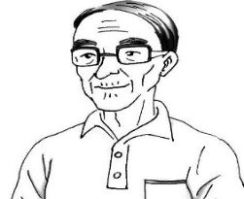 (C)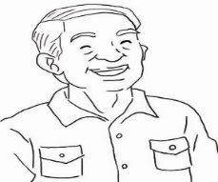
2. (A)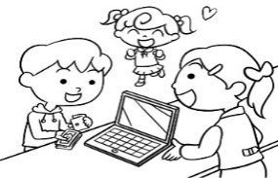 (B)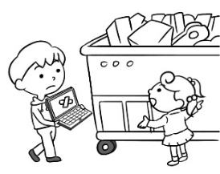 (C)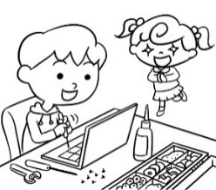
3. (A)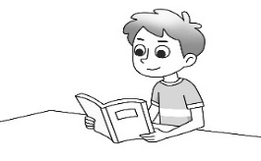 (B)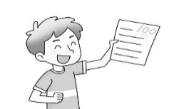 (C)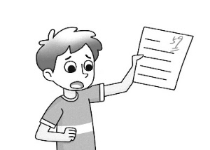
4. (A)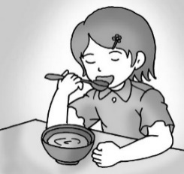 (B)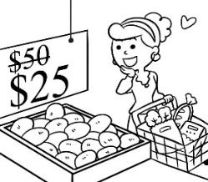 (C)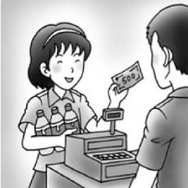
5. (A)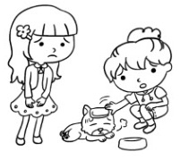 (B)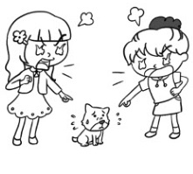 (C)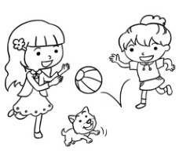
II. 基本問答：每題均有三個選項，請依據所聽到的內容，選出一個最適合的回應
6. (A) It’s good for your teeth.
(B) Why did you fail so many times?
(C) Wow! You want to be as successful as them, right?
7. (A) Because it’s noisy inside.
(B) Because the thing I’m telling you is a secret.
(C) Because I lost my sight.
8. (A) You’re amazing.
(B) You should go to the dentist.
(C) You have to fulfill the plan.
9. (A) Please don’t touch the fruit before you buy it.
(B) It is as expensive as tomato juice.
(C) It’s on the bottom of the shelf by the door.
10. (A) You won’t be able to reach it. It’s below your eye level.
(B) But that is a sample, not a product for sale.
(C) Don’t be fooled by the deal. It’s a trick.
【背面尚有試題】
III. 言談理解：每題均有三個選項，請依據所聽到的對話與問題，選出一個最適當的答案
11. (A) Because he is married.
(B) Because he is poor.
(C) Because he isn’t nice to others.
12. (A) He has no hair.
(B) He is seventy years old.
(C) The man doesn’t like him.
13. (A) The beef is usually kept in the bottom drawer.
(B) The pumpkin will be cooked in the soup for dinner.
(C) The man didn’t buy tomatoes because they are sold out.
14. (A) The man with a big nose lied to her.
(B) She helped a man in need this morning.
(C) She bought a train ticket for the poor man.
15. (A) A tomato.
(B) A pumpkin.
(C) A lemon.
二、請依題意選出最適當的答案：34 %
16. Is there ________ with your cellphone?
(A) wrong anything (B) anything wrong (C) thing wrong (D) wrong thing
17. The woman _______ long hair is my aunt.
(A) have (B) has (C) with (D) in
18. Taipei 101, _______ is the tallest building in Taiwan, attracts many visitors.
(A) who (B) that (C) which (D) whose
19. The building _____ down to the ground because there was a big fire last night.
(A) popped (B) failed (C) dealt (D) burned
20 My uncle has been single for many years, and I don’t think he will get _____.
(A) rise (B) married (C) amazing (D) mark
21. The house ______ three bedrooms belongs to Mr. Chen.
(A) which have (B) that is (C) with (D) which with
22. He works very hard because he wants to _______ his dream of having his own house.
(A) deal (B) mark (C) repeat (D) fulfill
23. The dogs _____ tails are shorts came from Japan.
(A) whose (B) which (C) who (D) that
24. The woman __________ is an old friend of mine.
(A) they talked about (B) who they talked (C) that we saw her (D) in a blue bag
25. He is the bad guy who _________me out of my money.
(A) expected (B) cheated (C) reached (D) touched
26. The plane was flying at a ________ of 3000 meters at that time.
(A) pound (B) bottom (C) kilogram (D) height
27. God helps those ______ help themselves.
(A) which (B) who (C) that (D) whose
28. The bread _________ by my mom is delicious. You can give it a try.
(A) which baked (B) baked (C) which were baked (D) baking
29. The apartment _______ Sam lives is next to a bakery.
(A) which (B) in that (C) X (D) where
30. The company has made ____________ dollars since 2000.
(A) 5 million of (B) 5 millions (C) millions of (D) million of
31 Do you know ______ the girl and her cat ______ were playing over there went?
(A) where; that (B) what; that (C) that; which (D) where; x
32. Choose a correct sentence from the four sentences below.
(A) The salesman who you bought the product left ten minute ago.
(B) I don’t trust the man who only care about himself.
(C) Nobody is able to read the file that just downloaded from the web page.
(D) This is the book that he gave to me last week.

三、克漏字選擇及閱讀測驗：36 %
Alina’s story started 33. a simple visit to a bank when she was seven. A clerk gave her a lollipop, but her father stopped her 34. eating it because it was bad for her teeth. So, Alina asked her father, "Why can’t we make a lollipop 35. actually good for our teeth?"
Alina 36. the same question over and over until her father agreed to help. She then looked for information on the Internet. She also asked her dentist and other people who have 37. of how to keep our teeth clean and healthy.
33. (A) at (B) for (C) with (D) against
34. (A) from (B) to (C) of (D) about
35. (A) which (B) that’s (C) who’s (D) that are
36. (A) repeated (B) answered (C) brought (D) dealt
37. (A) understood (B) known (C) information (D) knowledge
Daughter: Hey, Dad. We’re back from the supermarket.
Dad: Wow! How much did all that 38. ?
Daughter: We spent three thousand dollars 39. total.
Dad: I thought you were just going there to get some rice for the week.
Mom: We were, but then we saw many products that 40. sale. They were great deals 41. prices we just couldn’t 42. up.
38. (A) cost (B) spend (C) take (D) pay
39. (A) on (B) for (C) in (D) about
40. (A) was on (B) were on (C) was for (D) were for
41. (A) who (B) that (C) which (D) whose
42. (A) pass (B) give (C) reach (D) notice
There comes a time to help the world.
It's time for us to be as one.
There are people hungry every day.
Let's give our hand to help them.
Eat up your food and don't waste any.
Love is the greatest gift from God.
With it, we can do more things for those who are in need.
We can't live on day by day seeing people hungry.
We are the ones to make the world better.
Let's do more for the ones who are hungry.
Let's give them a hand.
Make their lives strong and free.
We are the world.
We are one family.
43. What does the word “it” in line 7 refer to?
(A) Food. (B) God. (C) Gift. (D) Love.
44. Which of the following is closest in meaning to the sentence, "It's a time for us to be as one" in the second line?
(A) People on earth are like a family. When trouble comes, we should help each other.
(B) There is only one earth, so everyone needs to have a green lifestyle.
(C) It is a small world, and it is very easy to fly from one country to another.
(D) The different kinds of human beings in the world are like a gift from God.
【背面尚有試題】
45. Which of the following does NOT match the idea in the reading?
(A) Kevin eats up all of his lunch every day.
(B) On weekends, Joe helps people who have no food.
(C) Sue enjoys cooking a big meal for her close friends in her free time.
(D) The Wang family often prepares a free dinner for the hungry people in their neighborhood.
Long ago, the mice held a general meeting to discuss what they could do to outsmart their common enemy, the Cat. Some said this, and some said that.
At last, a young mouse got up and said that he had an idea that would solve everything. “You will all agree,” said he, “that the real problem is the sly way the Cat sneaks up on us. She moves so silently that we never know when she is around. We never know when she will pounce on us from behind. Now, if we only had some warning that she was coming, we could easily escape from her. So, what I suggest is that we find a small bell, and simply tie it with a ribbon around the neck of the Cat. This way, we will always know when she is coming, and we can easily run away and hide.
All the mice clapped, and some stood up and cheered. They started to get ready to leave. Then, an old mouse went up to the front of the room. He pounded on a table to get everyone’s attention.
“This is all very well,” the old mouse said. “But WHO will bell the Cat?” The mice all looked around at one another and nobody spoke.
46. Which is true about the story?
(A) The young mouse will tie a bell around the Cat’s neck.
(B) The mice want to hide from the Cat.
(C) The mice never know when the Cat is around.
(D) The mice never know how to run away from the Cat.
47. Why did the mice hold the meeting?
(A) To discuss moving to another place. (B) To discuss what to do about the Cat.
(C) To discuss how to find more food. (D) To discuss where to hide from the Cat.
48. What’s the main problem that the mice face?
(A) The main problem is that the Cat is so silent.
(B) The main problem is that the Cat has a good sense of smell.
(C) The main problem is that there are too many Cats.
(D) The main problem is that the Cat is very big.
Watching the travel show about the trip to Hokkaido, the woman was too glad to say a word. Her boyfriend said, “Wow! Let’s go there together some day!” When a beautiful necklace caught the woman’s eye, her boyfriend, again, promised her that he would buy it for her someday. On the night of their special day, the woman presented a special gift to the man. However, the man said sorry, for he forgot such an important day. The man promised that he would make up for it as long as he had time. Several days later at the airport, the woman called the man, saying that she would go to Japan by herself.
“Why not go with me?” said the man, angry and confused. “Whatever you say, it makes no difference to me, honey. You postpone everything.” “I’m busy on business now, but I promise I will call you later. Please wait for me!”
49. Why did the woman say “whatever you say, it makes no difference to me?”
(A) Because she fell in love with another man.
(B) Because she has been busy on business.
(C) Because she wants to take a trip to Japan by herself.
(D) Because her boyfriend never fulfilled the promise.
50. Which is the lesson we learn from this story?
(A) It’s never too late to say sorry.
(B) Keeping one’s promise is important.
(C) Women can take a trip to Japan by themselves.
(D) We should make excuses for what we have done.
【試題結束】

111-1-3 九年級 英語科－解答
1-10 BCCCA CBBCB
11-20 CAAAB BCCDB
21-30 CDAAB DBBDC
31-40 ADCAB ADACB
41-50 DADAC CBADB

新北市立溪崑國民中學111學年度第一學期第三次定期評量
九年級 英語科 聽力測驗稿

一、辨識句意：每題均有三張圖片，請依據所聽到的句子，選出符合描述的圖片
1. The man with glasses likes to wear a shirt with a pocket.
2. Mike is fixing the broken notebook computer with some tools.
3. The student didn’t study for the test and failed it.
4. Sally doesn’t want to pass up the chance to buy her favorite drink because today she can
buy two and get one free.
5. The girl on the right is touching the little dog to check if it’s all right.
二、基本問答：每題均有三個選項，請依據所聽到的內容，選出一個最適合的回應
6. I bought a book which is about kidpreneurs.
7. Why are you speaking in a low voice?
8. There is something wrong with my teeth.
9. Excuse me. Where can I find peach juice?
10. I’m going to get the jacket whose pockets are blue.

三、言談理解：每題均有三個選項，請依據所聽到的對話與問題，選出一個最適當的答案
11. M: Emma, I heard that you said no when Bob asked you to marry him.
W: Yes.
M: Why? Every woman in our company wants to marry him.
W: Not me. I don’t want to be married to a guy who laughs at poor people.
He’s not nice at all.
Q: Why DOESN’T Emma want to marry Bob?
12. W: Who is the old man with no hair over there?
M: Shh… He’s my boss. He’s not an old man. He is only fifty years old.
W: What? But he looks like a seventy-year-old man.
M: Don’t say that. He is wise and hard-working, and he is nice to us.
W: I see. He has to run a big company, so he might be very busy and have no time to
take good care of himself.
Q: Which is true about the man’s boss?
13. M: Honey, I’ve bought those things you need.
W: Thanks. Can you put them in the kitchen?
M: I know the beef should be kept in the bottom drawer, but what about the pumpkin
and peaches?
W: Just put them on the dining table. I’ll put them away later. Did you buy the tomatoes
that I need for the soup?
M: No. All of the tomatoes in the supermarket look terrible, and they cost $300 a kilogram.
W: I think that’s because the typhoon is coming. Anyway, the food we have is enough for us
to stay home for a few days.
Q: Which is true?

14. W: You know what? I did something good this morning.
M: Oh? What was it?
W: A man came to me and said he needed some money to go home by train because his
mother was sick. I wanted to help him, so I gave him NT$50.
M: Does he have a big nose?
W: Yes. How do you know that?
M: He does the same thing to everyone on the street every day. It’s clear that he never
goes home for his sick mother.
W: What? I can’t believe it.
Q: What do we know about the woman?
15. B: Mom, can you buy something for me at the supermarket?
W: Sure, but no more popcorn or lollipops!
B: I’m not asking you to buy those. I need a kind of vegetable, but I don’t remember its
name. It’s big and orange, and you sometimes use it to cook soup.
W: I know. Is it for your Halloween party?
B: That’s right!
Q: What does the boy ask his mother to buy for him?

