新北市立溪崑國民中學111學年度第一學期第三次定期評量 英語科 試題卷
八年級 班 座號 姓名
第一部分聽力測驗
一 辨識句意 每題1分(5%)
- (A)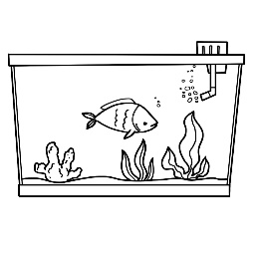 (B)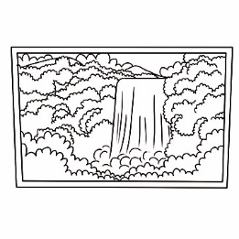 (C)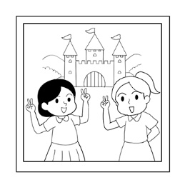
- (A)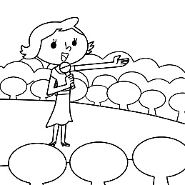 (B)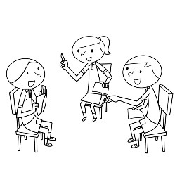 (C)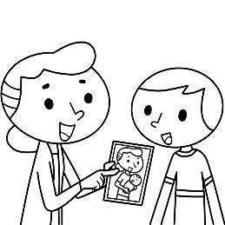
- (A)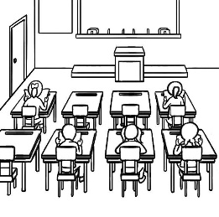 (B)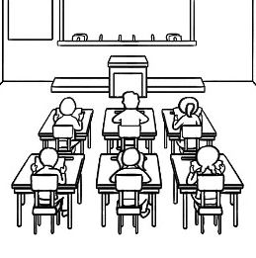 (C)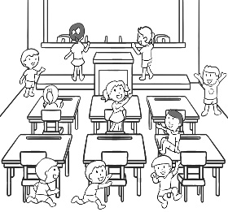
- (A)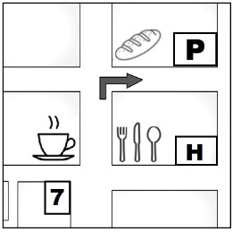 (B)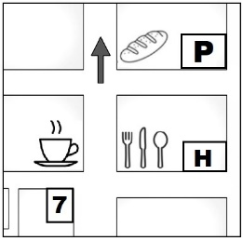 (C)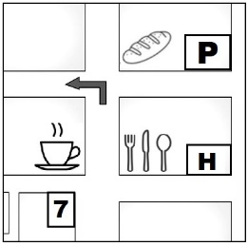
- (A)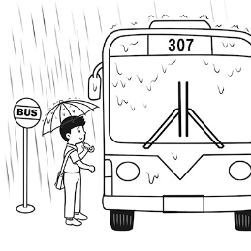 (B )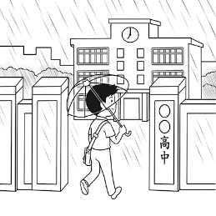 (C)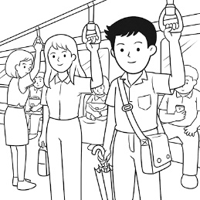
二、基本問答：每題均有三個選項，請依據所聽到的內容，選出一個最適合的回應 每題2分 (10%)
- (A) I will leave Taiwan in May.
(B) I am going there next month.
(C) I will live there with my family.
- (A) Will she go there today?
(B) How long did she stay there?
(C) How long did it take her to go there?
- (A) Yes, she is going to visit her uncle by train.
(B) Yes, she is going to visit her friend with her family.
(C) No, she isn’t, but her brother is.
- (A) Go straight for one block, and you’ll see the park across from my house.
(B) That’s right. I can go jogging there every day.
(C) It’s in the north of the country.
- (A) I’m sorry, young lady. I can’t stop or park the car on the red line here.
(B) We are lucky. There are two clerks in the convenience store.
(C) You made a big mistake. You took a wrong bus.
三、言談理解：每題均有三個選項，請依據所聽到的對話與問題，選出一個最適當的答案 每題2分 (10%)
- (A) He’s going to a post office.
(B) He’s going to a flower shop.
(C) He’s going to a department store.

- (A) The boy never sleeps late in the morning.
(B) The boy often stays up on weekends.
(C) The boy just can’t get up early on weekends.
- (A) In a hotel.
(B) By the river bank.
(C) In a fireworks show.
- (A) It takes the man thirty minutes to go to work by bus.
(B) It was a mistake for the man to go to work with the woman.
(C) Both the man and the woman go to work by bus.
- (A) They are going to find a nice hotel on Google.
(B) They are going to look around the city by boat.
(C) They will visit some museums tomorrow.
(二)綜合測驗 每題2分 (38%)
- My home,Taitung, is in the _____ of Taiwan.
(A) west (B) east (C) south (D) north
- They plan to cross the river by _____.
(A) truck (B) plane (C) scooter (D) ship
- These two men _____ hands when they first met.
(A) shake (B) shock (C) shook (D) sock
- Judy: I’m so thirsty. Can we get something to drink?
Tina: Sure. There’s a _____ just one block away from here. Let’s go there and buy some juice.
(A) supermarket (B) bank (C) hotel (D) post office
- The flower shop is _____ the train station.
(A) at the corner (B) between (C) next (D) across from
- Mom: The phone is ringing. Who _____ it? Son: Sorry, I’m busy now.
(A) answers (B) is answering (C) will answer (D) answered
- Jack: How are you going to _____ your holidays?
Tim: I am going to Japan to the Disneyland with my children. You know, they really like it.
(A) pay (B) cost (C) take (D) spend
- Tony: _____ will it take to walk to the bookstore?
Maggie: About 15 minutes.
(A) How soon (B) How often (C) How much (D) How long
- Father usually _____ his bike or _____ a taxi to work.
(A) rides ; takes (B) drives ; takes (C) takes ; drives (D) rides ; drives
- Don’t leave the airport. I _____ pick you up right away.
(A) am going (B) am coming (C) will (D) won’t
- Penny: _____ to buy two dozen eggs for me on your way home?
Vivian: No problem.
(A) Are you convenient (B) Do you convenient (C) Does it convenient for you (D) Is it convenient for you
- Look! It’s getting cloudy. _____
(A) It will be rain. (B) It is going to be rainy. (C) It rains a lot. (D) There will be rainy.
- Mr. Black forgot _____ the key with him. He had to stay out until his wife got home.
(A) to bring (B) bringing (C) brought (D) bring
- Alan: How is Grandma going to Far Eastern Memorial Hospital?
Bella: _____
- Yes, she’s going there on foot. (B) She’ll be there in one hour. (C) She’s going to visit her friend. (D) She’s going to take the metro.
- There _____ many people in the church on Christmas Eve.
(A) is going to be (B) will have (C) are going to (D) will be
- Mark: How’s the weather there in Canada? Is it snowing?
Amy: No, but _____ for the next few days. I learned it from the TV news.
- it will (B) it is (C) it has (D) it was
- Walk _____ the street _____ three blocks, and you’ll see my school.
(A) to ; for (B) across ; at (C) along ; for (D) from ; on
- Larry: Why don’t you buy the smartphone you really like?
Oscar: It _____ too much.
- takes (B) spends (C) costs (D) pays
- Andy: Why is Dad so happy?
Kevin: He said he _____ his brother tomorrow.
- saw (B) will see (C) sees (D) would see

(三)克漏字選擇 每題1分 (11%)
On December 31st, Jack always 35 the beautiful fireworks in New York City on TV. He really wants to visit the Big Apple and 36 the fireworks there one day. Now the long wait is over. This winter, Jack 37 New York City with his family.
Jack’s parents 38 an itinerary last week. They let him choose the hotels, the restaurants, and the sights. Jack spent a lot of time 39 the travel plans because he 40 his parents to have a good time. He also collected some travel tips for the trip.
itinerary旅遊行程
- (A) will watch (B) watch (C) watches (D) watched
- (A) will watch (B) watch (C) watches (D) watched
- (A) visited (B) is visiting (C) visits (D) is going to visit
- (A) ask him to make (B) asked him making (C) asked him to make (D) will ask him making
- (A) to make (B) make (C) for making (D) making
- (A) wants (B) wanted (C) will want (D) want
Alan: Where did you buy the blanket? Did you buy it online, too?
Bella: No, I bought it at a shop near the station.
Alan: I 41 five hundred dollars for my blanket. What about you?
Bella: It was on sale, so I 42 fifty dollars on it.
Alan: Oh my! You’re so lucky.
Bella: Not really. They put the wrong blanket in my bag, so I went back to the store to change it. However, many people were there for the big sale. So, I 43 a lot of time waiting. The blanket only 44 me fifty dollars, but it 45 me half a day to get it.

- (A) spent (B) cost (C) took (D) paid
- (A) spent (B) cost (C) took (D) paid
- (A) spent (B) cost (C) took (D) paid
- (A) spent (B) cost (C) took (D) paid
- (A) spent (B) cost (C) took (D) paid

(四)閱讀測驗 每題2分 (26%)
It’s okay not to be perfect.
It sounds strange, right? That’s because we’re used to trying to be perfect. Our parents want us to get full marks. We want the very best life. And our minds never stop looking for new ways to improve.
But here’s the catch. Although it’s good to have goals, you’re more likely to achieve them by just being yourself. Trying to be perfect only makes things more difficult. It adds stress and slows you down by making you overthink everything. It’s better to just calmly and coolly get the job done. Even if you make a mistake, you can learn from it next time.
Remember that perfection doesn’t even actually exist. It’s just an idea that we have fallen in love with. Even if you did achieve “perfection, ” you wouldn’t know it. You’d be too busy worrying about how to improve it.

perfect完美 improve進步 goal目標 achieve達成 stress壓力 exist存在
- What is this article trying to say?
(B) Listen to your parents.
(D) It’s good to have goals.
  - Always be perfect.
- Be brave and be yourself.

- Which of the following is not a tip from the article?
(B) Be yourself
(D) Always get full marks.
- Slow down when you’re feeling stressed.
- Learn from mistakes.
- Which of the following sentence uses “catch” in the same way as the article?
- The baseball player made a great catch.
- Use the catch to close the window.
- The fisherman returned with a big catch.
- There was a catch in the agreement (協議).
- Which of the following tips would the writer likely offer(提供)?
- Don’t be scared to make mistakes.
- The faster you do something, the better.
- You should learn to love perfection.
- Worry about what others think of you.

It’s interesting to look at the relationship between people and their pets. Sometimes, it’s like the animals are our children since they’re treated so well. In parks, it’s common to see people carrying around small birds in cages. Others hold their dogs just like little babies. At home, people often treat their pets like members of the family.
What’s the reason for this close bond between people and the animals they raise? One reason is the love and friendship a pet can bring. No matter what kind of a day you’ve had at school or work, or what mood you’re in, your pet is always glad to see you when you get home. You can say anything you want, and your dog will still lick your face. Your cat will still be warm and furry, and it will keep you company.
Of course, pets can’t talk to you the same way a friend can, but they’ll listen to whatever you have to say. It doesn’t matter if they can’t understand you. They’re just happy to be with you. (But, while you’re talking, they may still try to lick your face.)
Loyalty is another reason for this special relationship. Once an animal is used to living at your house, it will always stay there. You can let your cat run around outside, but it will always come back to its home. Not all pets, however, can be let loose. A bird or snake will probably disappear if you let it out of its cage.
Some pets, like dogs, will also try hard to protect you. That’s why people like to go jogging with their dogs. There are also many stories of dogs saving people in rivers and lakes.
People in most countries raise pets. Once we bring them into our homes, they become an important part of our lives.
Sometimes it’s hard to explain why. But in the end, it’s pretty simple. Just look at the way a dog and its master smile at each other. That says it all.
relationship關係 bond 聯繫 raise 飼養 mood 情緒 furry 毛茸茸 company 陪伴 loyalty 忠誠
- What is the main idea?
- Dogs make the best pets.
- Some pets need to be kept in cages.
- Everyone treats their pets like their own children.
- There are different reasons why people are attached(依戀) to their pets.
- The article compares(比較) small dogs to little babies. This suggests that______.
- pets are easier to raise than children
- some people treat their pets with great care and love
- the best dogs are small, like babies
- small dogs and babies are almost the same
- If you’re angry when you get home, your dog will ______.
(B) also be angry
(D) still greet you and welcome you home
- probably bite you
- run away and hide
- Which of the following is NOT a reason given for people’s closeness to pets?
- Pets treat you well, no matter what mood you’re in.
- Pets don’t eat too much.
- Pets will listen to all of your problems.
- Pets can be very loyal.

I just got this month’s issue of World Magazine!
I can’t wait to read it. Let’s look at what’s inside!
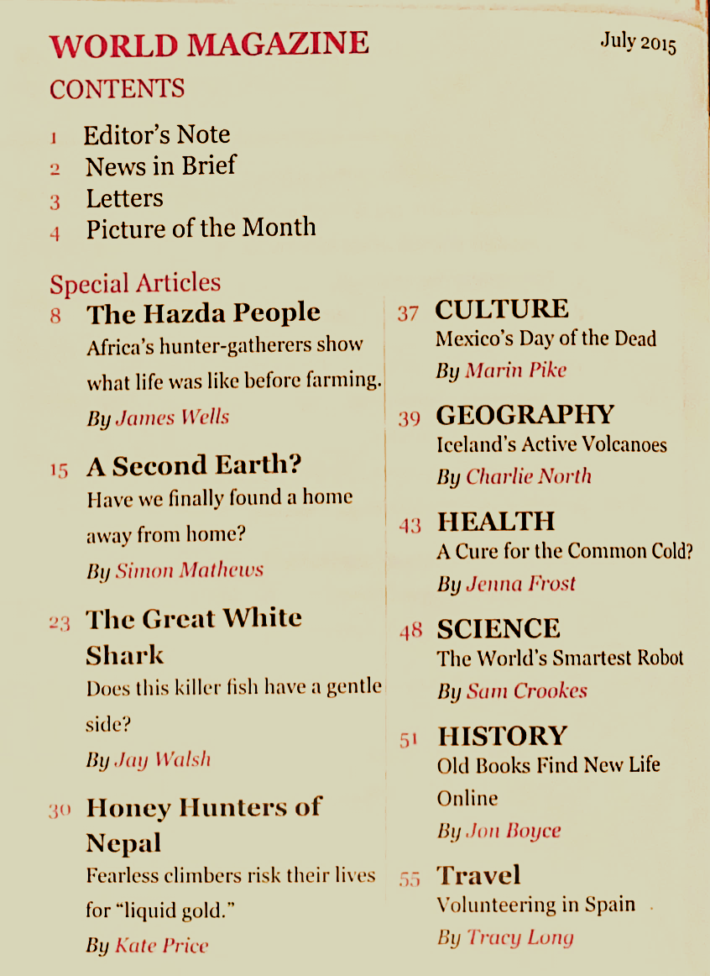
issue議題 content 內容 brief簡短 editor編輯 gentle溫和 geography地理 hunter-gatherers狩獵採集者
- What is the point of the table(表格)?
- To show you who works for the magazine.
- ﻿﻿﻿To show you where you can buy the magazine.
- ﻿﻿﻿To show you what's inside the magazine.
- To show you who buys the magazine.
- Which of the following can you read about in the magazine?
- ﻿﻿﻿A festival in a foreign country.
- ﻿﻿﻿How to apply makeup(化妝品).
- ﻿﻿﻿This year's most popular video game.
- ﻿﻿﻿New ways to grow plants.
- Which of the following is probably true about the article on page 23?
- ﻿﻿﻿It suggests that we should kill more sharks.
- ﻿﻿﻿It suggests that sharks aren't as bad as you think.
- ﻿﻿﻿The writer is someone who hates sharks.
- ﻿﻿﻿It tells you how to cook using shark meat.
- I want to read the article about the cure for the common cold.
Which page should I turn to?
- Page 30.
- Page 55.
- Page 15.
- Page 43.
- What's on page 2 of the magazine?
- ﻿﻿﻿An article about another planet.
- ﻿﻿﻿An article about traveling in Europe.
- ﻿﻿﻿A quick review of recent events.
- ﻿﻿﻿A message from the magazine's editor.

111-1-3 八年級 英語科－解答
- BABBC 6. BACBA 11.ACACC 16.BDCAD
21.CDDAC 26.DBADD 31.ACCDC 36.BDCDB
41.DAABC 46.CDDAD 51.BDBCA 56.BDC

溪崑 國中 英語科 考試卷 ___年 ___班 座號：___ 姓名：__________
一、辨識句意：每題均有三張圖片，請依據所聽到的句子，選出符合描述的圖片(每題1分，共5分)
- 《腳本區》
CD: Lily drew a picture of nature yesterday.
《題目區》
(A) (B) (C)
《答案區》
答案：B
- 《腳本區》
CD: The lady is speaking to the public.
《題目區》
(A) (B)(C)
《答案區》
答案：A
- 《腳本區》
CD: There are half a dozen students in the classroom.
《題目區》
(A) (B) (C)
《答案區》
答案：B
- 《腳本區》
CD: Keep walking down the street and go past the bakery.
《題目區》
(A) (B)(C)
《答案區》
答案：B
- 《腳本區》
CD: Ted usually walks to school, but this morning he took the metro because it was rainy.
《題目區》
(A) (B)(C)
《答案區》
答案：C
二、基本問答：每題均有三個選項，請依據所聽到的內容，選出一個最適合的回應(每題2分，共10分)
- 《腳本區》
CD: When are you going to leave for Taiwan?
《題目區》
(A) I will leave Taiwan in May.
(B) I am going there next month.
(C) I will live there with my family.
《答案區》
答案：B
- 《腳本區》
CD: Wendy didn’t remember to go to the bank yesterday morning.
《題目區》
(A) Will she go there today?
(B) How long did she stay there?
(C) How long did it take her to go there?
《答案區》
答案：A
- 《腳本區》
CD: Is Jane going to drive her family to Tainan to visit her uncle this weekend?
《題目區》
(A) Yes, she is going to visit her uncle by train.
(B) Yes, she is going to visit her friend with her family.
(C) No, she isn’t, but her brother is.
《答案區》
答案：C
- 《腳本區》
CD: M: There is a park next to my house.
W: Wow. It’s very convenient.
《題目區》
(A) Go straight for one block, and you’ll see the park across from my house.
(B) That’s right. I can go jogging there every day.
(C) It’s in the north of the country.
《答案區》
答案：B
- 《腳本區》
CD: (W:) Could you stop the taxi at the corner for a minute, sir? I need to buy something at the convenience store.
《題目區》
(A) I’m sorry, young lady. I can’t stop or park the car on the red line here.
(B) We are lucky. There are two clerks in the convenience store.
(C) You made a big mistake. You took a wrong bus.
《答案區》
答案：A
三、言談理解：每題均有三個選項，請依據所聽到的對話與問題，選出一個最適當的答案(每題2分，共10分)
- 《腳本區》
CD: M: I’m going out to send the letter.
W: You still write letters?
M: Well, my grandmother doesn’t have a phone, and she doesn’t use the Internet, either.
W: I can’t believe it!
Q: Where is the man going?
《題目區》
(A) He’s going to a post office.
(B) He’s going to a flower shop.
(C) He’s going to a department store.
《答案區》
答案：A
- 《腳本區》
CD: B: Did Mom and Dad go out for a hike again?
G: Yes, they left home in the early morning today.
B: Why do they never bring me along?
G: Because you are never an early bird on weekends.
Q: What does the girl mean?
《題目區》
(A) The boy never sleeps late in the morning.
(B) The boy often stays up on weekends.
(C) The boy just can’t get up early on weekends.
《答案區》
答案：C
- 《腳本區》
CD: M: Hi, Ms. Lin. This is your room key. Enjoy your stay.
W: Thanks. Do you have a map of the city?
M: Sure. Here you are. This map can show you the sights of the city. By the way, there will be a fireworks show along the river at eight tomorrow night. You can watch it from your room.
Q: Where are the man and the woman?
《題目區》
(A) In a hotel.
(B) By the river bank.
(C) In a fireworks show.
《答案區》
答案：A
- 《腳本區》
CD: M: How do you go to work?
W: I go to work by bus. I take Bus 299 every morning.
M: Me too. We can wait for the bus together.
W: Great. I usually get to the bus stop at ten. What about you?
M: Too bad. I need to take the bus before 9:30.
Q: What can we know from the talk?
《題目區》
(A) It takes the man thirty minutes to go to work by bus.
(B) It was a mistake for the man to go to work with the woman.
(C) Both the man and the woman go to work by bus.
《答案區》
答案：C
- 《腳本區》
CD: W: What are we going to do tomorrow in London?
M: We’ll visit some markets and museums.
W: Great! And we’ll look around the city by bus, right?
M: Yeah. We’ll also try Thames River Water Taxi. We can enjoy the views along the river.
W: A water taxi?
M: In fact, it’s not a taxi. It’s a small ship on the river to take people to different sights. We take the water taxi from Greenwich to Tower of London and get to Westminster by noon.
W: We can have lunch there. Let me find some good restaurants on Google.
Q: Which is right about the woman and the man?
《題目區》
(A) They are going to find a nice hotel on Google.
(B) They are going to look around the city by boat.
(C) They will visit some museums tomorrow.
《答案區》
答案：C

