新北市立溪崑國民中學111學年度第一學期第二次定期評量 英語科 試題卷
九年級 班 座號 姓名
第一部分:聽力測驗 30%
- 辨識句意：每題均有三張圖片，請依據所聽到的句子，選出符合描述的圖片
- (A)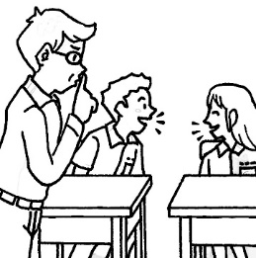 (B)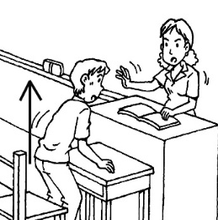 (C)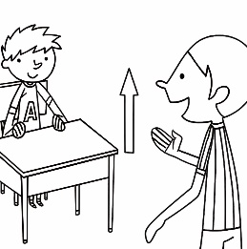
- (A)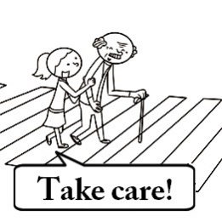 (B)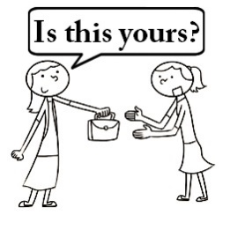 (C)

- (A) (B)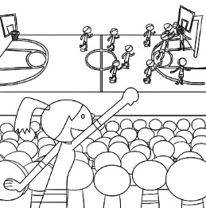 (C)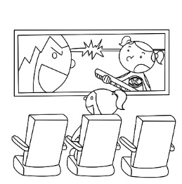
- (A)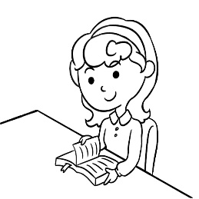 (B) (C)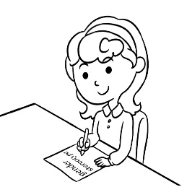

- (A)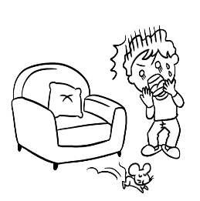 (B)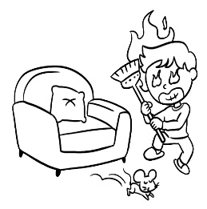 (C)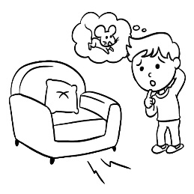

- 基本問答：每題均有三個選項，請依據所聽到的內容，選出一個最適合的回應
- (A) Yeah, they can be seen everywhere now.
(B) Well, the style of this smartphone is not modern enough.
(C) Look, the newest computer is being presented in the meeting.
- (A) Doing housework is women’s responsibility.
(B) People lose their jobs because of their age.
(C) People often make jokes about fat people on the Internet.
- (A) The table was created by my grandpa.
(B) Then let’s combine two tables for the whole family.
(C) Grandpa found pleasure in making his own tables.
- (A) Yes. It opens from 7 a.m. to 9 p.m.
(B) Yes. It was built at least 20 years ago.
(C) Yes. It’s on Main Street next to the park.
- (A) People have to pay after the first month.
(B) In fact, it has been on the market for years.
(C) Sure. It’s my pleasure to learn with the app.
三、言談理解：每題均有三個選項，請依據所聽到的對話與問題，選出一個最適當的答案

11. (A) The man used to go camping with the woman very often.
(B) The man isn’t allowed to go camping this time.
(C) The man became interested in camping because of a movie.
12. (A) Report the news about an earthquake on TV.
(B) Tell the woman more about the class.
(C) Practice for the report about the earthquake.
13. (A) She often misses the woman’s messages.
(B) She and the woman use the same app.
(C) She has already read all the woman’s messages.
14. (A) She doesn’t fully believe in Google Maps.
(B) Google Maps isn’t sure where they are.
(C) The man doesn’t know how to read maps.
15. (A) Dolly was at the metro station when the man saw her.
(B) The man remembers where Dolly went.
(C) The woman doesn’t know what Dolly was wearing.


第二部分: 綜合選擇 30%
16. Look at the picture. The _______ was ________ by Peter yesterday.
(A)blanket; made (B)case; taken out
(C)blanket; washed (D)case; cleaned
17. King Charles III began carrying out his _______ less than a day after the death of his mother, Queen Elizabeth.
(A)duties (B)charts (C)hearts (D)plants
18. The latest iPhone 14 that came out in September really ______ me away.
(A)blow (B)blowing (C)blown (D)blew
19. Over 80% of people in Taiwan are _________, and it’s getting worse.
(A)trainees (B)hunters (C)phubbers (D)heroes
20. The taste of the ice cream is still on my ________.
(A)tongue (B)decipher (C)grass (D)tip
21. Because Kevin has been sick for one week, we have decided that the report _______ by Carol.
(A)had been finished (B)will be finished (C)be finished (D)has finished
22. In Korean drama series, women are often ___________ housework at home or _________ with friends at restaurants.
(A)seen doing; chat (B)seeing doing; chatting (C)seeing to do; chatting (D)seen doing; chatting
23. The novels about daily life in France ____________ by Annie Ernaux. She wins the 2022 Nobel prize, ________?
(A)were written; doesn’t she (B)was written; does she (C)has written; doesn’t she (D)wrote; is she
24. The street vendor could hardly make a living because of COVID-19, _____________?
(A)couldn’t he (B)didn’t he (C) could he (D)did he
25. All the packages ______ carefully at the airport to make sure that they’re safe.
(A)have checked (B)checked (C)are checking (D)are checked
26. My best friend is coming to my home today. She __________ with me for a week.
(A)is stayed (B)stays (C)is staying (D)must be stayed
27. Don’t let the children swim in the river. We don’t know _____________. It could be dangerous.
(A)that it is thick (B)how deep it is (C)what is it (D)how long it is
28. Guess _____________.
(A)how he should do (B)how did I feel (C)what to do it (D)what will happen next
29. Please let me know ________________________.
(A)if Peter will be back next week (B)if it rains this Saturday
(C)whether Ryan comes tomorrow (D)if Rita leaves for the USA next year
30. Sam had butterflies in his stomach before the interview. Who may have the same feeling?
- Tina is going to sing in the public. (B)Tom is seeing his favorite movie in the theater.
(C)Ted can’t understand what young people are talking about. (D)Billy was chosen to be the model student.
第三部分: 克漏字及閱讀測驗 20%
(31~33)
Malala Yousafzai is different from any other woman her age. In 2012, at the age of 15, she 31 in the head because she spoke up for girls in Pakistan and their right to go to school. Luckily, she didn’t lose her life and got well. Malala became a voice for girls’ education and then, in 2014, she 32 became the youngest winner of the Nobel Peace Prize. After facing problems with getting her own education, she finally finished high school in the UK in 2017. The first time she used Twitter, she wrote: "I’m excited about my future, but I know that millions of girls around the world are out of school and many never get the opportunity to complete their education." What’s next for Malala? She is in the UK for her studies at Oxford. She said, " 33 — a good university education. My dream is to empower myself with education, and then it is a weapon." Malala is working to make her dream come true. education 教育 opportunity 機會 weapon 武器
31.(A)shot (B)shoot (C)was shot (D)has shot
32.(A)also (B)however (C)at least (D)sadly
33.(A)I want to be the winner of Nobel Peace Prize. (B)I’m studying how to make weapons in Pakistan.
(C)I want to be different from others. (D)I want to get my education.

(34~35)
Emilie : Please excuse me while I go powder my nose.
Meiling: Do you need a mirror? I have one here.
Emilie : No thanks. I’m just going to 34 .
Meiling: Oh, I see.
Emilie : Um, why are there no seats on the toilets? I’ve never seen that kind before.
Meiling : Those are squatting toilets. They’re very common here. Let me show you 35 .
34.(A)order something I like on the menu (B)use the ladies’ room
(C)read as many books as I can (D)creamy my personal profile on the website.
35.(A)where the squatting toilets are (B)where are the squatting toilets
(C)where are the sitting toilets (D)where the sitting toilets are

(36~38)
What languages do you know or can you speak? Among all the languages, English might be the most known and spoken one in the world. Do you know that there are over seven thousand languages in the world, but less than one hundred are still spoken? What’s more, only twenty-five of them are used as the first language by about half the people in the world.
As for the rest, they are dying out. Reports even show that one language is disappearing every fifteen days. Many people call for taking action to save these languages. Governments have so many things such as hiring teachers to teach these dying languages at schools and recording the words and sounds of them.
Take Navajo as an example. It is one of the living languages used in the USA, and there were once about three hundred languages used, or historically had been used, but there are only fifty left now. For a long time, Navajo had been used by both the young and the older speakers and passing it on to the children. As time went by, people used it less and less. Most of the time, it was seldom used in their daily lives and could only be read in the book.
The government believed that the language could be brought back through the use of songs, dances, and the children’s games and decided to save the language. They hired lots of artists to teach children how to dance and sing in the Navajo languages. At first, it was difficult for them to find teachers he/she could both speak and sing in Navajo. However, as more and more people started learning to speak it and passing it on to others, the language has been saved and keeps growing. Now, it is one of the most spoken languages among all the many Native American languages. There are now around 200,000 speakers in the US.
- What does they mean in the second paragraph?
- languages (B)reports (C)governments (D)Navajo people
- Which may not be true about the reading?
- English might be the most spoken language around the world.
- The Navajo language is spoken in the USA today.
- Only twenty-five languages are spoken in the USA today.
- There are more than seven thousand languages in the world.

- What can we learn about the Navajo and their language?
(A)The US government decided to give up the Navajo language long time ago.
(B)Navajo is among the most used Native American languages.
(C)People don’t speak the Navajo language in the USA now.
(D)Navajo has only ever been a spoken language.

(39~40)
Rank | Superhero | Number of Countries | % Share in Study
1 | Spider-Man | 57 | 48.7%
2 | Wonder Woman | 15 | 12.8%
3 | Batman | 11 | 9.2%
4 | Iron Man | 10 | 8.5%
5 | Superman | 6 | 5.1%
6 | Captain America | 4 | 3.4%
7 | Aquaman | 4 | 3.4%
8 | Hulk | 3 | 2.5%
9 | Wanda Maximoff | 2 | 1.7%
10 | Groot | 1 | 0.8%
With great power comes great responsibility, the study names Spider-Man the world’s most popular superhero. Created by Stan Lee, Spider-Man is the superhero alter ego of Peter Parker and has been the focus of comics, film series and video games so it’s no surprise that he comes out on top in 57 countries.
Wonder Woman comes in second place and is the highest-ranking DC superhero, with 15 countries searching for her the most!
Batman rounds off the top three, being the most searched for hero in 11 countries and claiming a 9.2% share in the study.
10 countries were most obsessed with Iron Man placing him in fourth while Superman is favorite in six countries and is fifth in the results.
When it comes to superheroes, Marvel rules with six of the most popular superheroes and four being DC heroes in the study.
39. To get the information above, what words may you most likely surf?
(A)The greatest stars of all time.
(B)Top movies--favorites in theaters this week.
(C)Where to enjoy an action movie this winter.
(D)The most popular superheroes around the world.
40. From the reading, which is not true?
(A)The Marvel’s superhero comes out on top.
(B)The rankings suggest DC superheroes are more than Marvel ones.
(C)Wonder woman is the most popular DC superhero.
(D)Batman comes in third place and claims a 9.2% share.

第四部分:翻譯 20% (引導式翻譯，一格一分，整句式翻譯，每題4分)
41~43我們應打破關於女性的刻板印象並在大銀幕上呈現不同種類的強大女性。
We should break the 41 about women and 42 different kinds of powerful women on 43 .
44~46這部電影真的很討人喜歡，不是嗎？的確如此。這部電影充滿了愛，而且我忍不住站在那些玩具的立場看事情。
The movie was really lovely, wasn’t it? It sure was. The movie was 44 with love, and I can’t 45 but put 46 in the toys’ shoes.
47~48此字第一次出現於十九世紀末，並顯示出一些人如何把兩餐併為一餐。
It first 47 up in the late 19th century and showed 48 some people made one meal out of two.
49.電影不僅關於幫助人們夢想而且還攸關改變事情並讓人們思考他們的未來。
50.早午餐的歷史實際上是人們如何改變他們的飲食習慣的故事。
51.如你所見，語言不只關乎聲音、字詞和句子。它還乘載著說該語言的人的文化。

新北市立溪崑國民中學111學年度第一學期第二次定期評量 英語科 答案卷
九年級 班 座號 姓名
第四部分:翻譯 20% (引導式翻譯，一格一分，整句式翻譯，每題4分)
41. | 42. | 43. | 44.
45. | 46. | 47. | 48.

49.
50.
51.

111-1-2 九年級 英語科－解答
111-1-2 九年級 英語科－解答
- B | - B | - C | - B | - C | - A | - A | - B | - B | - A
- C | - C | - B | - A | - B | - C | - A | - D | - C | - A
- B | - D | - A | - C | - D | - C | - B | - D | - A | - A
- C | - A | - D | - B | - D | - A | - C | - B | - D | - B

第四部分:翻譯 20% (引導式翻譯，一格一分，整句式翻譯，每題4分)
41. stereotypes | 42. present | 43. screen | 44. filled
45. help | 46. myself | 47. showed | 48. how

49. Movies aren’t only helping people dream but also about changing things
and making people think about their futures.
50. The history of brunch is actually the story of how people changed their eating habits.
51. As you can see, language is more than just sounds, words, and sentences.
It also carries the culture of its speakers.

新北市立溪崑國民中學111學年度第一學期第二次定期評量
九年級 英語科 聽力測驗稿
一、辨識句意：每題均有三張圖片，請依據所聽到的句子，選出符合描述的圖片(每題2分，共10分)
- 《腳本區》
CD: (B:) The teacher didn’t allow me to stand up during the class.
《題目區》
(A)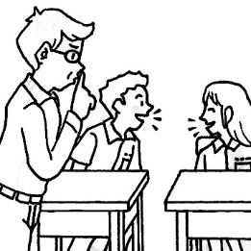 (B)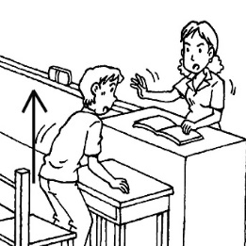(C)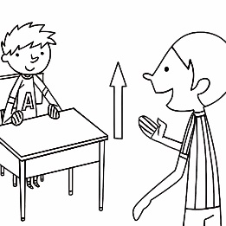
《答案區》
答案：B
- 《腳本區》
CD: You can tell that Gina is an honest girl.
《題目區》
(A) (B)(C)
《答案區》
答案：B
- 《腳本區》
CD: Iris didn’t go to the museum. She went to the movie theater instead.
《題目區》
(A)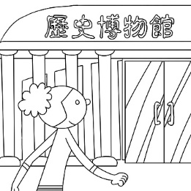 (B)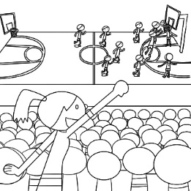(C)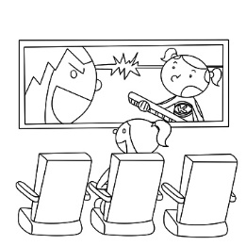
《答案區》
答案：C
- 《腳本區》
CD: Sandy doesn’t know what the word means, so she is looking it up in an online dictionary with her notebook computer.
《題目區》 (A)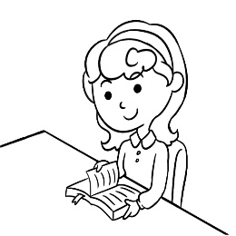 (B) (C)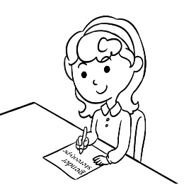
《答案區》
答案：B
- 《腳本區》
CD: Kevin isn’t sure if there is a rat under the couch, and he doesn’t know what to do.
《題目區》
(A)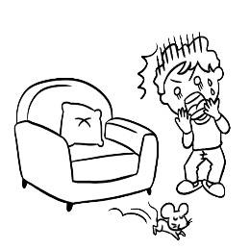 (B)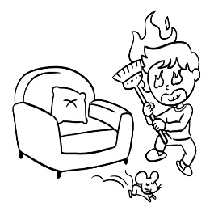(C)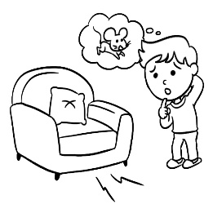
《答案區》
答案：C
- 基本問答：每題均有三個選項，請依據所聽到的內容，選出一個最適合的回應(每題2分，共10分)
6.《腳本區》
CD: Smartphones are very common in the modern world.
《題目區》
(A) Yeah, they can be seen everywhere now.
(B) Well, the style of this smartphone is not modern enough.
(C) Look, the newest computer is being presented in the meeting.
《答案區》
答案：A
7.《腳本區》
CD: What are common gender stereotypes?
《題目區》
(A) Doing housework is women’s responsibility.
(B) People lose their jobs because of their age.
(C) People often make jokes about fat people on the Internet.
《答案區》
答案：A
8.《腳本區》
CD: The table is not big enough for all of us.
《題目區》
(A) The table was created by my grandpa.
(B) Then let’s combine two tables for the whole family.
(C) Grandpa found pleasure in making his own tables.
《答案區》
答案：B
9.《腳本區》
CD: The airport is big and beautiful. Do you know when it was built?
《題目區》
(A) Yes. It opens from 7 a.m. to 9 p.m.
(B) Yes. It was built at least 20 years ago.
(C) Yes. It’s on Main Street next to the park.
《答案區》
答案：B
10.《腳本區》
CD: Can you explain more clearly how the app makes money for us?
《題目區》
(A) People have to pay after the first month.
(B) In fact, it has been on the market for years.
(C) Sure. It’s my pleasure to learn with the app.
《答案區》
答案：A
- 言談理解：每題均有三個選項，請依據所聽到的對話與問題，選出一個最適當的答案(每題2分，共10分)
11.《腳本區》
CD: M: You and Jane are going camping this weekend, aren’t you?
W: Yes, we are. Why do you ask?
M: Well, may I join you this time?
W: Of course, but I didn’t think you like camping.
M: I didn’t, but after watching the movie Blue Planet, I started to think about getting close to nature.
Q: Which is true?
《題目區》
(A) The man used to go camping with the woman very often.
(B) The man isn’t allowed to go camping this time.
(C) The man became interested in camping because of a movie.
《答案區》
答案：C
12.《腳本區》
CD: W: What are you doing?
M: I’m going to present a report in class tomorrow, so I’m preparing for it.
W: What is the report about?
M: It’s about last month’s earthquake.
Q: What is the man going to do later?
《題目區》
(A) Report the news about an earthquake on TV.
(B) Tell the woman more about the class.
(C) Practice for the report about the earthquake.
《答案區》
答案：C
13.《腳本區》
CD: W: The app shows Mary hasn’t read my message yet since yesterday. She never misses my messages. It’s strange, isn’t it?
M: Oh, she caught a cold last night, so she went to bed very early.
W: I see. Maybe I can buy some fruit to visit her tonight.
M: That will be great. I can drive you to her place.
Q: Which is true about Mary?
《題目區》
(A) She often misses the woman’s messages.
(B) She and the woman use the same app.
(C) She has already read all the woman’s messages.
《答案區》
答案：B
14.《腳本區》
CD: W: I think we should make a right turn at this corner.
M: I don’t think so because Google Maps shows we should turn left at the next corner. Here, take a look!
W: Google Maps isn’t always right. I’ve been on this road many times since I was a child.
Q: What does the woman mean?
《題目區》
(A) She doesn’t fully believe in Google Maps.
(B) Google Maps isn’t sure where they are.
(C) The man doesn’t know how to read maps.
《答案區》
答案：A
15.《腳本區》
CD: W: Sir, have you seen a girl in a red coat? I’m looking for my daughter, Dolly.
M: I just saw a girl walking by, but I don’t remember the color of her clothes.
W: Here’s a photo of her.
M: Yes, that’s her. She was going north when I saw her. Maybe she is going to the metro station.
W: Thank you so much!
Q: What do we know from the talk?
《題目區》
(A) Dolly was at the metro station when the man saw her.
(B) The man remembers where Dolly went.
(C) The woman doesn’t know what Dolly was wearing. 《答案區》答案：B

