新北市立溪崑國民中學111學年度第一學期第二次定期評量 英語科 試題卷
八年級 班 座號 姓名
- 聽力測驗 (30%)
A 辨識句意: 每題均有三張圖片，請依據所聽到的句子，選出符合描述的圖片。
- (A) 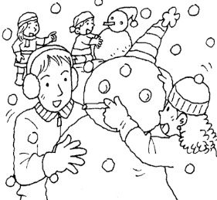 (B) 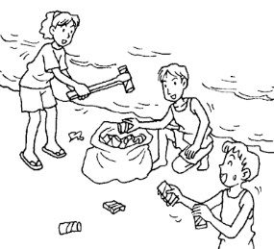 (C) 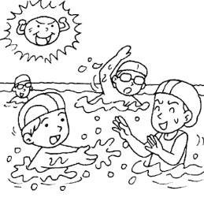
- (A) 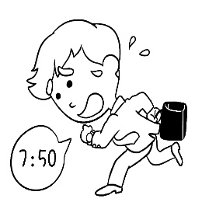 (B) 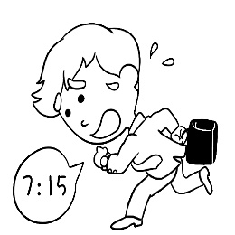 (C) 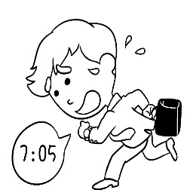
- (A) 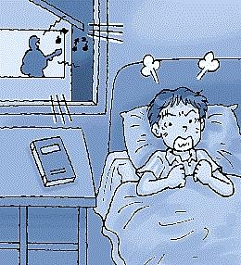 (B) 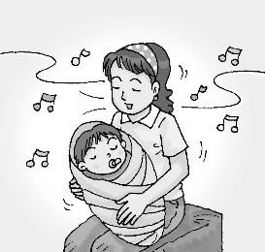 (C) 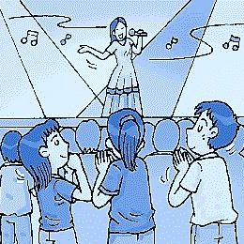
- (A) 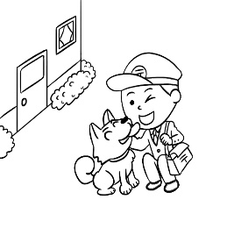 (B) 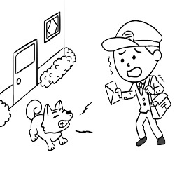 (C) 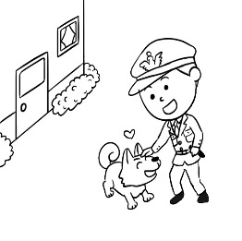
- (A) 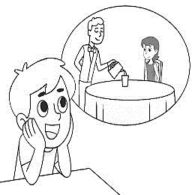 (B) 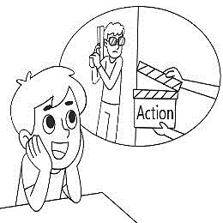 (C) 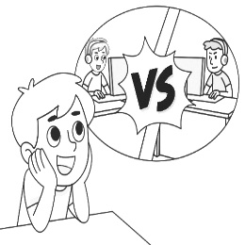
B 基本問答: 每題均有三個選項，請依據所聽到的內容，選出一個最適合的回應。
6. (A) His dad found him on the road. (B) He was crying by the roadside. (C) His father walked back and forth then.
7. (A) No, thanks. I can do it without you. (B) No, I don’t know the reporter. (C) No, I cannot help you write the report.
8. (A) Because I am a teenager. (B) Because I am good at acting. (C) Because I never thought about it.
9. (A) I went to the forest last Saturday. (B) Your plan led to lots of problems. (C) I plan to visit a temple in Lukang.
10. (A) Are you serious? It’s not funny to me. (B) Sure. I want to make a lot of money. (C) No problem. It was a lot of fun.

C 言談理解: 每題均有三個選項，請依據所聽到的內容對話與問題，選出一個最適當的答案。
11. (A) The man dropped something onto the road. (B) The man got lost on his way to the town.
(C) There is a rock in the middle of the road.
12. (A) Buy the man a watch. (B) Check the seats near the door. (C) Ak the man to call again.
13. (A) She wants to be a writer. (B) She is making money by writing stories. (C) She only finished the first part of the story.
14. (A) At a quarter to seven. (B) At seven. (C) At half past seven.
15. (A) He enjoys being a singer now. (B) Being an actor is his dream job. (C) It is easy for him to make a lot of money.

二、 綜合測驗 (30%)
16.There are always a lot of cars on the _____ between 7 am. and 9 am.
(A) road (B) camp (C) sky (D) hand
17. The movie begins at five thirty. Let’s meet in front of the theater at a _____ past five.
(A) forest (B) clock (C) quarter (D) sight
18. We can’t let Ted and Jack work together; they just _____ like cat and dog. They never agree on anything.
(A) visit (B) arrive (C) catch (D) fight
19. Billy is so _____ that he always thinks he’s right. That’s why he never says sorry even when he does something wrong.
(A) serious (B) proud (C) quiet (D) clear
20. It’s bad for your health to work long hours ______ taking a break.
(A) through (B) across (C) about (D) without
21. I did not do my homework, so my teacher said I _____ stay after school to finish it.
(A) had to (B) used to (C) hoped to (D) failed to
22. She _____ hard for the race, sometimes running as much as 60 miles a week. No wonder she won first place.
(A) dreamed (B) trained (C) stayed (D) reached
23. This restaurant is _____ for its roast duck. You need to order at least a month in advance.
(A) careful (B) heavy (C) bright (D) famous
24. The first call to the police from Itaewon came at 18:34 - several hours before the deadly crush ____ in an alley. There were
at least ten more calls from this area in the next three and a half hours.
(A) went through (B) dropped off (C) took place (D) picked up
25. When the baby cried, Mr. Wu _____ in the kitchen and did not hear it.
(A) cooked (B) was cooking (C) cooks (D) is cooking
26. You should always check the oil, water and tires _____ taking your car on a long trip.
(A) before (B) because (C) after (D) but
27. Hank has to cook dinner for his kids because his wife needs _____ in the evening.
(A) working (B) to work (C) works (D) work
28. ____ on time is very important. It shows to others whether they can trust you or rely on you.
A) Being (B) Be (C) To being (D) Is
29. It’s not right _____ my videos without asking me first.
(A) upload (B) be uploaded (C) uploaded (D) to upload
30. We were playing soccer on the sports field _____ the window broke.
(A) after (B) because (C) when (D) then

三、克漏字選擇: (8%)每題1分
A
Lots of kids and teenagers enjoy 31 video games, so 32 for them to be pro gamers. Some famous pro gamers are rich and meet a lot of people from other countries. 33 , pro gamers usually have health problem because they 34 playing games for long hours.
31. (A) to play (B) played (C) play (D) playing
32. (A) it may have fun (B) they can be funny (C) it can be much fun (D) there will be fun
33. (A) As usual (B) On the other hand (C) In the beginning (D) Back and forth
34. (A) stay up (B) take off (C) hold on (D) find out
B

It was 35 twelve. Tina and Billy 36 water when Billy saw a jar with some water in it. However, 37 . Tina had an idea. She picked up rocks and dropped them into the jar and the level of water rose little by little. Billy helped Tina get more rocks close to the jar. Three hours later, they finally drank the water. Billy asked Tina 38 she found the rocks. It turned out these rocks were near a river. It was silly of Tina to spend so much time.
35. (A) half past (B) half to (C) a quarter to (D) a quarter after
36. (A) look for (B) is looking for (C) looking for (D) were looking for
37. (A) they were not thirsty (B) they couldn’t reach the water (C) the water was not clean (D) there was no river on the map
38. (A) when (B) why (C) where (D) what
四、閱讀測驗: (16%)
A
One way to stay healthy is to exercise. Exercise helps you feel better, lose weight, and grow stronger. Taking a walk is a form of exercise. It helps you go outside and get fresh air. Playing a sport is another form of exercise. Taking classes at a gym is a way to be healthy and fit. There are many types of exercises you can do to keep healthy.
39. What is the main idea of the passage?
(A) Choose an easy way to exercise.
(B) There are many kinds of exercise.
(C) If you are not happy, exercise can fix it.
(D) Being a player helps you lose weight.

B
Superheroes are super popular in comic books and movies. Which superhero is the most popular? You might be surprised. Spiderman seems to be the superhero that people like most. In the Spiderman story, a special spider bit a teenager, Peter Parker. Then Peter Parker got the ability to climb up walls and shoot spider webs. One reason that Spiderman may be so popular is that Peter Parker is just a normal teenager, just like everyone else. However, he tries his best to help others. He uses his power to protect people. He’s smart, strong, and has a sense of responsibility. In fact, Spiderman’s motto is “With great power comes great responsibility.”
40. What is the reading mainly about?
(A) The motto of a superhero
(B) How popular superheroes protect people
(C) Why a superhero is popular with fans
(D) How to become a superhero

C
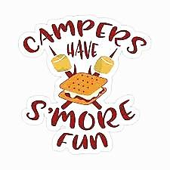
S’more is made of chocolate, marshmallows, and graham crackers. Here are the steps:
1. Get a graham cracker. Break it in half. Place one chocolate on one half.
2. Put a marshmallow on a stick. Hold it over a campfire.
3. Use the stick to set the hot marshmallow on the chocolate.
4. Take the other cracker half. Put it on the marshmallow.
5. Smooth the crackers together. Pull out the stick.
6. Eat!
Who first made s’mores? No one is sure. Maybe it was the Girl Scouts. A 1927 Girl Scouts manual talks about the snack. What if you don’t have a campfire? You can make a s’more in the oven or microwave. It’s so yummy that you will say give me some more. (graham 全麥的 scout 童子軍 manual 手冊)

41. Why do some people think Girl Scouts made s’mores first?
(A) Girl Scouts have to learn how to make campfires.
(B) A Girl Scouts guidebook talked about s’mores.
(C) Girl Scouts sell lots of crackers.
(D) Only girls like marshmallow.
42. Let’s say you are retelling the reading to your friends. It’s most important to tell ______.
(A) how to make a s’more
(B) who made the first s’more
(C) how yummy marshmallow is
(D) where to find the sticks
43. “What if you don’t have a campfire? You can make a s’more in the oven or microwave.” helps the readers to know _____.
(A) that campfires are not safe
(B) that oven s’mores are the best
(C) every step about making s’mores
(D) that there are different ways to make s’mores
D
Smith Bus Company has some exciting news to share! On June 1, our first east-west route will open! On this route, passengers can finally ride from City Center to Lemon Town without changing buses. There are also four new stops on this route. West Point, Green Garden, Grape Village, and East Beach. If you board at any of these stops this month, your trip is free.
We are also making our bus stops better, so some will be closed for repairs. Starting at 10 a.m. on Saturdays, there is no service at River Street, Forest Hill, Third Street, or City University. A free bus will take passengers from City Center and drop them off near these stops. Service returns to these stops at 6 a.m. each Monday.
Our new Circle Route also opens in June. It’s perfect for weekend travel! You can travel the route all day long with a Circle Route ticket. On race days, bused also stop at the race course. After the race, ride to the city zoo and see the baby lions. Then go to Old Town for some delicious snacks. If you have any questions, please call us. At Smith Bus Company, we just want to see you smile. (route路線 passenger乘客 board上車 repair整修 service 服務)
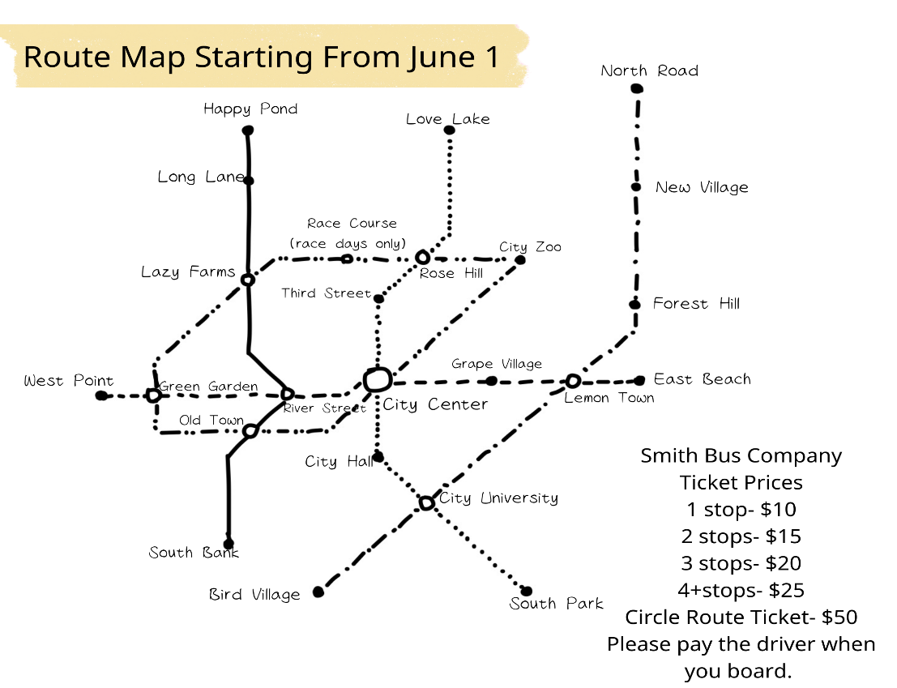

44. What did Smith Bus Company bus routes probably look like before June 1? (probably 可能)
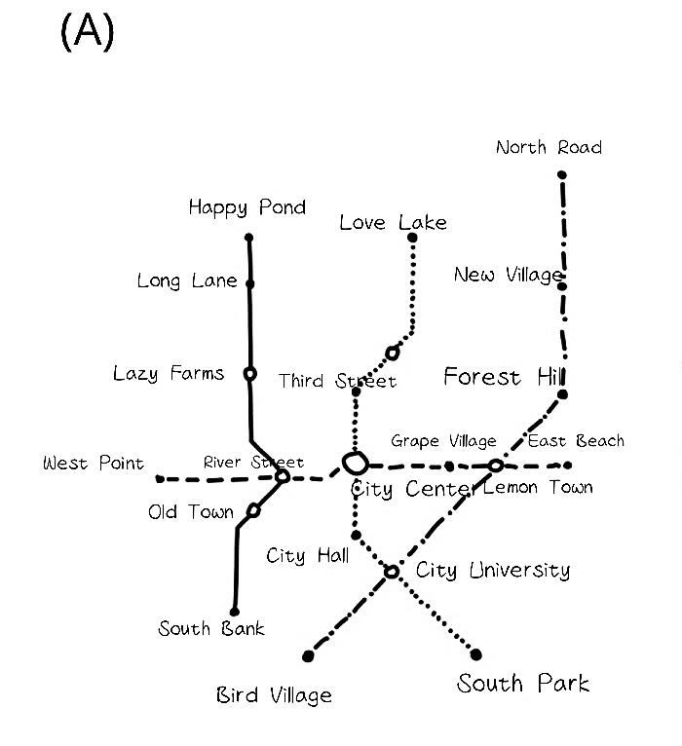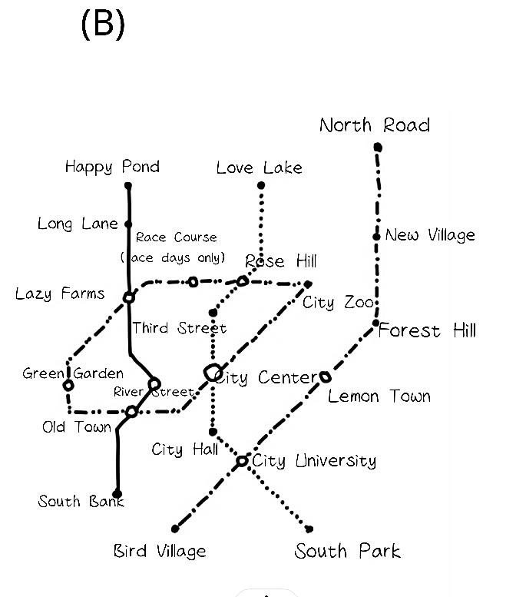
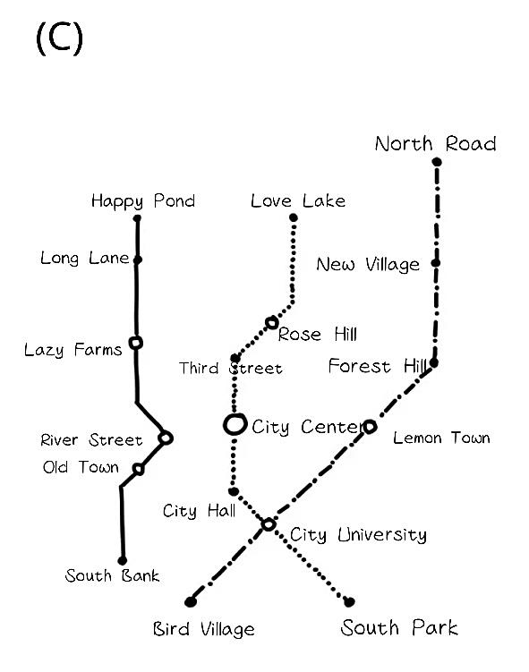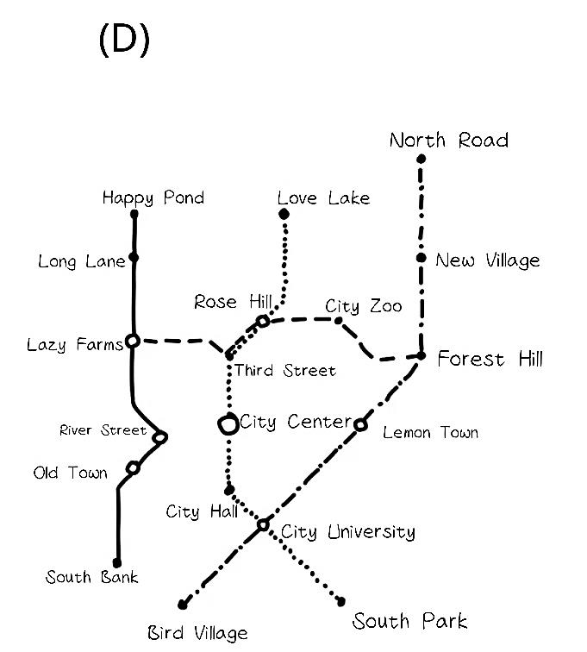
45. These charts show passenger numbers for some stops on different dates. Which is probably from Sunday, June 16?
(A) (B)
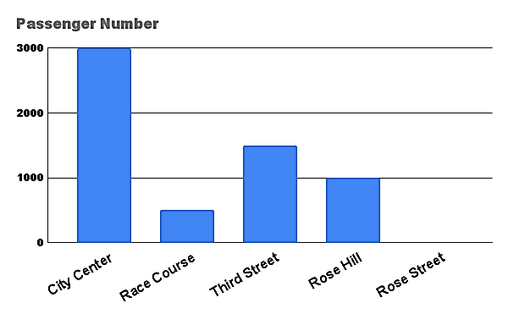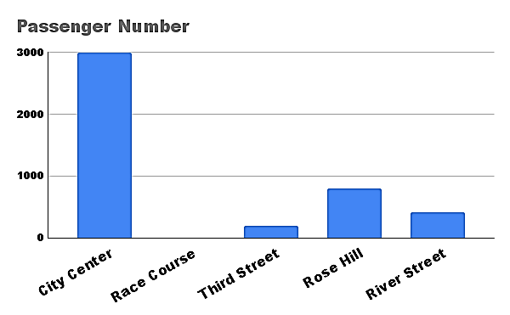
(C) (D)
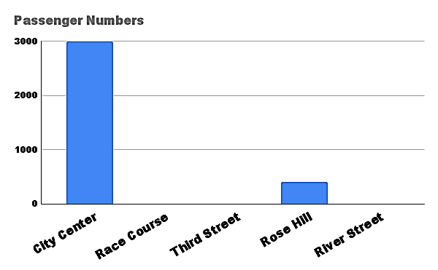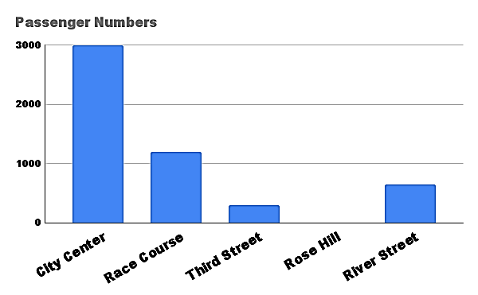
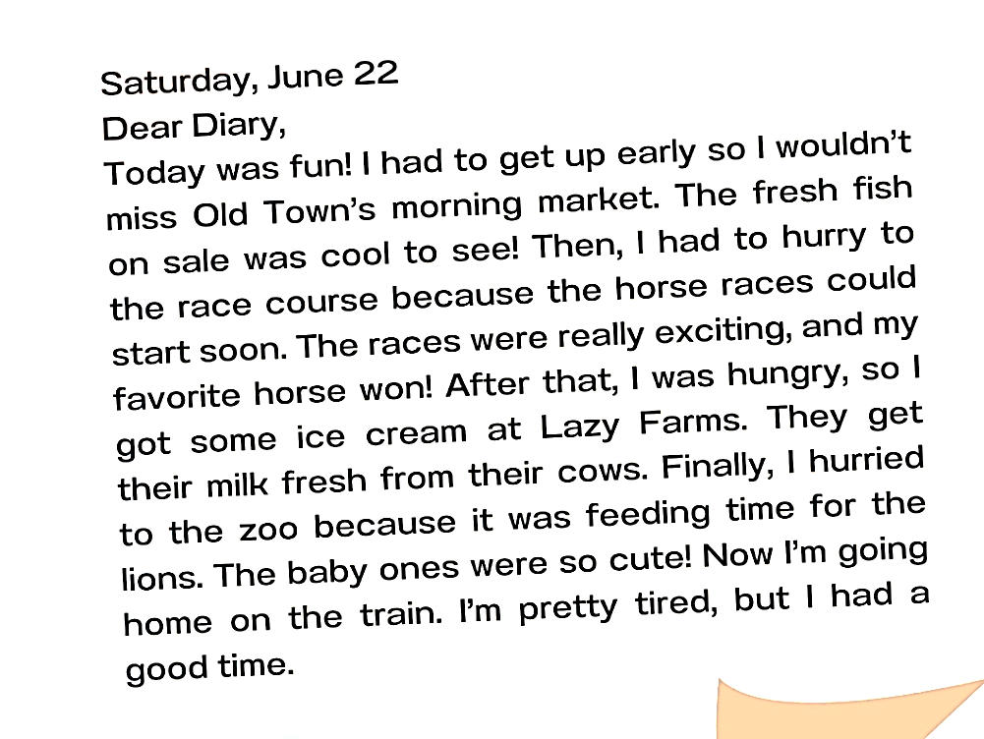
46. Annie traveled around the city on Sunday, June 22.
Read her diary from that day.
How much did she pay for the bus?
(A) 25 (B) 50 (C) 75 (D) 60

五、看圖作答或翻譯: (16%)
(題目見書寫題答案卷)

新北市立溪崑國民中學111學年度第一學期第二次定期評量 英語科 答案卷
八年級 班 座號 姓名
五、看圖作答或翻譯: (16% 空格一格1分，翻譯每句4分)

47. 4%  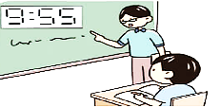 | It was _________ _______ ten in the morning.  Jack _________ _________ to his teacher in class.
48. 4%  專業玩家總是尋找獲勝的新方法，並且藉由彼此的對抗練習中學習。 | Pro gamers are always ___________ __________ new ways to win, and they learn _____________ ________________ fighting one another.
49. 4%

Tina飛越到石頭處，然後用鳥嘴撿起一顆大石頭。
50. 4%

我喜歡演戲也享受做影片，但是我做那些事只是為了好玩。

111-1-2 八年級 英語科－解答
一 聽力 1 C A A B C 6 B A B C C
11 C B A B A
二 綜合 16 A C D B D 21 A B D C B
26 A B A D C
三 克漏字 31 D C B A 35 A D B C
四 閱讀 39 B C B A D 44 C C B
五 看圖作答或翻譯
47 five, to, was, listening
48 looking for, by practicing
49 Tina flew over to the rocks and then picked up a big one with her beak.
50. I like acting and enjoyed making videos, but I only do those for fun.

新北市立溪崑國民中學111學年度第一學期第二次定期評量
八年級 英語科 聽力測驗稿
- 聽力測驗 (30%)
A 辨識句意: 每題均有三張圖片，請依據所聽到的句子，選出符合描述的圖片。
- It was a bright Sunday. The Sky was clear, and the weather was warm. The students were playing in the water then.
- The businessman has to get to his office at half past seven a.m., but he is twenty minutes late.
- Someone was singing loudly outside. The noise woke Bob up, and he couldn’t go back to sleep again.
- Sadly, being a mailman isn’t a good idea for the man because he is afraid of dogs.
- Kenny enjoys playing video games. He dreams of being a pro gamer in the future.

B 基本問答: 每題均有三個選項，請依據所聽到的內容，選出一個最適合的回應。
- What was the little boy doing when his dad found him?
- Do you want me to help with your report?
- Why do you want to be an actor?
- What do you plan to do this Saturday?
- Thank you for practicing soccer with me.

C 言談理解: 每題均有三個選項，請依據所聽到的對話與問題，選出一個最適當的答案。
- W: Sir, you need to turn around now.
M: Why? What happened?
W: A big rock blocks the way.
M: Then, how can I get to the town? This is the only way to the town.
Q: What happened?
- W: Good afternoon, Patty’s kitchen. May I help you?
M: Yes, I just had lunch at your restaurant. I think I might leave my watch there. Could you
check it for me?
W: Sure. Where did you sit, sir?
M: I sat near the door.
W: OK. Hold on, please.
Q: What is the woman going to do next?
- M: The story is interesting. Did you write it?
W: Yes, and I really love writing.
M: Then do you plan to be a writer? You can make money by writing.
W: Yeah, that’s my dream job.
M: Are you serious?
W: Yes, but before that, I have to finish the last part of the story.
Q: What can we know about the woman?
- W: Hi, Ben. This is Amber. What time and where are we going to meet tonight? The restaurant is open at seven thirty p.m. So, could you pick me up at seven at my place? Call me when you get this.
Q: When does Amber want to meet up with Ben?
- W: Andrew was a popular actor before. Now, he is a singer, and he sings at some pubs at night. Life is not easy for him because he makes little money. However, he enjoys his life very much. He loves singing and writing songs. On the other hand, he can finally have more time with his family. He is happy with his life now.
Q: Which is true about Andrew?

