新北市立溪崑國民中學111學年度第一學期第二次定期評量 英語科 試題卷
七年級 班 座號 姓名
一 聽力：30％(每題2分)
(一) 辨識句意：根據聽到的內容，選出符合描述的圖片10%
1.
(A) 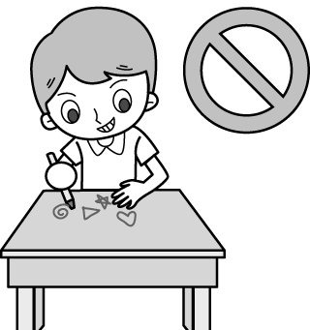 (B) 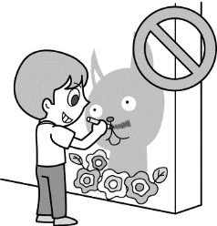 (C)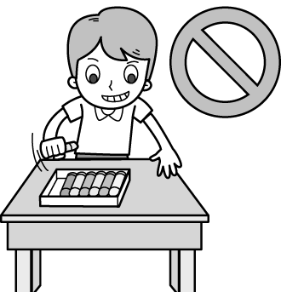

2.
(A) 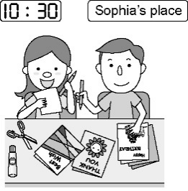 (B) 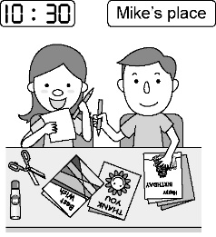 (C)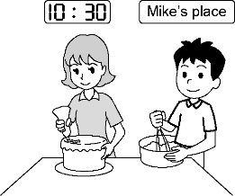

3.
(A) 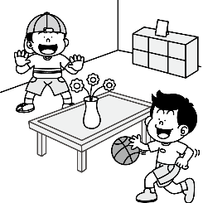 (B) 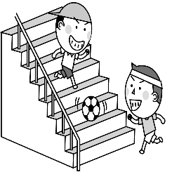 (C) 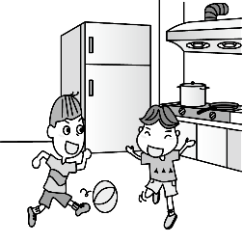
4.
(A) 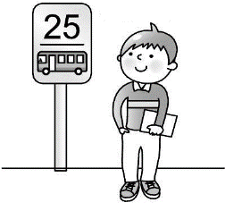 (B)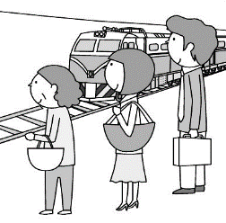 (C) 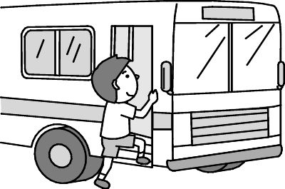
5.
(A) 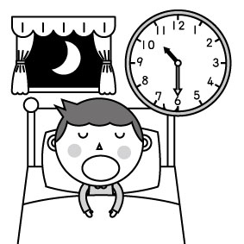 (B) 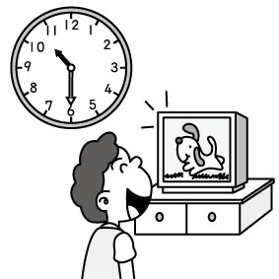 (C)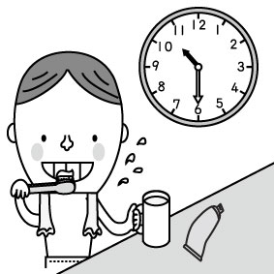

(二) 基本問答：依據所聽到的內容，選出一個最適合的回應10%
6. (A) Yes, I can turn off the TV. (B) Yes, we are a happy family. (C) Sure. Let me turn it off.
7. (A) Great! Let’s go there with Peter and Jane. (B) The museum is between the school and the park.
(C) What day is today?
8. (A) He is studying English. (B) He is in his parents’ bedroom. (C) He is a new student in my class.
9. (A) Good. I like the music. (B) I like basketball, too. (C) That’s a very good idea.
10. (A) He is reading to his son. (B) I am writing to my father. (C) He is writing to his daughter.

(三) 言談理解：請依據所聽到的對話與問題，選出一個最適當的答案10%
11. (A) Run at home. (B) Eat cookies. (C) Cook at home.
12. (A) It’s at 7 p.m. (B) It’s at 8 p.m. (C) It’s at 9 p.m.
13. (A) At school. (B) On the farm. (C) In the kitchen.
14. (A) Don’t talk in class. (B) Look at the blackboard. (C) Don’t eat or drink in class.
15. (A) They are looking at pictures. (B) They are taking pictures. (C) They are talking on the phone.

二 綜合選擇(選出最適合的答案)：32％(每題2分)
16. Alleys Kitchen is really _______. Look! It’s 8 p.m. now, but many people are still waiting for a table.
(A) magic (B) free (C) quiet (D) popular
- Tina, be a good sister. Don’t _______ with your younger brother.
(A) talk (B) wait (C) fight (D) check
18. A _______ “ Customer (客戶) is always right! ” is on the wall.
(A) sign (B) person (C) place (D) rules
- The day between Wednesday and Friday is ________.
(A) Tuesday (B) Thursday (C) Monday (D) Sunday
- ________ me, please. This is your table for four.
(A) Fight (B) Check (C) Follow (D) Wait
21. The beautiful girl is dancing on the ________.
(A) park (B) classroom (C) Sunday (D) stage
22. Don’t eat snacks________ talk on the phone in class.
(A) but (B) X (C) or (D) and
- May: Can you swim? Tim: ________ But I can play baseball.
(A) Can you? (B) Yes, I can. (C) No, I am not. (D) No, I can’t.
- Derek: ________ John: Good idea. (A) Let’s not drink water in class. (B) Let’s run in the lab.
(C) Let’s play basketball after school. (D) Can you give me a hand?
- ________ Friday evening, everyone in the Lin family ________ happy.
(A) In; is (B) On; is (C) X; is (D) On; are
- Jack: What are you doing? Andy: ________
(A) I am in the park. (B) I’m doing it. (C) I am a student. (D) I’m studying in the bedroom.
27. Nina: Mom, I’m going to a meet-and-greet with my friend now. Mom: ________
(A) Let’s go. (B) Have a good time. (C) Yes, you can. (D) Are you free now?
- It’s ________ nine p.m. ________ Sunday. They are at the concert.
- X; on (B) X; X (C) at; on (D) at; X
- (A) Please, stand here, David. (B) Please not stand here, David.
(C) Please stand here, David. (D) David stand here, please.
- Let’s watch a new music video from Jay Chou. Amy: ________
- I’m OK, too. (B) I can’t wait. (C) Oh my! (D) Sorry.
- ________ my dog. ________ name is Lucky.
(A) It’s; It (B) It is; It’s (C) Its; It’s (D) It’s; Its
~還有題目～
三 閱讀理解：14％(每題2分)
(一)
Hospital Rules
When you visit a sick friend in the hospital, please follow these rules.
- Call first because a patient(病人) needs a rest.
- Wash your hands before and after a visit.
- Don’t talk loudly.
- Don’t sit on the patient’s bed.
- Don’t go too early in the morning or too late at night. Keep the visit short, 20 to 30 minutes is long enough.
32. Before we visit a patient in the hospital, we can ________.
(A) take a look (B) take a rest (C) write an e-mail (D) make a phone call
33. What is a good time to visit a patient in the hospital?
(A) 7 a.m. (B) 3 p.m. (C) 10 p.m. (D) 12 a.m.
(二)
A Museum For All
It’s a sunny day in Tainan, Jason and Derek are having a good time at the Chimei Museum.
The Chimei Museum is a wonderful place. Inside the museum, there are shops, restaurants, and showrooms (展覽室) Some people are lining up for tickets. Some people are looking at the artworks. Outside the museum, there is a bridge. Jason and Derek are taking selfies (自拍). There is also a beautiful meadow (草地). Some people are taking pictures, some families are picnicking. Everyone is having fun.
The Chimei Museum is not just about art. It is also a place of joy. It is a museum for all.

34. What is NOT inside the museum?
(A) Shops. (B) Showrooms. (C) Restaurants. (D) Meadow.
35. Jason can _______ in the showroom.
(A) look at the artworks (B) touch the artworks (C) run and play (D) eat and drink
36. Which is right?
(A) Some people are picnicking in the museum.
(B) Some people are lining up for tickets on the bridge.
(C) You can take pictures outside the museum.
(D) The Chimei Museum is a place only about artworks.

~還有題目～

(三)
Tim’s Schedule (行程)
Date | Time | Memo(備忘錄)
12/10 Sun. | 8:30 in the morning | Basketball game
12/11 Mon. | 7:00 in the evening | Magic show
12/12 Tue. | 8:00 in the evening | BTS’s new music video
? (Today) | 7:30 in the evening | Study English
12/14 Thur. | 3:00 in the afternoon | Read comic books

37. What day is today?
(A) Friday. (B) Saturday. (C) Wednesday. (D) Sunday.
38. What time does Tim watch BTS’s new music video?
(A) In the evening. (B) At eight o’clock. (C) On Tuesday. (D) At eight a.m.

以下為非選擇題，請在答案卷上作答 24%
四 填空: 請將括號部分用代名詞的主格、所有格或受格改寫4％ (每格1分)

- Mom: Where are ____1____ (the pictures)? Mary: On the dining table.

- Teacher NKiambi teaches (教) ____2____ English. We teach ____3____ Chinese. (依題意填入)

- Anna sings a song for ____4____ (Tina).
五 依提示作答: 8％（每題2分）
- Billy is jumping rope at the park. (依畫線部分造原問句 )
- I can go to bed at 10:30 p.m. (依畫線部分造原問句 )
- The students sit in the classroom. (加入now 改寫句子)
- Andy is not a bad boy. (改成祈使句)

六 翻譯: 12％ (每題3分)
1. 我們這個週末有空，而且我們已經準備好音樂派對了。
2. 防彈少年團正在和他們的粉絲拍照及握手。
3. A: 棒球比賽幾點開始？ B: 六點半開始。(時間請用英文書寫)
4. 嘿，大夥兒! 請仔細聽我說。

試題結束!

新北市立溪崑國民中學111學年度第一學期第二次定期評量 英語科 答案卷
七年級 班 座號 姓名
非選擇題24%
四 填空: 請將括號部分用代名詞的主格、所有格或受格改寫4％ (每格1分)
1. | 2. | 3. | 4.
五 依提示作答: 8％（每題2分）
1.

2.

3.

4.

六 翻譯12% （每題3分）
1.

2.

3.

4.

試題完! Good Luck!
111-1-2 七年級 英語科－解答
一、聽力測驗30% (每題2分)
1~5 BACAB 6~10 CAACC 11~15 AABBC
二、綜合選擇(選出最適合的答案) 32% (每題2分)
16~20 DCABC 21~25 DCDCB 26~31 DBACBD
三、閱讀理解：14％ (每題2分)
32~33 DB 34~36 DAC 37~38 CB
四 填空: 請將括號部分用代名詞的主格、所有格或受格改寫4％ (每格1分)
1. they 2. us 3. him 4. her
五 依提示作答: 8％（每題2分）
- What is Billy doing at the park?
- What time can you go to bed?
- The students are sitting in the classroom now.
- Andy, don’t be a bad boy.
六 翻譯:12％ (每題3分)
- We are free this weekend, and we are ready for the music party.

- The BTS boys are taking pictures and shaking hands with their fans.

- A: What time is the baseball game? B: It’s at six thirty.

- Hey, guys! Listen to me carefully, please.

新北市立溪崑國民中學111學年度第一學期第二次定期評量
七年級 英語科 聽力測驗稿
錄音稿：
（一）辨識句意：依據聽到的內容，選出符合描述的圖片
1. Don’t draw on the wall.
2. W: Mike, let’s draw cards for your classmates at my place in the morning.
3. Boys, you can’t play ball in the kitchen. Go and play in the park.
4. W: Is David waiting for the bus? M: Yes, he is going to school.
5. It’s 10:30 p.m. Don’t watch TV. Go to bed now.
答案：(B) (A) (C) (A) (B)

（二）基本問答：依據所聽到的內容，選出一個最適合的回應
6. Can you turn off the phone? It’s family time.
7. Today is Saturday. Let’s go to the museum.
8. What is Amanda’s brother doing?
9. Let’s go play in the park in the afternoon.
10. Who is the man writing to?
答案：(C) (A) (A) (C) (C)

（三）言談理解：依據所聽到的對話與問題，選出一個最適當的答案

11.
B: Mom, I’m home and I’m hungry.
W: Those cookies on the table are for you.
B: Wow... I can’t wait!
W: Hey, don’t run at home.
Q: What CAN’T the boy do at home?

12.
M: Aren’t you reading now? It’s eight p.m.
W: No, I’m watching TV. Jay’s concert is on TV from 7:00 to 9:00. Let’s watch it together.
M: No, it’s time for reading.
Q: What time is the TV concert?

13.
M: Please don’t run after the pigs here.
W: OK! They are hungry. These cookies are for them.
M: Oh, please don’t! The cookies are not good for the pigs.
Q: Where are the man and the woman?

14.
G: Why is Ms. Lin angry at Max?
B: He doesn’t follow the rules.
G: Oh, like what?
B: He eats and drinks in class. He likes to run in the classroom, too.
G: Does he talk in class?
B: Yes, he does. That’s why Ms. Lin is so angry.
Q: Which is NOT a rule in Ms. Lin’s class?

15.
G: Hi, Henry, this is Alisa. Are you in Taiwan now?
B: No, I am not. I am in Japan now.
G: Japan?
B: Yes, I am looking at beautiful pictures in a museum with my parents.
G: Oh, I see.
Q: What are Henry and Alisa doing?

答案：(A) (A) (B) (B) (C)

