新北市立溪崑國民中學111學年度第一學期第三次定期評量 英語科 試題卷
七年級 班 座號 姓名
一 聽力測驗 (30%)
A辨識句意 : 根據聽到的句子，選出符合描述的圖片(10%)
- (Ａ) 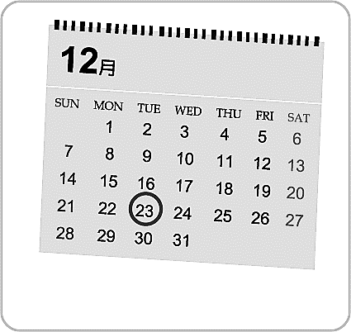 (Ｂ)  (Ｃ) 

- (Ａ) 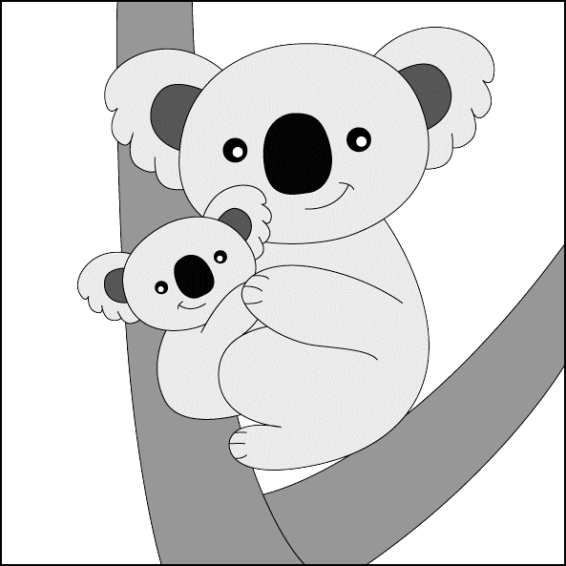 (Ｂ) 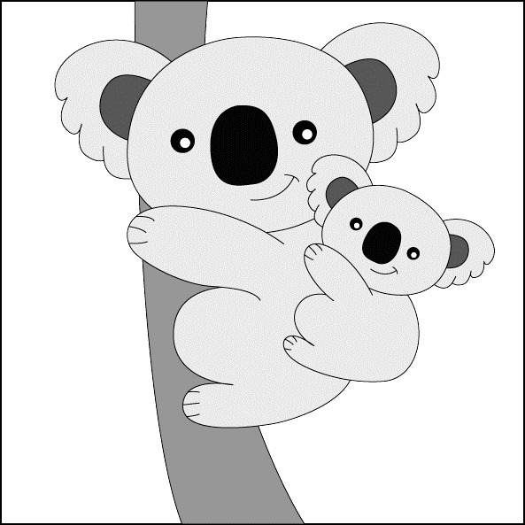 (Ｃ) 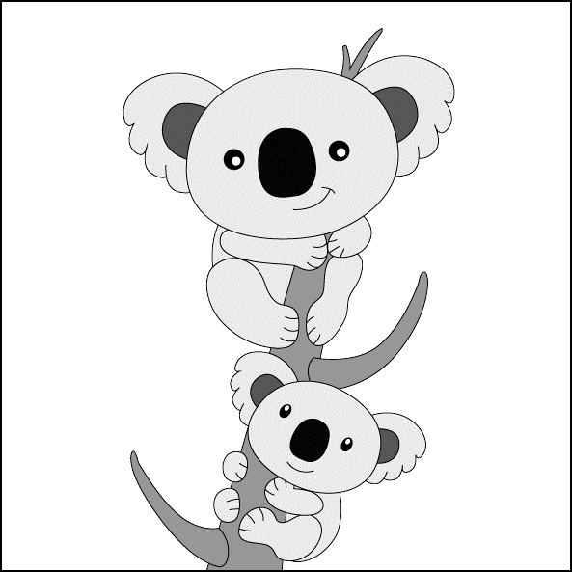

- (Ａ) 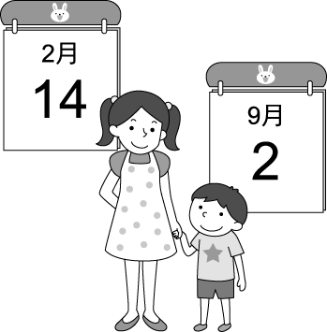 (Ｂ) 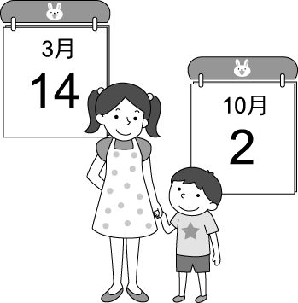 (Ｃ) 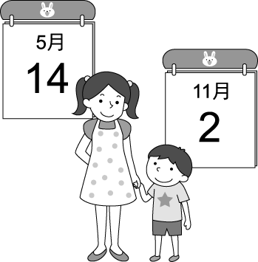
- (Ａ) 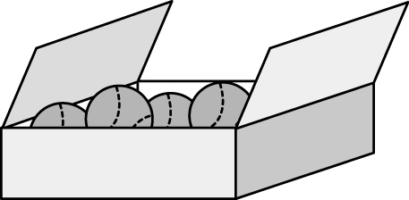 (Ｂ)  (Ｃ) 

- (Ａ) 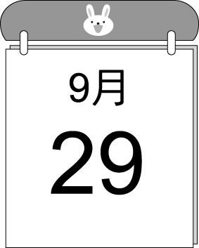 (Ｂ) 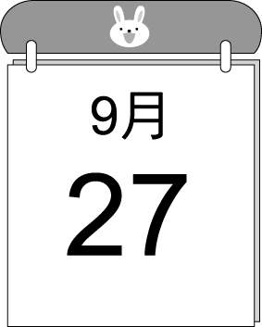 (Ｃ) 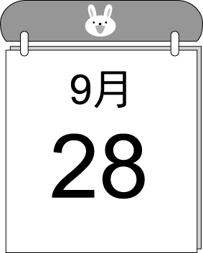

B基本問答：根據聽到的內容，選出合適的回應。(10%)
- (Ａ) Yes, it is. It is on November 28 this year. (Ｂ) Yes, there is. (Ｃ) No, it is not.

- (Ａ) Yes. We can’t wait. (Ｂ) Yes. We are full. (Ｃ) No. We are hungry.

- (Ａ) No. There’s only one. (Ｂ) No. There are three boys. (Ｃ) Of course. There are four.

- (Ａ) What’s your gift for Mom? (Ｂ) You’re right. It’s this month. (Ｃ) What day is today?

- (Ａ) It’s a great bear. (Ｂ) It’s from you. (Ｃ) It’s for Peter.

C. 言談理解：根據聽到的內容，選出最適合的答案。(10%)
- (Ａ) Elephants are the girl’s favorite animals. (Ｂ) Mother elephants are with baby elephants all the time. (Ｃ) They are watching a video about tigers and lions.
- (Ａ) The girl’s mom can’t go to Diana’s concert. (Ｂ) Diana’s first concert is on May 12. (Ｃ) The concert is in the Green Apple Park.
- (Ａ) In Mike’s room. (Ｂ) On the desk. (Ｃ) Under the girl’s bed.
- (Ａ) Lisa’s birthday gift. (Ｂ) A new coat. (Ｃ) A box in the living room.
- (Ａ) October 14. (Ｂ) October 15. (Ｃ) October 16.

二 綜合測驗 (40%)
- Food and water are so to people. (A) favorite (B) enough (C) free (D) important
- Father elephants are never in the with their family. (A) kingdom (B) hide (C) herd (D) back
- The singer is very . She can't sing a word on the stage. (A) joyful (B) nervous (C) careful (D) safe
- the night of Thanksgiving, my family and I go the table and give our thanks.
(A) At ; between (B) On ; between (C) At ; around (D) On ; around
- There are two big dogs behind the door. Let’s close to them.
(A) hiding ; not (B) hide ; not (C) hiding ; not be (D) hide ; don’t
- Which one is right?
(A) Your room is a mess.(髒亂) Please clean it up. (B) Adele’s concert is in Sunday evening.
(C) The boy is still sleeping in bed in eleven a.m. (D) Lucky, the oxpeckers are a big help to zebras.
- Leo : What’s the date today?
Ted : It’s .
(A) 18th January, 2023, Wednesday (B) Wednesday, January 18th, 2023
(C) 2023, Wednesday , January 18th (D) 2023, 18th January, Wednesday
- Lisa : There’s a party this Saturday. Can you come and help me?
Brain : Sure.
Lisa :
(A) Let’s thank him. (B) You are a big help to me. (C) There are many people at the party. (D) Not really.
- They can enough food for us. (A) show (B) wake (C) help (D) provide
- Andy: Let’s go to the movies evening.
Bill: Sorry. I’m not free tonight.
Andy : Saturday evening?
Bill: This Saturday? Sure.
(A) in; Around (B) this; Around (C) this; How about (D) of; On
- Which one is right?
- She is only girl in her family. (B) There are not any sofa in the living room, too.
(C ) There are no tigers or lions under the tree. (D) Where are you, Sherry? Don’t hide me.
- Alex: May’s Kitchen is of people. Tina: The food there is and yummy.
(A) many; health (B) full; health (C) some; good (D) full; healthy
- My sister is helping me my homework. She's so nice. I’m thankful her.
(A) in; with (B) at; to (C) with; for (D) for; for
- A： your car in front of the park?
B：Yes. It’s cool, right?
(A) Isn’t there (B) Isn’t that (C) Aren’t there (D) Are
- A：Are there students in the classroom?
B：No, there aren’t students there.
(A) many; any (B) any; some (C) not; no (D) some; some
- your help, we can go to zoo in the afternoon. (A) Thanks to (B) Next to (C) Good to know (D) Because
- Rita: Pete is cleaning up his bedroom. Helen:
(A) Good to know him. (B) Not really. (C) We are right. (D) Really? That’s new to me.
- many monkeys under the tree. Look at . They are so cute!
(A) They are; they (B) There are not; their (C) There are; them (D) There are; they
- Susan: Are you and Ricky ready for the party?
Emma: I am waiting for Ricky.
(A) Not really. (B) Thank goodness! (C) Thanks for your help. (D) Nice to know.
- There are . (A) my pencils on the bed in my room (B) any notebooks on the table (C) some monkeys under the tree (D) one or two toys in the box
三 題組 (30%)
A

It's 36 beautiful Christmas Eve! My dad is not cooking in the kitchen, he is running with 37 dads at the park.
Mom is not cooking, either. She is cleaning up the house. Grandpa is decorating the Christmas tree with me. Who is cooking?
What can we eat for dinner? 38 Grandma is cooking in the kitchen. She cooks the turkey 39 . And then she cooks fish. The turkey and fish are really yummy. Everyone in my family 40 having a good time.

- (A) a (B) in (C) at (D) X
- (A) Paul and Tina (B) Paul and Tina’s (C) Paul’s and Tina’s (D) Paul’s and Tina
- (A) How about you? (B) Thank goodness! (C) It's bad to know . (D) I'm not sure.
- (A) the first (B) first (C) the next (D) next
- (A) there (B) can (C) are (D) is
B
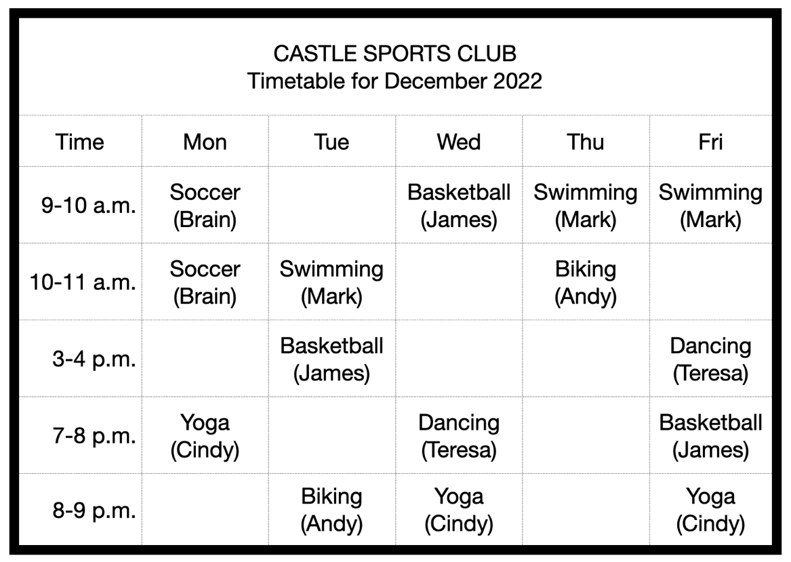

Every class is NT$1500/month.
Special offer: Old students get 10% off for every class.
timetable 時間表 yoga瑜珈 off 折扣 soccer 足球 signs up 報名 fee 費用

- Tina only has free time in the evening. From the timetable, what day “CAN’T” she do any sports in the evening?
(A) Monday. (B) Wednesday. (C) Thursday. (D) Friday.
- Kevin was in Mark’s swimming class in November. He signs up for all the swimming classes in December. The fee is . (A) NT$4050 (B) NT$3000 (C) NT$4500 (D) NT$3600
- Linda is a housewife. She is free in the afternoon. She wants to learn a sport, but she doesn't like ball games. Which class can she go?
(A) Andy's biking class. (B) Teresa's dancing class. (C) Mark's swimming class. (D) Brain's soccer class.
C

2023 Basketball Camp
Do you like playing basketball?
Do you like to learn basketball skills?
Welcome to join us !

Date: 2/1~2/3
Place: Happy Gym
2/1: Basketball Skills and Lessons
2/2: Group Activity
2/3: Basketball Game Time

ㆍOnly for junior high school students
ㆍFee: NT$4,000
ㆍFor more information, please call Mr. Lin at 0922-123-678
ㆍTom Lin@basketballteam.com

camp營隊 skill 技巧 fee 費用 information資訊

- Who can join the camp?
(A) Robin ; 14 years old.
(B) Mr. Black ; 40 years old.
(C) Eason ; 10 years old.
(D) Miss Lee ; 24 years old.

- What can the students do at the camp ?
(A) They can play baseball at the camp.
(B) They can write short stories.
(C) They can roller-skate at the camp.
(D) They can learn basketball skills.

- Which is “NOT” correct ?
(A) The fee is NT$4,000 for one student.
(B) You can call Mr. Lin for more information.
(C) The camp lasts(持續)for three days.
(D) The place for the camp is at the Happy Zoo.

【試題尚未結束】

D

Wonderland Zoo
Zoo Hours
ㆍJune - October: Monday - Sunday (9:00 a.m. - 7:00 p.m.)
The zoo is closed on the third Monday of the month.
ㆍ November - May: Monday - Sunday (9:30 a.m. - 5:00 p.m.)
The zoo is closed on the fourth Monday of the month.

Special Time with Your Animal Friends
ㆍHave Fun with Dolphins (30 minutes)
Tuesday - Sunday 10:30 a.m. and 4:00 p.m.
ㆍMeet the Goat Family (30 minutes)
Every Monday, Tuesday , Thursday and Saturday 11:00 a.m. and 3:00 p.m.
ㆍPlay with the Rabbits (30 minutes)
Every Wednesday, Friday, and Sunday. 10:00 a.m. and 2:30 p.m.

hour開放時間 closed 關閉的 dolphin海豚 goat山羊

- What time can you go to the zoo on weekends in September?
- 8:00 a.m. (B) 8:30 a.m. (C) 9:00 p.m. (D) 9:30 a.m.
- What day can’t Mia take pictures of the dolphins?
(A) Monday. (B) Wednesday. (C) Thursday. (D) Friday.
- Which is true?
(A) The Wonderland Zoo is a great place. It is open every day.
(B) Max can play with the rabbits at 10:00 a.m. on Friday.
(C) Eason can take pictures with goats at 11:00 p.m. on Saturday.
(D) The Wonderland Zoo is closed at 5:00 p.m. in July.
- Eric: Can we go to the zoo on ? It is my birthday.
Billy: No. It is closed on that day.

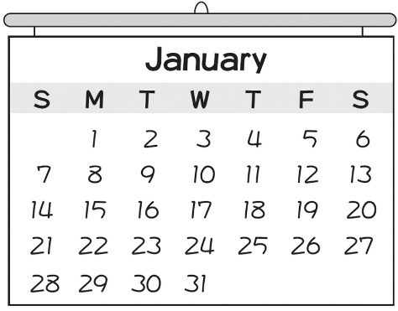

(A) January 1 (B) January 8 (C) January 15 (D) January 22

111-1-3 七年級 英語科－解答
1-5 ABCCA 6-10 CAABC
11-15 BBCBA 16-20 DCBDC
21-25 ABBDC 26-30 CDCBA
31-35 ADCAC 36-40 ACBBD
41-45 CABAD 46-50 DDABD

新北市立溪崑國民中學111學年度第一學期第三次定期評量
七年級 英語科 聽力測驗稿

一 辨識句意：根據聽到的內容，選出符合描述的圖片。
- A: Is the welcome party on the first Tuesday of December?
B: No. It’s on the fourth Tuesday.
- The baby koala is on the back of its mother.
- My birthday is on May 14, and my brother’s birthday is on November 2.
- A: What is there in the box? B: There is a dog in the box.
- Tina’s basketball game is on the day after Teacher’s Day.

二 基本問答：根據聽到的內容，選出一個最適合的回應。
- Isn’t Thanksgiving on the fourth Tuesday of November?
(Ａ) Yes, it is. It is on November 28 this year. (Ｂ) Yes, there is. (Ｃ) No, it is not.

- Are you two ready for the Christmas dinner?
(Ａ) Yes. We can’t wait. (Ｂ) Yes. We are full. (Ｃ) No. We are hungry.

- Are there three boys next to the girl?
(A) No. There's only one. (B) No. There are three boys. (C) Of course. There are four.

- Hey! Father’s birthday is coming.
(Ａ) What’s your gift for Mom? (Ｂ) You’re right. It’s this month. (Ｃ) What day is today?

- There’s a bear doll on the desk. Who is it for?
(Ａ) It’s a great bear. (Ｂ) It’s from you. (Ｃ) It’s for Peter.

三 言談理解：根據聽到的內容，選出一個最適合的答案。
- G: What are you watching?
B: A video about elephants. They are my favorite animals.
G: Great! Tell me something about them.
B: Father elephants are never in the herd with their family.
G: That’s new to me.
B: The mother elephant is with baby elephants all the time, so tigers and lions can’t eat them.
Q: Which is true?
(Ａ) Elephants are the girl’s favorite animals.
(Ｂ) Mother elephants are with baby elephants all the time.
(Ｃ) They are watching a video about tigers and lions.

- B: Diana’s first concert is on May 12, this Sunday.
G: Really? The day is also my mother’s birthday.
B: My mom is Diana ’s fan. She will come to the concert. Can you come with us?
G: Sure. That’s a great idea. We are free on that day.
B: Maybe Diana can sing a special song for her.
G: I can’t wait.
B: Let’s meet at 5 p.m. in front of the Green Park.
G: OK.
Q: Which is true ?
- The girl’s mom can’t go to Diana’s concert. (Ｂ) Diana’s first concert is on May 12. (Ｃ) The concert is in the Green Apple Park.
- G: Mike , where is my watch?
B: I’m not sure. There are too many things in your room.
G: Help me, please.
B: OK. Let’s clean up your room. Maybe it is on your desk.
G: Here it is. It is under my bed.
Q: Where is the watch?
- In Mike’s room. ( B ) On the desk. ( C ) Under the girl’s bed.

- Betty: Hey, Lisa. There is a box in your bedroom. What is in it?
Lisa: A new coat. It is my Christmas gift from Aunt Annie.
Betty: Wow. Can I take a look at it?
Lisa: Sure.
Q: What are the two girls talking about?
(A) Lisa’s birthday gift. (B) A new coat. (Ｃ) A box in the living room.

M: Hey, Kate. I am in front of Bob’s house. Where are you? Isn’t his birthday today?
W: Oh, really? Isn’t Bob’s birthday on October 15?
M: Yes, but his birthday party is today, the day before his birthday.
W: I see. Wait for me.
Q: When is the party ?
(Ａ) October 14. (Ｂ) October 15. (Ｃ) October 16.

