新北市立溪崑國民中學111學年度第一學期第一次定期評量 英語科 試題卷
九年級 班 座號 姓名
- 聽力測驗30%
壹、 辨識句意：每題均有三張圖片，請依據所聽到的句子，選出符合描述的圖片(每題2分，共10分)
- (A)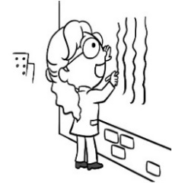 (B)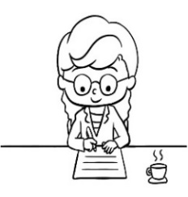 (C)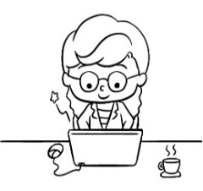
- (A)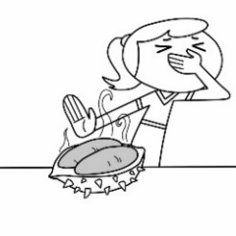 (B)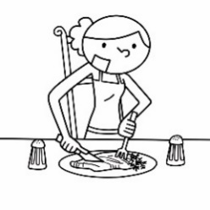 (C)
- (A)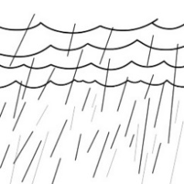 (B)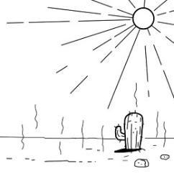 (C)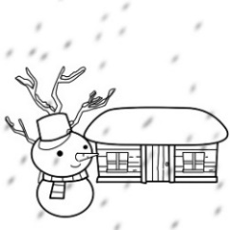
- (A)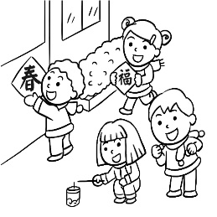 (B)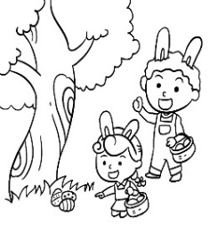 (C)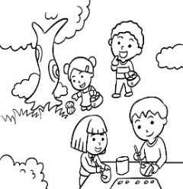
- (A)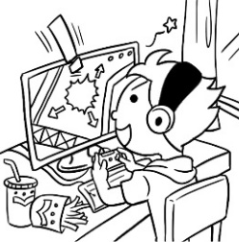 (B)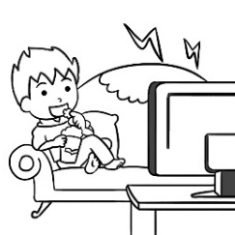 (C)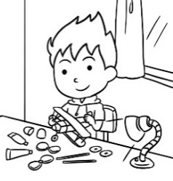

貳、基本問答：每題均有三個選項，請依據所聽到的內容，選出一個最適合的回應(每題2分，共10分)
- (A) History. I always get a good grade in it. (B) PE. I don’t like sports. (C) Paper. We don’t use it anymore.
- (A) Yes, and please don’t use too much oil. (B) Yes, please bake them in the oven（烤箱）.
(C) Yes, please boil them with hot water.
- (A) Since 2020. (B) About twenty years ago. (C) For ten years.
- (A) No, I don’t mind. (B) No, I have no choice. (C) No, I don’t like his service.
- (A) It’s their choice. (B) About three out of five. (C) They seldom use the service.
參、言談理解：每題均有三個選項，請依據所聽到的對話與問題，選出一個最適當的答案(每題2分，共10分)
- (A) She hasn’t finished her homework. (B) She has had enough sleep during the day.
(C) She is celebrating the holiday with her friends.
- (A) She hasn’t found a secretary. (B) She’s been the man’s secretary for years.
(C) She’s cleaning a space for her new worker.
- (A) Free shoes. (B) Two pairs of shoes. (C) A discount on his shoes.
- (A) For a week. (B) Since last night. (C) Since she was a college student.
- (A) It’s boring. (B) It’s helpful. (C) It’s exciting.

二、綜合選擇 42%
16. John ____ to Japan when he was three and _____ there since then.
(A) moved ; has lived (B) moves ; lives (C) would move ; is living (D) moved ; was living
17. In the history____ hot dogs, we know that Charles brought his recipe ____ German sausages ____ Coney Island.
(A) in ; on ; of (B) of ; in ; for (C) of ; for ; to (D) for ; of ; to
18. Lisa ____ math at school in 2005 and ____ a new car the next year.
(A) taught ; bought (B) teaches ; buys (C) will teach ; buy (D) has taught ; bought
19. Ally believes ____ everything is possible if she never ____ up.
(A) which ; give (B) that ; gives (C) how ; gave (D) whether ; giving
20. Many of my friends ____ the experience of taking an airplane, but I ____ .
(A) have had ; don’t (B) had ; wasn’t (C) have ; won’t (D) have had ; haven’t
21. A: ____ you ____ fed pandas before? B: No, ____. What about you?
(A) Do ; ever ; don’t (B) Will ; already ; won’t (C) Have ; never ; haven’t (D) Have ; ever ; never
22. My husband and I ____ the national park many times. We love there a lot.
(A) have been in (B) have been to (C) have gone to (D) are in
23. A: ____ have they studied in the library? B: ____ more than ten hours.
(A) How often ; In (B) When ; Since (C) How long ; For (D) How many times ; Since
24. I was ____ know from the newspaper yesterday ____ flowers do not always smell sweet; some can smell like dead fish.
(A) surprised to ; that (B) surprised at ; when (C) surprising to ; how (D) surprising about ; which
25. Lily thinks that being a factory worker is ____ , but she will never get ____ of it.
(A) tiring ; tiring (B) tired ; tired (C) tired ; tiring (D) tiring ; tired
26. Working with a robot in the modern world is the most ____ thing ____ me.
(A) interesting ; to (B) interested ; in (C) interest ; to (D) interested ; for
27. Most people in Taiwan are ____ the coming Moon Fetival because it is a time for people to get together.
(A) exciting to (B) excited about (C) excitingly (D) exciting
28. Amy ____ a day since the last time we____ . (A) was old ; met (B) hasn’t aged ; met (C) wasn’t old ; meet (D) is aging ; meet
29. Aren’t you ____ the same TV shows every day? You should get up and do some housework.
(A) bored watching (B) boring to watching (C) bored with watching (D) boring to watch
30. Tina’s dad felt ____ when Tina said that ____ go out with Jack.
(A) worried ; she would (B) worried ; she will (C) worrying ; I would (D) worried ; I will
31. My daughter ____ in music since she was a little girl. (A) interested (B) has interested (C) was interested (D) has been interested
32. Bill ____ ten pounds for the past two months. He looks much thinner now. (A) loses (B) has lost (C) will lose (D) was losing
33. A: Do you hear of the news about Kitty? B: No. I haven’t ____ my Facebook page ____ .
(A) checked ; already (B) checked ; yet (C) check ; already (D) checking ; yet
34. The bus ____ five minutes ago, so we’ll have to wait for the next one.
(A) has left (B) would leave (C) left (D) is going to leave
35. A: ____ Grandma ____ the file? B: Yes, she spent a long time doing it.
(A) Will ; download (B) Has ; downloaded (C) Is ; downloading (D) Does ; download
36. Don’t be of the roaches on the ground. I’ll do something to scare them away.
(A) scared ; scary (B) scary ; scared (C) scared ; scared (D) scary ; scary

三、閱讀測驗 8%
Artificial intelligence is a skill of computer program that enables machines to learn and think like humans. It has three features, which are generalized learning, reasoning and problem solving. Generalized learning means it can do things and get better in an environment with different kinds of things in it. Reasoning means it can make choices, like choosing which path to go on from a choice of two. Problem solving means it can provide solutions when there is an obstacle.
Artificial Intelligence is different from machine learning and deep learning, but they are related. Deep learning is a subset of machine learning and machine learning is a subset of artificial intelligence. That means that AI uses these two abilities to learn, reason and problem-solve. Since it first showed up, AI has succesfully helped machines to understand human speech, take part in strategic games like chess, and drive. Now, many jobs have been done by machines in factories. People say that AI will take over 40% of our work in the future.
There are two types of AI. One is Weak AI and the other is Strong AI. The computer programs, Alpha Go and Amazon's Alexa, are examples of Weak AI. An example of Strong AI is Ultron, the Marvel super villain. Actually, Strong AI doesn't exist yet. Will it ever? Some people think that by 2045 we will reach something called the singularity, which means that AI will be smarter than humans. Therefore, we should use AI skills wisely, or it will bring us big troubles.
artificial intelligence 人工智慧 feature特色 generalized 廣泛的 solve 解決 envionment 環境 path 路徑
provide 提供 obstacle 障礙 related 相關的 subset子集 human人類 strategic策略的 take over 接管 villain 壞人 exist 存在 reach達到 singularity 奇點 ability能力
37. According to the reading, which is NOT correct?
(A) AI is a person that looks like a machine.
(B) AI is a skill that enables machines to learn and think like humans.
(C) AI has the ability to learn, reason and problem-solve.
(D) AI can help machines to understand human speech, take part in strategic games like chess, and drive.
38. What do some people think the future world of AI will be?
(A) There will be more Strong AI than Weak AI. (B) AI will be smarter than humans.
(C) The singularity will be a big problem for the world. (D)Ultron will turn from a super villain to a super hero.

In the past, we saw the following colors most on Halloween, pumpkin orange, black or ghost white. But now, bright blue has become a new color for Halloween since 2018, and how it started was from a mom's love. A mother named Alicia Plumer shared a photo of a blue Halloween candy bucket on Facebook and wrote:
"My son is BJ and he is autistic . He has problems getting along with people. Although he has the body of a 21 year old, he loves Halloween. If you see someone who appears to be an adult dressed up to trick or treat carrying this blue bucket this year, please help us keep his spirit alive & happy. These precious people are not too big to trick or treat." ~ Alicia Plumer
Alicia knew that some people would have problems with his son’s behavior. she came up with the idea of a blue Halloween bucket because she hopes that her son can still enjoy the fun of Halloween. She posted it on Facebook to explain the situation, and people were deeply touched and shared it over 28,000 times. So it seems that since 2018, blue has become a new color for Halloween buckets.
Alicia got this idea from her friend, Lisa Lee. Teal Pumpkin Project inspired Lisa. Placing a teal-colored pumpkin at your doorstep means that you offer non-food treats for children with food allergies. Lisa saw a blue bucket when shopping at Walmart, and she thought why not blue pumpkins for autism. So when you see a kid with a blue bucket at your doorstep, sharing a candy with him can simply make his day. Having fun trick-or-treating on Halloween should be for everyone. No matter what colors you see on Halloween, they’ll only make Halloween more colorful and joyful for all!
bucket 桶子 autistic自閉症 behavior行為 explain 解釋 situation 情況 touched 受到感動的 seem 似乎
inspire 鼓舞 teal藍綠色 offer 提供 allergy 過敏
39. What is the main idea of the reading?
(A) What people wear for Halloween. (B) Which color is the best.
(C) A new way to help people with special needs. (D) A mother’s special idea to get the candy.
40. Which is correct?
(A) Teal buckets help adults give away candies faster.
(B) Alicia saw a blue bucket herself at a supermarket and got the idea of using it.
(C) A blue Halloween candy bucket is for kids to collect candies of different flavors.
(D) Everyone should have the right to have fun trick-or-treating no matter what.

四 翻譯 20% (引導式翻譯，一格一分，整句式翻譯，每題四分)
41-44在臺灣，那數字在各年齡層都還在成長。
In Taiwan, that _41 is _42 _43_ people of all 44 .
45-48由這張圖表，我們可以看到人們因為一些原因而對這些應用程式感興趣。
From the _45_ , we can see that people are _46_ in these apps for _47_ _48_ .
49. 雖然它們自十九世紀以來，就存在於美國，但實際上它們源自德國。
50. 當時在該區域的人們捕撈魚並炸魚是很普遍的，但當冬天河水結冰時，捕魚變得困難。
51. 首先，使用食物外送應用程式節省人們的時間，因為他們不必排隊進餐廳。

(試題結束)

新北市立溪崑國民中學111學年度第一學期第一次定期評量 英語科 答案卷
九年級 班 座號 姓名
四 翻譯 20% (引導式翻譯，一格一分，整句式翻譯，每題四分)

41 | 42 | 43 | 44
45 | 46 | 47 | 48

49
50
51

111-1-1 九年級 英語科－解答
1-5 B C A C B 6-10 B A B C B 11-15 A C C A B 16-20 A C A B D

21-25 D B C A D 26-30 A B B C A 31-35 D B B C B 36-40 A A B C D

41. number 42. growing 43. among 44. ages
45. chart 46. interested 47. several 48. reasons.
49. Although they have been around in the USA since the 19th century,
they were actually from Germany.
50. It was common for people in the area to catch and fry fish, but that was difficult
when the river froze in the winter.
51. First of all, using food delivery apps saves people time
because they do not have to stand in line to get into restaurants.

新北市立溪崑國民中學111學年度第一學期第一次定期評量
九年級 英語科 聽力測驗稿

一、辨識句意：每題均有三張圖片，請依據所聽到的句子，選出符合描述的圖片(每題2分，共10分)
1: To clear your mind, you can write down your problems on a piece of paper first.
2: Sally doesn’t like the taste of the medicine, but she has to take it because she has been sick for three days.
3: It has been cold and rainy, but it hasn’t snowed yet.
4: Some of the kids are coloring eggs, and some of them are hiding eggs.
5: Bill was tired of playing with his toy, so he sat on the couch and watched a game.
二、基本問答：每題均有三個選項，請依據所聽到的內容，選出一個最適合的回應(每題2分，共10分)
6: Which subject gives you a headache at school?
7: How do you like your eggs? Do you want to fry them?
8: When did the writer move to the island?
9: Are you going to tip the waiter after you finish your meal?
10: How many students in your school use the food delivery app?
三、言談理解：每題均有三個選項，請依據所聽到的對話與問題，選出一個最適當的答案(每題2分)

11: M: Honey, it’s 11 p.m. Turn off the computer and go to bed.
G: But I’m doing homework.
M: Homework? What did you do all day?
G: It’s a holiday. I went out with friends, of course.
M: Next time finish homework before you have fun.
Q: Why is the girl staying up?
12: M: Hey, you look busy.
W: I have to clean up the desk for my new worker.
M: Oh, you finally got yourself a secretary.
W: I guess so. The business is growing, so I really need a hand.
M: Well, I can give you a hand right now. Let me help with those heavy things.
W: Thank you.
Q: What do we know about the woman?
13:
M: Excuse me. Do you have larger sizes for this pair of shoes?
W: What size do you wear?
M: 42.
W: We don’t have 42 in the store. Do you mind coming back next week? I can get the shoes for you and also give you a discount then.
M: Excellent.
Q: What will the man get next week?
14: M: Where is Cathy? I haven’t seen her for a week.
W: She is taking a break from work. Now she’s somewhere in America.
M: Oh, I remember. She told me she wanted to hike through the country when she was a college student, but she never had time to do it.
W: Now her dream has come true.
M: That’s right. Good for her.
Q: How long hasn’t the man seen Cathy?
15: M: Have you come to New York many times?
W: No, this is my first time.
M: Really? It looks like you know every restaurant here.
W: Well, this app helps. One of my friends has visited the city many times, and she told me about the app. I downloaded it before the trip.
Q: What does the woman think about the app?

