新北市立溪崑國民中學111學年度第一學期第一次定期評量 英語科 試題卷
八年級 班 座號 姓名
【聽力測驗】共三大題
一、辨識句意：選出符合描述的圖片(每題2分，10%)
- (A)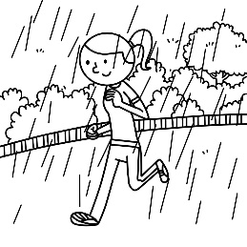 (B)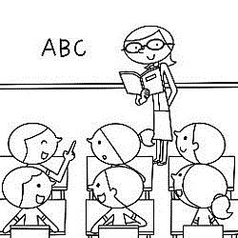 (C)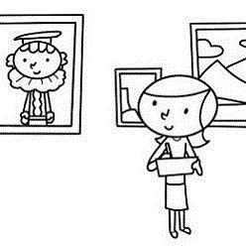

- (A)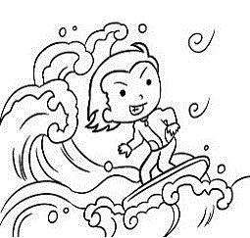 (B)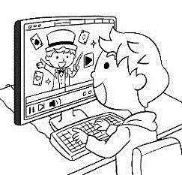 (C)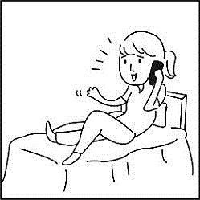

- (A)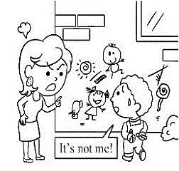 (B)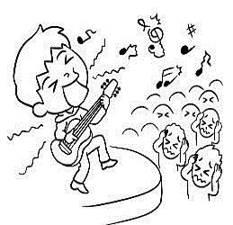 (C)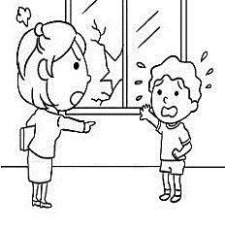

- (A)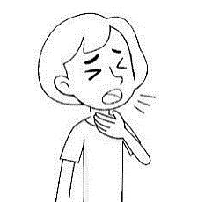 (B)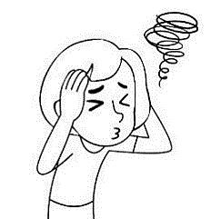 (C)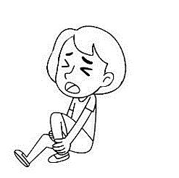

- (A)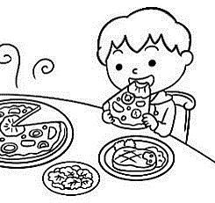 (B)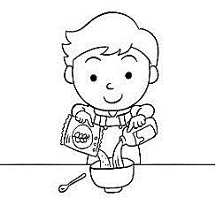 (C)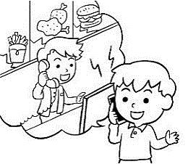

二、基本問答：請依據所聽到的內容，選出一個最適合的回應(每題2分，10%)
6. (A) Just two days. I came back last Friday.
(B) I stayed at my friend’s place.
(C) It was a wonderful trip. I really enjoyed my stay there.
7. (A) I joined the camp this winter vacation.
(B) I stayed in Tainan for three months this winter vacation.
(C) I learned a lot about the city Tainan.
8. (A) No, I had a wonderful time there.
(B) No, I loved all the songs they played.
(C) Yes, I sang and danced to the music during the festival.
9. (A) I got up late this morning, so I’m hurrying to school.
(B) My head hurts, so I sit here to have a rest.
(C) My nature calls, so I need to use the restroom.
10. (A) The medicine is not safe for children.
(B) Some ice cream can help you with that.
(C) I know. Sometimes, I can’t even talk.
三、言談理解：請依據所聽到的對話與問題，選出一個最適當的答案(每題1分，5%)
11. (A) Wait in a line for the tickets.
(B) Buy the tickets on the Internet.
(C) Take the air balloon ride.
12. (A) It’s the man’s car now.
(B) The woman’s dad washed it once a week.
(C) The woman bought it five years ago.
13. (A) Through it, the boy learned a lot about science.
(B) The boy didn’t have a good time there.
(C) The boy played basketball with some players at the camp.
14. (A) She had a date with her old friends.
(B) She went to an art camp with the man.
(C) She went to the movies with the man.
15. (A) In a theater. (B) In a classroom. (C) In a hospital.
----------------------------------------------------------------------------------------------------------------------------------------------------
四、克漏字：(每題2分，30%)
(Bella is calling Scott.)
Bella: May I speak to Scott?
Scott: 16
Bella: Scott, you didn’t go to school today. What happened?
Scott: I did not feel well, so I stayed at home.
Bella: That’s too bad. Did you see a doctor?
Scott: No, I didn’t. I just drank a lot of water and 17 all day.
Bella: It’s almost dinner time. Did your mom make dinner 18 you?
Scott: No, she didn’t have time for that. Can you help me?
Bella: Ok, I can 19 you the dinner. By the way, do you know today’s homework? I can send a copy one
20 you if you need.
Scott: It’s so kind of you. Thank you so much.
16. (A) Sorry, he is not here. (B) You have the wrong number.
(C) Please hold on. (D) This is he speaking.
17. (A) sleep (B) slept (C) am sleeping (D) to sleep
18. (A) X (B) to (C) of (D) for
19. (A) to bring (B) brought (C) bringing (D) bring
20. (A) X (B) for (C) of (D) to
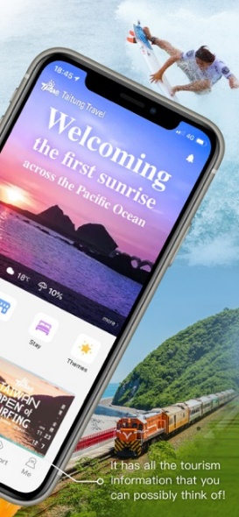
Dream of flying to the sky—
Hot air balloon rides
No need to go overseas! 21 a tethered hot air balloon ride at Taitung Luye Highland in the morning and afternoon. The wind conditions in the morning are relatively stable, which are perfect for photo-taking. While the balloon 22 , dreams and freedom fly; it 23 all the effort of waiting in line worthwhile. For more details about the tethered hot air balloon rides, please visit the official website of the balloon 24 . What’s more, use our app, and you can get a smart guide to Taitung easily! Stay tuned to see what’s coming up!
21. (A) Experience (B) To experience (C) Experiencing (D) Experienced
22. (A) goes down (B) puts on (C) wakes up (D) rises
23. (A) holds (B) treats (C) hurts (D) makes
24. (A) festival (B) basket (C) machine (D) question
25. What can we do to get useful information easily when we travel to Taitung?
(A) Visit the official website of our country. (B) Download the Taitung Travel app.
(C) Take a tethered hot air balloon ride. (D) Check on Instagram or YouTube.
26. (A) hometown (B) country (C) clothes (D) message
Today we met our new foreign teacher—Teacher Nkiambi, and he talked about his 26 Philadelphia and
introduced himself to us in class. Philadelphia is a big city in the USA, and it often 27 in winter. There are a
famous NBA basketball team and an MLB baseball team in this city; 28 , he doesn’t play basketball or baseball.
He likes to go 29 and do weightlifting in his free time. His favorite foods are fried chicken and sweet potatoes.
He loves sweet potatoes because they are sweet, healthy, and easy to buy at a 7-11. He stayed in South Korea before,
and he 30 Taiwan to teach English because he heard that there are friendly people, delicious foods, and many
beautiful places to visit. We hope to learn English from him and teach him some Chinese, too.
27. (A) snow (B) snowy (C) snows (D) snowed
28. (A) maybe (B) however (C) because of (D) so
29. (A) swimming (B) swam (C) swim (D) swims
30. (A) choose (B) chose (C) chosen (D) choosing

五、單題：(每題2分，20%)
31. The boy his arm and leg yesterday, so he can’t go outside.
(A) kept (B) treated (C) tried (D) broke
32. Ken got in the car accident, and he is still in hospital now.
(A) grew (B) hurt (C) broke (D) cut
33. We didn’t go to the movies the heavy rain.
(A) because of (B) because (C) so (D) as for
34. Kristie can’t Chinese, but we can chat with each other in English.
(A) tell (B) speak (C) talk (D) say
35. Allen: did Tina go to the hospital?
Betty: She there because she cut her finger while she was cooking.
(A) Why; went (B) What; went (C) How; went (D) When; goes
36. I when I had a vacation in Taitung this summer.
(A) bought a gift my friend (B) bought her for a gift (C) bought my friend a gift (D) bought a gift her
37. Allen: What you do after dinner?
Betty: I my mom wash the dishes in the kitchen and then watched TV.
(A) did; help (B) do; helped (C) do; helped (D) did; helped
38. Allen: I didn’t see Ted this morning. Where was he?
Betty: Oh, he and some stories in his room this morning.
(A) is reading; is writing (B) read; write (C) reads; writes (D) read; wrote
39. Allen: Grandma and Grandpa surfing the Internet?
Betty: Yes.
Allen: I can’t believe it. They never the Net before.
(A) Did; surfed (B) Do; surf (C) Are; surfed (D) Are; surfing
40. Chris a lot many years ago, but he now.
(A) exercises; doesn’t (B) exercises; didn’t (C) exercised; does (D) exercised; doesn’t

六、閱讀：(41-44題1分; 45-46題2分; 8%)
Lukang is always a famous place for visitors to go sightseeing. They can walk around the old street, visit the old
buildings, and enjoy the local food in Lukang. Besides Taiwanese people, many foreigners visit this town to see its
historic and beautiful temples. The must-visit place is called Lukang Mazu Temple (天后宮).
Lukang Mazu Temple is more than 430 years old and the main goddess is Mazu. She stands for the protector of the
fishermen because people believe that Mazu will protect them and bring them home safely when they work on the sea.
Lukang was an important port at that time and many people fished for a living. People built the temple in 1591 when the
sea-trade between Taiwan and China became more and more often.
There were six sculptures in China at first. But now, the one in Lukang becomes the only one because the rest of
the sculptures were destroyed. So, that is why Lukang Mazu Temple becomes so popular and important in people’s eyes.
historic歷史的 sculpture雕像 port港口 trade貿易 protect保護 rest其餘的
41. What do visitors always do in Lukang Mazu Temple?
(A)  (B) 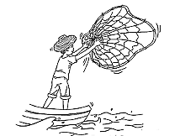 (C) 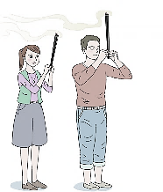 (D) 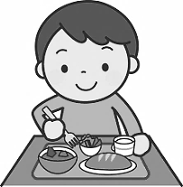
42. Why did people choose Lukang to build Mazu Temple?
(A) Because Lukang was Mazu’s hometown.
(B) Because there was nobody to stand for the fishermen.
(C) Because Lukang was a port and many fishermen lived there.
(D) Because there were too many Mazu sculptures and no place to keep.
43. Which one is not the reason why Mazu temples catch people’s eye?
(A) The temples are beautiful and historical.
(B) There is the only one Mazu sculpture left in Taiwan.
(C) People come here to pray for the safety on the sea.
(D) There is still lots of sea-trade between Lukang and China.
How to do a Covid-19 Self-Test
We all know that the Covid-19 virus spreads quickly around us. If you have symptoms like sore throat, fever, and
headache, you should take a Covid-19 Self-Test. Here are four steps to do a Covid-19 Self-Test.
Step One
Put the swab into one nostril. Wipe the swab around inside of the nostril, making 5 circles. And do the same thing
in the other nostril.
Step Two
Put the swab into the tube and mix it with the liquid. Put five drops to the test device. Wait for 15 minutes and check the result.
Step Three
If the test device shows two lines, it means positive. If it shows one line, it means negative (C) or invalid (T).
Step Four
Put all the things into the bag and throw it into the trash can.
If you find yourself positive, please don’t be afraid. Be sure to see a doctor in the hospital or get an appointment
online. After that, take medicine on time and do a Self-health monitoring at home for 7 days.
spread傳播 swab棉花棒 nostril鼻孔 tube試管 liquid溶液 positive陽性 negative陰性 invalid無效的
44. What is the correct order of doing a Covid-19 Self-Test?
A- put five drops on the test device
B- wait for 15 mins and check the result
C- put the swab into the tube and mix it with the liquid
D- put the swab into your nostrils and circle it five times each
(A) C → D → A → B (B) D → A → C → B (C) D →C→ A → B (D) A → B → C → D
45. Which picture shows the positive of Covid-19 Self-Test?
(A) 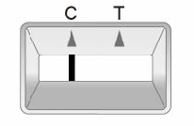 (B) 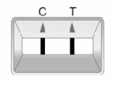 (C) 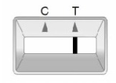 (D) 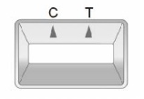
46. According to the article, what should we do next if we are positive?
(A) We should make an appointment with the doctor online.
(B) We should be afraid and call for 911.
(C) We should take the photo and post on the Instagram.
(D) We should not care about it and go out with friends.

新北市立溪崑國民中學111學年度第一學期第一次定期評量 英語科 答案卷
八年級 班 座號 姓名
七、翻譯 (一格1分；共17%)
1. 今年夏天我參加了一個營隊，這營隊持續了一週的時間。
I joined a camp this summer, and the camp a week.
2. 我們只有在嚴重的健康問題時才那麼做。
We only do that for problems.
3. 他讓自己的身體保持涼爽，並沒有穿上任何厚重的衣服。
He his body cool and didn’t on any heavy .
4. 至於 Scott，他沒有去看醫生或服用任何藥物。(3分)
5. 我喉嚨痛且發燒，所以昨天我在家休息。(3分)
6. 在婚禮的最後，我甚至用打包袋帶了一些剩下的菜回家。(4分)

111-1-1 八年級 英語科－解答
聽力(25%)
1-5 CBAAC 6-10 ACCBB 11-15 CBCAC (1分)
克漏字(30%)
16-20 DBDDD 21-25 ADDAB 26-30 ACBAB
單題(20%)
31-35 DBABA 36-40 CDDCD
閱讀(8%)
41-44 CCDC(1分) 45-46 BA

七、翻譯 (一格1分；共17%)
1. | lasted | for
2. | serious | health
3. | kept | put | clothes
4. | (3分) As for Scott, he didn’t see a doctor or take any medicine.
5. | (3分) I had a sore throat and had a fever, so I rested at home yesterday.
6. | (4分) At the end of the wedding, I even took some leftover dishes home  in a doggie bag.

新北市立溪崑國民中學111學年度第一學期第一次定期評量
八年級 英語科 聽力測驗

一、辨識句意：選出符合描述的圖片
1. The woman was an art teacher before, but now she works at an art museum.
2. My cousin did not go surfing at the beach but surfed the Net at home all his summer vacation.
3. Hank’s parent was angry at him. He drew everywhere and made the house dirty.
4. My sister was sick and had a sore throat.
5. Peter is hungry, so he is calling a restaurant to get some food.
二、基本問答：請依據所聽到的內容，選出一個最適合的回應
6. How long did you stay in Tainan?
7. What did you learn through the history camp?
8. Was the music festival interesting?
9. What happened? Why are you resting here?
10. I have a sore throat, but it is not serious. What can I do?

三、言談理解：請依據所聽到的對話與問題，選出一個最適當的答案
11.
M: Look at that hot air balloon. It’s a big strawberry.
W: That’s special. Wow! There are many different hot air balloons here.
M: Let’s take a hot air balloon ride and enjoy the beautiful view in the mountains.
W: Sure. But there are too many people waiting in line for the tickets.
M: Don’t worry. I bought the tickets on the Internet two weeks ago.
W: Great. Let’s go.
Q: What are the man and the woman going to do next?
12.
M: Wow! Your new car is cool.
W: Thanks. But in fact, it’s not new. My dad bought it five years ago.
M: The car is still in good shape. It’s very clean. How often did you wash it?
W: My dad washed it every week until he gave it to me.
Q: What can we say about the car?
13.
B: The camp was wonderful.
W: What did you do there?
B: The players taught us to play basketball. They also practiced basketball with us.
W: Did you learn a lot from the players?
B: Yes. It was a great experience.
Q: What do we know about the camp?
14.
M: How was your vacation?
W: It was great. I visited my old friends. We watched a movie, had dinner, and talked a lot. What about you?
M: Not bad. I joined an art camp.
W: An art camp? What was it about?
M: It was about making movies. It was interesting.
W: Cool! Maybe we can go to the camp together next time.
Q: What did the woman do during her vacation?
15.
M: Good morning, Ms. Lin. How do you feel now?
W: Well, I still have a sore throat.
M: Did you take the medicine on time?
W: Yes. I took it four times a day.
M: OK. Let me check your throat.
Q: Where are the man and the woman?

新北市立溪崑國民中學111學年度第一學期第一次定期評量
八年級 英語科 聽力測驗

一、辨識句意：選出符合描述的圖片
1. A03L1169
2. My cousin did not go surfing at the beach but surfed the Net at home all his summer vacation.
3. A03L1180
4. A03L2181
5. A03L2182
二、基本問答：請依據所聽到的內容，選出一個最適合的回應
6. A03L1062
7. A03L1066
8. A03L1205
9. A03L2062
10. A03L2205

三、言談理解：請依據所聽到的對話與問題，選出一個最適當的答案
11. A03L1092
12. A03L1094
13. A03L1096
14. A03L1105
15. A03L2096

