新北市立溪崑國民中學111學年度第一學期第一次定期評量 英語科 試題卷
七年級 班 座號 姓名
一、聽力測驗 30%
(一) 辨識句意：請依據所聽到的句子，選出符合描述的圖片10%

1. ( ) (A) (B) (C)
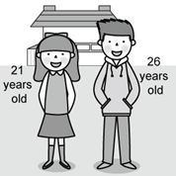 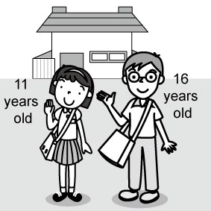 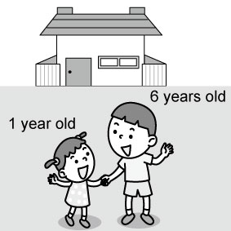
2. ( ) (A)  (B)  (C) 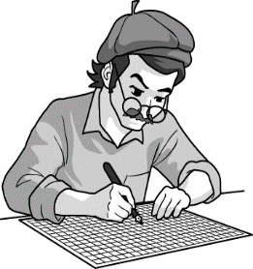

3. ( ) (A) 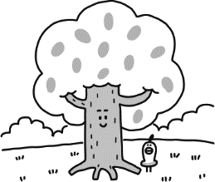 (B) 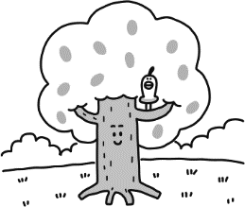 (C) 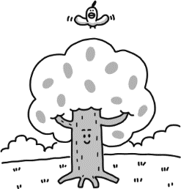

4. ( ) (A) 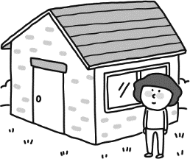 (B) 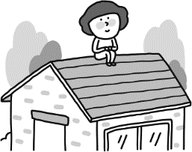 (C) 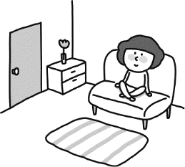

5. ( ) (A)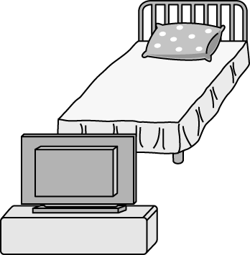 (B) 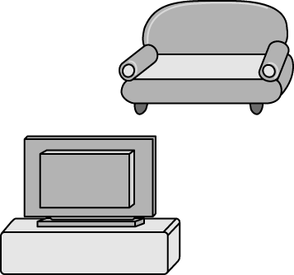 (C) 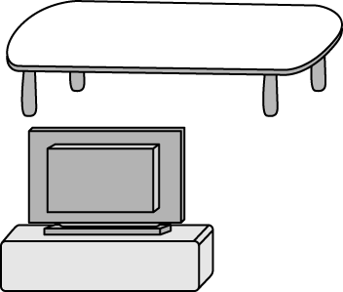
(二) 基本問答：請依據所聽到的內容，選出一個最適合的回應10%
6. ( ) (A) He is short. (B) He is Ms. Johnson’s student. (C) He is not a teacher.

7. ( ) (A) No, my mom is a good cook. (B) No, look at that handsome cook. (C) No, I am the cook in my family.

8. ( ) (A) Tim. T-I-M. (B) I am Nancy’s sister. (C) I’m your classmate.

9. ( ) (A) My cat is on the sofa. (B) That’s my favorite sofa. (C) A blue pencil.

10. ( ) (A) He is a student. (B) He is between Paul and Lisa. (C) He is very tall.

(三) 言談理解：請依據所聽到的對話與問題，選出一個最適當的答案10%

11. ( ) (A) The boy’s mother. (B) The boy’s aunt. (C) A writer.

12. ( ) (A) He is the girl’s father. (B) He is the boy’s father. (C) He is a good police officer.

13. ( ) (A) They are in the classroom. (B) They are in the pictures. (C) They are in the woman’s house.

14. ( ) (A) In her bedroom. (B) In the living room. (C) On the table.

15. ( ) (A) They are from Japan. (B) They are from Taiwan. (C) They are from the USA.

二、 綜合測驗(每題2分) 36%
16. ( ) Hugh’s father cooks dinner in the ______ every day. (A) bathroom (B) marker (C) wall (D) kitchen

17. ( ）＿＿＿like to play on-line games every Sunday. (A) He ,you and I (B) I, you and he (C) You, I and he (D) You, he and I

18.（ ）John is my mother’s brother. He is my _______. (A) sister (B) uncle (C) brother (D) aunt

19.（ ）A：What are these? B：They’re ＿＿＿.
(A) my classmate’s books (B) my classmate’s book (C) our classmates’ book (D) our classmates books

20.（ ）Tom has three brothers. They are his ________. (A) cookies (B) markers (C) family (D) cousins

21.（ ）A：Are these new pencil cases? B：_＿＿＿. (A) Yes, these are (B) No, they’re (C)Yes, they’re (D) Yes, they are

22. ( ) _____ is your phone number? ______ 2383-5656. (A) What; It’s (B) How; It’s (C) What ; Its (D) How; Its

23.（ ）My mom doesn’t have a job. She is often busy at home. She is a __________.
(A) office worker (B) police officer (C) housewife (D) teacher

24. ( ) A：Steve is _______ man. He is not ____ young man. He needs someone to help him.
(A) a 85-year-old; an (B) an 85-year-old; an (C) a 85-years-old; a (D) an 85-year-old; a

25. ( ) A：Where is my book bag? B: It’s ________. (A) in the bed (B) in bed (C) on the bed (D) on bed

26.（ ）The sofa is __________ the fan and the table in the living room. (A) above (B) between (C) next (D) in

27. ( ) A: Are you and Mary brother and sister ? B: No, aren’t. (A) he (B) you (C) they (D) we

28.（ ）A: Dad , I am ________. B: Here are some cookies for you. (A) favorite (B) special (C) hungry (D) tall

29.（ ）Simon doesn’t have his own _______, so he sleeps with his brother every night.
(A) bedroom (B) dining room (C) kitchen (D) living room

30. ( ) The people study with me in the same room at school every day. They are my _______.
(A) singers (B) classmates (C) office workers (D) cooks

31.（ ）This is a ___________ car. I love it. (A) new white good (B) good new white (C) new good white (D ) good white new

32. ( ) Eddie is tall and thin, ____ his father is short and heavy. (A) but (B) so (C) and (D) too

33.（ ）A: _____ is the singer from Korea? B : She is cute and pretty. (A) When (B) What (C) Where (D) How

三、閱讀測驗(每題2分) 12%
(一)
Maxine is in her bedroom. It is big. There are two windows. There is a wardrobe in the room, and there is her desk next to the window. There is a chair next to her desk. Now her room is mess! There are her jeans on the floor, and there is one sock on the sofa, and one sock on the lamp. Her mother is angry. She says “You cannot go to the park. Please tidy up your room! Put those jeans in the wardrobe, and find the socks!”
wardrobe 衣櫃; mess混亂
34.( ) What does tidy up mean(意指)?
(A) Wash. (B) Move. (C) Brush. (D) Clean.
35.( ) Which(哪一個) is true(真實的)?
(A) Maxine is angry.
(B) Maxine’s desk is next to her chair.
(C) Maxine’s socks are under her bed.
(D) Maxine’s bedroom is not big.

(二)
His name is Tim. He is 28 years old, and he works hard every day. In the morning, Tim wakes up early at five thirty. He takes a shower. He gets dressed, and he goes to work at six o’clock.
Tim save people by putting out fire. He uses a long hose to spray water on buildings that are on fire. He drives the fire truck. Tim wears special clothes that protect him from fires. He also wears a helmet and boots.
Tim’s job is dangerous, but he loves it. He is a hero.
36.( ) What is Tim’s job?
(A) A truck driver. (B) An office worker. (C) A firefighter. (D) A police officer.
37.( ) What does Tim NOT do when he works every day?
(A) He puts out fire. (B) He wears special clothes. (C) He often gets up late. (D) He sprays water.
protect保護; hose水管; helmet頭盔

(三)
Good evening, I am Tina Myers. I work at Central News and Today I am making a report on immigrants. Today’s guests are immigrants from China. They are Mary Lee and John Wang. They are students at the community college. She is 18 years old, and he is 19. They are students, not workers. They live in an apartment downtown.
Tina: Where are you from?
John: We are from the Guangdong Province.
Tina: Are you happy in America?
Mary: Yes, we are. We enjoy living here.
Tina: Mary, do you miss your friends in China?
Mary: Yes, I do, but I also love to meet different friends from different countries here.
They are two Chinese people living the American Dream. This is Tina Myers reporting from the Community College, and tomorrow we will have more quests in “living in America”. See you then.
immigrant移民 community社區 province省 apartment公寓

38.( ) What is Tina’s job?
(A) A reporter. (B) A college teacher. (C)A worker. (D) A cook.

39.( ) Which is true?
(A) John and Mary are teachers
(B) John and Mary are from America.
(C) John and Mary don’t miss their friends.
(D) John and Mary are happy in America.

~以下題目，請在答案卷上作答，否則不予計分~

四、字母改寫(大寫改小寫，小寫改大寫) (每題1分) 4 %
1. coronavirus 2. DIAGNOSE 3. negative 4. QUARANTINE
五、 可數名詞單數變複數(每題1分) 6 %
EX: bed→ beds
1. watch 2. family 3. mouse

4. potato 5. zoo 6. wolf

六、依提示改寫句子(每題2分) 4%
1. The man is my uncle.（依畫線部分造原問句）
_____________________________________________

2. What are those?（改為單數句）
______________________________________

七、翻譯：(每題2分) 8%

1. 我表妹是位國小生，而我是國中生。

__________________________________________________

2. 這臥室不大，但是它足夠給兩個人用了。
__________________________________________________

3. 每個人的家庭，對每個人而言非常寶貴。

__________________________________________________

4. 在這非常小的房子裡，廁所、廚房和飯廳相連。

__________________________________________________

~試題完~

新北市立溪崑國民中學111學年度第一學期第一次定期評量 英語科 答案卷
七年級 班 座號 姓名
四、 字母改寫(大寫改小寫，小寫改大寫) (每題1分) 4%
1 |  | 2 |  | 3
4
五、 可數名詞單數改複數(每題1分) 6 %
1 |  | 2 |  | 3
4 |  | 5 |  | 6
六、依提示改寫句子4% (每題2分)
1.
2.
七、翻譯8% (每題2分)
1.
2.
3
4
111-1-1 七年級 英語科－解答
一、聽力測驗 30%
1~5 BACCB 6~10 BCACB 11~15 BACAC
二、綜合測驗36%
16~20 DDBAC 21~25 DACDC 26~30 BDCAB 31~33 BAD

三、閱讀測驗12%
34~39DBCCAD

四、大小寫轉換：(每題1分) 5 %
1. CORONAVIRUS 2. diagnose 3. NEGATIVE
4. quarantine
五、 可數名詞單數變複數(每題1分)5 %
1. watches 2. families 3. mice

4. potatoes 5. zoos 6. wolves

六、依提示改寫句子4%
1. Who is the man?

2. What is that?

七、翻譯：(每題 2分) 8 %
1. My cousin is an elementary school student, and I’m a junior high school student.
2. The bedroom is not big, but it is enough for two people.
3. Everyone’s family is very dear to them.
4. Inside the very small house, the bathroom, the kitchen, and the dining room are right next to each other.

新北市立溪崑國民中學111學年度第一學期第一次定期評量
七年級 英語科 聽力測驗稿
聽力測驗 30%
(一) 辨識句意：請依據所聽到的句子，選出符合描述的圖片10%
1.G: I’m 11 years old, and my brother is 16.
2.My father is a cook, not a writer.
3.The bird is above the tree.
4.The girl is inside the house.
5.The television is in front of the sofa.
(二) 基本問答：請依據所聽到的內容，選出一個最適合的回應10%
6.Who’s the boy?
7.Who is the cook in your family? Your mother?
8. M: Hi, my name is Joe. What’s your name?
9.What’s under the sofa?
10.Look at the picture. Where is David?
(三) 言談理解：請依據所聽到的對話與問題，選出一個最適當的答案10%
11. G: Who is the woman in the picture?
B: She’s my Dad’s big sister, Fiona Chou.
G: Fiona Chou? The singer Fiona Chou?
B: Yes, she is.
Q: Who is the woman in the picture?
12. B: Is your father a police officer?
G: No, he is a singer. His name is Richard Clarkson.
B: Your father is Richard Clarkson? Oh, he is a good singer!
Q: Who is Richard Clarkson?
13. W: Welcome to my house. This is my living room.
M: Wow. The pictures here are very beautiful. Your sofa is beautiful, too.
W: Thanks.
Q: Where are they?
14. B: Where are you, Mom? Aren’t you in the living room?
W: No, I’m in my bedroom.
B: I’m hungry, Mom.
W: The cookie on the table is for you.
Q: Where is the boy’s mother?
15. M: Are the apples from Japan?
W: No, they aren’t. They are from the USA.
M: They are very big apples.
Q: Where are the apples from?

