新北市立溪崑國民中學110學年度第二學期第三次定期評量 英語科 試題卷
八年級 班 座號 姓名
- 辨識句意：依據所聽到的內容，選出符合描述的圖片。(每題2分，共10分)
1. | (A) 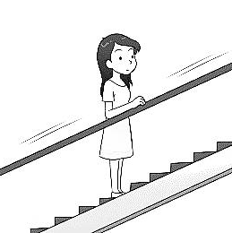 | (B) 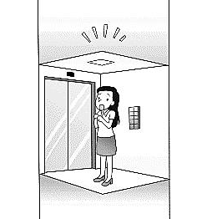 | (C) 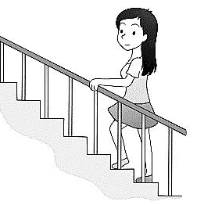
2. | (A) 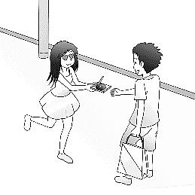 | (B) 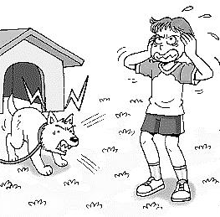 | (C) 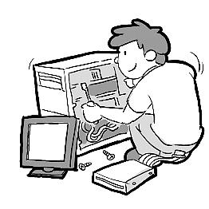
3. | (A) 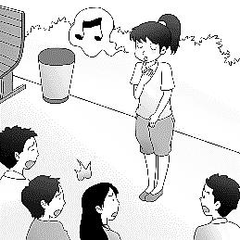 | (B) 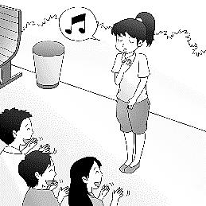 | (C) 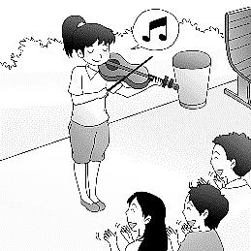
4. | (A) 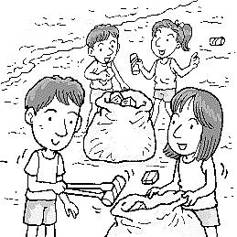 | (B) 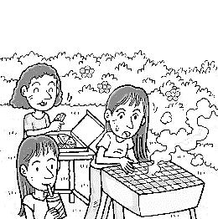 | (C) 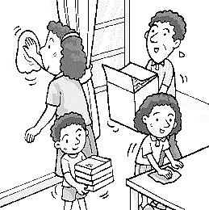
5. | (A) 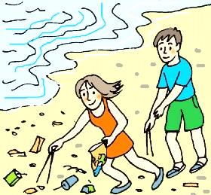 | (B) 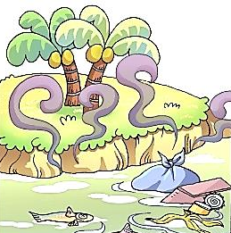 | (C) 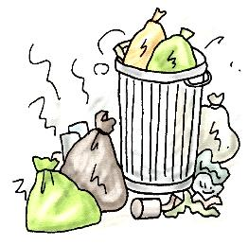
二、基本問答：根據聽到的內容，選出一個最適合的回應或最適合的問句。(每題1分，共5分)
6. | (A) Well, I actually worked abroad twelve years ago.
6. | (B) The idea crossed my mind suddenly. I decided to live there.
6. | (C) Luckily, I visited the country in my dream.
7. | (A) Yes, a little boy fell off his bike when the earthquake hit. He must be scared.
7. | (B) Yes, a man in black hid behind the tree and kept looking at our house.
7. | (C) Yes, don’t worry at all. Nothing was outside the house.
8. | (A) No, I held onto the table quickly. (B) Not at all. I saw the clock falling off the wall.  (C) Of course not. I was still in a deep sleep at that moment.
9. | (A) Here you are. Put the socks on. (B) Sure. Did you cut them yourself?  (C) Just rub them against each other.
10. | (A) Yes, it takes a short time to break down. (B) Yes, it is, but it’s bad for the nature.  (C) Yes, it lasts longer than us.
三、言談理解：根據聽到的內容，選出一個最適合的答案。(每題1分，共5分)
11. (A) It has an unhappy ending. (B) It is about a real-life story. (C) A sad event happens in the end.
12. (A) Buy another piece of land with a lower price. (B) Build another factory on Mr. Wang’s land.
(C) Look for other pieces of land from other sellers.
13. (A) He would miss the big meal with his friends. (B) He finished nothing but the soup.
(C) He had a lovely date with someone else.
14. (A) It is convenient or not. (B) It has great views or not. (C) It costs a high price or not.
15. (A) She no longer likes him. (B) He is too popular with girls. (C) He cleans himself every day.
四、綜合測驗 (選出最適當的答案)：(每題2分，共40分)

16. My dog, Lucky, was lying on the sofa under the fan on the ceiling. So when the fan _____, she was hit right on the head.
(A) broke down | (B) ended up | (C) took action | (D) fell off
17. When the kid was trying to reach the plate on the top shelf, it dropped, __________ the floor, and broke into pieces.
(A) hid | (B) hung | (C) hit | (D) hurt
18. A newspaper report said animals and plants from _________ aren’t always trouble-makers. With these new friends, New Zealand
becomes a country with many different kinds of animals and plants.
(A) ahead | (B) anywhere | (C) above | (D) abroad
19. Please make yourselves at home. I ____________ hope you can have a wonderful night at my house-warming party.
(A) suddenly | (B) sincerely | (C) seriously | (D) surprisingly
20. After the terrible earthquake hit the village, many pieces of ____________ have been wasted for more than ten years.
(A) lake | (B) library | (C) land | (D) letter
21. If you must get a new pair of jeans lately and you don’t want to __________ looking for one in a clothing store. Online selling
sites like eBay always have many different styles at a lower price.
(A) save | (B) choose | (C) pay | (D) bother
22. The February 28 incident was one of the most important __________ in Taiwan history. It’s so terrible and sad that many
Taiwanese people still can’t forget it easily.
(A) environments | (B) elevators | (C) events | (D) earthquakes
23. Judy works so hard. She still went to work yesterday ________ it was Sunday.
(A) if | (B) although | (C) before | (D) because
24. Don’t give up! You just went through the hardest _________ of this job. Trust me. The rest will be much easier. You can make it.
(A) light | (B) scene | (C) knee | (D) part
25. We bought some ___________ forks, spoons, and bowls for the afternoon tea party because we forget to do the dishes.
(A) disposable | (B) dangerous | (C) different | (D) difficult
26. Karen will learn many interesting things __________ she takes these English lessons.
(A) though | (B) even if | (C) before | (D) if
27. Joseph saved a lot of money by __________ meals at home and no longer buying expensive clothes.
(A) make | (B) to make | (C) made | (D) making
28. Gary noticed a stranger __________ at him and give him a big bright smile
(A) waved | (B) waving | (C) wave | (D) to wave
29. I have two sisters. ________ of them are beautiful and good at sports.
(A) Each | (B) Both | (C) Some | (D) One
30. Not only the students but also the teacher _________ to take a few more days off after the short winter vacation ends this year.
(A) wishes | (B) wish | (C) are wishing | (D) to wish
31. Luckily, before the fire got bigger, I smelt the cigarette (菸) __________ the grass inside our garden in time. Nobody was hurt.
(A) burned | (B) burn | (C) to burn | (D) burning
32. Ladies and gentleman, welcome to today’s year-end dinner party. Please _________ some food and drinks before our show starts.
(A) enjoy yourselves with | (B) make yourselves at | (C) help yourselves to | (D) by yourselves
33. I really enjoy listening to the singer’s latest album (專輯) because each of the songs _________ beautiful.
(A) sounds | (B) sound | (C) is sounding | (D) are sounding
34. _________ of his books were popular, and he gave up being a writer in the end. To my surprise, now he’s a successful songwriter.
(A) A few | (B) Few | (C) Most | (D) Several
35. If Gina _______ enough money, she will buy a new car. Sadly, she hasn’t saved that much yet.
(A) has | (B) had | (C) will have | (D) is having

五、克漏字選擇 (每題2分，共20分)
A Letter to Save Ocean Animals
Dear Waffle House,
My name is John. I am writing this letter to ask you to stop ___(36.)___ plastic tableware. Many of my friends and I love
eating at Waffle House. We go to your restaurant a lot because you sell delicious waffles. However, there are only
disposable tableware for us to use, and it’s very bad for our planet.
A lot of disposable plastic tableware ___(37.)___ in the ocean. There, it may ___(38.)___ into sea animals’ noses or stomachs
and then kill them. Metal tableware is better for our Earth because you don’t have to ____(39.)____ after each use.
Would you please help us __(40.)__ the Earth? We shouldn’t use plastic tableware anymore and let’s choose metal tableware
instead? If you do so, we will love your restaurant even more and invite all our friends to go there more often.

Sincerely,
Johnny Green
36. | (A) to use | (B) use | (C) using | (D) used
37. | (A) end up | (B) ending up | (C) are ending up | (D) ends up
38. | (A) get | (B) got | (C) getting | (D) gets
39. | (A) put it on | (B) throw it away | (C) take it off | (D) pick it up
40. | (A) saved | (B) saving | (C) to save | (D) saves

May cares a lot about the Earth. She does everything she can to ___(41.)___. Here are some examples in her daily life. First, she never goes out without ___(42.)___ her own metal chopsticks, fork, spoon, and straw. In this way, when she eats at a restaurant, she doesn’t need to use the disposable tableware. Although a lot of restaurants now have metal tableware for people to use, she still ___(43.)___ all the time. Besides, May ___(44.)___. After she takes out food or something else from a plastic bag, she won’t throw the bag away. Instead, she keeps it in a box for the next use. If the bag is dirty, she will wash it, hang it to dry, and keep it. When she does the shopping, she always has one or two plastic bags in her handbag for stores to put things in. May always chooses to do the correct things for the environment. She knows many others are also taking action to save the Earth and hopes more will join. __(45.)__, the nature will also be friendly to us, she believes.

41. | (A) tell good from bad | (B) save ocean animals | (C) stop using plastic | (D) take care of it
42. | (A) carries | (B) carrying | (C) carried | (D) carry
43. | (A) ends up there | (B) pays for them | (C) brings her own | (D) chooses one of them
44. | (A) no longer use plastic bags |  | (B) often picks up plastic bags on the street
 | (C) brings her own plastic bags all the time |  | (D) uses plastic bags again and again
45. | (A) If we are nice to the nature |  | (B) Because we have only one Earth
 | (C) When people no longer use plastic straws |  | (D) Though some people do something bad to the nature

六、閱讀測驗 (每題2分，共20分)
Earthquakes
Do you feel the ground shaking suddenly under your feet? The shaking is probably an earthquake. This kind of event happens all the time in many parts of the world. In fact, around five hundred thousand earthquakes rock the Earth every day.
The outside of the Earth is not a whole piece of land. Actually, many pieces, or plates, make it up. These plates not only move but also rub against and push into each other. As a result, earthquakes happen.
People do not feel most earthquakes. That is because they are too small and deep in the ground or under the sea. However, some are really strong. When a big earthquake happens, people can feel the ground shaking. They can also see building falling and hear windows and other things breaking. Earthquakes are no joke because they can be very dangerous.
46. | What is the main idea of this reading?
 | (A) The natural shaking of the ground. | (B) How the land is made up.
 | (C) Where earthquakes usually happen. | (D) What to do during an earthquake.
47. | Look at the first and second paragraphs, which is true?
 | (A) Actually, earthquakes seldom rock the earth. | (B) Earthquakes caused the Earth to break into pieces.
 | (C) Earthquakes happen in few parts of the world. | (D) An earthquake happens when plates push into each other.
48. | Look at the third paragraphs, which is NOT true?
 | (A) They can hurt people. | (B) Some earthquakes are under the sea.
 | (C) People can feel most earthquakes. | (D) Earthquakes can happen closely to the ground.
49. | What does “plates” mean in line 3?
 | (A) round dishes people put food on. | (B) very large pieces of rock.
 | (C) flat pieces of metal with words or numbers on it. | (D) places where a hitter stands.
50. | How does the writer feel about earthquakes?
 | (A) They are something serious. | (B) They make the writer angry.
 | (C) They cause no damage. | (D) They are nothing to worry about.
World Oceans Day
Many people around the world celebrate World Oceans Day on June 8 every year. They celebrate this special day by holding movie festivals to show the public how beautiful and important our oceans are. They are also clean up the trash on their countries’ beaches.
Our oceans were once rich in fish and plants. However, now there is a lot less life in the oceans than before. Sadly, people created this serious problem. This is because a lot of our trash ends up in the oceans. When fish eat it by mistake, it kills them. Water pollution also kills a lot of the oceans’ fish and plants. If we don’t fix these problems right away, more marine life will die.
By celebrating World Oceans Day, people not only learn a lot about the world’s oceans, but also start to make them cleaner. However, it shouldn’t just be a one-day event. Let’s work together and save our oceans!
celebrate (v.) 慶祝 create (v.) 造成
51. | How do people celebrate World Oceans Day?
 | (A) They go fishing on that day. | (B) They pick up trash on the beaches.
 | (C) They watch a few movies about air pollution. | (D) They eat a lot of seafood for lunch and dinner.
52. | What is true about our oceans?
 | (A) Our oceans are rich in fish and plants. | (B) There is a lot less trash in the oceans than before.
 | (C) There used to be much marine life in it. | (D) Pollution in the oceans isn’t a big problem at all.
53. | What is true about World Oceans Day?
 | (A) People have great music festivals on that day. | (B) Every country around the world celebrates it.
 | (C) People clean not only beaches but rivers and lakes. | (D) It is celebrated once a year.
54. | What does “marine” mean in line 6?
 | (A) About keeping life from dangerous places. | (B) About a problem that needs to be fixed right away.
 | (C) About the sea and life living there. | (D) About different ways to celebrate.
55. | How does the writer feel about World Oceans Day?
 | (A) It’s a great day to have much fun with friends on beaches. | (B) It will be better if the event is more than one day.
 | (C) People can learn so little about the world’s oceans. | (D) The oceans and beaches can stay clean themselves.

110-2-3 八年級 英語科－解答
一、辨識句意：依據所聽到的內容，選出符合描述的圖片。(每題2分，共10分)
01-05 BCAAB
二、基本問答：根據聽到的內容，選出一個最適合的回應或最適合的問句。(每題1分，共5分)
06-10 ABCAB
三、言談理解：根據聽到的內容，選出一個最適合的答案。(每題1分，共5分)
11-15 BCACB
四、綜合測驗 (選出最適當的答案)：(每題2分，共40分)
16-25 DCDBC DCBDA
26-35 DDCBA DCABA
五、克漏字選擇 (每題2分，共20分)
36-45 CDABC DBCDA
六、閱讀測驗 (每題2分，共20分)
46-55 ADCBA BCDCB

新北市立溪崑國民中學110學年度第二學期第三次定期評量
八年級 英語科 聽力測驗稿
- 辨識句意：依據所聽到的內容，選出符合描述的圖片。
  - Maria is in the elevator by herself.
  - When the man sees a problem, he always takes action to fix it.
  - Few of the people like the girl’s singing.
  - The people are doing something good for the environment.
  - Lots of trash ended up in our ocean.
- 基本問答：根據聽到的內容，選出一個最適合的回應會最適合的問句。
6. Did you ever dream of living in another country?
7. Do you notice anyone strange outside the house?
8. Didn’t you feel the whole house shaking this morning?
9. Could you give me something to cover my feet?
10. Isn’t using plastic straws convenient?
- 言談理解：根據聽到的內容，選出一個最適合的答案。
11. M: Did you finish the action movie last night?
W: Yes, I did. I felt unhappy about the ending, but I still like it a lot.
M: Well, what happens in the end?
W: The boy finds the real bad guy. Before the bad guy hurts the boy, the robot fights against the
bad guy in time. However, although the boy is safe at last, he lost his best robot friend at the
same time.
Q: Which is wrong about the movie?
12. W: Daniel, do you still want the land? Mr. Wang says he can give us a better price for it.
M: I don’t want the land anymore.
W: Oh? Is there a better one?
M: No. I just checked about Mr. Wang’s land. There were factories before, so there must be some
pollution under the ground.
W: I see.
Q: What might the man do next?
13. M: Here comes the soup. Where’s Paul?
W: He left right after he got phone call.
M: Who was calling him then? Today is his 30th birthday.
W: I have no idea. But he sounded quite worried and unhappy while talking on the phone.
M: He didn’t even have a bite of anything. Should we keep waiting for him?
W: Oh, I got a message from him. He’ll buy something to eat by himself. So, sit down and dig in.
Q: What happened to Paul?
14. M: M: The old apartment has good sea views.
W: I like the new one better because it has elevators.
M: But it’s much more expensive.
W: Do you want to take lots of stairs when you come home from work? I don’t.
Besides, we both have a job. It’s OK to pay more for a better home.
Q: Which doesn’t matter to the woman when it comes to choosing a house?
15. W: I want to break up with Jim.
M: Why?
W: He doesn’t like to clean his house and himself. He doesn’t take a shower or brush his teeth
every day.
M: I can’t believe it. He looks cool. Girls like him.
W: You’re right. Too many girls like him, and he enjoys it. I can’t stand it anymore, either.
M: Well, that’s the last straw.
Q: Why does the woman want to break up with Jim?

