新北市立溪崑國民中學110學年度第二學期第三次定期評量 英語科 試題卷
七年級 班 座號 姓名
一、聽力測驗 30% (每題2分)
A、辨識句意：每題均有三張圖片，請依據所聽到的句子，選出符合描述的圖片
- (A) 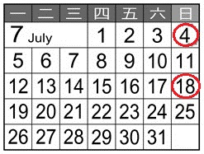 (B) 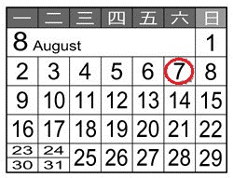 (C) 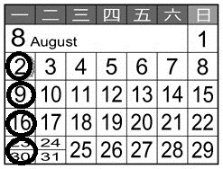
- (A) 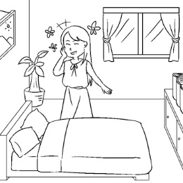 (B) 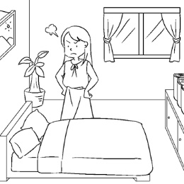 (C) 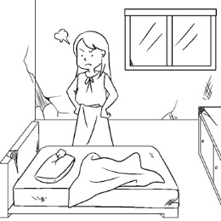
- (A) 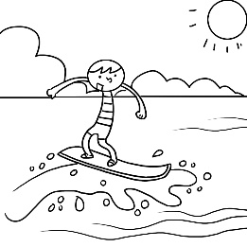 (B) 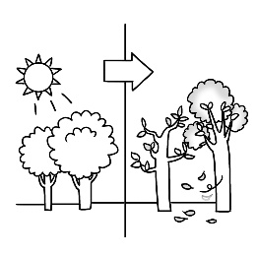 (C) 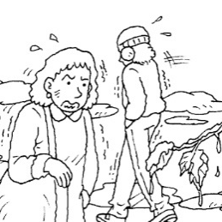
- (A) 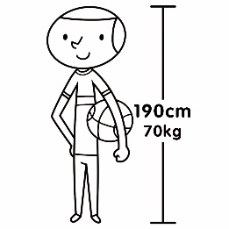 (B) 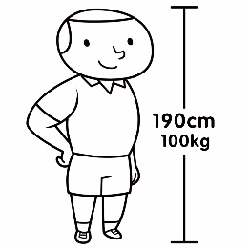 (C) 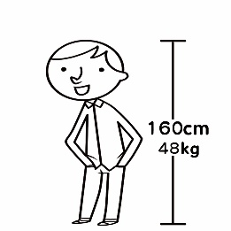
- (A) 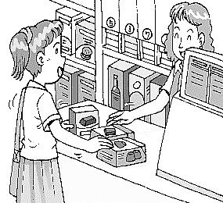 (B) 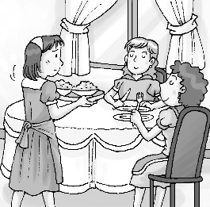 (C) 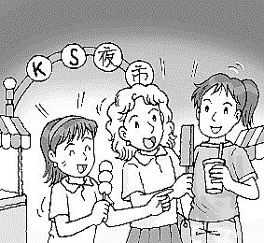
B、 基本問答:每題均有三個選項，請依據所聽到的內容，選出一個最適合的回應
6. (A) No, he isn’t.
(B) No, he was on time.
(C) Yes, he was in school this morning.
7. (A) Once or twice a week.
(B) Forty times.
(C) I can do it from now on.
8. (A) Yes, he often helps me with housework at home.
(B) Not very often. He likes to be with me on weekends.
(C) No, he doesn’t even want to move a finger on weekends.
9. (A) I never do.
(B) He’s usually busy.
(C) Yes, I do it for him sometimes.
10. (A) It is windy in Kyoto in autumn.
(B) It was fun, and the food was delicious.
(C) There are many visitors in London every year.
C、言談理解：每題均有三個選項，請依據所聽到的對話與問題，選出一個最適當的答案
11. (A) It’s sometimes cloudy in London.
(B) The museums in London aren’t beautiful.
(C) The man was in some museums last week.
12. (A) There isn’t a pond in the park.
(B) There are many visitors in the park.
(C) There is a beautiful park in the photo.
13. (A) He was tall and cool in the movie.
(B) He was old and heavy at that time.
(C) He wasn’t tall then.
14. (A) She does it every day.
(B) She cleans it twice a week.
(C) She washes it four times a week.
15. (A) She doesn’t have time to check her cellphone.
(B) She’s using her cellphone.
(C) She’s reading a study about computers.
二、語法選擇70% (每題2分)
16. There are a lot of _____ on your cellphones. Always wash your hands before meals.
(A) factories (B) toilets (C) habits (D) germs
17. Hong Kong was a _____ many years ago. There were no tall _____, and there were only small houses.
(A) season ; fishermen (B) activity ; fingers (C) fishing town ; buildings (D) space ; rivers
18. There’s a _____ near my house and I usually buy things there. The food and vegetables are always great.
(A) market (B) activity (C) spring (D) answer
19. The talent show on TV is really _____, and people don’t enjoy it.
(A) possible (B) rising (C) terrible (D) energetic
20. Mom: Please _______ after dinner. I don’t like a dirty house.
Paul: No problem.
(A) read the following (B) take out the trash (C) set the table (D) break your habits
21. A: What do you usually do______?
B: I usually play the guitar with my brother at home. We both love music a lot.
(A) at that time (B) from now on (C) on your trip (D) in your free time
22. A: _____ Paul at Emma’s house at seven last night?
B: No. He was usually busy at work in his office then.
(A) How often was (B) Wasn’t (C) What time was (D) Weren’t
23. Ann usually takes a walk near the museum. She goes there _____.
(A) a year twice (B) every other day (C) every two day (D) two days
24. _____ little rain in Taipei in winter. Winter is usually a dry season.
(A) It (B) There is not (C) We have (D) It’s
25. A: How was the weather in Kaohsiung last night?
B: _____ was hot and sunny.
(A) This (B) There (C) The season (D) It
26. Scott always mops the floors on Saturdays, but Fiona _____.
(A) often mops (B) never does (C) never mops (D) often does
27. Tom usually buys hamburgers at McDonald’s, but he ____ buys hamburgers at Burger King.
(A) seldom (B) usually (C) always (D) sometimes
28. A: _____ a lot in your city in summer?
B: Yes, _____ a lot in summer. It’s often sunny and hot in summer.
(A) Is there rain; there rain (B) Do you rain ; we rain (C) Does it rain; It rains (D) Is it rainy ; it’s rainy
29. A: Look at this photo. Nick and Katie were classmates long time _____.
B: Yeah, Nick was cute and Katie was pretty _____.
(A) before ; ago (B) ago ; then (C) ago ; ago (D) before ; then
30. Amy_____ does the housework ,and her brother doesn’t, either. They are both lazy children.
(A) seldom (B) usually (C) often (D) sometimes
31. Last two years, the business of Alan’s restaurant ____ very good, but now there are few people in his restaurant after COVID-19.
(A) do (B) does (C) was (D) were
32. A: Would you like some guavas? They are delicious.
B: No, thanks. I _____ have fruit in the evening. I like to eat fruit in the mooring.
(A) seldom (B) often (C) always (D) usually
33. A: Who_____ early for school?
B: Sam. He _____ to school early. He gets up very early, and he never breaks his habits.
(A) is often ; often goes (B) often is ; goes often (C) often is ; often goes (D) is often ; goes often
34. _____ use your cellphone too often. You need to take good care of your eyes.
(A) Don’t never (B) Not (C) Never (D) Always
35. A: How often do you clean your bedroom? It looks dirty.
B: Come on. It’s not dirty at all. _____.
(A) I clean my bedroom from Sunday to Monday (B) I don’t always take out the trash
(C) I seldom clean my bedroom in my free time (D) I usually clean my bedroom every other day
36. A: It’s hot in summer in Taiwan. _____ in your hometown?
B: It’s winter in Sydney now. It’s usually cold and wet.
(A) How’s the weather like (B) How was the weather
(C) What’s the weather like (D) Isn’t the weather rainy
37. A: There were many tall trees along this river when I was a kid. Now, there are many tall buildings.
B: _____
(A) Everything is different now. (B) What were the trees like many years ago?
(C) There were tall buildings, too. (D) What might you see next?
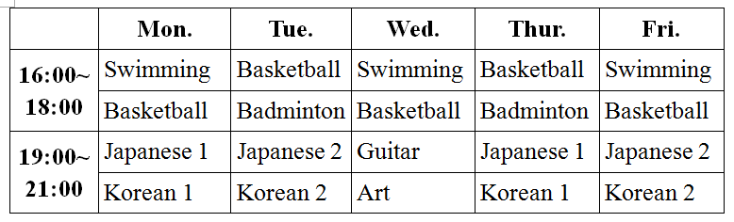
Welcome to CK Talent School! The 38 is the weekly schedule. As you can see, we have many different classes. You can join our sports teams and learn languages here. There are 39 many people in our basketball classes. But don’t worry because we have a basketball class every day. For swimming, make sure you are free 40 if you want to join the class. We also have Japanese and Korean classes. Check out our website for 41 classes at www.cktalent.com.tw.
【talent 才藝 weekly schedule 一週行程表 language 語言 because 因為if 如果 website 網站】
38. (A) change (B) example (C) following (D) fact
39. (A) always (B) never (C) seldom (D) some times
40. (A) every three day (B) three times a day (C) three days a week (D) every three times
41. (A) a lot (B) more (C) few (D) some
Emily: Look! The talent show is on. Come and take a look!
Alice : I like Atom Boyz a lot. Those boys are good singers.
Emily: Yes, their songs are special and great, too.
Alice : By the way, are they popular with girls?
Emily: Yes. They are tall, handsome, and cool. No wonder they are hot in girls’ eyes.
Alice : Are they hot in your eyes, too?
Emily: Of course! I like them a lot.
42 What is the meaning of hot?
(A) warm and sunny (B) good and popular (C) sunny and cool (D) handsome but terrible
43 Which is NOT true about Atom Boyz?
(A) Alice is watching a talent show. (B) The boys are good at singing.
(C) The boys are actors or models. (D) The boys are popular with girls.
Extreme Chile
Chile is the longest country in the world. It’s 4,630 kilometers long from north to south. The Atacama Desert in Chile is the driest desert in the world. In some places in the Atacama, there is no rain. In these places in the desert, plants and animals cannot live. The Atacama is also the highest desert in the world. It’s hot, dry, and sunny in summer. The temperature is about 27° C. In winter, the temperature is about 22°C. It’s warm and dry. 【Chile 智利 desert 沙漠】
44. There is no _____ in some places in the Atacama, so plants and animals cannot live there.
(A) snow (B) rain (C) wind (D) sun
45. According to the reading, Chile is a _____ country.
(A) hot (B) rainy (C) long (D) rich

Table Manners in India
Many people visit India because of its delicious food. There are some rules for everyone to follow when they eat in India.
First, Indians eat with their right hands. Always use your right hand when you eat. Keep your left hand by your side, and do not put it on the table. Second, don’t pass food to people with your left hand. This is because Indian people think the right hand is clean and the left hand is dirty. Third, always touch your own food, and never touch people’s food. When you touch their food, it becomes dirty in their eyes.
Follow these rules, and you can enjoy Indian food with Indians!
【manners 禮儀 when 當⋯⋯時 left 左邊的 pass 傳遞 touch 碰觸 become 變成 India 印度 Indian 印度人；印度的】
46. Why don’t Indians use their left hands when they eat?
(A) Because their left hands are setting the table. (B) Because they don’t know the way to eat with their left hands.
(C) Because left hands are “dirty hands” to them. (D) Because their left hands are always on the table.
47. What is the reading mainly about?
(A) Ways to make friends in India (B) Different kinds of food in India
(C) Indian people’s cleaning habits (D) Good ways to eat in India

Lungs of the World Choking
The Amazon rainforest in Brazil is called as “the lungs of the world.” As a home to a rich and colorful variety of plants, animals and birds, it plays a major role in oxygen production. About twenty percent of the world’s oxygen is from the Amazon rainforest. Unfortunately, Brazilian president thinks this land should be used for business.
Wildfires can be common in the dry season, but it is believed that people set fires on purpose to clear the land for farming. Some businessmen burn more land to have more tall buildings. We are losing this rainforest soon. Worryingly, images from satellite show that the dark smoke is moving from the world’s largest tropical rainforest to Brazil’s Atlantic coast. However, Brazilian president said the satellite images were a lie.
Now, thousands of trees that help the earth breathe are gone in the fires. World leaders and many organizations hope people can help in any way to save the rainforest. Donating to organizations, such as Amazon Watch and World Wildlife Fund, is one way to support from far away. Posting your ideas on social media, like Facebook, Instagram, or Twitter, is another. If nothing else, send messages to tell your friends that the Amazon fires need urgent action. The only unacceptable answer is to do nothing.
【lung 肺 choke 窒息Amazon rainforest 亞馬遜雨林Brazil 巴西oxygen 氧氣production 製造 percent 百分率
president 總統wildfires野火burn燃燒 satellite 人造衛星 Atlantic 大西洋breathe 呼吸donate捐款】
48. Which is NOT true about “lungs of the world”?
(A) It makes oxygen. (B) It gives magic power.
(C) Lots of plants and animals live in it. (D) About twenty percent of the world’s oxygen is from it.
49. What can you do to help fight the fires?
(A) Donate money to some environment organizations. (B) Send messages to tell your friends.
(C) Post what you think on Facebook, Instagram, and Twitter. (D) Above all.
50. Which is NOT true?
(A) The Amazon rainforest fires now are mostly man-made.
(B) Thousands of trees in Amazon rainforest are missing.
(C) Brazilian president doesn’t believe the images from the satellite are real.
(D) Brazilian president feels sorry for the wildfires in the Amazon rainforest.

110-2-3 七年級 英語科－解答
每題2分
01-10 BCBAC BACAB
11-20 CAAAB DCACB
21-30 DBBCD BDCBA
31-40 CAACD CACAC
41-50 BBCBC CDBDD

新北市立溪崑國民中學110學年度第二學期第三次定期評量
七年級 英語科 聽力測驗稿
一、辨識句意：每題均有三張圖片，請依據所聽到的句子，選出符合描述的圖片
- 《腳本區》
CD: Our players only practice once this month.
《題目區》
(A) (B)(C)
《答案區》
答案：B
- 《腳本區》
CD: The girl’s room was dirty and old, and she wasn’t happy about that.
《題目區》
(A) (B) (C)
《答案區》
答案：C
- 《腳本區》
CD: It was summer last month. Now it’s autumn.
《題目區》
(A)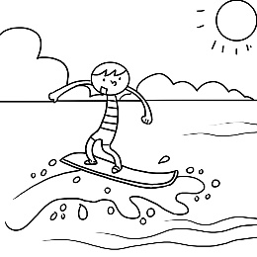 (B)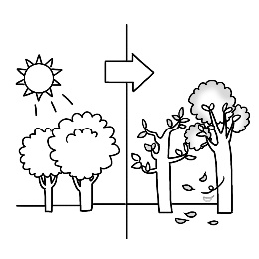(C)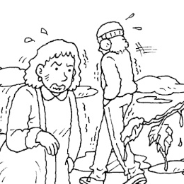
《答案區》
答案：B
- 《腳本區》
CD: Tom was fat and short last year, but now he is tall and thin.
《題目區》
(A)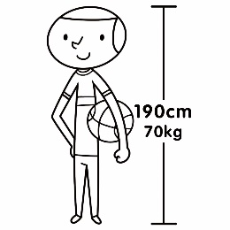 (B)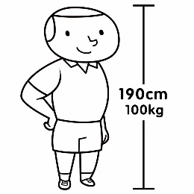(C)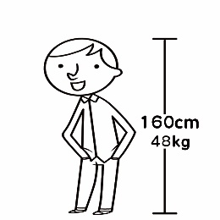
《答案區》
答案：A
- 《腳本區》
CD: The girls often have some food together at a night market.
《題目區》
(A)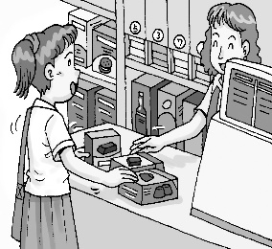 (B)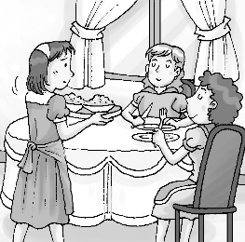(C)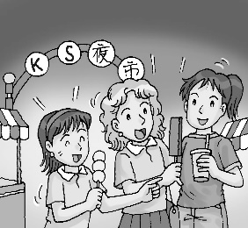
《答案區》
答案：C
二、基本問答：每題均有三個選項，請依據所聽到的內容，選出一個最適合的回應
6《腳本區》
CD: Was Jack late for school this morning?
《題目區》
(A) No, he isn’t.
(B) No, he was on time.
(C) Yes, he was in school this morning.
《答案區》
答案：B
7《腳本區》
CD: How many times a week do you practice soccer with the team?
《題目區》
(A) Once or twice a week.
(B) Forty times.
(C) I can do it from now on.
《答案區》
答案：A
8《腳本區》
CD: Does your husband often go out with you on weekends?
《題目區》
(A) Yes, he often helps me with housework at home.
(B) Not very often. He likes to be with me on weekends.
(C) No, he doesn’t even want to move a finger on weekends.
《答案區》
答案：C
9《腳本區》
CD: How often do you play video games with your son?
《題目區》
(A) I never do.
(B) He’s usually busy.
(C) Yes, I do it for him sometimes
《答案區》
答案：A
10《腳本區》
CD: M: Were you happy in London last week?
W: Yes, I was. What about your trip to Kyoto?
《題目區》
(A) It is windy in Kyoto in autumn.
(B) It was fun, and the food was delicious.
(C) There are many visitors in London every year.
《答案區》
答案：B
三、言談理解：每題均有三個選項，請依據所聽到的對話與問題，選出一個最適當的答案
11.《腳本區》
CD: M: My friends and I were in London last week. London is a big city. Many visitors visit London every year. They usually visit beautiful museums there. And I was in some of the museums last Sunday. I like these beautiful buildings, but I don’t like the weather there. It is usually rainy and cloudy in London.
Q: What can we know from the talk?
《題目區》
(A) It’s sometimes cloudy in London.
(B) The museums in London aren’t beautiful.
(C) The man was in some museums last week.
《答案區》
答案：C
12.《腳本區》
CD: M: Look at this photo. Where were you then?
W: I was at Logan Park. It was ten years ago.
M: What? That was Logan Park? There wasn’t a pond ten years ago.
W: And there weren’t so many visitors.
M: Logan Park is beautiful now. Many people like to visit here.
Q: Which is NOT true about Logan Park?
《題目區》
(A) There isn’t a pond in the park.
(B) There are many visitors in the park.
(C) There is a beautiful park in the photo.
《答案區》
答案：A
13. 《腳本區》
CD: M: Batman is my favorite movie. What about you?
W: My favorite one is Indiana Jones.
M: You like Harrison Ford, right?
W: Yeah, he was tall and cool in that movie.
M: But now he is old and can only be someone’s grandpa in movies.
Q: What do we know about “Harrison Ford”?
《題目區》
(A) He is an actor（男演員）.
(B) He is old.
(C) He wasn’t tall then.
《答案區》
答案：A
14.《腳本區》
CD: W: Do you often do the housework?
M: Sure. For example, I mop the floors four times a week and wash the bathroom twice a week. My wife cleans the kitchen and takes out the trash every day.
W: Wow! Your house must be very clean.
Q: How often does the man’s wife clean the kitchen?
《題目區》
(A) She does it every day.
(B) She cleans it twice a week.
(C) She washes it four times a week.
《答案區》
答案：A
15.《腳本區》
CD: M: A study shows people check their cellphones about forty-seven times a day.
W: Really? I don’t believe it. We don’t have time to check our cellphones so often.
M: Then what are you doing now?
Q: What is the woman doing?
《題目區》
(A) She doesn’t have time to check her cellphone.
(B) She’s using her cellphone.
(C) She’s reading a study about cellphones.
《答案區》答案：B

