新北市立溪崑國民中學110學年度第二學期第二次定期評量 英語科 試題卷
九年級 班 座號 姓名
- 聽力：30％ (每題2分)
- 辨識句意：請依據所聽到的句子，選出符合描述的句子。
- (A) 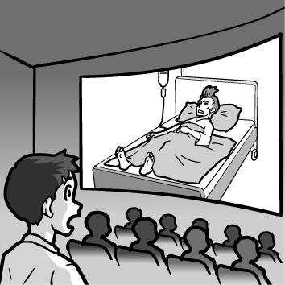 (B) 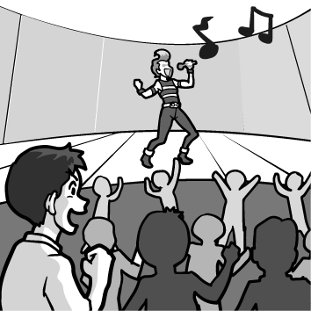 (C) 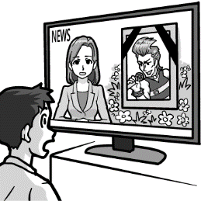
- (A) 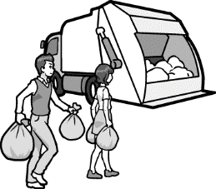 (B) 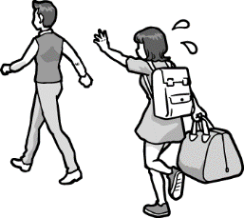 (C) 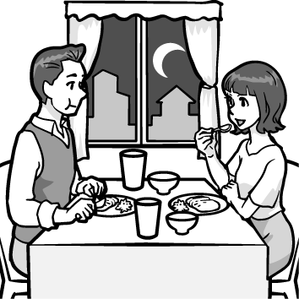
- (A) 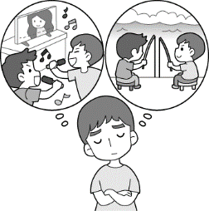 (B) 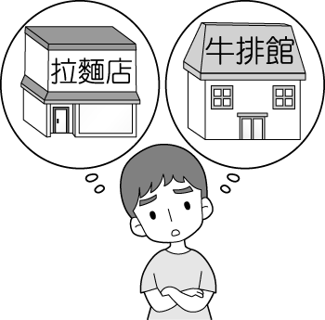 (C) 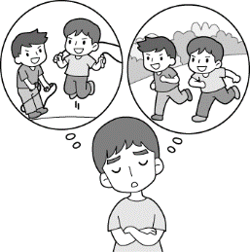
- (A) 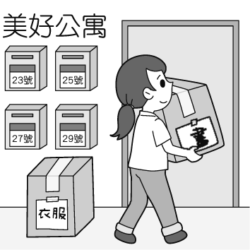 (B) 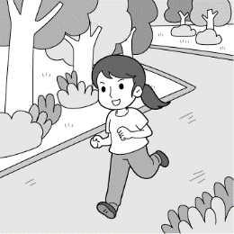 (C) 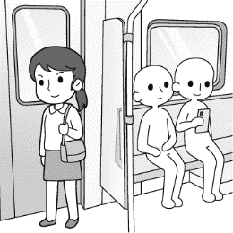
- (A) 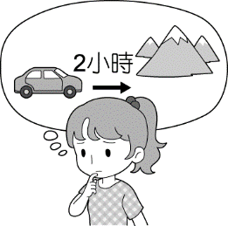 (B) 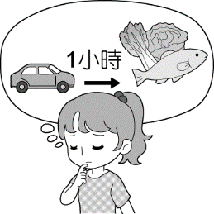 (C) 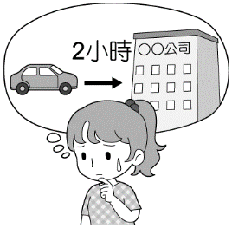
- 基本問答：請依據所聽到的內容，選出最適合的回應。
- (A) I want to buy a new phone. (B) I am in the bathroom. Can you answer the phone for me?
(C) I was at home. I didn’t hear the phone because I was taking a shower.
- (A) Yes, I will be very busy then. (B) Sure. Sounds like a good idea. (C) Of course. It snows a lot.
- (A) Yes, it is my favorite type of food. (B) No, I can talk to you on the phone later. (C) I’m sorry. I should use the earphones
- (A) Call the store to deal with the problem ASAP. (B) It’s really a good buy. (C) You can invite your friends to dinner.
- (A) Let’s go shopping in the department store in the afternoon, shall we? (B) How come? Its business isn’t so bad.
(C) Then we need to go there by 8 p.m. before it closes.
- 言談理解：請依據所聽到的對話或短文，選出一個最適合的答案。
- (A) In his parents’ house. (B) In a department store. (C) In a restaurant.
- (A) They watched the ball game on TV. (B) They watched the movies together, (C) They played badminton in the gym.
- (A) She had a toothache. (B) She was preparing for a test. (C) She was watching a TV show about science.
- (A) In a department store. (B) In a bank. (C) In a post office.
- (A) He cleaned the living room. (B) He cooked some spaghetti. (C) He cleaned his room.
- 單題：請依照題意選出一個正確或最佳的答案30％ (每題2分)
- In the picture, the woman is ________ her hand to get a taxi. 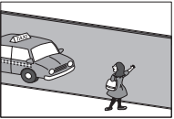
(A) picking (B) wrapping (C) waving (D) dealing
- Can you _____ your feet a little off the floor? I want to see if my keys are under the sofa.
(A) check (B) raise (C) point (D) count
- Nicole doesn’t like her ______ job, so she is looking for a new one. (A) present (B) friendly (C) correct (D) honest
- Mark studies very hard and never _______ classes. He goes to school even when he is sick.
(A) loses (B) changes (C) forgets (D) misses
- The last five years have not been _______ to Jennie. Her face is covered with lines and she looks much older than she is.
(A) special (B) fake (C) kind (D) enough
- Sam didn’t know how to do the math homework _______ he asked Ann for help.
(A) if (B) while (C) since (D) until
- I don’t think Katie will read any one of the books you’ve picked out for her: ________ look(s) very boring.
(A) they (B) it (C) one (D) some
- I believe ________ you will be chosen to be a member of the basketball team. You are tall enough and practice very hard.
(A) if (B) that (C) how (D) why
- The weather _______ rainy and cloudy in the last few days. I hope the sun will come out soon.
(A) will be (B) would be (C) has been (D) had been
- Alice: Do you know ______ Grandma is going to visit us?
Willy: It’s next week. She told me on the phone. And we’ll take her to the national park.
(A) where (B) when (C) whether (D) why
- It is important _______ off your cellphone before the meeting. We don’t want to be interrupted by calls.
(A) turn (B) turned (C) turning (D) to turn
- Cake Square is a place _______ you can learn to make cakes. (A) where (B) which (C) that (D) what
- Ben always uses his birthday as a(n) ______ to ask Dad to buy him something expensive.
(A) action (B) prize (C) rule (D) excuse
- Peter was angry with Jessica because she lost the comic book ________ he lent to her last month.
(A) what (B) where (C) that (D) who
- Jessie ______ how dangerous it was to swim in the sea when the weather is bad.
- picked up (B) pointed out (C) knocked out (D) stayed up

- 閱讀題組：40％ (每題2分)

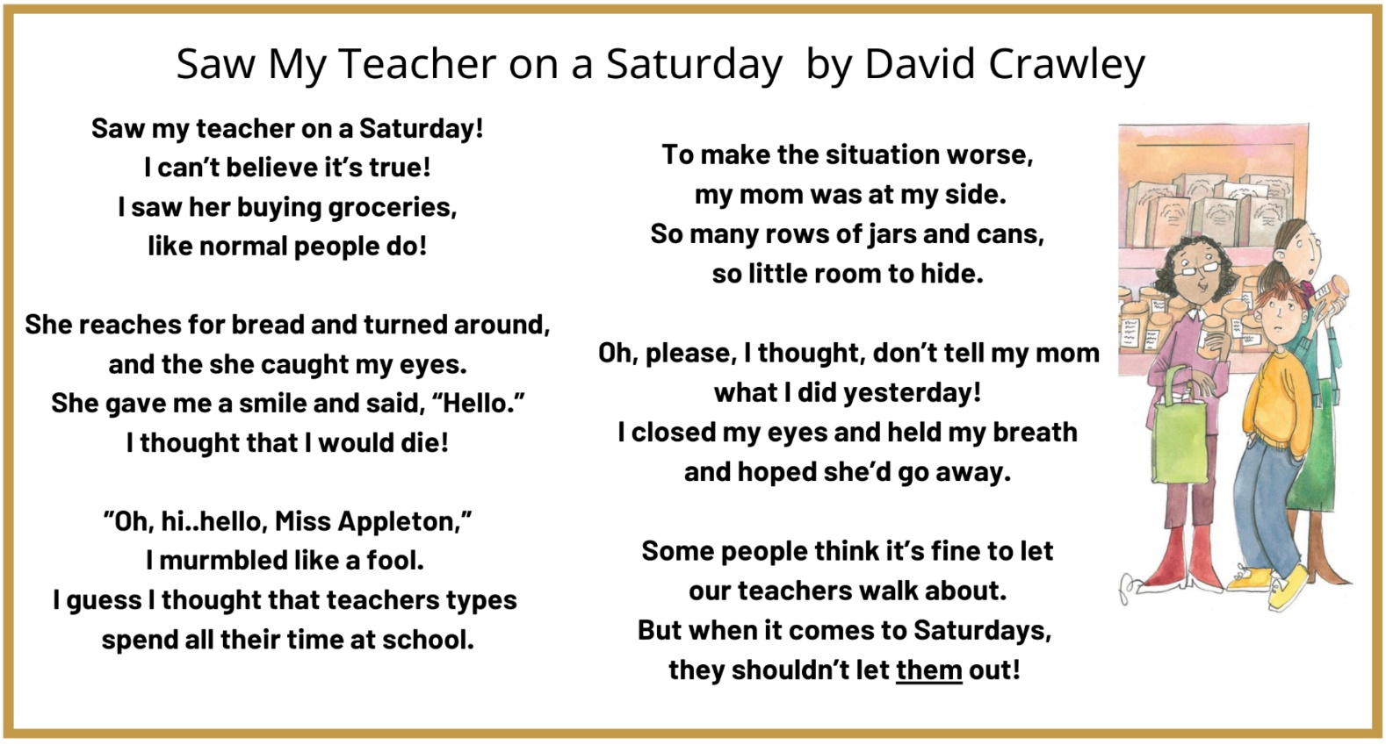
- The poet uses the line” I thought I would die!” to show _______.
(A) why the boy is excited (B) Miss Appleton is going to kill the boy (C) the boy is scared (D) the store is so crowded
- The poet uses these lines “So many rows of jars and cans, so little room to hide.” to show ________.
(A) that the boy is surprised by how big the store is (B) how badly the boy wants to avoid being seen by his teacher
(C) how many items there are in their shopping cart (D) that the boy is worried about his grades
- These lines “Oh, please, I thought, don’t tell my mom what I did yesterday!” best support that _______.
(A) the boy is hoping to talk about something at school (B) the boy wants to get home as quickly as possible
(C) the teacher is kind to all the students (D) the boy knows he did something wrong at school
- On the last line, “them” means ______. (A) customers (B) shopkeepers (C) teachers (D) groceries

Late one night, Marcus was lying in bed looking at his phone. Suddenly, he heard a noise outside the room. He looked at the clock. It was midnight! He wondered 35. . He got out of bed and opened his bedroom door 36. , trying not to make any noise. He headed for the living room 37. it seemed to be where the noise had come from. When he got there, He saw a dark shape on the floor. He 38. and realized that it was a picture which had fallen off a table. There was wind 39. in through an open window, and that had blown the picture over. Happy that it was nothing, Marcus put the picture back in its place and went back to his room.
- (A) who opened the window (B) whether he should leave (C) why he couldn’t sleep (D) what the noise was
- (A) quietly (B) simply (C) angrily (D) hardly
- (A) so (B) but (C) because (D) until
- (A) ran away (B) was too scared to move (C) saw something moving on the floor (D) turned on the light right away
- (A) come (B) coming (C) comes (D) came

Depression is a common and serious problem in today’s world. People who have depression often feel unhappy and find it hard to follow their daily routines. 40. It is called smiling depression.
People with smiling depression appear happy, but at the same time, they may feel sad. The reasons that 41. may be because they care a lot about what others think about them or they don’t want to cause problems for others. Some don’t even notice that they have a depression problem.
42. , doctors find that they are more likely to hurt themselves than people with typical depression. If you have problems dealing with smiling depression, you can try to talk about your feelings to your doctor or someone you trust. You don’t have to be happy or perfect all the time. Everyone has the right to be sad.
- (A) In the end, you have to stand on your own feet. (B) What’s more, scientists have found many kinds of depression.
(C) At first, we don’t know why we feel depressed. (D) However, there is one type of depression that is different.
- (A) they don’t trust friends (B) they feel lonely (C) they hide their feelings (D) they can’t take care of themselves
- (A) Besides, people with smiling depression are bad at lying
(B) It is reported that honest people are more popular
(C) To understand people with smiling depression
(D) Although people with smiling depression are still able to do daily activities

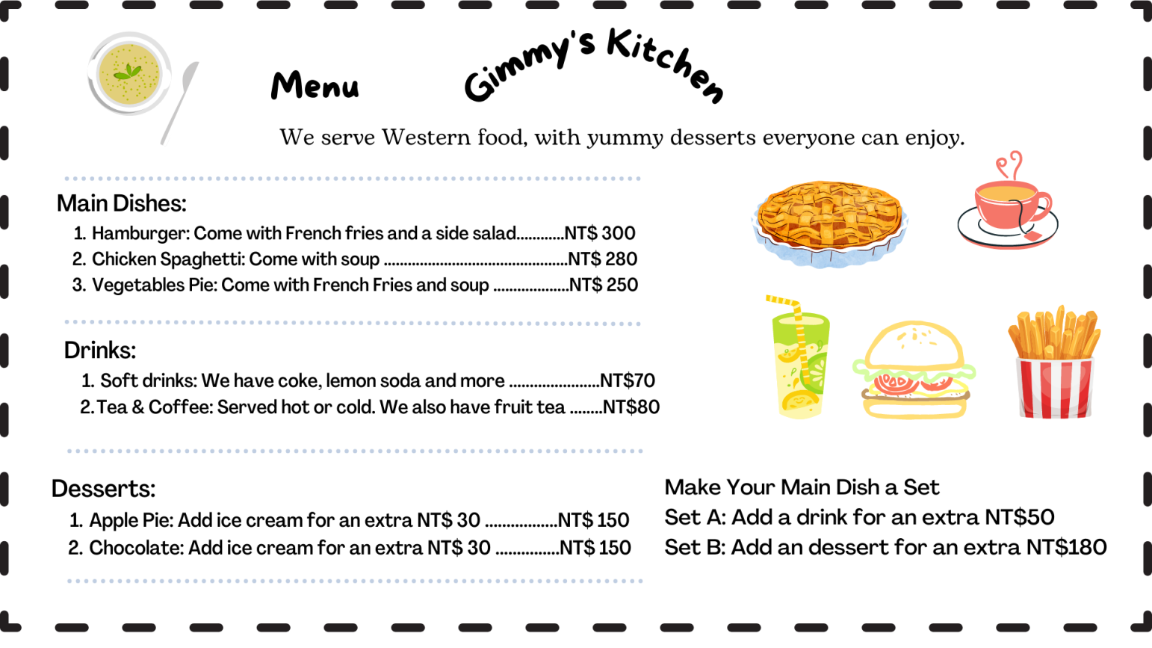
- What comes with a hamburger?
(A) Only French fries. (B) French fries and a salad. (C) French fries or a salad. (D) Only a salad.
- Which of the following is the order of someone who got Set A?
(A) Vegetable pie and chocolate cake. (B) Hamburger meal and Coke.
(C) Apple Pie and fruit tea. (D) Chicken spaghetti, a cup of tea, and apple pie.
- Which of the following is True?
(A) Both desserts are served with ice cream for free. (B) Chicken spaghetti is the cheapest main dish.
(C) Lemon soda cost less than a cup of coffee. (D) A drink and a dessert cost less than NT$150.

Matsu means a lot to many Taiwanese people. They believe that Matsu protects people who go fishing far away from home, helps people in need, listens to people’s feelings and hopes.
Every year, there is a celebration held in Taiwan--Dajia Matsu Pilgrimage. During the festival, a statue of Matsu is placed in a litter and carried by people walking on a round-trip journey from Jenn Lann Temple in Dajia, Taichung to Fengtian Temple in Xingang, Chiayi. The journey stops at many temples where people can show respect to Matsu. The festival lasts for nine days and attracts large crowds of pilgrims, who travel alongside the litter.
People follow the route to worship Matsu and pray for good luck. Some people consider miracles will happen on the way. Others think it brings health and peace to families. Still others want to enjoy the wonderful cultural experience. The Dajia Matsu Pilgrimage is seen as one of the world’s three largest religious activities by Discovery Channel, along with Christmas Mass in Vatican and the Haji.
(statue雕像 litter轎 worship 敬仰 Haji朝聖)
- What is the main idea of the article?
(A) People like to gather around especially on Matsu’s birthday.
(B) Matsu is a great person who helps fishermen away from home.
(C) Dajia Matsu Pilgrimage is a meaningful religious activity in Taiwan.
(D) Christmas Mass in the Vatican and the Haji are important to western culture.
- What does the word “Pilgrimage” mean in the article?
(A) It means a way that people show respect to god or goddess.
(B) It means that people enjoy the activity very much.
(C) It means a natural way of living that a lot of fishermen lead.
(D) It means that people share food and clothes with the poor.
- What would Not the reason that people like to join the Dajia Matsu Pilgrimage?
(A) Some people pray for healthy and peaceful life.
(B) People enjoy the delicious snacks, drinks, and food on the way.
(C) People enjoy the cultural activity and have fun on the way.
(D) People think the Dajia Matsu Pilgrimage may bring good luck.

The Internet is a strange place. It’s like a country with its own special language. To help you learn about that language, here are some common Internet words and their meanings:
Netizen: Anyone who uses the Internet often. (e.g., “Taiwanese netizens love watching food videos on YouTube.”)
Troll: Someone rude or mean on the Internet. (e.g., “Stop writing bad comments about my photos. You’re such a troll!”)
Go viral: If a video, picture, or a story goes viral, it spreads quickly on the Internet. (e.g., ‘Jonny’s dance video went viral.
It already has over 1,000,000 views!”)
Influencer: A person with many fans on social media. (e.g., “It seems like these days everyone wants to be an Instragram
influencer.”
Hashtag: The # symbol followed by a word or phrase. People often use hashtags to point out the topic of a post. (e.g., “I
just bought some metal straws. #savetheplanet”) comment 意見 symbol 符號 phrase 詞組
- What’s the reading about?
(A) Common Internet words. (B) Popular Internet videos. (C) Rude people on the Internet. (D) Internet users in Taiwan.
- I couldn’t stop laughing when I watched popcorn popping in Ahan’s funny video. The news said the video had been viewed three million times this week. So many people shared and talked about the “landing of Juitian Xuannu”. Ahan successfully made the video _______ again.
(A) add the hashtag #ootd. (B) become a troll (C) go viral (D) influence every netizen

110-2-2 九年級 英語科－解答
1 C B B A C 6 C B C A B 11 C A B A C.
16 C B A D C 21 D A B C B 26 D A D C B
31 C B D C 35 D A C D B 40 D C D
43 B B C 46 C A B 49 A C

新北市立溪崑國民中學110學年度第二學期第二次定期評量
九年級 英語科 聽力測驗稿

- 辨識句意：請依據所聽到的句子，選出符合描述的句子。
- M: I was surprised while I was watching the news about the death of a singer.
- W: Please wait for me. I am so tired now. I can’t catch up with you.
- W: Jacob hasn’t decided where to have lunch with his friends this Friday.
- W: The woman who is moving into the apartment is my son’s elementary school teacher.
- W: Iris couldn’t decide whether she should take the job because it takes two hours to drive to
work.

- 基本問答：請依據所聽到的內容，選出最適合的回應。
- Where were you last night? I called you many times, but you didn’t answer the phone.
- Will you go mountain climbing with us if it is sunny tomorrow?
- Would you mind turning off the music on your cellphone?
- There is something wrong with my new TV I bought three days ago. What can I do for it?
- TV news says So Cool Department Store where we often go shopping is closing down.

- 言談理解：請依據所聽到的對話或短文，選出一個最適合的答案。
- M: Hello, is this Joe’s Steak House?
W: Yes. What can I help you with?
M: May parents and I had dinner there last night, and I left my umbrella at my seat.
W: Okay, so what’s its color?
M: It’s a yellow one with some dots on it.
W: I think we have it here. We can keep it for you until you come to get it in person.
M: Thank you so much. I’ll pick it up soon.
Q: Where was the man last night?
- M: Helen, did you watch the badminton game last night?
W: Of course, I did. I was so nervous in the beginning because the two teams were so close. But
Lee Yang and Wang Chi-Lin played better and better and finally won the game.
M: Yes, they did. All of our family members were touched when they won the Olympic gold
medal.
W: I felt so proud of them. They did pretty well this time. I hope more and more people can
support them.
Q: What did Helen and the man do last night?
- M: Lindy, what are you doing? It is pretty late now.
G: Dad, I am still studying for my science test tomorrow.
M: But it is almost 12 o’clock. You should go to bed now.
G: Okay. M: Before you go to bed, remember to brush your teeth. Don’t forget what the dentist
said last week.
G: I will keep that in mind.
Q: Why didn’t the girl go to bed?
- W: Hi, I am looking for a birthday present for my mom.
M: Is there anything you have in mind?
W: Anything useful. Can you show me some items in your store?
M: OK, how about this new shopping bag? It just came in last week. You can put a lot of things in
it. Or the new dress? It is beautiful and there are many different colors.
W: Both are very nice. But I like the shopping bag more. How much is it?
M: It’s on sale now. It is only two thousand dollars.
Q: Where are the man and the woman?
- W: Have you tidied up your room?
B: Sure, Mom. It is very clean now. I had tidied it up before you got home. But I haven’t cleaned the living room and the kitchen because I don’t have much time.
W: That’s fine. Maybe we can do that after dinner. What do you want to have for dinner?
B: How about some spaghetti? W: Sound great.
Q: What did the boy do before his mom got home?

