新北市立溪崑國民中學110學年度第二學期第二次定期評量 英語科 試題卷
七年級 班 座號 姓名
一、聽力測驗30%
(一)辨識句意：每題均有三張圖片，請依據所聽到的句子，選出符合描述的圖片(每題2分，共10分)
- (A) 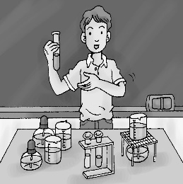 (B)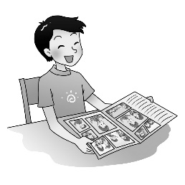 (C)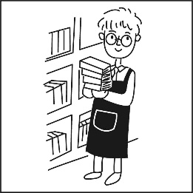
- (A)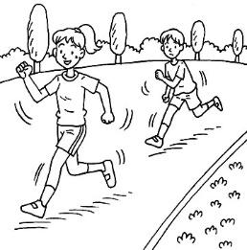 (B)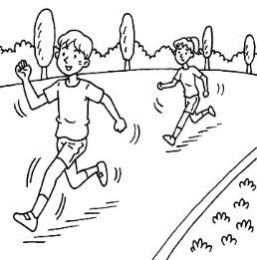 (C)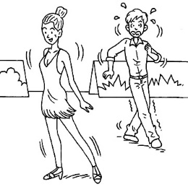
- (A) 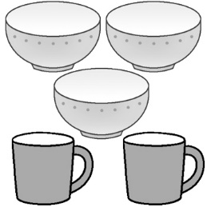 (B)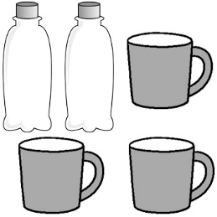 (C)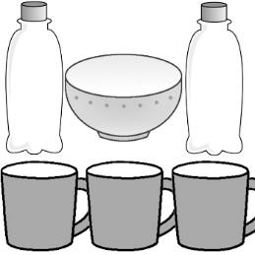
- (A)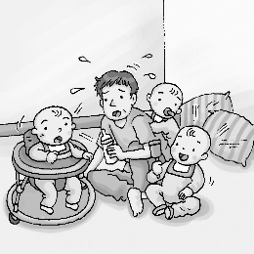 (B)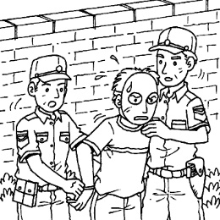 (C)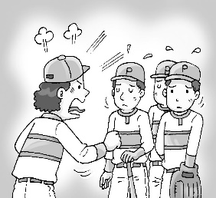
- (A)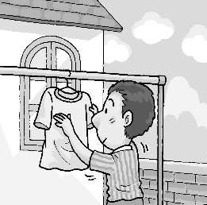 (B)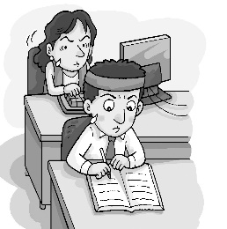 (C)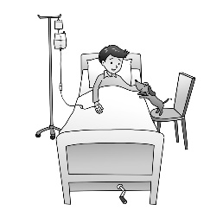
(二)基本問答：每題均有三個選項，請依據所聽到的內容，選出一個最適合的回應(每題2分，共10分)
- (A) It’s Wednesday.
(B) It’s January.
(C) It’s May first.
- (A) I have three. Juice, milk, and water.
(B) I have three. English, math, and PE.
(C) I have three. Red, blue, and brown.
- (A) It’s yummy.
(B) It’s one hundred dollars.
(C) I need two bowls of rice.
- (A) A bag of flour and some apples.
(B) A pan and a plate.
(C) Some butter and noodles.
- (A) No, they’re my tickets.
(B) Yes, they’re over there.
(C) No, they’re Jenny’s.
(三)言談理解：每題均有三個選項，請依據所聽到的對話與問題，選出一個最適當的答案(每題2分，共10分)
- (A) Watching a race.
(B) Chatting with Ryan.
(C) Running on the sports field.
- (A) Fifty dollars.
(B) A cup.
(C) Two.
- (A) At home.
(B) In a junior high school.
(C) In a senior high school.
- (A) He doesn’t like the woman’s dishes.
(B) He doesn’t want to eat lunch.
(C) He wants to eat different food.
- (A) He has different food every day.
(B) He doesn’t exercise.
(C) Fast food is his favorite.

二、綜合測驗(每題2分, 共26分)
16. There is a party for my grandmother’s birthday tonight. We prepare a big dinner for her.
(A) eight (B) the eightieth (C) eightieth (D) eighty
17. One third of my classmates have their own computers, and of them share ones with their family.
(A) two third (B) two three (C) two threes (D) two thirds
18. There are floors in the building, and Mike’s home is on the floor.
(A) thirty ; twenty-nine (B) thirty ; twenty-ninth (C) thirtieth ; twenty-ninth (D) thirtieth ; twenty-nine
19. We have club activities the morning of Friday every two weeks.
(A) in (B) at (C) to (D) on
20. Their rooms are new and big; but old and small.
(A) we ; are (B) we ; is (C) our ; is (D) ours ; are
21. A: is Double Tenth Day in Taiwan? B: It’s October tenth. It’s also called National Day.
(A) When ; X (B) When ; on (C) What day ; on (D) What ; X
22. A: cellphone is it ? B: It’s Eric’s. He forgets to take it home.
(A) Which (B) Who’s (C) What (D) Whose
23. My sister isn’t hungry, and she doesn’t eat much. She only has bread for breakfast.
(A) a little (B) any (C) a few (D) lots of
24. A: What’s the date today?
B: It’s .
A: Isn’t Father’s Day coming ?
B: Oh, it’s 7 days . Let’s make a card for Dad.
(A) on August 1st ; away (B) August 1st ; away (C) August 1st ; also (D) in August ; away
25. Amy has money with her. Luckily, she has friends in Taipei, so she can call out for help.
(A) little ; much (B) most ; few (C) many ; a little (D) little ; a few
26. A: sheep do you see in the picture on the wall ? B: About 12. Is that right?
(A) How many (B) How much (C) What (D) Which
27. We need two of flour, eggs and some sugar for making the cookies in our cooking class.
(A) bottles (B) glasses (C) pan (D) bags
28. A: How much milk do you drink every day? B: .
(A) There is no milk at home.
(B) Yes, 500cc is enough.
(C) About 500cc.
(D) I drink two glasses of juice.

三、克漏字測驗10%
Follow these (29) , and you can make your own yummy pumpkin cake. It’s not difficult.
First, (30) sugar and butter in a bowl.
Second, (31) to the bowl.
Third, mash the pumpkin (32) they are soft and add them to the bowl.
Then put the flour and salt in.
Next, put the batter in a pan.
Last, bake it for 30 to 35 minutes, and there you have it ─ a yummy pumpkin cake.
Now, the pumpkin cake (33) . Enjoy!
29. (A) roads (B) steps (C) books (D) food
30. (A) miss (B) heat (C) need (D) mix
31. (A) add the eggs and milk (B) adding the eggs and milk (C) no eggs and milk (D) there are eggs and milk
32. (A) even (B) also (C) which (D) until
33. (A) ready (B) are ready (C) is ready (D) is enough

四、閱讀測驗(每題2分, 共10分)
Why does Russia Invade Ukraine?
The biggest European war since 1945 is happening in Ukraine right now, and the whole world is watching. Russia invaded their neighbor, and thousands of people are dying. Why does Russia invade Ukraine?
Russia and Ukraine have a long and complicated history. They were both part of the same socialist country-the Soviet Union, but they are separate countries in 1991. Because of this, Russia and Ukraine share much of their culture, language and history.
(38) , for the reason who should control Crimea. Russia took control of Crimea in 2014. In late February 2022, Russia’s leader Vladimir Putin said that the Russian army would do a ‘special military operation’ in Ukraine. This really means war. Putin told the people of Russia that the Ukrainian government was dangerous and that he wanted to save Ukraine. Most people think this is a lie, and believe that Putin wants to enlarge his country.
Russia’s army are attacking many cities in Ukraine using soldiers, tanks and bombs. Though Russia is a large country, Ukraine’s army is defending the country well. Putin is upset, and he is sending more troops to Ukraine. Most countries in the world help Ukraine. Many countries are worried, however, that if they help too much, Putin will get very angry and start a world war. The situation is changing every day, and no-one knows when this war will end.
Ukraine烏克蘭 Russia俄羅斯 invade侵略 socialist社會主義
Soviet Union蘇聯 Crimea克里米亞 defending 防衛 troops 軍隊
34. According to the reading, what’s Putin’s motive for invading Ukraine? motive 動機
(A) He wants to make Ukraine become a part of Russia.
(B) He wants to build factories in Ukraine.
(C) He wants to save Ukraine people.
(D) He hates Ukraine for attacking Crimea.
35. According to the reading, what is surprising about Ukraine’s defending ?
(A) The Ukrainian army is defeated fast. defeat 打敗
(B) The Ukrainian army is stronger and bigger than Russia’s.
(C) The Ukrainian army’s tanks and weapons are good, but Russia’s are not.
(D) The Ukrainian is doing a good fight, even though they have fewer soldiers.
36. From the reading, why some other countries aren’t sending troops to help Ukraine?
(A) They don’t like Ukraine.
(B) They don’t have any troops.
(C) They think Putin may attack their own countries.
(D) They think Putin is right .
37. What does complicated mean in the reading?
(A) very easy (B) not simple (C) very busy (D) almost the same
38. Which is the best sentence for (38) ?
(A) The two countries are really good friends
(B) The two countries share many things together
(C) The two countries hate each other for many years
(D) The two countries love each other for many years
以下答案請寫在答案卷上
五、翻譯24%
(A)中翻英(4%)
1. 九月 | 2. 美味的(d….) | 3. 當然 | 4. 十二月

(B) 每句(4%)
- 賽跑是在什麼時候？在母親節，五月的第二個禮拜天。
- 爸爸也可以扮演媽媽的角色。
- 在我眼中，爸爸是個超級爸爸，而您是個超級媽媽。
- 桌上有多少顆蛋呢？有十二顆蛋。
- 你想要哪個，一些草莓蛋糕或是香蕉派？

新北市立溪崑國民中學110學年度第二學期第二次定期評量 英語科 答案卷
七年級 班 座號 姓名
五、翻譯24%

(A)中翻英(4%)
1. 九月 | 2. 美味的(d….) | 3. 當然 | 4. 十二月

(B) 每句(4%)
1.

2.

3.

4.

5.

110-2-2 7年級 英語科－解答
一~四 76%
1 | 2 | 3 | 4 | 5 | 6 | 7 | 8 | 9 | 10
C | A | B | A | A | C | B | B | A | C
11 | 12 | 13 | 14 | 15 | 16 | 17 | 18 | 19 | 20
A | B | C | C | C | C | D | B | D | D
21 | 22 | 23 | 24 | 25 | 26 | 27 | 28 | 29 | 30
B | D | A | B | D | A | D | C | B | D
31 | 32 | 33 | 34 | 35 | 36 | 37 | 38
A | D | C | A | D | C | B | C

五 、翻譯:24％
(A)中翻英(4%)
1. 九月 | 2. 美味的(d….) | 3. 當然 | 4. 十二月
September | delicious | of course | December
(B)每句4 %
1. When is the race? It’s on Mother’s Day , the second Sunday of/in May.

2. A father can also play the role of a mother.
3. In my eyes , Dad is a superdad , and you are a supermom.
4. How many eggs are there on the table? There are twelve.
5. Which do you want , some strawberry cake or banana pie?

新北市立溪崑國民中學110學年度第二學期第二次定期評量
七年級 英語科 聽力測驗稿
一、辨識句意：每題均有三張圖片，請依據所聽到的句子，選出符合描述的圖片(每個答案2分，共10分)
- 《腳本區》
CD: Eddie works in the library.
《題目區》
(A) 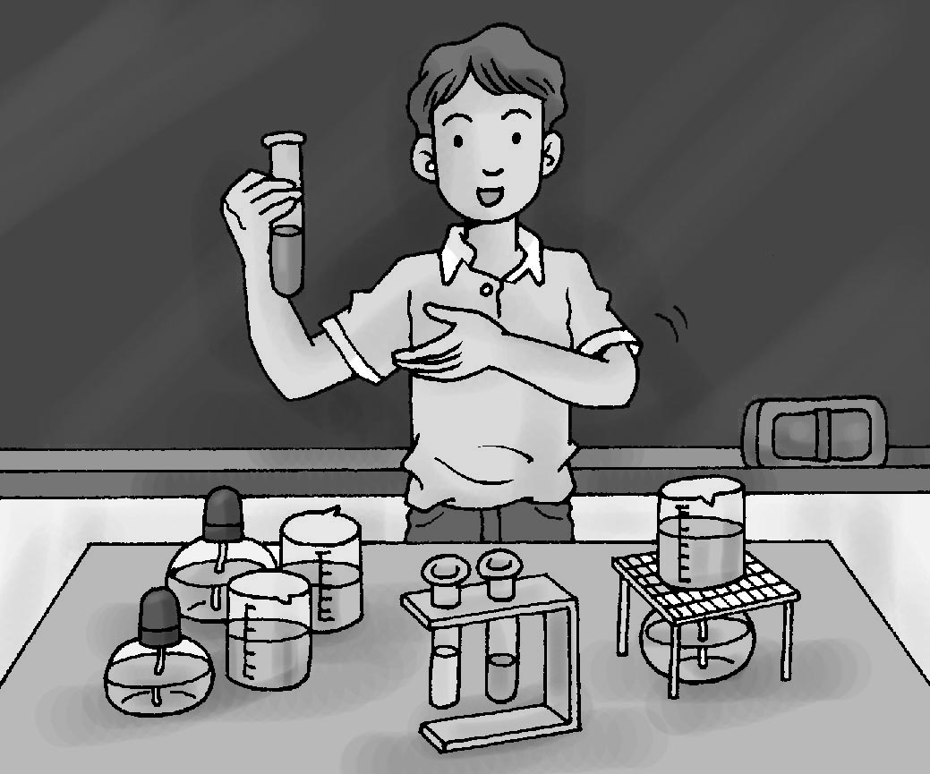 (B)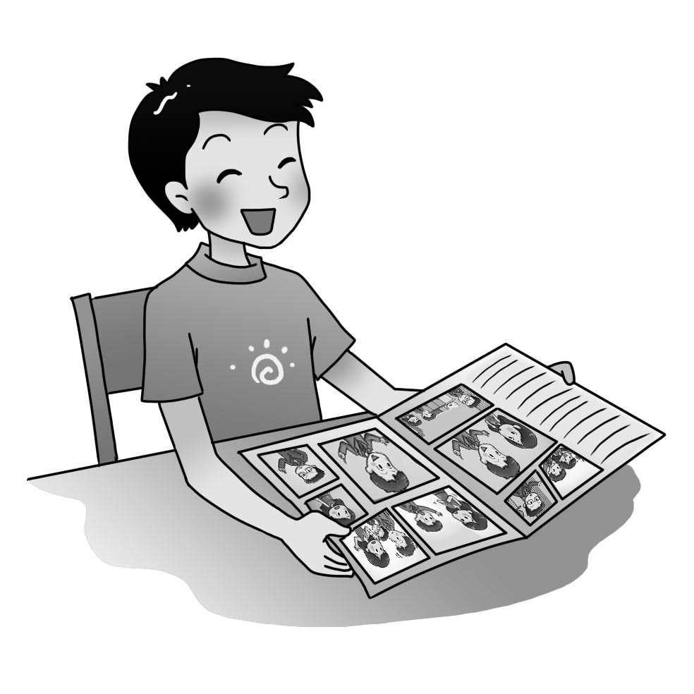 (C) 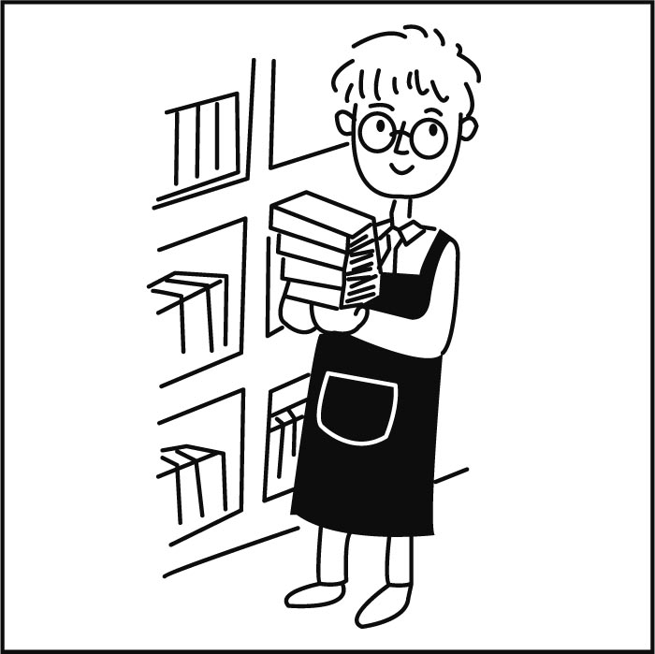
《答案區》
答案：C
- 《腳本區》
CD: The first runner is a girl.
《題目區》
(A)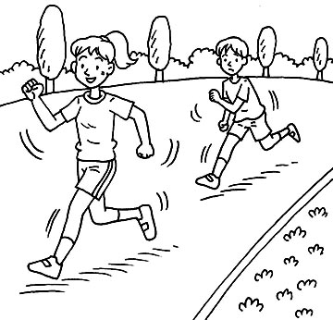 (B)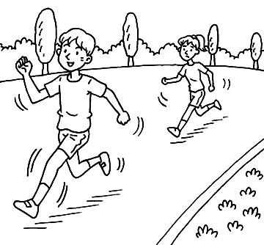 (C)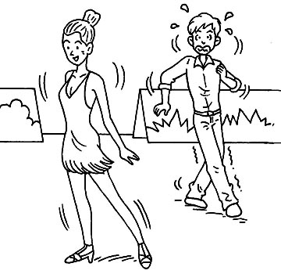
《答案區》
答案：A
- 《腳本區》
CD: There are two bottles and three cups on the table, but there isn’t a bowl there.
《題目區》
(A) 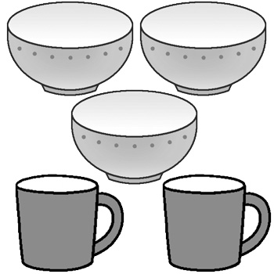 (B) 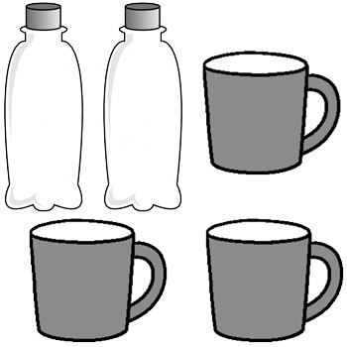(C)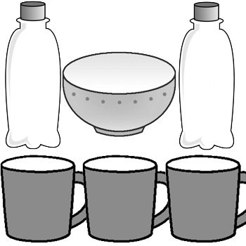
《答案區》
答案：B
- 《腳本區》
CD: Mr. White has to take care of his sons.
《題目區》
(A)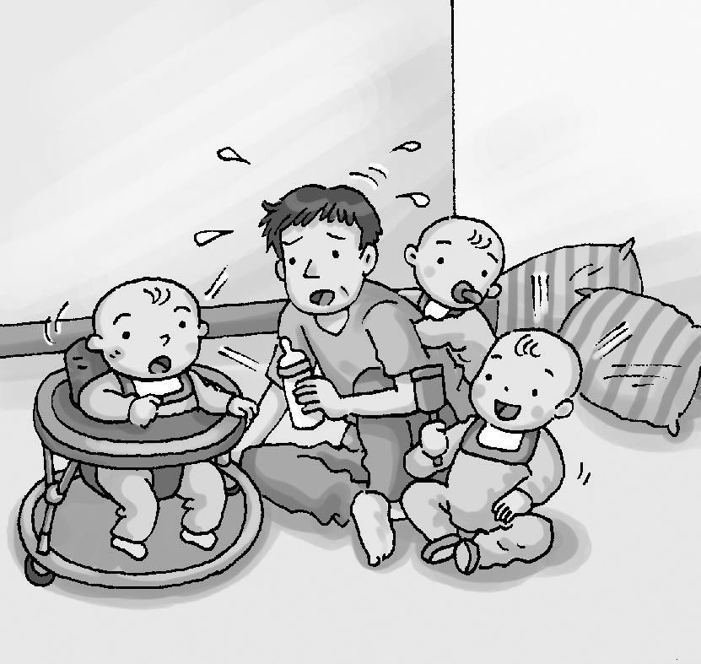 (B)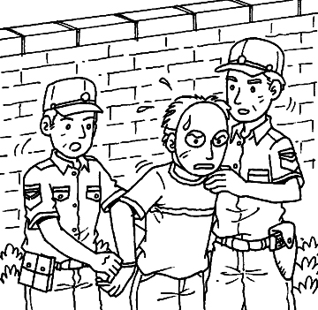 (C)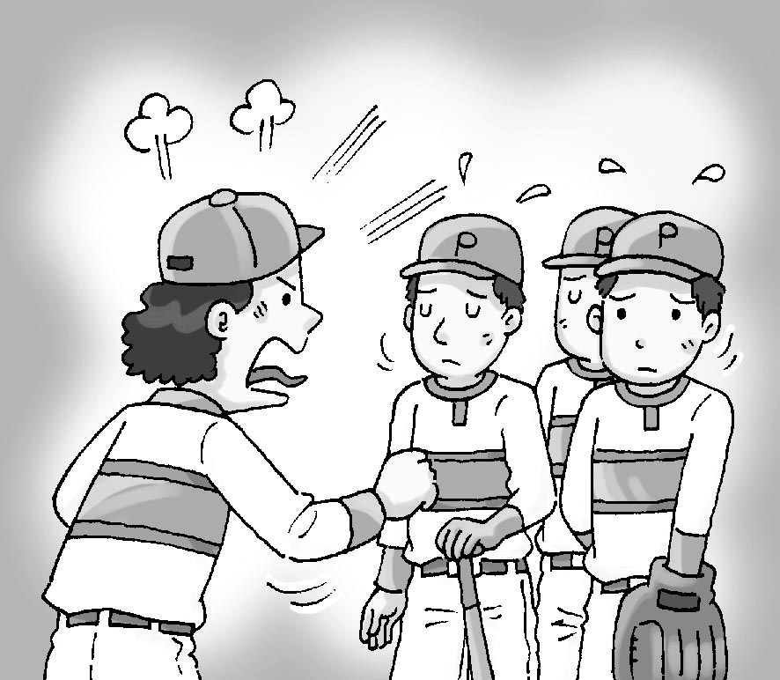
《答案區》
答案：A
- 《腳本區》
CD: Doing housework isn’t hard for Richard.
《題目區》
(A)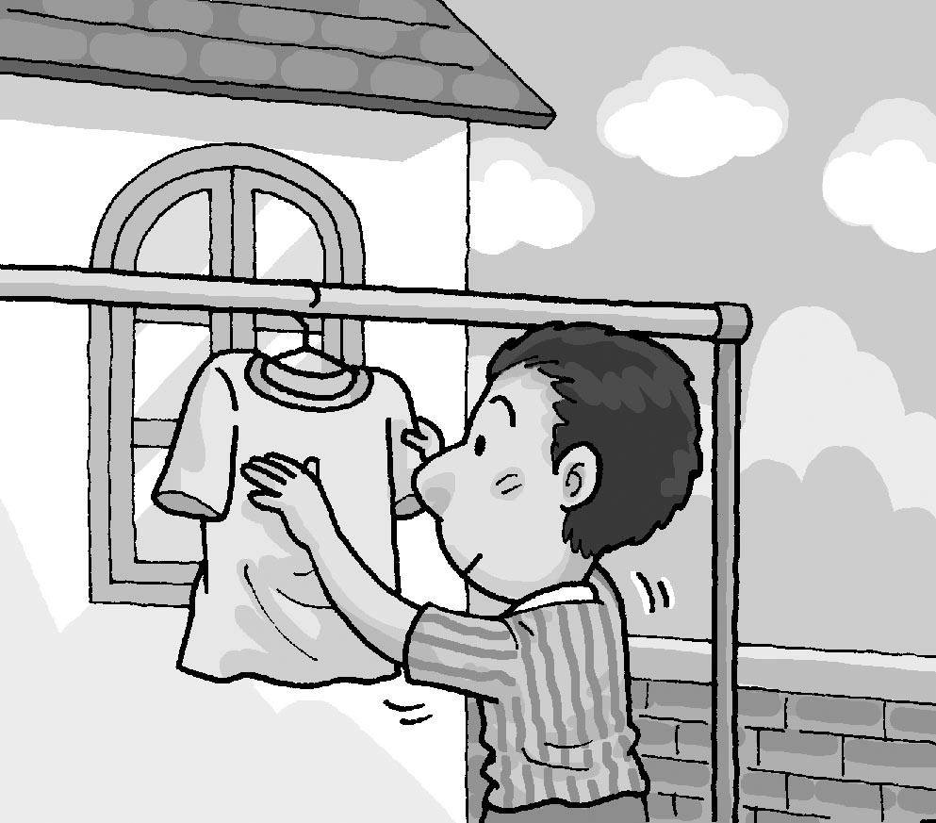 (B)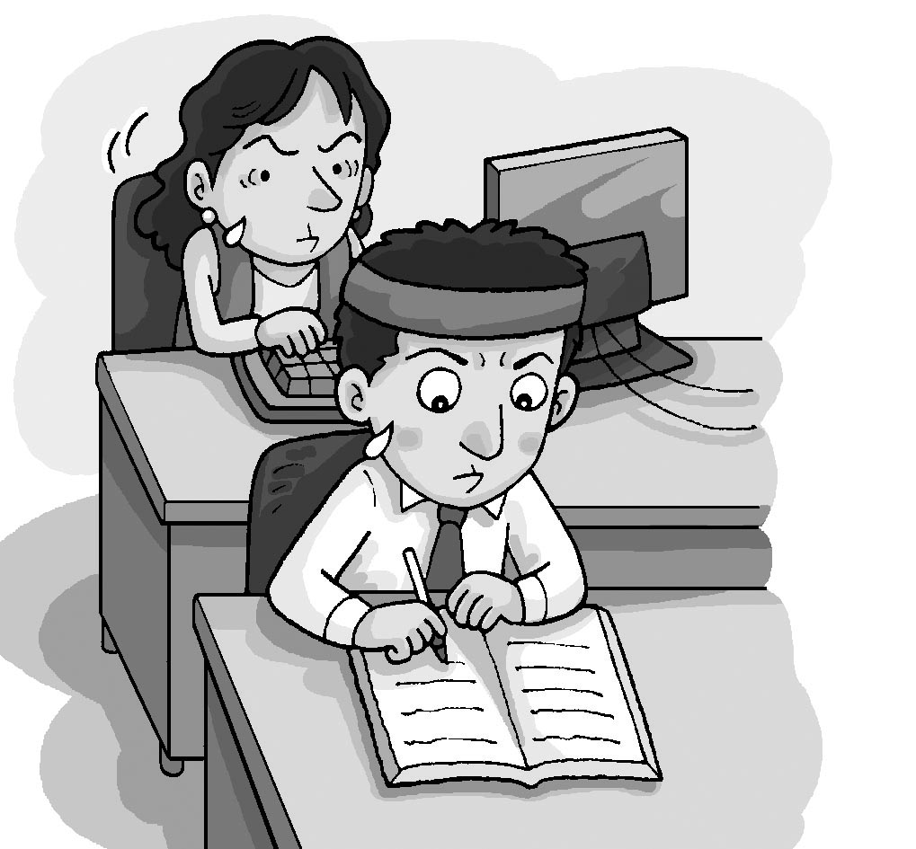 (C)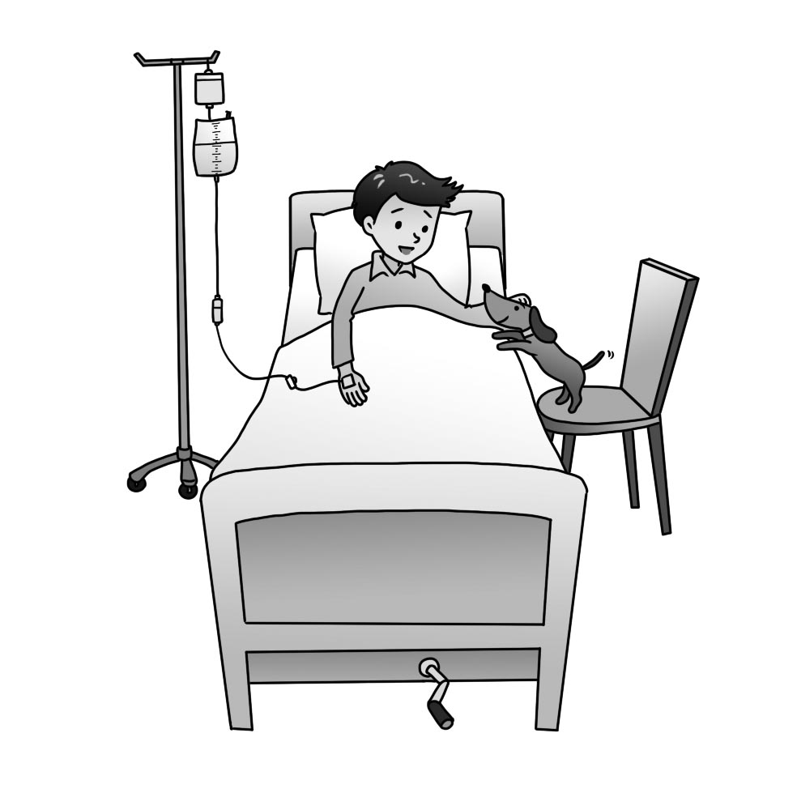
《答案區》
答案：A
二、基本問答：每題均有三個選項，請依據所聽到的內容，選出一個最適合的回應(每個答案2分，共10分)
- 《腳本區》
CD: What’s the date today?
《題目區》
(A) It’s Wednesday.
(B) It’s January.
(C) It’s May first.
《答案區》
答案：C
- 《腳本區》
CD: How many classes do you have on Wednesdays?
《題目區》
(A) I have three. Juice, milk, and water.
(B) I have three. English, math, and PE.
(C) I have three. Red, blue, and brown.
《答案區》
答案：B
- 《腳本區》
CD: How much is the bag of rice?
《題目區》
(A) It’s yummy.
(B) It’s one hundred dollars.
(C) I need two bowls of rice.
《答案區》
答案：B
- 《腳本區》
CD: M: Let’s make some apple pie.
W: Good idea. What do we need for the pie?
《題目區》
(A) A bag of flour and some apples.
(B) A pan and a plate.
(C) Some butter and noodles.
《答案區》
答案：A
- 《腳本區》
CD: Are the tickets over there yours?
《題目區》
(A) No, they’re my tickets.
(B) Yes, they’re over there.
(C) No, they’re Jenny’s.
《答案區》
答案：C
三、言談理解：每題均有三個選項，請依據所聽到的對話與問題，選出一個最適當的答案(每個答案2分，共10分)
- 《腳本區》
CD: W: Go! Go! Ryan, go!
M: Is Ryan the second runner?
W: Yes, but look, he’s the first now.
M: He can win the game!
Q: What are the man and the woman doing?
《題目區》
(A) Watching a race.
(B) Chatting with Ryan.
(C) Running on the sports field.
《答案區》
答案：A
- 《腳本區》
CD: M: I want a cup of banana milk and two oranges.
W: OK. It’s one hundred dollars.
M: Oh, sorry. I also want a cup of papaya milk.
W: Here you are. It’s one hundred and fifty dollars then.
Q: How much papaya milk does the man want?
《題目區》
(A) Fifty dollars.
(B) A cup.
(C) Two.
《答案區》
答案：B
- 《腳本區》
CD: G: Your mother is nice. Is she a nurse?
B: No, she is a senior high school teacher.
G: Wow! What does she teach?
B: Math. She helps me a lot with my math homework.
Q: Where does the boy’s mother work?
《題目區》
(A) At home.
(B) In a junior high school.
(C) In a senior high school.
《答案區》
答案：C
- 《腳本區》
CD: M: What are you busy with in the kitchen?
W: I’m making noodles for our lunch.
M: Again? Can we eat out today?
Q: What does the man mean?
《題目區》
(A) He doesn’t like the woman’s dishes.
(B) He doesn’t want to eat lunch.
(C) He wants to eat different food.
《答案區》
答案：C
- 《腳本區》
CD: W: Jim, don’t eat too much fast food. It’s not good for you.
B: Sorry, Mom. But it is delicious.
W: I know. But you have fast food every day this week.
Q: What can we say about the boy?
《題目區》
(A) He has different food every day.
(B) He doesn’t exercise.
(C) Fast food is his favorite.
《答案區》
答案：C

