新北市立溪崑國民中學110學年度第二學期第一次定期評量 英語科 試題卷
八年級 班 座號 姓名
一、聽力測驗
(一)辨識句意：每題均有三張圖片，請依據所聽到的句子，選出符合描述的圖片(每題1分，共5分)
- (A)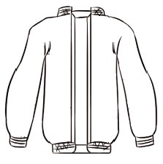 (B)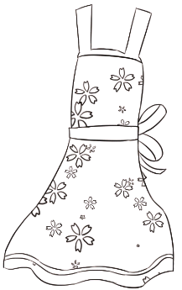 (C)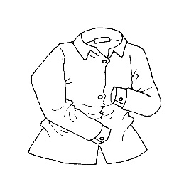
- (A)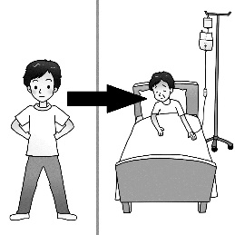 (B)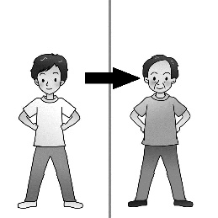 (C)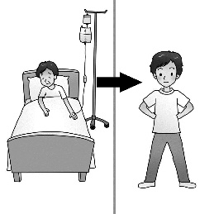
- ＿＿＿
(A)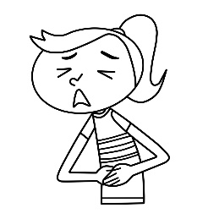 (B)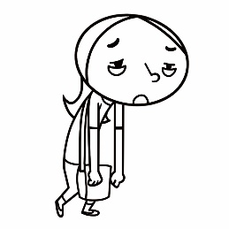 (C)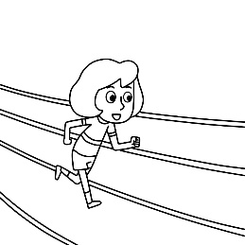
- (A)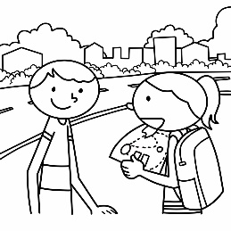 (B)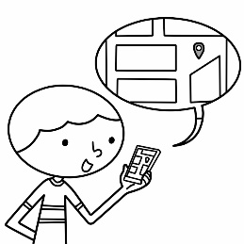 (C)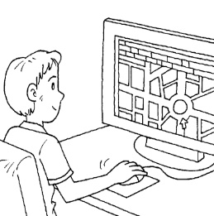
- (A)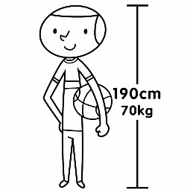 (B)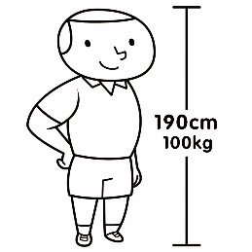 (C)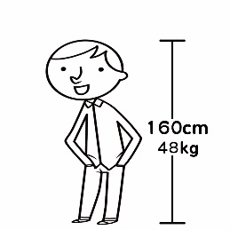

(二) 基本問答：每題均有三個選項，請依據所聽到的內容，選出一個最適合的回應(每題1分，共5分)
- (A) Because they are less comfortable.
(B) Because its price is high.
(C) Because it’s soft and easy to wash.
- (A) It’s great on you. It’s out of style.
(B) It’s great on you. It goes well with your pants.
(C) It’s great on you. Put it on now.
- (A) The table over there. It’s almost 100 years old.
(B) I started working at the store twenty years ago.
(C) This is one of the oldest stores in the city.
- (A) Sure. I just bought a new table lamp.
(B) Sure. Let’s check them all before leaving.
(C) I used to read by the light of the street lamp.
- (A) Sorry, it’s out of order. I’ll have someone fix it tomorrow.
(B) Please show me some useful ways to cool down a hot room.
(C) The room is usually hotter than the rest of the house.
(三) 言談理解：每題均有三個選項，請依據所聽到的對話與問題，選出一個最適當的答案(每題2分，共10分)
- (A) A new jacket. (B) A new sweater. (C) A new coat.
- (A) Watch a show. (B) Have a race. (C) Do sports.
- (A) Ted. (B) Sam. (C) Ken.
- (A) He had bad memories of working with Tina.
(B) It will not be easy for Tina to save the broken team.
(C) Tina could always do something useful and helped the team.
- (A) Asking the man to take photos for her.
(B) Hiking to the top of Yushan with the man.
(C) Sharing one of her happiest memories with the man.

二、綜合測驗
- The books in the bookstore are ____, so they’re cheaper now.
(A) over there (B) in public (C) on sale (D) put on
- Be sure to put the eggs in the ______ to keep them fresh.
(A) washing machine (B) medium (C) already (D) refrigerator
- Mrs. Jackson lives in a big _______ with her children.
(A) industry (B) apartment (C) candle (D) drawer
- Shopping on the Net is truly one of the greatest things for busy housewives like me. It _____ me so much trouble and time that I don’t have to go to the supermarket.
(A) takes (B) saves (C) costs (D) wastes
- Kevin collects _____ toy cars than the other two boys; he collects ______ toy cars of the three.
(A) the more ; the most (B) the less; the least (C) bigger; biggest (D) more; the most
- Cindy is nine, and Bill is eleven. She is ______ than he.
(A) younger (B) the younger (C) more younger (D) the youngest
- Jason is _____ than Ken, but he is _______ him.
(A) thinner; as taller as (B) more thin; taller than (C) thinner; as tall as (D) more thin; as taller as
- Jenny doesn’t like those blue pairs of pants. Would you please show her some black _____？
(A) ones (B) one (C) it (D) them
- Jolin is _________ than she was last year, so her old pants are too _____ for her.
(A) very taller; small (B) so tall; smaller (C) little taller; small (D) much taller; small
- Of all the subjects, math is ______ for me. I never get good grades in it.
(A) the most difficult (B) more difficult (C) most difficult (D) the more difficult
- Tommy ______ to work, but he takes the MRT now.
(A) is used to drive (B) used to drive (C) used to driving (D) used to drove
- Most people choose to live in the south because the weather is a lot warmer than ______ in the north.
(A) it (B) one (C) that (D) the one
- Andy is the ＿＿＿ student in his class, and he is also the ＿＿＿ student of all.
(A) smarter; most popular (B) smarter; more popular (C) smartest; more popular (D) smartest; most popular
- Before the test, everyone reads as _____ books as he can to prepare for it.
(A) many (B) much (C) more (D) little
- Doctor: How do you feel today? Linda: I’m feeling much _____ now. Thanks a lot, Dr. Li.
(A) good (B) well (C) better (D) best
- Talking about Kevin and Derek, Kevin is ____ of the two.
(A) very handsome (B) more handsome (C) the most handsome (D) the more handsome
- In Class 825, Tracy is the most beautiful girl of all. Tracy is more beautiful than _____ in her class.
(A) everyone (B) any other girl (C) all the girls (D) any other girls
- A: Who won _____ prizes, Peggy, Emily or Lily? B: Peggy did.
(A) the most (B) the less (C) the more (D) the fewest
- Having good night’s sleep is as important as ________.
(A) study (B) studing (C) studys (D) studying

- Your notebook is much more expensive than ____. Maybe you can buy a cheaper ___ .
(A) mine; one (B) me; one (C) me; ones (D) mine; ones
- David is going to Tokyo with his girlfriend to celebrate her birthday next Friday. He’s not sure where a good place for them to have dinner is. What words should he type in to look for the information on the Internet?
(A) Metro in Tokyo. (B) Great Museums in Tokyo. (C) Nice restaurants in Tokyo. (D) Tokyo’s weather.

三、題組
(In a clothes shop)
Ann: This shop ____37____ nice clothes.
Nick: These jeans and pants are great. Ann, __38_____ this blue jacket. It’s fashionable.
Ann: Look at this brown coat. It’s ___ 39 __ the jacket.
Nick: Which one should I buy? The coat is ___40___ than the jacket. It’s hard to decide.
Ann: Wait! Don’t you already have a lot of jackets?
Nick: I do, but I have to get a new one this season.
Ann: Why?
Nick: Styles change every season, and the style of this jacket is ___41__ fashion now.
- (A) is out of order (B) is put on (C) is full of (D) come out
- (A) take a look at (B) as a result (C) look for (D) look after
- (A) as fashion as (B) more fashion than (C) the most fashionable than (D) as fashionable as
- (A) the lighter but more expensive (B) lighter but more expensive
(C) more light but more expensive (D) the lightest but the most expensive
- (A) at (B) to (C) in (D) of

Fashions change fast. Look at the clothes people wore in the 1900s.
Q: What clothes were popular in the 1950s?
A: In the 1950s, big skirts were popular, and many women wore hats. Some young men liked to wear white T-shirts, a motorcycle jacket, and blue jeans.
Q: Did women wear jeans, too ?
A: Not really. Women usually wore dresses and skirts, not pants or jeans.
Q: What did people wear in the 1960s?
A: In the 1960s, we saw “baby doll” dresses on women. We also saw bell-bottom jeans on men and women.
Q: Did styles change in the 1970s?
A: We had some crazy clothes in the 1970s. Maxi dresses were popular with women. There were a lot of interesting patterns. And platform shoes were hot!
Q: How did people dress in the 1980s?
A: In 1980s, people wore bright colors. A popular style for two women was a big, long shirt, and tight pants. Jean jackets were also very popular.
Q: Did people look different in the 1990s?
A: In the 1990s, the “Grunge look” was in. A lot of people – men and women – wore big, “baggy” pants and shirts.

bell-bottom jeans 喇叭褲 maxi dress (及踝)長版連身裙 pattern 圖案
platform shoes 厚底鞋 tight 緊 baggy 寬鬆的

- What can we learn from the reading?
(A) Fashion changes with time. (B) Men care about fashion more than women.
(C) Women wore short skirts in the 1970s. (D) Fashion has nothing to do with colors.
- Which is true?
(A) Bell-bottom jeans have been popular since 1960.
(B) Maxi dresses went well with hats in the 1990s.
(C) Young men liked to wear white T-shirts and blue jeans in the 1980s.
(D) Platform shoes were hot in the 1970s.
- Four students took notes on the information about the fashion in the 1990s. Who is right?
Tim | People liked the grunge look.
Jack | Men wore big pants, but women didn’t.
Hank | Big pants and big shirts were in.
Paul | “Baby doll” dresses were popular.
(A) Tim and Hank. (B) Jack and Hank. (C) Tim and Paul. (D) Paul and Hank.

Apes  Apes don’t have tails. Apes are usually larger than monkeys. They are primates like monkeys. Most of the primates have long legs and hands. One cool thing to know aobut is that apes have bigger brains than monkeys do. Apes are smarter than monkeys. Some of them know how to use tools to get food. Apes also live longer than monkeys. When Apes are moving in the woods, they like to swing between the trees with their long arms. | Monkeys  Most of the monkeys have tails, and they are smaller than apes. They are primates as well. People think that there are a lot of similarities between monkeys and humans. Actually, monkeys are like four-legged animals, such as dogs and cats. When monkeys move in the forest, unlike apes, they always run and jump in the trees.
primate 靈長類動物 wood 木； 樹林 similarity 相似處 unlike 不像 Actually

- On which website did Leo most likely find the information above?
(A) Human and monkeys are friends. -- I love animals
www.loveanimals.com.tw
(B) My ape’s friend and me. -- Wonderful diary
www.mydiary. com.tw
(C) Facts about apes and monkeys. -- Fun facts about animals
www.funfacts. com.tw
(D) Saving monkeys and apes. -- Love the Earth
www.lovetheearth.com.tw
- Leo took the notes on the information about apes and monkeys. What will be most likely in his notes.
(A) Apes are the largest primates (B) Apes can live longer than Monkeys.
(C) Monkeys don’t have tails. (D) Monkeys are very good friends with humans.

四、翻譯 20%
(A) 中翻英 每題 1 分 (共4分)
- 舒服的 48. 公司 49. 收音機 50. 聲音
(B) 整句式翻譯 每題 4分 (共16分)
51. 那會讓地球付出很高的代價，只是為了讓我們有更多時尚的衣服可以穿。
52. 每週都有新衣服推出，所以有更多衣服供人們選擇。
53. 每張照片都述說著一段故事，而每一段故事都是一個甜蜜的回憶。
54. 洗衣機是三個當中體型最大和最重的。它負責清洗全家人的髒衣服。

新北市立溪崑國民中學110學年度第二學期第一次定期評量 英語科 答案卷
八年級 班 座號 姓名
四、翻譯 20%
(A) 中翻英 4% (每題1分)
47 |  | 48 |  | 49 |  | 50

(B) 整句式翻譯 16% (每題4分)
51
52
53
54

110-2-1 八年級 英語科－解答
一~三 80%
- A | - C | - C | - B | - B | - C | - B | - A | - B | - A
- C | - B | - C | - A | - C | - C | - D | - B | - B | - D
- A | - C | - A | - D | - A | - B | - C | - D | - A | - C
- D | - B | - A | - D | - A | - C | - C | - A | - D | - B
- C | - A | - D | - A | - C | - B

四、翻譯 20%
(A) 中翻英 4% (每題1分) 47. comfortable 48. company 49. radio 50. voice
(B) 整句式翻譯 16% (每題4分)
51 | That is a high price for the Earth to pay just for us to wear more fashionable clothes.
52 | New clothes come out every week, so there are more clothes for people to choose from.
53 | Every picture has a story to tell, and every story is a sweet memory.
54 | Washing machine is the largest and heaviest of the three. He takes care of the dirty clothes for the family.

新北市立溪崑國民中學110學年度第二學期第一次定期評量
八年級 英語科 聽力測驗稿

一段聽力稿 國中 英語科 考試卷 ___年 ___班 座號：___ 姓名：__________
一、辨識句意：每題均有三張圖片，請依據所聽到的句子，選出符合描述的圖片(每題1分，共5分)
- CD: It’s cold outside. Put on your jacket when you go out.
答案：A
- CD: The boy is much stronger than before.
答案：C
- CD: Doris exercises a lot. She is the healthiest person in her family.
答案：C
- CD: My cousin usually uses his smartphone to find ways because it’s useful and convenient.
答案：B
- CD: The man is tall, and he’s the heaviest in his family.
答案：B
二、基本問答：每題均有三個選項，請依據所聽到的內容，選出一個最適合的回應(每題1分，共5分)
- CD: Why is the pair of jeans so expensive?
答案：C
- CD: What do you think about the jacket on me?
答案：B
- CD: What is the oldest thing in the store?
答案：A
- CD: Can you help me turn off all the lights?
答案：B
- CD: It’s so hot in the room. May I turn on the fan?
答案：A
三、言談理解：每題均有三個選項，請依據所聽到的對話與問題，選出一個最適當的答案(每題2分，共10分)
- 《腳本區》
CD: G: Dad, can I buy a coat?
M: A coat? Why?
G: It is colder than last year this winter, so I need a coat to keep me warm.
M: Don’t you have lots of sweaters and jackets?
G: Yes. But I really need a coat.
M: I have a coat. You can wear mine.
G: Oh, come on....
Q: What does the girl want?
答案：C
- 《腳本區》
CD: M: Do you really want to do this?
W: Of course.
M: You’re going to lose. I ride much faster than you do.
W: Let’s see.
Q: What are the man and the woman going to do?
答案：B
- 《腳本區》
CD: W: Who is stronger, Ted or Sam?
M: In fact, Ken is much stronger than them.
W: Really? Could he help me bring the heavy box home?
M: Let me ask him.
Q: Who is the strongest person, Ted, Sam, or Ken?
答案：C
- 《腳本區》
CD: M: Brenda, do you have time this afternoon? We need more hands to prepare for the meeting.
W: Sorry, I’m busy today. Ask Tina. She would love to help.
M: Well, I worked with her before, but she never did anything useful. In fact, she almost broke the team. I don’t want to work with her anymore.
Q: What does the man mean?
答案：A
- 《腳本區》
CD: M: What is your happiest memory from your trip to Taiwan?
W: I’ll never forget the hike to the top of Yushan.
M: That must be great. It’s one of the most popular hikes in Taiwan. Did you take any pictures?
W: Sure. I took a lot of photos there. Let me show you. I saved them in my computer.
M: OK.
Q: What is the woman doing?
答案：C

