新北市立溪崑國民中學110學年度第二學期第二次定期評量 英語科 試題卷
八年級 班 座號 姓名
一、辨識句意：每題均有三張圖片，請依據所聽到的句子，選出符合描述的圖片10%
- (A)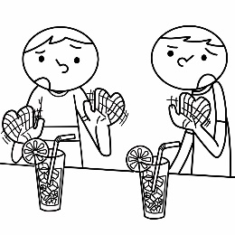 (B)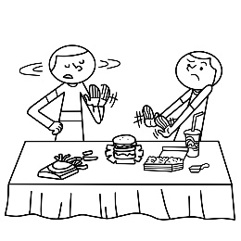 (C)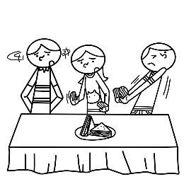
- (A) (B)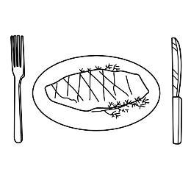 (C)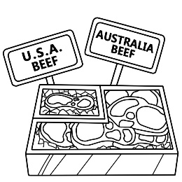
- (A)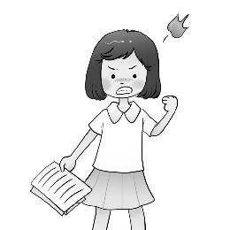 (B)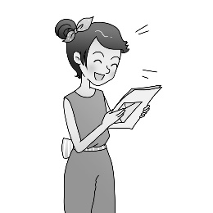 (C)
- (A)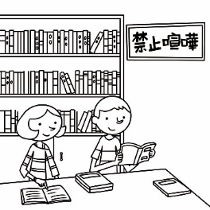 (B)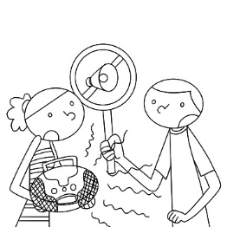 (C)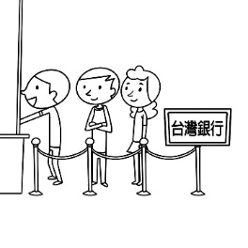
- (A)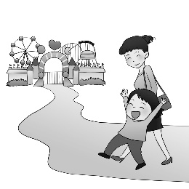 (B)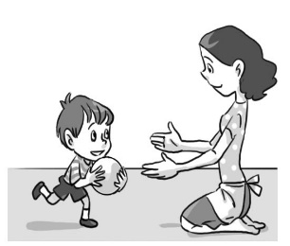 (C)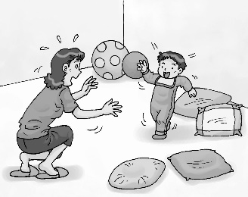
二、基本問答：每題均有三個選項，請依據所聽到的內容，選出一個最適合的回應10%

- (A) Let’s pack the boxes quickly, guys.
(B) We should collect as many boxes as possible.
(C) I can’t move the boxes because they are too heavy.
- (A) It looks like a fish.
(B) It smells so fresh.
(C) It stands for a good business.
- (A) He is not able to walk fast.
(B) He was lying on the ground.
(C) He tripped and hurt his left foot.
- (A) The steak.
(B) Anything else?
(C) You should dig in soon.

- (A) Really? I didn’t notice it.
(B) No, she became a reporter a year ago.
(C) Yes, it’s nice to do business with her.

三、言談理解：每題均有三個選項，請依據所聽到的對話與問題，選出一個最適當的答案10%
11. (A) They left trash by the wall.
(B) They drew pictures on the wall.
(C) They kept breaking the sign on the wall.
12. (A) He can cook anything in the kitchen.
(B) The restaurant has the best food for him.
(C) Mrs. Lin pays him a lot.
13. (A) Cleaning the ground.
(B) Climbing stairs on the hill.
(C) Collecting leaves in nature.
14. (A) Go out to buy some bread.
(B) Go inside his room.
(C) Dig in his dinner.
15. (A) The woman likes funny movies better.
(B) The story got worse at the end of the movie.
(C) The man laughed a lot when he watched the movie.

四、綜合測驗30%

16. Linda looks ＿＿＿ in dress than in pants.
(A) pretty (B) prettily (C) prettier (D) the prettiest
17. Andy ＿＿＿ wrote a letter to his uncle.
(A) carefulˉ (B) carefullyˉ (C) more carefulˉ (D) most carefully
18. I like my new school. Everyone is so nice and to me.
(A) fresh (B) friendly (C) light (D) medium
19. A: What’s wrong with your voice? It a duck. B: I got a bad cold.
(A) listens (B) sounds (C) listens to (D) sounds like
20. Dickson took care of his grandpa when they stayed together.
(A) well (B) great (C) bad (D) late
21. Wow! All the food delicious in the night market.
(A) looks (B) looks at (C) looks like (D) looks for
22. Stella plays the piano as as her sister.
(A) beautiful (B) beautifully (C) more beautiful (D) much beautifully
23. More and more children stay online for long hours. Parents should take the problem than they did before.
(A) serious (B) more serious (C) more seriously (D) the most seriously
24.It’s raining outside. It will colder and colder during the night.
(A) feel (B) become (C) smell (D) taste
25. Stop laughing at Bill just because he talks than most people.
(A) slowly (B) more slowly (C) the most slowly (D) the slowest
26. A: How do you like my new bike? B: I don’t like its color. It an old one.
(A) looks (B) looked (C) looks like (D) is looking
27. John was very sad because everyone in his class was ＿＿＿ to Helen’s party except him.
(A) invited (B)dug in (C) signed (D) noticed
28. does the snake meat taste ?
(A) What’s ; like (B)What ; X (C) How ; X (D) What ; get
29. After having five year’s training, Nana has ＿＿＿ a famous singer. Now, everyone is talking about her.
(A) liked (B) been like (C) got (D) become
30. Teenagers and their parents seldom ＿＿＿ with each other on almost everything because they look at things from different
angles. (A) agree (B) sell (C) grow (D) waste

五、克漏字填充10%
A.
Tina is from the USA. She wanted to try a lot of Taiwanese food, so her friends took her to a night market. When they got there, Tina 31 a strange smell. That was from the stinky tofu. Surprisingly, she didn’t let the smell stop her from taking a(n)
32 . She even fell in love with it. She also 33 milkfish soup, Chinese hamburgers, Taiwanese fried chicken, and many other things. 34 , she loves the fruit in Taiwan because the fruit here is sweet and not expensive. The watermelon is her favorite. “It tastes as 35 as it looks,” she said. She will miss the food and fruit in Taiwan after she goes back to the USA.
Taiwanese 臺灣的 stinky tofu 臭豆腐 surprisingly 出人意料地 milkfish 虱目魚
31. (A) saw (B) felt (C) heard (D) noticed
32. (A) bite (B) eye (C) matter (D) sign
33. (A) drank (B) smelt (C) tasted (D) sounded
34. (A) Sadly (B) Besides (C) However (D) For example
35. (A) good (B) dark (C) bright (D) terrible
B.
Rita: Did you hear someone sing 36 last night?
Jacky: Yes, it was my brother, Mike. He is going to perform in a music show tomorrow, so he has to practice hard to make it 37 .
Rita: I didn’t sleep 38 last night. I could even hear his voice in my dreams.
Jacky: Sorry for that. He sings 39 . I can’t stand his voice, either.
Rita: I don’t want to hear him sing again.
Jacky: Tell me about it.
Rita: Why didn’t you teach him to sing? You’re good at singing.
Jacky: I tried, but I failed. He sang too 40 . I couldn’t even follow him.
perform 表演 fail 失敗
36. (A) loudest (B) loudly (C) louder (D) the loudest
37. (A) perfect (B) most perfect (C) more perfectly (D) perfectly
38. (A) good (B) bad (C) well (D) badly
39. (A) bad (B) good (C) well (D) badly
40. (A) quiet (B) fast (C) simple (D) beautiful

六、閱讀測驗10%

A.
Polar bears are the biggest bears in the world. They live in the Arctic(北極地區) and spend most of their time on floating ice. They feed mainly on seals from ice floating on the sea. Also, they have to eat a lot of food in order to stay fat and warm.
However, our Earth is becoming warmer because of global warming. As a result, the floating ice is melting under their feet now. As the sea ice disappears, polar bears have to swim further from the land to the floating ice. Many polar bears died because of drowning and starving. There are only 20,000 to 25,000 polar bears left in the world now.
Polar bears are endangered animals. If we don’t take action now, there will be no polar bears in 80 years.

floating 漂浮的 seal海豹 global warming全球暖化 melt融化 disappear消失
further更遠地 die死亡 drown溺死 starve餓死 endangered瀕臨絕種的
- Which is true?
- Polar bears are the smallest bears in the world.
- The sea ice is melting because of global warming.
- Many polar bears died because of eating too much.
- There are more than 25,000 polar bears in the world now.
- Why are polar bears endangered now?
- Because the Arctic is too cold for them.
- Because they don’t know how to catch seals.
- Because they spend too much time on the sea.
- Because the weather is getting warmer and warmer.

B.
The earth is getting warmer with more and more greenhouse gases in the atmosphere. To better understand how greenhouse gases heat up our earth, we should first know 43. . A greenhouse is a special house made of glass for plants. It holds the heat of the sun so that the plants inside can grow better. Some gases in the atmosphere work like a greenhouse and can keep the heat of the sun, so we call them greenhouse gases. Greenhouse gases help our earth stay warm enough for animals and plants. In fact,
44 .
There is, however, a big problem. More greenhouse gases than our earth needs are entering the atmosphere because of the way we live. 45 , with a great number of cars, there is too much CO2, a common greenhouse gas, and farm animals give off a lot of CH4, another greenhouse gas. If we want to “cool down” our earth, a good start is to change our way of life, like driving less and eating less meat. gas 氣體 atmosphere 大氣層
43. (A) how many greenhouse gases there are
(B) how long greenhouses have been used
(C) what a greenhouse is and how it works
(D) what greenhouse gases are and where they come from
44. (A) there are many kinds of greenhouse gases
(B) greenhouse gases are dangerous for our earth
(C) the atmosphere around our earth is getting thinner
(D) our earth would be too cold for life without greenhouse gases
45. (A) At last (B) Even so (C) What’s better (D) For example

七、單字與翻譯20% (46-49-1%)
46.快速地(q) 47.形狀 48.三明治 49.生意
50.對多數人來說，這顏色代表大自然，那讓他們在用餐時感到更舒適。4%
51.此外，當人們看到這兩種顏色時，他們會變得飢餓而也許會入內用餐。4%
52.為了贏得比賽，我們盡可能地努力嘗試拼出許多英文字。4%
53.派對後，我們在星光閃耀的天空下分享了我們對未來的夢想。4%

新北市立溪崑國民中學110學年度第二學期第二次定期評量 英語科 答案卷
八年級 班 座號 姓名
七、單字與翻譯:20%(46-49單字，50-53翻譯)
46. | 47. | 48. | 49.

50.

51.

52.

53.

110-2-2 八年級 英語科－解答
1-15 CABAC BACAB BABAC
16-30 CBBDA ABCBB CACDA
31-45 DACBA BACDB BDCDD
46. quickly 47. shape 48. sandwich(es) 49. business
50. For most people, the color stands for nature, and that makes them feel more comfortable
when they have their meals.
51. Besides, when people see these two colors, they will become hungry
and probably go in for a bite.
52. To win the game, we tried hard to spell as many English words as possible.
53. After the party, we shared our dreams for the future under the starry sky.

新北市立溪崑國民中學110學年度第二學期第二次定期評量
八年級 英語科 聽力測驗稿
本測驗分三部分，每題會念兩次，請仔細聽完句子或對話，選出最佳答案，聽力測驗開始:
一、辨識句意：每題均有三張圖片，請依據所聽到的句子，選出符合描述的圖片
- The sandwiches don’t look delicious to those people.
- My mother asked me to buy some pork at the market.
- Reading the letter makes Sarah laugh.
- The sign on the wall tells people to be quiet.
- The little boy walks slowly to his mother.
二、基本問答：每題均有三個選項，請依據所聽到的內容，選出一個最適合的回應
- How many boxes should we collect for the game tomorrow?
- What does the bread look like to you?
- What’s wrong with Kevin? Why is he walking like that?
- What’s your favorite dish in the store?
- Is Lucy still your secretary?

三、言談理解：每題均有三個選項，請依據所聽到的對話與問題，選出一個最適當的答案
11.W: I can’t believe it. Those kids drew on the wall again.
M: They call it art.
W: It’s not art to me. It only makes the wall look dirty. Some people even leave trash by the
wall because of those pictures.
M: Maybe you should put a sign on it.
W: I did, but they just keep drawing.
Q: What did the kids do?

12. W: This kitchen is hot, wet, and small. How can you cook here?
M: It doesn’t matter. I enjoy being a cook here. People love my food, and Mrs. Lin let me run
the whole kitchen.
W: How much does she pay you?
M: A room to sleep and rest, and a lot of food to eat and cook.
Q: Why does the man like to work for Mrs. Lin?
13. W: Greg, don’t sit on the ground. It’s wet.
M: I need a rest.
W: Come on. Don’t you want to lose weight?
M: I do, but, seriously, do we really have to finish the stairs?
W: Of course. At the top of the hill, there’s a beautiful view of the city. Besides, it’s good to be
out in nature.
Q: What are they doing?
14. B: Mom, I’m home. When will dinner be ready?
W: Soon.
B: OK. I’ll be in my room. Call me when it’s ready.
W: Wait. I need you to buy some bread for breakfast tomorrow.
B: Right now?
W: Yes. Dinner will be ready when you come back from shopping.
Q: What will the boy do next?

15. W: How was the movie?
M: It was great. You should find some time to watch it.
W: Is it a funny movie or a sad movie?
M: It’s hard to say. The story made me laugh a lot, but I also cried in the end.
Q: Which is true?
聽力測驗結束!

