新北市立溪崑國民中學110學年度第二學期第一次定期評量 英語科 試題卷
七年級 班 座號 姓名
一、辨識句意：依據聽到的句子，選出符合描述的圖片。(每題2分；共10分)
1. | (A) | 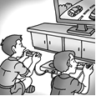 | (B) | 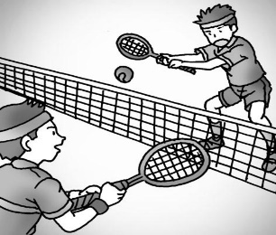 | (C) | 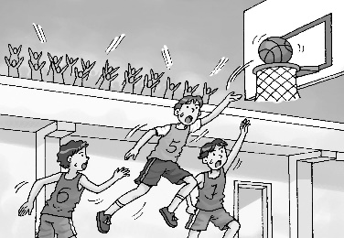
2. | (A) | 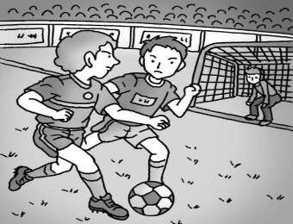 | (B) | 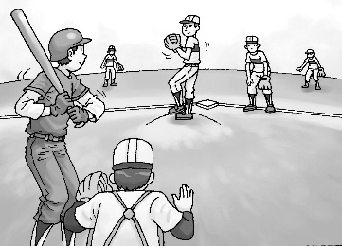 | (C) | 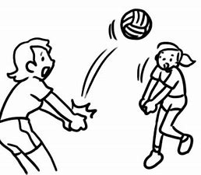
3. | (A) |  | (B) |  | (C) | 
4. | (A) | 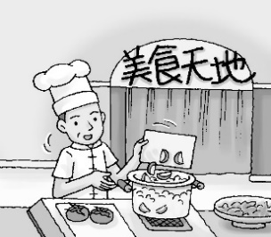 | (B) | 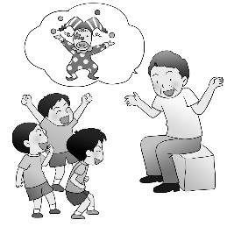 | (C) | 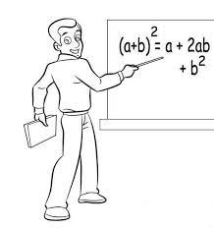
5. | (A) | 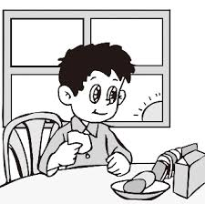 | (B) | 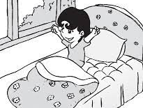 | (C) | 

二、基本問答：依據聽到的內容，選出一個最適合的回應。(每題2分；共10分)
6. | (A) They are nine hundred dollars. | (B) There are two shoes. | (C) The shoes are for my son.
7. | (A) The picture is beautiful. | (B) OK. I won’t touch it. | (C) Don’t worry. Everything is great here.
8. | (A) Let’s choose table tennis club. | (B) Badminton club. My good friend is  in the club, too. | (C) It’s my favorite film.
9. | (A) Yes, your phone is here. | (B) Yes, you can share it with me. | (C) Sure, here you go.
10. | (A) Sure. When do you have time? | (B) No problem. I have too much  homework to do every day. | (C) Give me a break. I do a lot of  exercise every week.
三、言談理解：依據聽到的對話及問題，選出一個最適當的答案。(每題1分；共5分)
11. (A) They practice every day. (B) They practice from Monday to Friday. (C) They practice on weekends.
12. (A) Breakfast. (B) Lunch. (C) Dinner.
13. (A) Her cousins. (B) Her brother and sister. (C) Her parents.
14. (A) They are classmates. (B) They are sharing a book. (C) They don’t like the class.
15. (A) She can use the boy’s computer. (B) She doesn’t have any homework today. (C) She doesn’t want to use her
father’s computer.
----------------------------------------- 聽力測驗結束 ---------------------------------------------
四、綜合選擇：(每題2分；共30分)
16. Mom: Get up, Billy.
Billy: Mom,
Mom: No. Go clean yourself up and get dressed now, or you’ll have to walk to school.
(A) can I walk to school now?
(B) what do you mean?
(C) what can I do now?
(D) can I sleep for one more hour?
17. Bill: I’m hungry now.
Ann:
Bill: Let’s have snacks and drinks together.
(A) Me either. (B) Me too. (C) Wait a minute. (D) It’s on me.
18. A: Does your brother help you with your math?
B: He is good at it.
(A) Yes, he can. (B) No, he can’t. (C) Yes, he does. (D) No, he doesn’t.
19. Mia: Can you say that again? John: OK. Let me give you an example.
(A) What do you mean?
(B) Do you exercise?
(C) Don’t worry about me.
(D) How much is the ticket?
20. I’m too tired. I can’t work all afternoon. Please give me a .
(A) sport (B) start (C) help (D) break
21. Jane is thin and healthy. She ＿＿＿ and eats a lot of fresh fruit and vegetables every day.
(A) exercises (B) practices (C) worries (D) steals
22. A: How can I share photos from my cellphone?
B: You can use this app to and share your photos with your family and friends.
(A) teach (B) last (C) upload (D) develop
23. A: Where are our seats?
B: Let me check the . We’re at D-15 and D-16.
(A) clubs (B) tickets (C) teams (D) guitars
24. A: Who is that basketball player? He plays well.
B: Don’t you him? Come on! He’s Stephen Curry.
(A) join (B) know (C) choose (D) help
25. students can get good grades on the math test. Only one of them can get a score of 60. It’s too hard for them.
(A) Little (B) A little (C) A few (D) Few
26. A: you want some papaya milk?
B: No, thanks. I milk.
(A) Are; am like (B) Are; am not like (C) Do; do like (D) Do; don’t like
27. A: ＿＿＿ Tai Tzu Ying play badminton well?
B: Sure. She ＿＿＿ a good badminton player. Take a look at the newspaper. Her photo is in it.
(A) Is; plays (B) Does; is (C) Does; plays (D) Is; is
28. Sara: ＿＿＿ is your new pen?
Belle: It’s 15 NT dollars.
(A) What sport (B) How many (C) How old (D) How much
29. Practice hard, and you can a great guitar player.
(A) are (B) do (C) be (D) being
30. Listen! David the song again. He really likes it.
(A) is singing (B) sings (C) does sing (D) sing

五、克漏字選擇：(每題2分；共10分)
I have a very happy family but we (31) live in a big house. There are six people in my family. My father is a cook at a famous restaurant. But he (32) cook for us because he is too busy. My mom is an English teacher. She (33) good English. My brother and I go to the same school. We have a cute puppy. It (34) short legs and big ears. It can catch a ball. My grandparents (35) it very much.
31. (A) aren’t (B) don’t (C) doesn’t (D) isn’t
32. (A) don’t (B) doesn’t (C) can (D) must
33. (A) says (B) tells (C) speaks (D) speak
34. (A) have (B) has (C) is (D) having
35. (A) loving (B) does love (C) love (D) loves

六、閱讀：(每題1分；共10分)
(36-38題)
The Pomodoro Technique
Do you ever have problems getting all your work done? If you do, you should try the Pomodoro Technique.
“Pomodoro” means tomato in Italian. The Pomodoro Technique was created by an Italian, Francisco Cirillo, who used a tomato clock to count time when he was studying. Here is how the technique works:
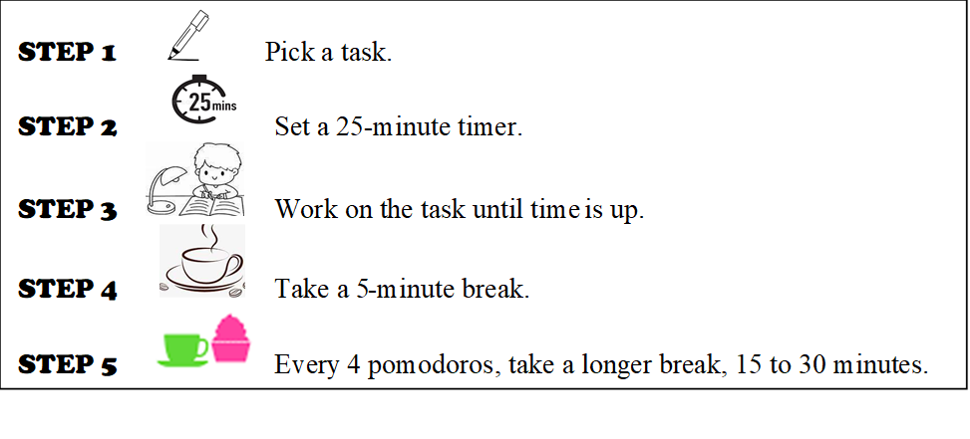
So, next time you are learning for a test or doing homework, give the Pomodoro Technique a try. It may be the answer you need for studying smarter!
 Pomodoro Technique 番茄鐘工作法 timer 計時器 focus 專注 tired 疲倦的
36. What is the main idea of the reading?
- To share a story about an Italian. (B) To show the best time to take a break.
(C) To share the history of the Pomodoro Technique. (D) To show a smart way of studying or working.
37. Which is true about the Pomodoro Technique?
(A) It’s the best way to count time. (B) You need to set a timer for the breaks.
(C) You must get a special timer for this technique. (D) It’s easy to get tired because the breaks are too short.
38. According to the study plans below, who uses the Pomodoro Technique?
(A) Jack. (B) Peter. (C) Mary. (D) Cathy.
(39-41題)
Brinicle—Finger of Death
Brinicle is known by the name ‘finger of death’. It forms in the cold polar ocean.
When seawater freezes into sea ice, it gets out of its salt and forms super salty seawater. The super salty water sinks because it’s much denser and much colder than the surrounding water. As it goes down, the surrounding water freezes upon contact, forming a ‘brinicle’, a frozen cover of ice that grows downward to the sea floor. When it touches the sea floor, it 'catches' bottom-dwelling animals like starfish, encasing them in ice. Those sea animals move too slowly to run away from the finger of death.
form 形成 salty 鹹的 sink下沉 denser 密度較大的 surrounding 周圍的 contact 接觸面 encase 包住
39. What does “freeze’ mean?
(A)  (B)  (C)  (D) 
40. Why does the brinicle sink?
(A) It’s denser than the surrounding water. (B) It forms a lot of sea ice.
(C) It gets out of its salt. (D) It’s not colder than the seawater.
41. How do the animals die?
(A) They are frozen to death. (B) They don’t know how to run away.
(C) The seawater is too salty. (D) They move too slowly to get food.
(42-45題)
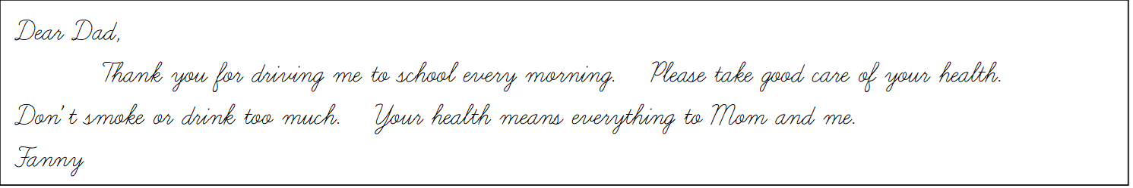
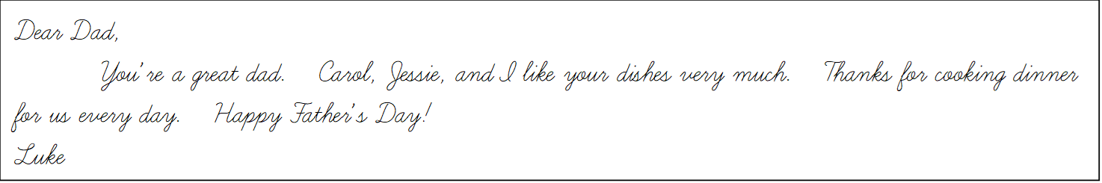
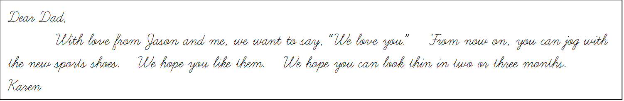
42. What does Luke’s dad do for his children every day?
(A) He makes dinner. (B) He prepares breakfast. (C) He jogs with them. (D) He helps them with their homework.
43. What’s Karen and Jason’s gift for their dad?
(A) Running shoes. (B) A sports watch. (C) Baseball tickets. (D) A big dinner.
44. How might Karen’s father look now?
(A) He’s fat. (B) He’s tall and thin. (C) He’s short and thin. (D) He’s young and short.
45. Which is NOT true about Fanny?
(A) She doesn’t want her dad to drink too much. (B) Her father’s health means a lot to her.
(C) She goes to school by car. (D) Her father doesn’t smoke.

新北市立溪崑國民中學110學年度第二學期第一次定期評量 英語科 答案卷
七年級 班 座號 姓名
七、將下列書寫體單字改寫成印刷體(3%，一字1分)
1. | 2. | 3.
八、翻譯(22%，一句5分，一格1分)
1. 在籃球賽中，一切都有可能發生。
in a basketball game.
2. 成為電影業冉冉升起的明星吧!
Be a star in the film .
3. Nick 在Collins老師的幫助下，將他的想法發展成故事。
Nick his ideas into stories Mr. Collins’ help.
4. 我們甚至會在最後幾秒贏得或輸掉比賽。
5. 我哥哥每天早上刷牙、洗臉、還有淋浴。
6.在一場排球賽中，球員必須在擊球三次前把球回過網。
110-2-1 七年級 英語科－解答
一〜五、每題2分
1-5 BCCAC 6-10 ABBCA 11-15 BABAC
16-30 DBCAD ACBBD DBDCA
31-35 BBCBC
六、閱讀：(每題1分；共10分)
36-38 DBD 39-41 BAA 42-45 AAAD
七、改寫成印刷體(3%，一字1分)
1. favorite 2. kangaroo 3. watermelon
八、翻譯(22%，一句5分，一格1分)
1. Everything is possible
2. rising business
3. develops with
4. We can even win or lose (the game) in the last few seconds.
5. My brother brushes his teeth, washes his face, and takes a shower every morning.
6. In a volleyball game, players must get the ball over the net in three touches.

新北市立溪崑國民中學110學年度第二學期第一次段考 七年級英語科 聽力測驗
本測驗共分成三部分，每題重複念兩遍，聽力測驗開始。
一、辨識句意：依據聽到的句子，選出符合描述的圖片。(每題2分；共10分)
1. My classmate and I practice tennis after school. (A02L1170)
2. Let’s join them and play volleyball together.
3. Sandy is taking a shower in the bathroom.
4. My father teaches people to cook. (A02L2177)
5. Peter brushes his teeth at 6:30 every morning.
二、基本問答：依據聽到的內容，選出一個最適合的回應。(每題2分；共10分)
6. Excuse me, how much are these shoes? (A02L1062)
7. Hey, don’t put your hands on the picture. (A02L1070)
8. What club are you in this year? (A02L2067)
9. Can I use your phone? (A02L2069)
10. Can you teach me to play the guitar? (A02L2073)
三、言談理解：依據聽到的對話及問題，選出一個最適當的答案。(每題1分；共5分)
11. (A02L1092)
M: You’re so tall. Are you basketball players?
W: No, but we’re baseball players.
M: That’s cool. Do you practice baseball every day?
W: No, we don’t practice on weekends.
Q: What day do the players practice?
12. (A02L2105)
W: Wake up, Tim. Come and eat at the dining table.
B: OK, Mom. Let me brush my teeth first.
W: OK. I’m preparing your favorite milk tea, too.
B: Thanks.
Q: What is the boy’s mom preparing?
13. (A02L2094)
W: Welcome to my house.
M: Wow, your bedroom is so big.
W: Yes, but this isn’t my own bedroom. My brother and sister use this bedroom, too.
Q: Who does the woman share the bedroom with?
14. (A02L2099)
G: The teacher is coming. Sit down.
B: All right. Oh, no. Where is my book?
G: You don’t have your book?
B: No, can I share a book with you?
G: I don’t have my book, either.
Q: What do we know about the boy and the girl?
15. (A02L2103)
G: Can I use your computer to do my homework?
B: But I’m using it right now. You can use Dad’s computer.
G: Well…his screen is small.
Q: What does the girl mean?

