新北市立溪崑國民中學110學年度第二學期第一次定期評量 英語科 試題卷
九年級 班 座號 姓名
一 聽力測驗 (30%)
A辨識句意 : 根據聽到的句子，選出符合描述的圖片(8%)

(Ａ) 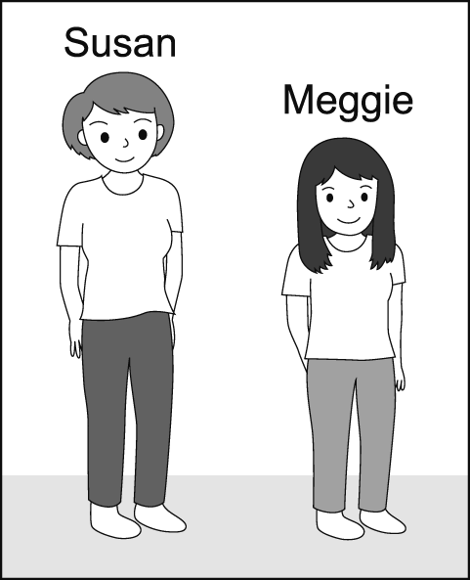 (Ｂ) 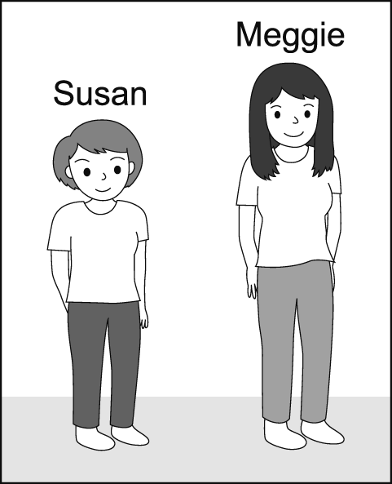 (Ｃ) 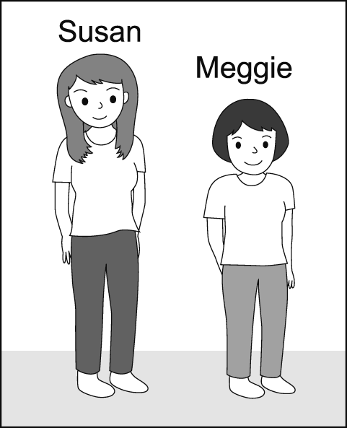

- (Ａ) 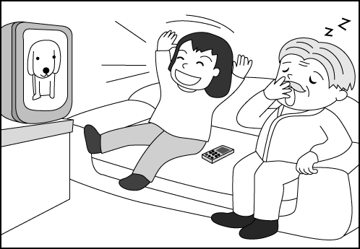 (Ｂ) 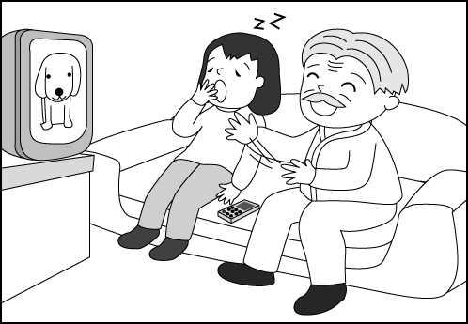 (Ｃ) 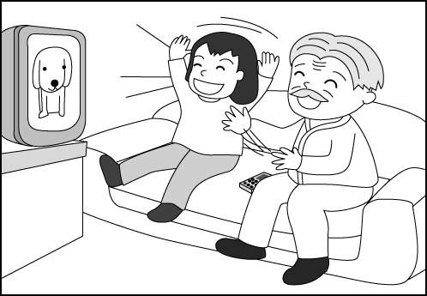

- (Ａ) 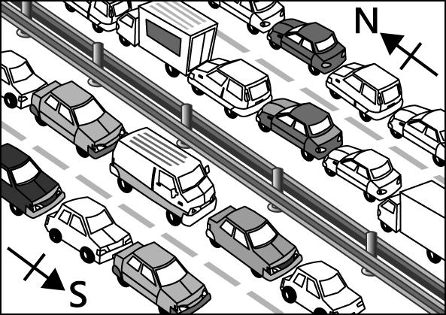 (Ｂ) 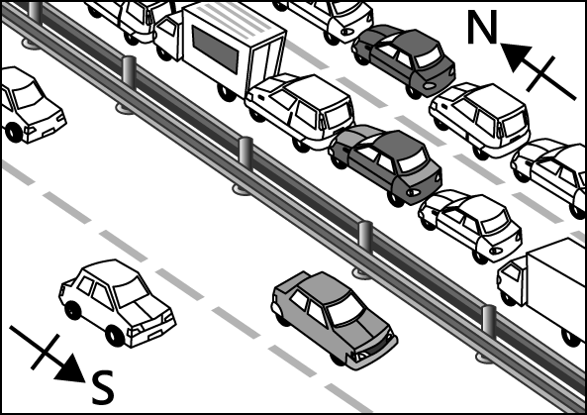 (Ｃ) 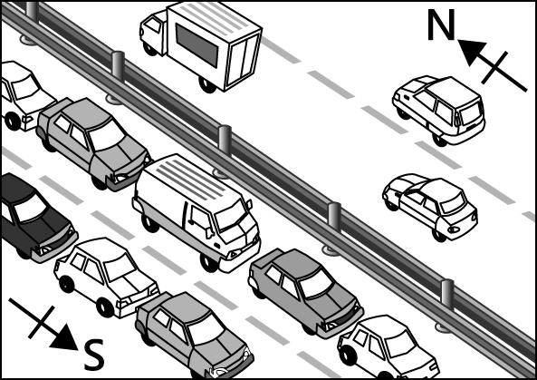

- (Ａ) 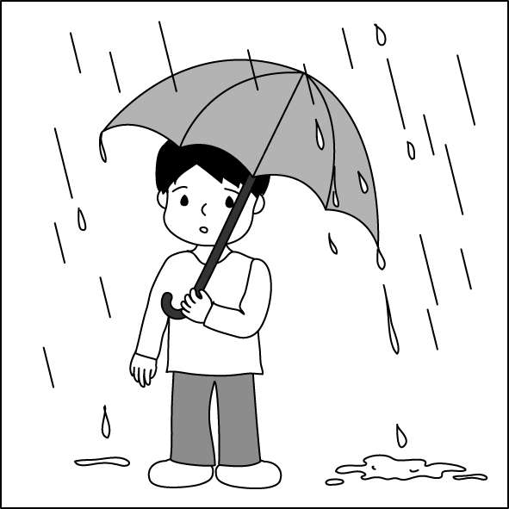 (Ｂ) 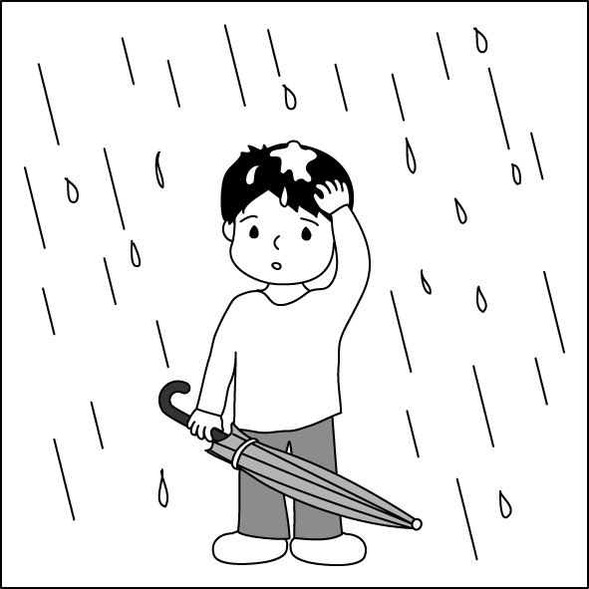 (Ｃ) 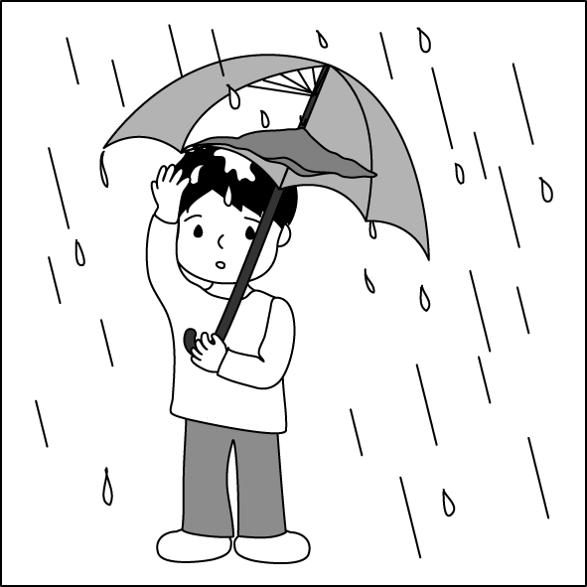

B基本問答：根據聽到的內容，選出合適的回應。(12%)
- (A) What's up? (B) Okay. Let's have hamburgers. (C) Yes, it's up to my house.
- (A) Did it make you sick? Have you seen a doctor? I'm so sorry! (B) Why? It didn't turn up today. (C) Sorry, I'll keep it down.
- (A) Let me explain it to you. (B) I can't see my point either. Let me look for it. (C) Why are you so scared?
- (A) Yeah, I can see you are keeping up with me hard. (B) Yeah, I can see you are having a hard time staying awake. (C) Okay, I'll slow down so you can catch up.
- (A) Me too. I used to have coffee in the mornings, but not anymore. (B) Me too. Coffee is what I used to have in the mornings. (C) Me too. What's better than a good cup of coffee in the morning?
- (A) I’m so glad to hear that. I’ll save three seats for you. (B) Too bad. I haven’t seen her for a long time. (C) Really? I can’t wait to see both of you.
C. 言談理解：根據聽到的內容，選出最適合的答案。(10%)
- (A) Choose a different shirt. (B) Ask for her money back. (C) Wait for the new order.
- (A) Not only the man but also the woman likes the paintings. (B) She agrees with the man about the paintings. (C) She does not have a chance to talk to the painters.
- (A) 11:00. (B) 10:00. (C) 9:00.
- (A) She feels lonely at school. (B) She’s interested in drawing pictures. (C) She has less homework .
- (A) It will rain next Friday. (B) The rain will stop this morning. (C) There will be rain for about five days.
二 綜合測驗 (34%)
- Look at the picture. The girl is _______ the clothes.
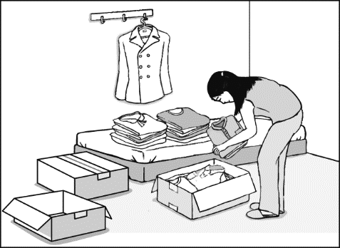
(A) packing (B) carrying (C) showing (D) making
- The police _______ lots of time finding out who entered Lisa’s house and killed her one year ago.
(A) took (B) spent (C) cost (D) made
- I’m not sure when Kevin tomorrow, but when he , I’ll call you. (A) will come in; will come in (B) comes in; does (Ｃ) will come in; does (Ｄ) comes in; is
- I think the road ends here ; it won’t go any . Shouldn’t we turn back?
(A) closer (B) farther (Ｃ) faster (Ｄ) longer
- The more the information is repeated or used, . (A) the less you’ll remember (B) the more you’ll forget (Ｃ) the longer you’ll remember it (Ｄ) the best you’ll remember it
- The excuse Nick made _______ a lot about how much he hates doing the job.
(A) to say (B) saying (C) which says (D) says
- _______ me a call and you’ll get the answer you want. (A) Giving (Ｂ) Give (Ｃ) Gave (Ｄ) Have given
- English is the only subject I like. I find ＿＿＿ other subjects boring. (A) all (B) few (C) many (D) some
- It is _______ of me to believe what Alice says. She lies to me all the time. (A) kind (Ｂ) tidy (Ｃ) nice (Ｄ) stupid
- My mom told my brothers to take care of in England. She worried that they couldn’t eat or sleep well there. (A) himself (B) him (C) her (D) themselves
- _____ that last piece of pie? If not, can I have ? I didn’t eat much this morning. (A) Are you going to eat ; it (B) Will you eat; one (C) Are you going to eat; one (D) Do you eat; one
- My little sister loves by my mother. Every time my mother gives her a hug, she will be so happy. (A) to hug (B) hug (Ｃ) being hugged (Ｄ) to be hug
- Sara seldom put a lot of money at home, ? (A) didn’t she (Ｂ) does she (Ｃ) did she (Ｄ) does Sara
- _____ of my brothers are taller than I. I’m the shortest of the three children in my family. (A) Two (B) Either (C) Neither (D) Both
- “She doesn’t look tall, and she doesn’t look heavy, either.” means . (A) She doesn’t look tall but heavy (B) She looks not only tall but also heavy (C) She looks neither tall nor heavy (D) She looks either slim or heavy
- I’ll forgive Alex as soon as he me the truth. (A) will tell (B) told (C) have told (D) tells
- Tim has to study hard and . (A) so has Betty (B) so does Betty (C) neither has Betty (D) Betty doesn’t, either
三 題組 (36%)
Jerry's friend needed to leave town for several weeks, so he asked Jerry to take care of his pet parrot. As all birds like freedom, being kept in a house made the parrot angry all the time. The smart parrot soon developed the habit of using rude words to express its anger. Jerry was the only person the parrot could meet, and it insulted him and called him names. Jerry tried to put up with all this. But on a Saturday morning, the parrot started scolding Jerry for no reason. Jerry was angry, threw the parrot into the freezer, and closed the door. "At least it wouldn't sound so loud through the door," he thought.
30 seconds later, the parrot stopped screaming, and Jerry opened the door. He thought the parrot would start yelling again. To his surprise, the parrot became gentle and polite. It said, “I’m sorry, sir. I’ll never say anything to upset you. Please forgive me!"
Jerry was surprised and happy. "Did the low temperature change the parrot's attitude?" he thought.
They got along quite well for the rest of the day. But the parrot made a decision not to be anywhere near the freezer. Several times it seemed to want to ask Jerry about something and then decide against it. Finally, Jerry said, "If you have questions, just ask!"
The parrot looked scared, pointed to the freezer with a wing, and asked, "So...what did the chicken do?"
insult 侮辱 scolding 罵 offend冒犯 scream尖叫 temperature溫度

- Why was the parrot always in a bad mood before it came out from the freezer?
- It didn't like to be kept in a house. (B) It missed its real owner very much. (C) It didn’t like Jerry (D) It wanted to show off its special talent.

- Jerry threw the parrot into the freezer to .
- kill it (B) force it to see something scary (C) reduce the noise (D) give it a cold and make it sick

- The parrot thought the chicken in the freezer must have .
- got offended by Jerry's manners (B) offended Jerry for some reason (C) lived in the freezer for a long time (D) felt happy for the loss of freedom

It could happen to you, on any given day.
It could happen to you, in any number of ways.
Because we all think we're good, and will stand up and fight.
We all think that what's wrong will lose to what's right.
But we can't know for sure until put to the test.
And our final scores can be hard to digest.
Courage, a spirit that moves history with its force.
Courage, a spirit of which I can find no source.
My own test happened in the school yard last week.
Before which I would never have called myself meek.
But when I saw four guys bullying that kid.
There was no rescue from me; I turned tail and hid.
Now he has stopped coming to school.
His only crime was not being "cool."
Courage, how is it that you choose
Those who rise up, and those who refuse?
Days went by and the kid still didn't show.
I decided to ask around, see what people know.
The kid was a loner, almost like he had no friends.
No games or jokes; for himself he did fend.
Now he's gone and I fear never coming back.
If only I had done something, and got him on the right track.
Courage, you left me at such great cost.
Courage, you left me and now I am lost.
digest 理解 force力 bully霸凌 crime罪 fend 保護

- What is this poem trying to say?
(A) It's not always easy to do what's right. (B) We all need to take tests at school. (C) Bullying is becoming a big problem.
(D) Courage is a force that moves history.

- Why is the writer worried?
  - He is being bullied at school. (B) A bullied kid stopped coming to school. (C) He is turning into a bully. (D) He is good friends with a bully.

- What does it mean that the writer "turned tail"?
  - He stood up and fought the bullies. (B) He ran away. (C) He tried talking to the bullies. (D) He didn't know what to do.

Viruses, worms, Trojan horses-all of these are programs that can do serious damage to your computer. Trojan horses are quite difficult to avoid, as they seem perfectly harmless at first. A Trojan horse might disguise itself as an email attachment or a fun-looking download. Then, when it's inside your computer, it steals all your personal data or deletes all your files.
But where does the term Trojan horse come from? A long time ago, a war is said to have been fought between Greece and the city of Troy. The wall around the city was so high and strong that the Greeks just couldn't get inside. After 10 years of war, the Greeks finally came up with a plan. They built a huge wooden horse and hid soldiers inside it. Then they pretended to sail home. The Trojans, thinking they had won the war, took the horse inside their city walls and celebrated. That night, the soldiers inside the horse jumped out and opened the city gates. The rest of the Greek army, which had sailed back to Troy secretly in the night, entered the city and destroyed it.
viruses病毒 attachment附件
- What is the reading about?
- Ancient Greek culture. (B) The dangers of the Internet. (C) The source of a phrase. (D) The history of cheating.
- How did the wooden horse help the Greeks win the war against Troy?
(A) It scared the Trojans away. (B) It brought them good luck. (C) It inspired them to fight harder. (D) It got them inside Troy's city walls.
- What does "disguise" most likely mean?
- Kill. (B) Lose. (C) Hide. (D) Win.

African elephants can sleep either lying down or standing up. Lately, scientists (42) that these elephants only get about two hours of sleep every day. (43) , sometimes they even stay awake for days in a row to travel long distances or to get away from predators such as lions. What's (44) is that they don't need to "catch up" on sleep after these long journeys; they do things the same as they always do without feeling tired.
One reason that African elephants can stay awake so long (45) be their large size. They are huge and eat a lot. They spend up to sixteen hours a day looking for food and can eat up around three hundred pounds of food during that time! Although scientists have thought of many other possible explanations, they aren't certain which is the right one. The (46) habits of African elephants are still one of nature's biggest mysteries.
predators 捕食者 journey 旅程
- (A) will be reporting (B) reporting (C) have reported (D) will report
- (A) In the end (B) However (C) After all (D) In fact
- (A) amazing (B) amazed (C) amazingly (D) amazement
- (A) need to (B) might (C) will (D) must not
- (A) sleep (B) eating (C) sleeping (D) slept

The earth is getting warmer with more and more greenhouse gases in the atmosphere. To better understand (47) , we should first know what greenhouse gases are and where they come from. A greenhouse is a special house made of glass for plants. It holds the heat of the sun so that the plants inside can grow better. Some gases in the atmosphere work like a greenhouse and can keep the heat of the sun, so we call them greenhouse gases. Greenhouse gases help our earth stay warm enough for animals and plants. In fact, (48) .
There is, however, a big problem. More greenhouse gases than our earth needs are entering the atmosphere because of the way we live. (49) , with a great number of cars, there is too much CO2, a common greenhouse gas, and farm animals give off a lot of CH4, another greenhouse gas. If we want to “cool down” our earth, a good start is to change our way of life, like (50) .
atmosphere 大氣層

- (A) how greenhouse gases heat up our earth (B) what the green house is (C) how to build a greenhouse (D) who creates greenhouse gases
- (A) our earth would be too cold for life without greenhouse gases (B) greenhouse gases are dangerous for our earth (C) the atmosphere around our earth is getting thinner (D) there are many kinds of greenhouse gases
- (A) At last (B) What’s worse (C) Best of all (D) Even though
- (A) driving less and eating less vegetables (B) driving more often and eating less meat (C) driving less and eating more meat (D) driving less often and eating less meat
110-2-1 九年級 英語科－解答
1-10 ABCAB CACCA
11-20 ABABC ABCBC
21-30 DBADD ACCDC
31-40 DBACB ABBCD
41-50 CCDAB CAABD

新北市立溪崑國民中學110學年度第二學期第一次定期評量
九年級 英語科 聽力測驗稿
一 聽力測驗(30%)
A辨識句意 : 根據聽到的句子，選出符合描述的圖片(8%)
- The taller one with short hair is Susan. And the other one is Meggie.
- The old man finds the TV program interesting, but the little girl doesn’t look like she does.
- There are a lot of cars going down South, but there are few cars going up North.
- The boy’s holding an umbrella to keep himself from getting wet.
B基本問答：根據聽到的內容，選出合適的回應。(12%)
- I can’t decide what to get for lunch, so it’s up to you.
(A) What's up? (B) Okay. Let's have hamburgers. (C) Yes, it's up to my house.

- I’m so sick and tired of your loud music. Turn it down.
(A) Did it make you sick? Have you seen a doctor? I'm so sorry! (B) Why? It didn't turn up today. (C) Sorry, I'll keep it down.

- I am afraid I don’t see your point.
(A) Let me explain it to you. (B) I can't see my point either. Let me look for it.
(C) Why are you so scared?

- You are walking too fast. I can hardly keep up with you.
(A) Yeah, I can see you are keeping up with me hard. (B) Yeah, I can see you are having a hard time staying awake. (C) Okay, I'll slow down so you can catch up.

- I’m used to having a cup of coffee in the mornings.
(A) Me too. I used to have coffee in the mornings, but not anymore.
(B) Me too. Coffee is what I used to have in the mornings.
(C) Me too. What's better than a good cup of coffee in the morning?

- Besides Betty, Cathy will go to your birthday party with me.
(A) I’m so glad to hear that. I’ll save three seats for you.
(B) Too bad. I haven’t seen her for a long time.
(C) Really? I can’t wait to see both of you.

C. 言談理解：根據聽到的內容，選出最適合的答案。(10%)
- (Ａ) Choose a different shirt. (Ｂ) Ask for her money back. (Ｃ) Wait for the new order.

W: Excuse me, sir. I bought this shirt yesterday, and found there was a hole . Can I have a new one?
M: Let me see. I am sorry. This shirt’s been sold out. But I can order you a new one if you don’t mind waiting for five days.
W: Oh, that’s a long time.
M: Or you can choose another at the same price.
W: OK. I think I’ll do that.
Q: What is the woman going to do?

- (A) Not only the man but also the woman likes the paintings. (B) She agrees with the man about the paintings. (C) She does not have a chance to talk to the painters.

M: So, what did you think about the paintings?
W: Well... they just didn’t speak to me.
M: Same here. All I saw there was just a lot of lines, dots, and shapes.
W: Why is the painting full of squares called “Lovely Houses”?
M: I don’t understand.
W: Next time, we should find something better to see.
M: Yeah. No more lines and dots and shapes.
Q: Which is true?

- (Ａ) 11:00. (Ｂ) 10:00. (Ｃ) 9:00.
W: Hello, this is Jenny. I just remember the book store we are going to won’t open until 11 tomorrow. If we meet up at 10, we have to wait for a long time. Can we meet up later? Please call me back before 9.
Q: What time may Jenny want to meet up with her friend?

- (Ａ) She feels lonely at school. (Ｂ) She’s interested in drawing pictures. (Ｃ) She has less homework .
M: Sara, is everything going well at school? It’s been two weeks, right?
G: Yeah, I’ve met three classmates, who love drawing pictures. Just like me.
M: How about classes?
G: Well... Most of them are interesting, but I have much more homework here than at my last school.
Q: What can we know about Sara?

- (Ａ) It will rain next Friday. (Ｂ) The rain will stop this morning. (Ｃ) There will be rain for about five days.
M: This is Jason Wang for ABC news with the weather for the weekend.Today will start with a fine morning, but in the afternoon the weather will change. It will rain heavily and last for several days until next Wednesday. Be sure to bring an umbrella with you when you go out. This is for the weather today. Have a nice weekend.
Q: Which is true?

