新北市立溪崑國民中學110學年度第一學期第三次定期評量 英語科 試題卷
九年級 班 座號 姓名
第一部分:聽力測驗 30% (每題2分)
- 辨識句意：根據聽到的內容，選出符合描述的圖片或符合圖片的描述。
- (Ａ)  (Ｂ) 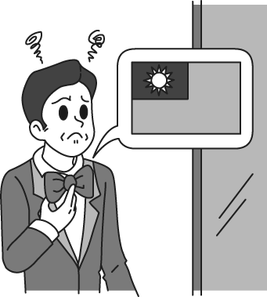 (Ｃ) 
- (Ａ) 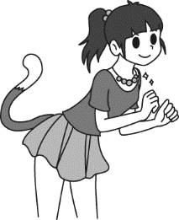 (Ｂ) 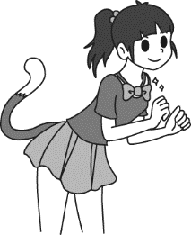 (Ｃ) 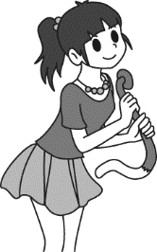
- (Ａ) 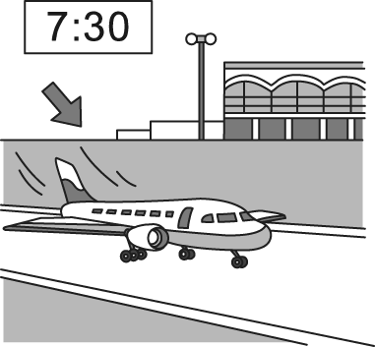 (Ｂ) 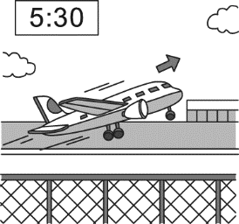 (Ｃ) 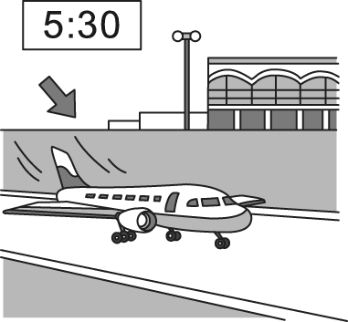
- (Ａ) 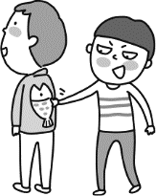 (Ｂ) 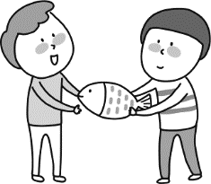 (Ｃ) 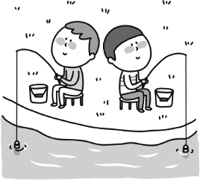
- (Ａ) 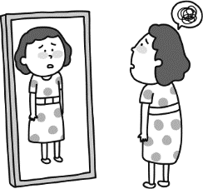 (Ｂ) 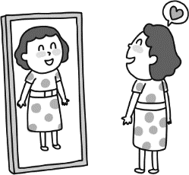 (Ｃ) 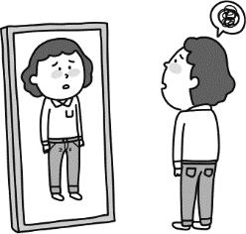

- 基本問答：根據聽到的內容，選出一個最適合的回應或最適合的問句。
- (Ａ) Call the computer store to handle the problem. (Ｂ) Why don’t you call me again? (Ｃ) Maybe you can lie by the window.
- (Ａ) Let’s play on the seesaw.
(Ｂ) Oh, she is not okay because she just broke up with her boyfriend.
(Ｃ) Yes, she has worked here for more than five years.
- (Ａ) Thank you. My mom showed me some tips to make the delicious sandwiches.
(Ｂ) I can’t believe you are an office worker.
(Ｃ) But I don’t really like the taste of the food.
- (Ａ) She doesn’t like the uniform. (Ｂ) She is my younger sister. (Ｃ) She is buying some food in the supermarket.
- (Ａ) How many times do you have to feed your dog a day?
(Ｂ) Is it the one that has brown color on the back?
(Ｃ) Do you know where the restroom is?

三、言談理解：根據聽到的內容，選出一個最適合的答案。
11. (Ａ) The woman. (Ｂ) The woman’s dad. (Ｃ) The woman’s grandpa.
12. (Ａ) She is the class leader in the class. (Ｂ) She is wearing a white T-shirt today. (Ｃ) She is interested in Pete.
13. (Ａ) In a park. (Ｂ) At the airport. (Ｃ) In the restaurant.
14. (Ａ) He is polite and nice. (Ｂ) He is blind and lazy. (Ｃ) He is rich and proud.
15. (Ａ) The woman enjoys everything in France. (Ｂ) It takes the woman too much time to have a meal with her friend there.
(Ｃ) The woman doesn’t really enjoy the taste of the food.

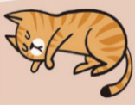
第二部分: 單題 50%
16. Look at the picture. The cat is _________ on its side.
(A) smoking (B)landing (C)surfing (D) lying
17. I worked long hours yesterday. It was dark by the time I _________ at home.
(A)arrived (B)led (C)dressed (D)collected
18. You’ve got to ________ calm on the stage even if you are scared inside.
(A)describe (B)lead (C)clap (D)appear
19. The girl didn’t notice her money fell from her pocket, so I picked it up and asked her if it ________ her.
(A)belonged to (B)went on (C)dressed up (D)closed to
20. A:What would you like for ______ dish? B:I’d like to have spaghetti.
(A)round (B)main (C)square (D)glad
21. If you want to ______ money from the ATM, just insert the card and enter your personal identification number.
(A)hear (B)rise (C)tape (D)draw
22. Although Shinkai didn’t go to an art school, he has a good _________ of using light in his works.
(A)attention (B) knowledge (C)politeness (D)spell
23. Martin gets _________ when he speaks in public.
(A)apartment (B)prize (C)butterflies (D)topic
24. The 921 Earthquake in 1999 was a terrible disaster. People in Taiwan are no _________ to earthquakes.
(A)stranger (B)fan (C)present (D)sidewalk
25. My old brother works as a salesman. He goes on a _________ trip to Kaohsiung once a month.
(A)family (B)school (C)business (D)skiing
26. The actor became tired of talking about the movie ___________ after he was interviewed it many times.
(A)is famous (B)which is famous for (C)that he is famous (D)he is famous for
27. The gate ________ to the room ______ we can take some rest later.
(A)leads; which (B)leads; where (C)marks; that (D)tapes; where
28. Grand Hyatt Taipei is the hotel ____________ 850 rooms.
(A)has (B)there has (C)there is (D)which has
29. Braille came from France. The blind read by touching it ____________
(A)with their fingers (B)who has hands (C)in a white dress (D)with pleasure
30. A comic con is a meeting of people ____________________ comic books.
(A)that has a great interest in (B)who are interesting to (C)who is interested in (D)who have an interest in
31. Many companies such as H&M, Adidas, and Nike refused to accept materials _______________ Xinjiang.
(A)what were made in (B)that were made in (C)which made by (D)which made in
32. In my mom’s school days, she _______ to English radio programs every day. That was how she learned English at that time.
(A)listens (B)was listening (C)used to listen (D)has listened
33. The man who ________ with a police officer the day before yesterday is on the news now.
(A)has fought (B)fights (C)was fighting (D)fought
34. Fruit or vegetable drinks ________ less than 10% real fruit or vegetable juice would have to be labeled as a “drink.”
(A)which contains (B)that contain (C)whose juice (D)have
35. French people enjoy a good meal, and that’s _______ they have around two hours for lunch breaks.
(A)because (B)how (C)why (D)what
36. Nick is looking for his smart watch his old brother _________ him on his 12th birthday.
(A)gives (B)to give (C)gave (D)that give
37. My aunt bought a box of chocolate as my Christmas present. She knows that ________________.
(A)I have bigger fish to fry (B)my mind just went blank (C)I have a sweet tooth (D)I have green fingers
38. COVID-19 vaccines are effective at protecting you from getting sick. However, _________ have been fully vaccinated still have a chance to get it.
(A)people (B)they (C)Who (D)people who
39. Eric Carl wrote many children books, ___________ were translated into many languages and shared around the world.
(A)some of which (B)some of that (C)some of who (D)some of whom
40. The storybook _________ cover is a big colorful caterpillar attracts not only children but also adults.
(A)that (B)whose (C)what (D)of

第三部分: 題組 20%
(41~42)
Pont des Arts is a famous bridge in Paris. Lots of artists go there to show their art. In 2008, people started to hang locks on the bridge railings.
Hanging locks on the bridge railings is a popular way for 41 . However, in June 2014, the heavy locks caused some parts of the railings to fall. Luckily, no one was hurt in the accident, but the public started to worry about the bridge. Then, in 2015, the love action was stopped. The city took down a million locks and replaced the railings with glass. 42 , it became difficult for people to put locks on the bridge.
Pont des Arts is now safe. Although people can’t hang their love locks there now, they can still take photos with each other.
41. (A)those who pray for good health (B)artists who want to show their art
(C)he who hopes for happiness (D)people who want to show love to their loved ones
42. (A)From then on (B)However (C)What’s more (D)For example

(43~44)
You may know Internet cafés－cafés in which you pay to use the Internet and a computer－but have you heard of manga cafés? Like Internet cafés, manga cafés provide Internet services. They also provide comic books. You pay for the time you spend there, and you can 43. .
In Japan, manga cafés are very common and can be found easily in the city. In a manga café, you can get your own room with a key. The room is usually very small; the space is only enough for a chair, a small desk, and a person. Also, people who are at a manga café have to be quiet, so they won’t disturb others.
Some people in Japan choose to live in a manga café because renting an apartment in a big city can be very expensive. Many manga cafés are open 24 hours, and they also have shower rooms, so it’s not a bad choice to live in a manga café. Many people who live in a manga café have a home, 44 . Living in a manga café means they don’t need to spend hours in traffic every day, and it’s also cheaper.
Although it may not be the most comfortable place to live in, for those who like comic books, living in a manga café is like living in their dream.
43. (A)order anything you like on the menu (B)connect with your friends and family
(C)read as many books as you want (D)create personal profile on the website
44. (A)but their home may be hours away from their workplace (B)and manga cafés are more than places where you can have a read
(C)so enjoying reading comic books is the main reason (D)but manga cafés offer a reasonable price

(45~46)
As a gentleman was walking through an elephant camp, he spotted that the elephants weren’t being kept in cages or held by the use of chains. All that was holding them back from escaping the camp was a small piece of rope tied to one of their legs.
As the man looked upon the elephants, he was completely confused as to why the elephants didn’t just use their strength to break the rope and escape the camp. They could easily have done so, but instead, they didn’t try to at all.
Curious and wanting to know the answer, he asked a trainer nearby why the elephants were just standing there and never tried to escape. “Well,” the trainer said, “ when they are very young and much smaller, we use the same size rope to tie them and, at that age, it’s enough to hold them. As they grow up, they are conditioned to believe they cannot break away. They believe the rope can still hold them, so they never try to break free.”
The only reason that the elephants weren’t breaking free and escaping from the camp was that over time they adopted the belief that it just wasn’t possible.
45. When someone is conditioned to do something, __________
(A)it’s fun to share experience with others. (B)it takes him hours to exercise every day.
(C)he meets their maker. (D)he gets used to doing a certain thing without thinking about it.
46. What’s the moral of the story?
(A)Don’t run after happiness. Enjoy your life. (B)Don’t limit yourself to a belief that you can’t.
(C)People will treat you the way you treat them, so you should be nice to others.
(D)Words can be nice like flowers and jewels, and words can also be bad like snakes and frogs.

(47~48)
We know that the planets of our solar system orbit the sun. Comets also orbit our sun--more than 4000 of them. Most comets circle the sun very slowly. While the earth circles the sun once a year, many comets take thousands of years to complete just one orbit of the sun.
Comets are made of frozen gases and bits of rock and dust. The solid part of most comets can be up to 10 miles across. As a comet gets close to the sun, the heat causes the comet’s frozen gases to turn into a cloud of vapor and dust. The cloud can be thousands of miles across. Solar winds cause this vapor cloud to trail out behind the comet like a tail. This “vapor tail” can be hundreds of millions of miles long.
Sometimes comets are visible from earth. You might think that when this happens you would see the comet whizzing across the sky. But in fact, it would appear to be motionless. This is because both the comet and the earth are moving.
The most famous comet is Halley’s Comet. Its orbit around the sun takes 76 years. This is pretty fast for a comet. There are records of sightings of Halley’s Comet from 2,500 years ago. The next time it will be visible from earth will be in 2061.
47. Which is not true about comets?
(A)When comets are visible from earth, they appear to be motionless.
(B)Some comets have tails that are millions of miles long.
(C)People can see comets whizzing across the sky.
(D)As comets get closer to the sun, some of the ice melts and forms the long tail.
48. Which is true about Halley’s Comet?
(A)Halley’s Comet passes through the solar system every 76 years.
(B)It’s possible for a human to see Halley’s Comet three times in his or her lifetime.
(C)The last time Halley’s Comet was seen on earth was in 1758.
(D)The first known sightings of Halley’s Comet will take place in 2061.

(49~50)
By any measure, Netflix’s Squid Game is a great hit. The South Korean TV series came out on September 17, 2021, and become an almost overnight success. After its release, Squid Game created memes across social media. The series follows a contest where 456 people from all kinds of life in deep debt play in several children’s games with the hope of winning 45.6 billion. There’s just one condition－if they lose, they die. Only one person can win the prize. Among the survival-style games, the “Red Light, Green Light” game and the honeycomb cookie are the most popular ones.
Squid Game’s success is such a fantastic payoff for Netflix’s decision to invest $500 million in Korean entertainment in 2021 that it is causing the company’s stock(股票) to boom. That might be somewhat ironic given that Squid Game is all about socioeconomic(社會經濟的) problems.
The most interesting thing about Squid Game is that the creator Hwang Dong wrote the story for the series back in 2009. He tried to sell it but no buyers wanted it because of its violent plot. In 2019, Netflix came across Hwang’s story and decided to make it as an original series. Now, Squid Game has not only become the most popular Korean drama in Netflix’s history, but it’s on its way to become the most-watched non-English show globally.
49. Which is a meme?
(A)A meme is a creator who wrote a story.
(B)A meme is a situation that becomes popular in a very short time.
(C)A meme is a debt that should be paid off.
(D)A meme is a drama that has a violent type.
50. Which is not true about Squid Game according to the article?
(A)The Korean thriller is on track to become Netflix’s biggest non-English-language show of all time.
(B)In the series, only one person can win the prize, and those who lose the children’s games have to pay with their lives.
(C)The series is a survival contest between 456 players who are in debt.
(D)As soon as the creator wrote the story, many buyers were eager to buy it.

110-1-3 九年級 英語科－解答
- C | - A | - C | - A | - A | - A | - B | - A | - B | - B
- C | - C | - C | - A | - B | - D | - A | - D | - A | - B
- D | - B | - C | - A | - C | - D | - B | - D | - A | - D
- B | - C | - D | - B | - C | - C | - C | - D | - A | - B
- D | - A | - C | - A | - D | - B | - C | - A | - B | - D

