新北市立溪崑國民中學110學年度第一學期第三次定期評量 英語科 試題卷
八年級 班 座號 姓名
- 聽力測驗：30%
I. 辨識句意：請依據所聽到的句子，選出符合描述的圖片
- (A)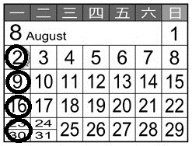 (B)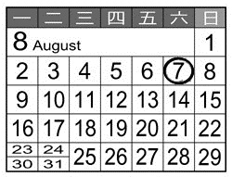 (C)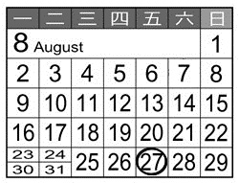
- (A)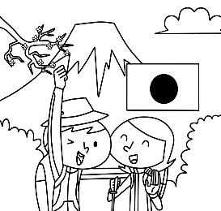 (B)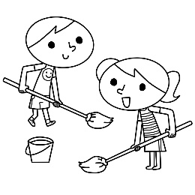 (C)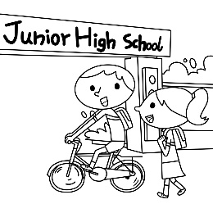
- (A)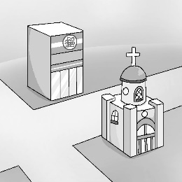 (B)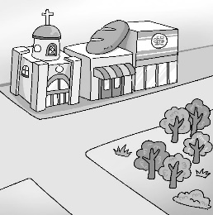 (C)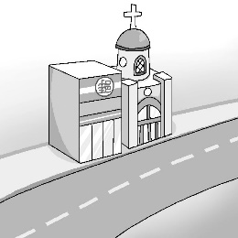
- (A)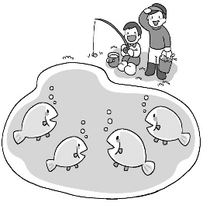 (B)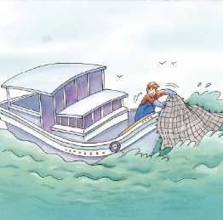 (C)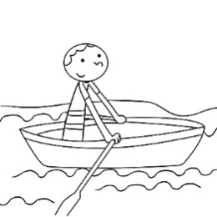
- (A) 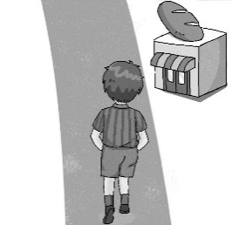 (B)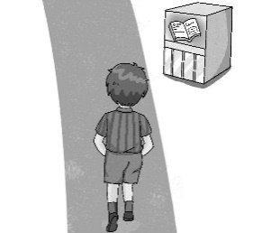 (C) 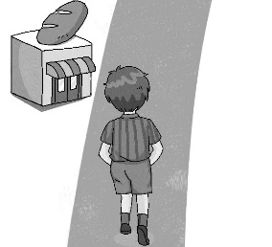

II. 基本問答：請依據所聽到的內容，選出一個最適合的回應
6. (A) Yes, I made my sisters do it.
(B) Well, the shop doesn’t open today.
(C) No, I bought them in a bakery.
7. (A) We’re so lucky. Is today a special day?
(B) It’s still early. Let’s rest at the hotel and wait until noon.
(C) The sights here are famous. Don’t you think so?
- (A) Yeah. It can lead to health problems.
(B) That’s right. I can go jogging there every day.
(C) It’s in the north of the country.
- (A) See? It’s a parking space.
(B) Sure. It’s a gift for you.
(C) Wow! It’s big enough for two people.
- (A) Usually after dinner.
(B) At six o’clock.
(C) About one hour.

【背面尚有試題】

III.言談理解：請依據所聽到的對話與問題，選出一個最適當的答案
- (A) He’s going to a post office.
(B) He’s going to a flower shop.
(C) He’s going to a department store.
- (A) The woman will go to Australia this year.
(B) The woman will go on vacation in Australia.
(C) The woman will leave Australia this September.
- (A) Shop for the week in a supermarket.
(B) Buy another newspaper in the bookstore.
(C) Have the woman read the newspaper for him.
- (A) A waiter in a restaurant.
(B) A doctor in the hospital.
(C) A clerk in a cellphone shop.
- (A) Amy and Andy live in the same block.
(B) Amy always fights with her cousins, Andy and Josh.
(C) Amy’s home is right across from Andy and Josh’s.
二、請依題意選出最適當的答案： 42 %
16. I often buy bread at this ________ after school.
(A) bank (B) church (C) bakery (D) bookstore
17. Don’t leave any trash here. Remember ________ it with you.
(A) take (B) to take (C) taking (D) took
18. They’ll set off __________ at Taipei 101 to celebrate the coming new year.
(A) fireworks (B) nature (C) mistakes (D) public
19. Jenny: Are we going to exchange gifts at the Christmas party? Dora: ________
(A) No, we won’t. (B) Of course, we are. (C) Take it easy. (D) We usually do.
20 Jim: _______ You’ll buy her a cake on her birthday. Alex: No, I’ll give her a surprise.
(A) By the way. (B) I can’t wait. (C) Let me guess. (D) That’s strange.
21. There ______ a soccer game next Saturday. Would you like to go?
(A) will have (B) are going to be (C) is going to have (D) will be
22. A: _______ did it take you to finish your homework? B: About one hour.
(A) How often (B) How much (C) How long (D) How fast
23. I will take a hot bath after I _______ home.
(A) get (B) got (C) will get (D) am getting
24. My grandparents enjoy being out in _______.
(A) nature (B) somewhere (C) sights (D) public
25. Carol _______ an hour _______ her house yesterday.
(A) took ; clean (B) spent ; to clean (C) took ; cleaning (D) spent; cleaning
26. Mark ______ his sister to help him _____ the dog.
(A) asked ; walked (B) asked; walk (C) had ; walk (D) had ; to walk
27. It _______ me $500 to buy the dress. = I _______ $500 on the dress.
(A) spent; cost (B) cost; spent (C) took; spent (D) cost; paid
28. Never make the same ______ again.
(A) block (B) mistake (C) monster (D) children
29. Go straight ______ one block, and you can see the library _____your right.
(A) for; on (B) for; in (C) to; on (D) to; in
30. A:______ can I get to the post office? B: You can go there _____ bus.
(A) How; on (B) How; by (C) What; on a (D) What; by
31. _______, sir. Is this your smartphone?
(A) Forget it (B) By the way (C) Excuse me (D) What’s more

32. Living in a city is very _________, isn’t it?
(A) dead (B) straight (C) cheap (D) convenient
33. The school is ________ Park Street and Flower Road
(A) in front of (B) on the corner of (C) across from (D) in the middle of
34. Peter goes to work _______, but his wife _____ to work.
(A) by foot; drives (B) on foot; drives (C) by feet; walks (D) on feet; walks
35. A:______ did the sweater cost you? B: Two _____ dollars.
(A) How much; thousand (B) How much; thousands
(C) How long; thousand (D) How long; thousands
36. My cellphone is _______. May I use yours?
(A) cheap (B) public (C) dead (D) left
三、克漏字選擇及閱讀測驗：28 %
A: Why are you 37. a map?
B: My family will take a trip to Japan during the winter break, so my dad
38. me study the map.
A: Are you going to stay in Tokyo?
B: Yes, we 39. . My uncle and aunt live there.
A: Maybe you can spend a day 40. near Mount Fuji.
B: Great! I can’t wait!
37. (A) reading (B) watching (C) looking (D) seeing
38. (A) asked (B) wanted (C) helped (D) had
39. (A) are (B) will (C) do (D) can
40. (A) ski (B) skiing (C) to ski (D) go ski
I went to the department store last Sunday, and that was a big mistake. There
41. enough parking spaces for visitors. It 42. me 25 minutes to drive there, but I had to wait one hour 43. a parking space. The toys and clothes there are cheap, but the food is expensive. I 44. three hundred and eighty dollars for a bowl of beef noodles. It is a great place for shopping, but not for eating.
41. (A) was (B) wasn’t (C) were (D) weren’t
42. (A) spent (B) cost (C) took (D) paid
43. (A) on (B) by (C) for (D) to
44. A) spent (B) cost (C) took (D) paid
The most beautiful humming birds are found in the West Indies and South America. The crest of the tiny head of one of these birds shines like a sparkling crown of colored light. The shades of color that adorn its breast are equally brilliant. As the bird flits from one flower to another, it looks more like a bright flash of sunlight than it does a living being.
Why are they called humming birds? It is because they make a soft, humming noise by the rapid motion of their wings—a motion so rapid, that as they fly, you can hardly see that they have wings.
When you approach the spot where one of these birds has built its nest, you need to be careful. The mother bird will dart at you and try to peck you. Its sharp beak may hurt you. The poor little thing knows no other way of defending its young, and instinct teaches it that you might carry off its nest if you find it.
crest鳥冠 sparkling閃閃發光的 adorn裝飾 brilliant色彩艷麗的
rapid快速的 approach接近 peck啄 defend保衛 instinct本能
【背面尚有試題】

45. Which is true about the humming birds?
(A) You can only find them in the West Indies and South America.
(B) The mother bird would try hard to defend its young.
(C) You can easily find and carry off their nests.
(D) There is only one kind of humming bird in the world.
46. Why are they called humming birds?
(A) They make a humming noise when singing.
(B) We can’t see their wings when they fly.
(C) We can hear the humming noise when they fly.
(D) Their motion is so rapid when they fly.
47. What might happen if you approach the nest of a humming bird?
(A) It may dart at you and try to peck you.
(B) It will hide the eggs.
(C) You may fall down and get hurt.
(D) The baby birds might be dead.

When you go to Nagoya in Japan, you must try this dish:Taiwan Ramen. It is a bowl of noodles with hot minced pork, also called Taiwan minced pork by people in Nagoya. Interestingly, you can see this kind of noodles in Taiwan. Then why is it called Taiwan Ramen? A Taiwanese in Japan made it first, so they called the dish Taiwan Ramen. Now it is popular in Nagoya, and you can see it on the menus of many restaurants.
Pizza is popular around the world, and we all know pizza is from Italy. However, people in Italy hate one kind of pizza. That is: Hawaii pizza. There are pineapples and ham on it. People in Canada made Hawaii pizza first, and then it became popular around the world. People in Italy despise it because they don’t think there should be pineapples on pizza. So remember: don’t try to order Hawaii pizza in Italy, or you may get yourself into trouble.
Nagoya名古屋 minced pork肉燥
48. What is the main idea of this reading?
(A) You can’t miss the two dishes: Taiwan Ramen and Hawaii pizza.
(B) Pizza and Ramen are delicious dishes.
(C) Taiwan Ramen and Hawaii pizza got their names from their countries.
(D) People may think some dishes from some countries, but in fact they aren’t.
49. What does the word “despise” mean?
(A) like
(B) hate
(C) need
(D) make
50. Which is true about the reading?
(A) You can only eat Taiwan Ramen in Japan.
(B) There is beef in Taiwan ramen.
(C) People in Italy don’t eat pineapples.
(D) There is fruit on Hawaii pizza.

【試題結束】

110-1-3 八年級 英語科－解答
1-10 BAABC CABBC
11-20 AABCA CBABC
21-30 DCAAD BBBAB
31-40 CDBBA CADAB
41-50 DCCDB CADBD

