新北市立溪崑國民中學110學年度第一學期第三次定期評量 英語科 試題卷
七年級 班 座號 姓名
第一部分-聽力測驗20%
一、辨識句意：每題均有三張圖片，請依據所聽到的句子，選出符合描述的圖片(每題1分，共5分)
- (A) 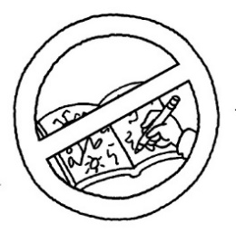 (B)  (C) 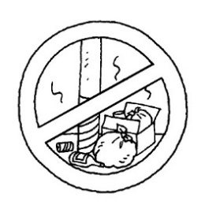
- (A) 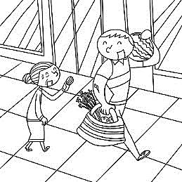 (B) 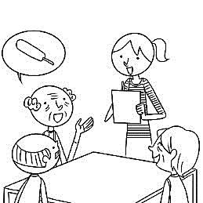 (C) 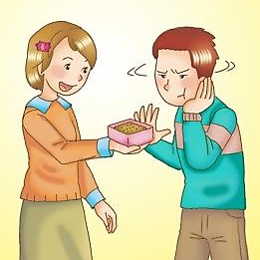
- (A)  (B) 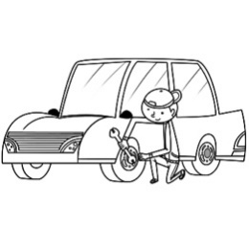 (C) 
- (A) 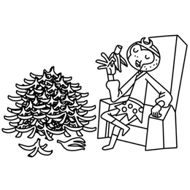 (B) 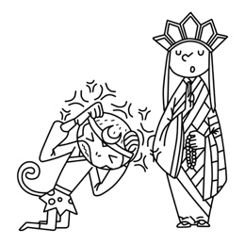 (C) 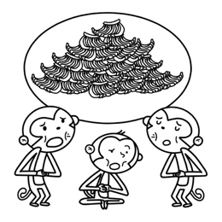
- (A) 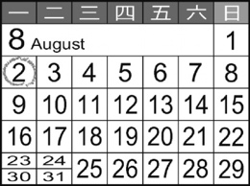 (B) 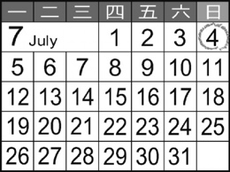 (C) 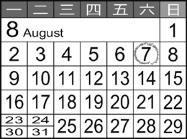
二、基本問答：每題均有三個選項，請依據所聽到的內容，選出一個最適合的回應(每題1分，共5分)
- (A) Let’s sit down.
(B) Yes, they’re kind.
(C) No, we’re fine.
- (A) It’s Wednesday.
(B) It’s on Wednesday .
(C) It’s not on Wednesday night.
- (A) What time is it, Sandy?
(B) It’s on Thursday evening, Sandy.
(C) Hi, Sandy.
- (A) No, it’s at four p.m.
(B) No, it’s at nine a.m.
(C) No, it’s on Tuesday morning.
- (A) Here we are.
(B) Let’s wait in line, too.
(C) Don’t lean on the doors.
三、言談理解：每題均有三個選項，請依據所聽到的對話與問題，選出一個最適當的答案(每題2分，共10分)
- (A) Rosa is late.
(B) Irene and Mark are late.
(C) The man is late.
- (A) There is a metro station under the castle.
(B) The castle is beside a metro station.
(C) The man and the woman are in the castle.
- (A) They are in the museum.
(B) They are in a park.
(C) They are near Lake Station.
- (A) It’s five fifty p.m. now.
(B) The dancing class is at five fifty p.m.
(C) The woman is eating dinner now.
- (A) Today is Tuesday.
(B) They are in a city now.
(C) The class is on the weekend.
第二部分-綜合測驗32%
- _____ the road for two miles, and then turn left.
  - Say (B) Rise (C) Follow (D) Short
- It’s time for class. Don’t make any _____.
  - rule (B) seat (C) city (D) noise
- A: What is Grandma _____?
B: Her smartphone.
  - preparing for (B) looking for (C) making for (D) eating about
- _____ is between Wednesday and Friday.
  - Tuesday (B) Saturday (C) Monday (D) Thursday
- The children _____ on the sofa and _____ TV.
  - is sitting ; watching (B) are sitting ; watching (C) sitting ; watching (D) sits ; watches
- A: The magic show is at 6:00 p.m. _____ We are almost late.
B: How about taking a taxi?
A: Ok.
  - Time is up. (B) No problem. (C) Hurry up. (D) By the way.
- A: _____
B: Thank you, young lady.
  - Please be kind to me. (B) Please don’t run. (C) Don’t eat on the metro. (D) Please take my seat.
- Solina, _____ games on the basketball court.
  - is playing (B) not play (C) don’t playing (D) don’t play
- 選出正確的句子
  - Let’s not shout or run here.
  - Don’t shout and run here.
  - Don’t bad to your friends.
  - Let’s don’t shout and run here.
- A:Who is in the computer classroom? Only Vivian?
B: No. Emily is _____ her.
  - and (B) with (C) for (D) about
- A: What are you doing?
B: _____
  - I am hungry. (B) Talk in class. (C) We are having lunch. (D) We are late.
- A: Where is Alice?
B: _____
  - She’s making dinner in the kitchen.
  - She’s talking about Mr. Wang’s house.
  - She’s from the USA.
  - She’s late for school.
- A: _____. This is my new house.
B:Wow! It’s so beautiful. And where is your new car?
  - Here we are.
  - Please follow it.
  - You’re welcome.
  - Let’s go.
- The group chat with students from Paris is _____
  - 6:30 p.m. in the evening.
  - six o’clock in the evening.
  - at six on Friday evening.
  - on Friday in the evening.
- A:_____
B: It’s Friday. We have a meeting with Mr. Suzuki from Sapporo.
  - What day is your meeting?
  - What time is your meeting?
  - What day is today?
  - What time is it?
- A: It’s so quiet at home now. _____
B: Yes, they are preparing for their English test on Monday.
  - Are you chatting with Jack and Frank?
  - Are Jack and Frank studying in their rooms?
  - What are Jack and Frank doing?
  - What day is Jack and Frank’s English test?

第三部分-克漏字選擇10%
Maggie: Hi, Tony. What’s that on the desk? Is it for (32) ?
Tony: No. Father’s birthday (33) ? This is a gift for (34) ?
Maggie: Wow! It’s cool! What about William’s and Frank’s gifts?
Tony: Are (35) birthday this Sunday, too?
Maggie: Yes. So let’s buy something for (36) .
- (A) us (B) we (C) their (D) his
- (A) coming (B) going (C) come (D) is coming
- (A) it (B) him (C) her (D) you
- (A) she (B) their (C) her (D) your
- (A) they (B) their (C) them (D) him

第四部分-閱讀測驗38%
Jennet, Amy, and Kelly are talking in the classroom. They are very excited because there is a dancing party tomorrow.

Jennet: What am I going to wear for the dancing party tomorrow? I really have no idea. What about you, girls?
Amy: Let me think about it. Well, I think I will be in a black dress because my dad's hair is black.
Kelly: That's a good idea. Then, I think I will be in a grey suit because my dad's hair is grey.
Jennet: Hey, what about me? My dad is a bald. What should I wear? Do you think I should wear nothing?

excited興奮的 suit套裝 should應該

- Where are the girls talking?
  - At the park. (B) At the restaurant. (C) In the living room. (D) At school.
- Why do the girls feel excited?
  - Because there's a tea party tomorrow.
  - Because there's a dancing party tomorrow.
  - Because they are going to wear new clothes.
  - Because they are going shopping together tomorrow.

- Which is true about the conversation?
  - Jennet doesn't want to go to the party.
  - Jennet doesn't know what to wear for the party.
  - Amy will be in a grey suit for the party.
  - Kelly will be in a black dress for the party.

- What does "My dad is bald" mean?
  - My dad doesn't have money.
  - My dad doesn't wear clothes.
  - My dad doesn't have any hair.
  - My dad doesn't like parties.

Bob: I take a bus to school every morning, but I don't like it. I hate to wait for the bus. What can I do?
Frank: You can ask your parents to buy you a bike. Can you ride?
Bob: Of course I can, but they say I have to save money for one. How can I save money? I'm only 10 years old.
Frank: Hey, I have a good idea. You take a bus every day, right?
Bob: Yes.
Frank: You have to pay for it, right?
Bob: Sure. And then?
Frank: So, if you run after a bus to school, you don't have to pay. Then, you can save money every day.
Bob: Oh, yes. And, if I run after a taxi, I can save more.
Frank: Yes, brilliant. You've got a better idea. Let's do it tomorrow. I can save money for my new pad, too.

save節省 pay付 if假如 run after追逐 better更好的

- Why does Bob need to save money?
  - He needs to buy a present for his parents.
  - He needs to take a taxi to school every day.
  - He needs to buy a bike.
  - He loves to save money.

- What does one mean here?
  - A bus. (B) A good idea. (C) Money. (D) A bike.

- What does brilliant mean here?
  - Stupid. (B) Ugly. (C) Smart. (D) Poor.

- Which of the following is NOT true?
  - Both the boys need to save money.
  - Both the boys are stupid.
  - If they run after a taxi, they really can save more money.
  - They both will run after a taxi the next day(隔天).

English Songs | English Stories and Jokes | English Teaching Experience | English Grammar
Cities in America | English Tests | E-mail Me | My New Book  "Fun Reading"

Solina’s Website

Hi, there,
Welcome to Solina's Website.
I'm Solina Wu, an English teacher from America.
Here, I'd like to share something fun with you, like English songs, English stories, English teaching experience, English grammar and so on. Or, if you have any questions about English, you can click on “E-mail Me”. I am ready to help at any time.
By the way, my new book "Fun Reading" is coming in two weeks.
If you book online, you can have 30 % discount, or you can get one at any bookstore.
Enjoy your visit.

experience經驗 grammar文法 and so on等等
click點選 book online線上預購 discount折扣 mainly最主要的

- This Website is mainly about ____.
  - selling books (B) learning English (C) telling stories (D) taking trips
- What can't you find at this Website?
  - Stories. (B) American Cities. (C) Songs. (D) Comics(漫畫).
- Ella wants to know about New York. Which may she click on?
  - English Songs. (B) English Grammar. (C) Cities in America. (D) My New Book.
- Which is NOT true about this Website?
  - You can buy "Fun Reading" cheaper(比較便宜) online.
  - You can learn English here.
  - You can e-mail Solina Wu.
  - You can see English movies on this Website.

Annie is a famous singer. Her voice is very sweet, and all her fans think her voice is from the heaven. So, most of her albums are like ice cream in hot summers. Besides, she is as beautiful as an angel: tall, slender, charming and eye-catching.
Two months later, she's going to marry Richard, a rich and handsome businessman. They will have a big wedding on an island Richard bought for her. Believe it or not, the name of the island is Annie. And after the wedding, they will travel around the world for their honey moon. How romantic!
Annie has everything most women dream to have: a good look, a successful carrier and a rich husband who loves her very much. She's really lying on the bed of roses.

heaven天堂 eye-catching搶眼的 albums專輯 honey moon度蜜月
slender苗條的 carrier事業 charming有魅力的 lie(lying)躺

- What does " like ice cream in hot summers" mean here?
  - Very convenient. (B) Very popular. (C) Very cool. (D) Very surprising.
- Who is Richard?
- Annie's friend. (B) Annie's cousin. (C) Annie's husband. (D) Annie's island.
- What does "She's really lying on the bed of roses" mean here?
- She grows lots of roses and lies on them.
- She has a big garden with lots of roses.
- She likes to lie on the bed full of roses.
- She is very successful in her life.

- Which is NOT true?
- Annie is a pretty and successful singer.
- She has her own island.
- Her husband bought her a lot of roses.
- Annie and her husband will travel around the world for their honey moon.

There are four food shops on Amanda's way to school. Here are their ads.
Papa Marko's  ~ Pizza to go~  Large $250 Medium $180 Small $100  * Ready in 15 minutes *  Open at noon 7 days a week  Call now: 1234-5678 | Apple Tree Bakery  ~Handmade Bread and Cookies~  Open at 6 o'clock every morning  20% off after 8 p.m.
GOOD TASTE FAST FOOD  Hamburgers, Hot dogs, Drinks  10:00 a.m. to 11:30 p.m. every day | Winnie's Sandwich Club  ~All you can eat ~  $180 a person  $120 for children under 12  Lunch hours: 11 a.m.~2p.m.  Dinner hours: 5 p.m. ~8 p.m.  Closed on Sundays
ad 廣告

- Amanda has to get to school before 7:00 this morning. On her way to school, where can she buy her breakfast?
  - At Papa Marko's.
  - At Apple Tree Bakery.
  - At Good Taste Fast Food.
  - At Winnie's Sandwich Club.
- Yesterday was Amanda's eleventh birthday. Her parents took her to Winnie's Sandwich Club for dinner. How much did they spend?
- $300. (B) $360. (C) $480. (D) $540.
- Amanda passes these four shops every day on her way to school. Look at the map. Which place is most likely(可能) to be Amanda's school?
- A
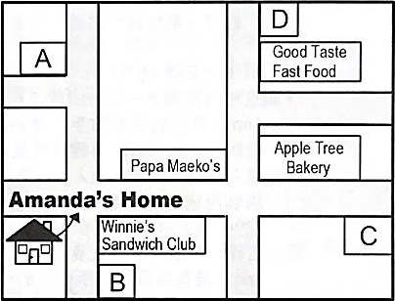
- B
- C
- D

{98-1 基測}

110-1-3 七年級 英語科－解答
1.BCAAB 6.CBCAB 11.CACAB 16.CDBDB 21.CDDAB 26.CAACC
31.BADBB 36.CDBBC 41.CDCCB 46.DCDBC 51.DCBCD

