新北市立溪崑國民中學110學年度第一學期第二次定期評量 英語科 試題卷
九年級 班 座號 姓名
一 聽力：30％(每題2分)
(一) 辨識句意：根據聽到的內容，選出符合描述的圖片10%
1.
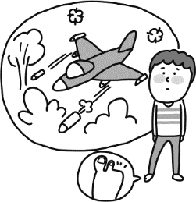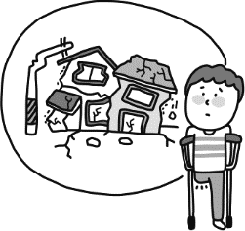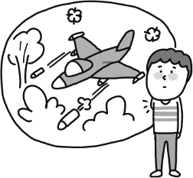
(A) (B) (C)
2.
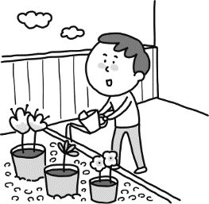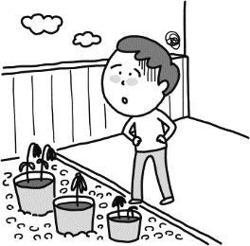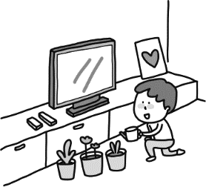
(A) (B) (C)
3.
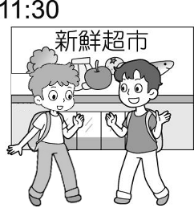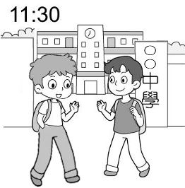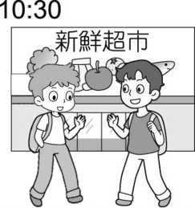
(A) (B) (C)

4. 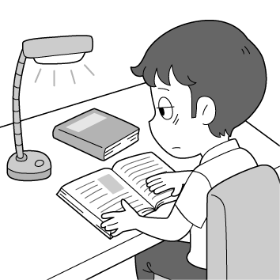 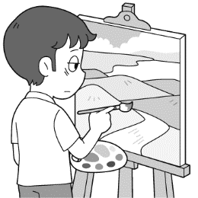 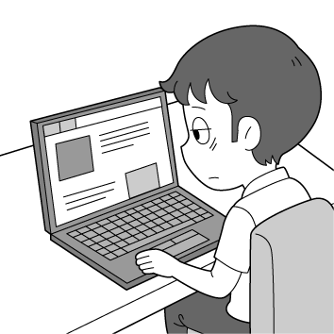
(A) (B) (C)
5.
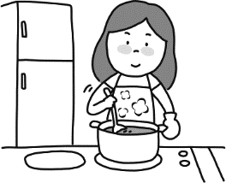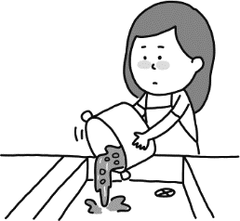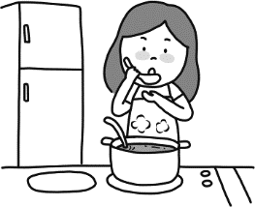
(A) (B) (C)

(二) 基本問答：依據所聽到的內容，選出一個最適合的回應10%
6. (A)Ｉdidn’t feel sad yesterday. (B) I was bullied by one of my classmates. (C) Yes, I am so happy to be here.
7. (A) Yes, it took me about 20 minutes. (B) Sure. I am good at Math. (C) Of course. I am glad to help you with that.
8. (A) An old woman was killed at home last night. (B) There is a police station over there.
(C) You can ask the police for help.

9. (A) We had a good time there. (B) We can take care of the children at the playground.
(C) We can play tennis with the seniors.
10. (A) Next Tuesday. (B) It is reported by a famous person. (C) Two times a week.
(三) 言談理解：請依據所聽到的對話與問題，選出一個最適當的答案10%
11. (A) The girl thinks he is cute.
(B) He has been to Taiwan three times.
(C) He got to Taiwan three days ago.
12. (A) She should buy a watch, so she can know what time it is.
(B) She shouldn’t stay up late for her studies.
(C) She should study harder for the English test.
13. (A) The man.
(B) The woman.
(C) Both of them.
14. (A) At 4 p.m.
(B) At 3 p.m.
(C) At 1 p.m.
15. (A) The man wants to go to the movies tonight.
(B) Lily can’t go to the movies because of the report.
(C) Rita will go to the movies with the man.
二 綜合選擇(選出最適合的答案)：30％(每題2分)
16. Tina always wears a _______ on her face. She is a sweet girl.
(A) hat (B) glass (C) glove (D) smile
- Elephants are the largest animals on _______.
(A) zoo (B) land (C) world (D) history
18. Why are there so many _______ every day? Can’t our teachers give us a break?
(A) errors (B) lists (C) homework (D) quizzes
- One of the ________ on May’s dress is missing, but she hasn’t known anything about it yet.
(A) buttons (B) keys (C) files (D) wallets
- A ________ helps food to stay cold and last longer.
(A) coffee machine (B) fan (C) refrigerator (D) ice
- Most fruit is ________ in Vitamin C. It is good for our health.
(A) full (B) poor (C) good (D) rich
- Alex enjoys watching TV all day long; he is a ________ potato.
(A) couch (B) modern (C) yummy (D) coach
- I am not sure if Melody ________ tonight, but if she does, I’ll tell her that you called.
- comes in (B) came in (C) will come in (D) has come in
- The garbage ________ away because it smells so terrible.
(A) needs throwing (B) has to throw (C) needs to throw (D) have to be thrown
- Derek has no idea ________ to do. (A) what (B) how (C) whether (D) when
- My dog Lucky loves ________ with a comb. Every time I comb his hair, he will fall asleep.
(A) brushing (B) to be brushed (C) to brush (D) to be brushing
- Tell me ________ (A) what is he going to do. (B) when will the bus come.
(C) which dress you like most. (D) what is left in the fridge?

- We are not sure ________ they have seen the latest horror movies. (A) after (B) what (C) because (D) whether
- Most of Kelly’s best books ________ when she was poor and sick.
(A) wrote (B) have been written (C) were writing (D) were written
- In 2011, many people ________ during the tsunami (海嘯) in Japan.
(A) are killed (B) killed (C) died (D) lose their lives
三 克漏字與閱讀理解：20％(每題2分)
(一)
(At the restaurant)
Mrs. Lin: I don’t think our chef, Frank, is doing a good job in the kitchen. Do you know how many times he has been late for work this month? More than four times.
Mr. Lin: Yes, it is true. Fewer and fewer customers enjoy coming to our restaurant for lunch or dinner. I think we need to take action to solve the problem.
Mrs. Lin: How about asking Frank ___31___ and finding another new chef?
Mr. Lin: Sound like a good idea.
Mrs. Lin: Do you know when ___32___ to the restaurant today? I need to have a good talk with him when ___33___ here.
Mr. Lin: Hope he can understand ___34___. chef 主廚
31. (A) leaving his job (B) to stay here for longer (C) coming earlier (D) to leave his job
32. (A) Frank will get (B) Frank gets (C) will Frank get (D) did Frank get
33. (A) he got (B) will he get (C) he will get (D) he gets
34. (A) what should he do next (B) where will he go (C) when to do (D) how we fell
(二)
Plan Your Career
What will be your career in the future? How are you going to make a successful career plan? The following
ways might be able to help you.
- You are 100% responsible for your life. No one can decide for you. You must take full responsibility for your career planning.
- Give yourself time to think.
Ask yourself:
“What do I really want?”
“What do I care about most?”
“What do I want my life to look like in the future?”
Think carefully. You might want to make your career decision based on these points above.
- Set your goals.
Dream big but start small. To reach your final big goal, you need to break it down into short, medium, and long-term goals. And take a small step each time.
- Know your abilities.
Know your strengths and weaknesses. Utilize your strengths and minimize your weaknesses.
- Find a career mentor.
Find one or some mentors. They can give you useful advice.
- Try new things.
Learning can bring you new ideas. If you don’t want to stay in your current career, learning is the best way to get out of it and find your true interests.
35. What do these points refer to in the reading? (A) Your dreams. (B) Your abilities. (C) Your mentors. (D) Your answers.
36. Which word has a similar meaning to Utilize? (A) Find. (B) Use. (C) Want. (D) Learn.
37. What is not true?
(A) Sometimes learning new things helps you find your real interests.
(B) You might want to make your career decision by yourself.
(C) It’s better not to ask mentors for any career advice.
(D) It’s important to set short, medium, and long-term goals.
(三)
How Virtual Reality Is Created

Virtual reality(VR) is the technology that gives a person a feeling that they are somewhere else. It builds a virtual environment with a device that can cheat our senses in our brain. All you need is a VR headset and a built-in program that produces images (pictures), sounds, and the air. A high-quality image is created, and this makes the user feel present in that place. A VR headset comes with a screen (to show the image) and speakers (to produce sounds). The image changes when your head moves. The user can also walk through the virtual space and move things in it.
How does VR work?
A natural light, which makes the eyes more comfortable, is produced by a low-power LED, and then the light goes into a set of special optics and shines onto two million mirrors fixed in the headset. The projections from the mirrors are then shaped into a clear image. Before we receive this image, it has to go through another set of special optics. They focus and project the image directly onto our eyes. Finally, our brain processes the information. The information is what we later see on the VR screen.

device裝置 optic 光學鏡片 project/projection 投射/投影

38. According to the reading, what is VR?
(A) It is a technology that really helps us experience swimming in the sea.
(B) It is a technology that helps people move heavy things.
(C) It is a technology that makes TV programs with images, sounds, and the air.
(D) It is a technology that gives people a feeling that they are in somewhere else.
39. How dose VR create images, sounds, and the air?
(A) With two million mirrors in the headset. (B) With the screen and speakers in the headset.
(C) With a set of special optics in the headset. (D) With a program in the headset.
40. Why does VR need a low-power LED to provide light?
(A) Because light produced by an LED is more comfortable for human eyes.
(B) Because only the light produced by an LED can be received by humans.
(C) Because only the light produced by an LED can go through the special optics in the VR headset.
(D) Because only the light produced by an LED can be shaped into a clear image.

~還有題目～
以下為非選擇題，請在答案卷上作答 20%
四 依提示作答: 4％（每題2分）
- People don’t use these tools today. ( 請改為被動語態 These….. )

- How many museums did Tim visit last year? 請用名詞子句將兩句合併為一句 ( Let’s.…how…)
Let’s find it out.
五 翻譯: 16％ (每題4分)
1. 當你在外面時，你的手機會告訴你是否成功的透過電子錢包付費。

2. 莫非定律要教導我們的是，作最壞的打算。

- 婦人帶士兵去廚房，遞給他一個鍋子，並幫忙開火。

- IoT （物聯網）的概念是將所有事物連結到網路，並讓它們互相分享資訊，來讓事物智慧化。

試題結束!

新北市立溪崑國民中學110學年度第一學期第二次定期評量 英語科 答案卷
九年級 班 座號 姓名
非選擇題20%
四 依提示作答: 4％（每題2分）
1.

2.

五 翻譯16% （每題4分）
1.

2.

3.

4.

試題完! Good Luck!

110-1-2 九年級 英語科－解答
一、聽力測驗30% (每題2分)
1~5 CABCA 6~10 BCABA 11~15 ABBAC
二、綜合選擇(選出最適合的答案) 30% (每題2分)
16~20 DBDAC 21~25 DACAA 26~30 BCDDC
三、克漏字與閱讀理解：20％ (每題2分)
31~34 DADD(34.送) 35~37 DB C 38~40 DDA
四、依提示作答: 4％（每題2分）
1. These tools aren’t used (by people) today.
2. Let’s find out how many museums Tim visited last year.
五 翻譯:16％ (每題4分)
- When you’re outside, your phone tells you if the money has been paid
from your online wallet successfully.
- The lesson behind Murphy’s Law is to be prepared for the worst.
- The woman led the soldier to the kitchen, handed him a pot,
and helped start the fire.
- The idea of IoT is to make things “smart” by connecting them to the Internet
and having them share information with each other.

新北市立溪崑國民中學110學年度第一學期第二次定期評量
九年級 英語科 聽力測驗稿
錄音稿：
（一）辨識句意：依據聽到的內容，選出符合描述的圖片
1. M: I lost my right arm during an attack that night.
2. Eric has green fingers, so he plants many flowers on the balcony.
3. Kevin, let’s meet in front of the school gate at 11:30 tomorrow.
4. It is bad for your eyes if you keep looking at the screen for a long time.
5. My mom is stirring the soup in the kitchen.
答案： (C) (A) (B) (C) (A)

（二）基本問答：依據所聽到的內容，選出一個最適合的回應
6. Why do you look so unhappy, Jerry?
7. Can you teach me how to learn English well?
8. I saw a lot of police over there. What happened?
9. What can we do at a children’s home?
10. Do you remember when Mr. Wu asked us to hand in the report?

答案：(B) (C) (A) (B) (A)

（三）言談理解：依據所聽到的對話與問題，選出一個最適當的答案
11. W: Kevin, your new classmate looks so cute and charming. Do you know where he is from?
M: Yes, we talked three days ago. He is from Canada and just arrived in Taiwan last week.
W: Why does he want to come to Taiwan?
M: Oh... He wants to learn Chinese. And he told me he loves Chinese culture so much.
Q: What is true about Kevin’s new classmate?

12. M: You are late, Judy. Don’t you know what time it is?
G: Sorry, Mr. Lin. I stayed up late studying for the English quiz last night, so I didn’t get up this
morning. Then, I missed the school bus.
M: Staying up late is not good for your studies. You should go to bed earlier.
G: Sorry. I promise I won’t do that again.
Q: What does Mr. Lin tell Judy to do?

13. W: I was invited to a TV program last Saturday.
M: What is the program about?
W: It is about cooking.
M: Cool. I enjoy cooking as well. How can I be invited?
W: Well, you can visit the website of the program and sign up. Maybe you’ll also have a chance.
Q: Who was invited to the TV program last Saturday?

14 W: Can you go to the supermarket with me this afternoon?
M: Maybe. What time do you want to go?
W: I am free at around four o’clock.
M: But I will be busy then. Can we go earlier?
W: Ok, let’s go at one o’clock instead.
M: Sure. See you then.
Q: What time is the man going to be busy?
15. M: Do you want to go to the movies with me tonight, Lily?
W: Sorry, I can’t. I have to finish doing the science report tonight. Maybe you can ask Rita to go
with you. I know she likes to watch movies a lot.
M: Rita? But I am not sure if she likes horror movies.
W: Why don’t you ask her in person now?
Q: Which is NOT true?

答案：(A) (B) (B) (A) (C)

